



2024 Maternity survey

Statistical release

NHS Patient Survey Programme

Independent analysis for England
Published: November 2024
Contents
Summary of findings 3
Maternity care policy 8
About the Maternity survey 18
Results from the survey 19
Care while pregnant (antenatal care) 22
Care during labour and birth 29
Postnatal care in hospital 40
Postnatal care at home 45
Midwifery continuity of carer 52
Awareness of medical history 53
Infant feeding 55
Perinatal mental health 57
Support with communication needs 59
Subgroup analysis 60
Appendix A: Survey methodology 65
Appendix B: Other sources of data related to the key findings 69
Appendix C: Other maternity surveys 72
Appendix D: Main uses of the survey data 74
Appendix E: Revisions and corrections 76
Appendix F: Further information and feedback 77
References 78

Summary of findings
In recent years, the quality and safety of maternity services has been a key focus of national policy, with the aim of ensuring that all maternity service users have a positive and safe experience of pregnancy and childbirth. The annual Maternity survey helps monitor progress against these aims by listening to respondents as they tell us about their experiences of care provided before giving birth (antenatal care), during labour and delivery, and in the period of 6 to 8 weeks following birth (postnatal care).

The 2024 Maternity survey involved 120 NHS trusts in England. All NHS trusts providing maternity services that had at least 300 live births were eligible to take part. Maternity service users who gave birth between 1 and 29 February 2024 (and during January 2024 if a trust did not have a minimum of 300 eligible births in February) were invited to participate. Fieldwork (the period of time when the survey is sent to participants and responses are received) took place between May and August 2024, and we received responses from 18,951 people, an adjusted response rate of 41%.

Results from the 2024 Maternity survey show less change overall in experiences of care than has been seen in recent maternity surveys. Having said this, when considering evaluative questions with comparable data between 2024 and 2023, results show statistically significant decline in experiences for some areas of care during labour and birth, shortly after the birth, and during postnatal care. This includes communication during labour and birth, information provided during care in hospital after birth and involvement in postnatal care.

The 2024 survey has shown improvements in experience of mental health support during pregnancy and, for those who had an induced labour, the information provided on the risks associated with induction. Furthermore, results remain high for antenatal care questions relating to communication and involvement in care.
Positive findings
Antenatal care
There has been an improvement in results for respondents being asked about their mental health during antenatal check-ups (76% said they were ‘definitely’ asked compared with 75% in 2023). Results also showed improvement in being given enough support for mental health during pregnancy (89% compared with 88% in 2023). Furthermore, the 5-year trend analysis from 2019 shows an upward trend in respondents being asked about their mental health.

Communication and involvement in care is another area where respondents reported positive experiences. For instance, most respondents said that their midwives ‘always’ listened to them (83%), they were ‘always’ spoken to in a way they could understand (88%), and they were ‘always’ given enough time to ask questions or discuss their pregnancy (80%). Similarly, most respondents (80%) said they were ‘always’ involved in decisions about their antenatal care.

Triage

Respondents were asked for the first time about their experience of maternity triage, which is the assessment of medical concerns that arise during pregnancy (e.g. increased blood pressure, reduced foetal movements, bleeding, or preterm labour). Most (79%) said they went through triage at some point during their pregnancy to have their symptoms assessed. Of the respondents who went through triage, three-quarters (75%) said that their concerns were ‘definitely’ taken seriously by the midwife or doctor they spoke to during triage.
Labour and birth
Nearly three-quarters (74%) of respondents said they were given appropriate information on the risks associated with an induced labour before they were induced, a 5 percentage point increase compared with 69% in 2023.

Most respondents (84%) said they were given appropriate advice and support when they contacted a midwife or the hospital at the start of their labour, although this has seen a small statistically significant decrease compared with 85% in 2023. Three-quarters (75%) of respondents said they were ‘always’ involved in decisions about their care during labour and birth, which is consistent with 2023 (76%).
In hospital after birth and postnatal care
There has been an improvement in experiences for respondents reporting that their partner or someone else close to them was able to stay as much as they wanted in hospital after the birth (63% compared with 56% in 2023).
A large majority (93%) of respondents reported that a midwife did ask them about their mental health during their postnatal care.
Areas for improvement
Antenatal care
Just over half (53%) of respondents said midwives or doctor ‘always’ appeared to be aware of their medical history during their antenatal check-ups, while 12% reported this was not the case.

Fewer people (70%) reported having confidence and trust in the staff providing their antenatal care (71% in 2023).

Labour and birth

For the first time, respondents were asked if they were sent home during labour when they were worried about themselves or their baby. One in 10 respondents said they were sent home at least once when they felt like this. In terms of being involved in the decision to be induced, 59% of respondents said that they were ‘definitely’ involved, while 9% said they were not.

When considering findings from 2019 to 2024, results show a statistically significant downward trend for those reporting they were ‘always’ able to get help from staff during labour and birth (64% in 2024 and 72% in 2019). Similarly, there is also a downward trend for those reporting they were ‘always’ spoken to in a way they could understand (85% in 2024 and 90% in 2019).

Almost 1 in 5 people (19%) said, if they raised concerns during labour and birth, these concerns were not taken seriously, which is in line with 2023 results. In addition, 14% of respondents said their healthcare professional did not do everything they could to help manage pain during labour and birth. A quarter (25%) of respondents said they did not have the opportunity to ask questions about their labour and birth after they had their baby, while just under half (49%) said they did ‘completely’. Analysis shows a statistically significant decline when considering results for this question from 2019 to 2024.

The 5-year trend analysis also showed a downward trend since 2019 for respondents reporting that they ‘definitely’ had confidence and trust in the staff providing care during labour and birth (77% in 2024 and 84% in 2019 ).
Care after birth
Results have declined compared with 2023 for ‘always’ being able to get help from staff while in hospital after the birth (54% compared with 55% in 2023), ‘always’ being given information and explanations needed (58% compared with 60% in 2023) and ‘always’ being treated with kindness and understanding (71% compared with 72% in 2023).

Results also show a decline in pain management after birth with 64% of respondents reporting they ‘definitely’ received this help (compared with 66% in 2023). In addition, 17% of respondents said their midwives did not give them enough support and advice to feed their baby after birth.
Postnatal care
Results have declined compared with 2023 for respondents seeing or speaking to a midwife as much as they wanted after the birth (60% compared with 63% in 2023), ‘always’ feeling listened to by the midwife or midwifery team providing postnatal care (75% compared with 77% in 2023), feeling personal circumstances were ‘always’ taken into account when being given advice (72% compared with 75% in 2023) and ‘definitely’ having confidence and trust in the staff providing postnatal care (69% compared with 72% in 2023).

Nearly a quarter (24%) of respondents also said their midwife or midwifery team did not appear to be aware of either theirs or their baby’s medical history during postnatal care. Over half (58%) of respondents said they were ‘definitely’ given information about any changes they might experience to their mental health after having their baby, a statistically significant decline compared with 60% in 2023. Almost 1 in 5 people (19%) said they were not told who to contact if they needed advice about changes to their mental health after the birth.
Support with communication needs
For the first time, respondents were asked whether staff helped them with their communication needs while in the maternity unit. Of those respondents who answered that they had any communication needs (including translation or interpreter, Easy Read materials and other communication needs), nearly a fifth (18%) said they did not receive this help.

How experience varies for different groups

Subgroup analysis found disparities in different demographic groups experiences of maternity care. Respondents reported poorer than average experiences of care if they had an emergency caesarean birth (23 out of 25 questions, including access to help when needed, and concerns taken seriously during labour and birth), were younger (aged 16 to 26, 11 out of 25 questions, including being sent home when worried during labour and birth, and having as much contact as wanted during postnatal care), or had pelvic health problems or another pregnancy-related condition (12 out of 25 questions and 16 out of 25 questions respectively, including pain management during labour and birth and during postnatal care).

Other groups reporting poorer experiences of care include those who had an assisted vaginal delivery (6 out of 9 labour and birth questions, including being treated with respect and dignity and kindness and compassion) and had a planned caesarean birth (7 out of 9 postnatal questions, including being treated with kindness and understanding, and their personal circumstances being taken into account).

As highlighted in the policy section below, maternity service users from Black and Asian ethnic groups are at higher risk of poorer maternal and baby loss outcomes. Survey results show that respondents who reported their ethnicity as ‘any other White background’ reported poorer experiences for 6 out of 25 questions, including feeling listened to during antenatal and postnatal care and confidence and trust in staff for all phases of their care. Respondents who reported their ethnicity as Indian reported poorer experiences for speaking to a midwife as much as they wanted, while respondents who reported their ethnicity as Pakistani reported poorer experiences of being given the help they needed during their pregnancy and feeling listened to during their postnatal care. Respondents with a long-term mental health condition reported poorer experiences for feeling listened to during their antenatal care and confidence and trust in staff during labour and birth.

See the subgroups analysis section for full results of subgroup analysis, including a full list of themes and subgroups.
Maternity care policy
Background to the standards of maternity care
Since 2016, NHS England’s Maternity Transformation Programme has led on a series of policy changes that aim to make care safer, more personalised, and more equitable in maternity and neonatal services. This was launched following the publication of the Morecombe Bay Investigation Report in 2015 and the government’s response to accept all recommendations made in the report, and more recently the Maternity and Neonatal Programme. These recommendations included an audit of maternity and paediatric services, reviewing skills, training and duties of care to ensure that standards are met, and better team working and risk assessment.

In 2016, NHS England’s Better Births report, published following the National Maternity Review, identified a number of key areas for improving maternity services and halving the number of stillbirths, neonatal and maternal deaths by 2030. The recommendations from Better Births included more personalised care, choice, continuity of carer, improved safety, improved perinatal and postnatal mental health support, adequate staffing, integrated care, improving data, and digitising maternity records. These recommendations were integrated into the NHS Long Term Plan in 2019, and the implementation period subsequently shortened to 2025.

In 2022, the Ockenden review set out ‘Immediate and Essential Actions’ to address the safety of maternity services across England. These actions included mandatory multidisciplinary training, minimum staffing requirements, and a mechanism for staff to escalate concerns. All trusts were required to provide access to pre-conception care, services for women with multiple pregnancy or a pre-existing condition, and to establish collaborative systems for the management of women at high risk of preterm birth. The Essential Actions also included clearly described pathways for induction of labour to deliver safe and quality care, and clear pathways of care for providing neonatal care agreed by maternity and neonatal care providers, commissioners and networks, including the designation of each unit and the level of neonatal care provided. Emotional and psychological support for women and their families was recognised as integral to all aspects of maternity and neonatal services. Trusts were also required to implement learning from independent reviews of serious maternity incidents and post-mortem examinations in a timely way.

In June 2022, a new independent review of maternity care at Nottingham University Hospitals NHS Trust led by Donna Ockenden was launched. The review set out to identify areas of concern within maternity care at the trust and to provide information and recommend actions to help improve the safety, quality and equity and the handling of concerns at the trust when they are raised by women, their families and the staff. The review began in September 2022, with a report to be published in September 2025.

In addition, the ‘Maternity and neonatal services in East Kent: 'Reading the signals' report (2022) was published in response to an investigation following concerns about the quality and outcomes of maternity and neonatal services at East Kent Hospitals University NHS Foundation Trust. This aimed to address:

- the development of effective and valid outcome measures for maternity and neonatal care
- compassionate care at the core of clinical practice in maternity and neonatal services
- measures to improve teamworking through multidisciplinary training and shared goals
- openness and honest in responding to challenges and addressing problems.

In 2023, the Black Maternal Health Report reviewed progress to date on the government’s efforts to reduce rates of maternal deaths. The report proposed solutions for addressing maternal health disparities, focusing on the disparity between Black and White women, as well as addressing the ethnic disparities more widely and the overlapping disparity for women experiencing socio-economic deprivation. The recommendations re-stated that all maternity staff should receive evidence-based training on maternal health disparities, their possible causes, and the delivery of competent, personalised and evidence-led care. The following recommendations for tackling the disparities were also re-established:

- Increasing the annual government budget for maternity services to between £200 million and £350 million a year from the next financial year
- monitoring and reporting on the progress of the Maternity Disparities Taskforce
- monitoring and assessing the implementation of the Equity and Equality guidance
- setting a cross-government target and strategy led by the Department of Health and Social Care for eliminating maternal health disparities.

The report also re-stated the need to reduce delays in delivery of data by the National Perinatal Epidemiology Unit and relevant stakeholders, capture accurate and complete ethnicity data at a granular level, and ensure representation of Black women in the Maternity Disparities Taskforce and as researchers and participants in maternal health research.

In July 2023, the Independent Pregnancy Loss Review stated that parents who experience the loss of a baby before 24 weeks’ gestation should receive supportive and compassionate care in appropriate healthcare settings. The report described a vision for improving the care of individuals who experience pre-24-week baby loss, which included:

- mandatory bereavement training and education for all healthcare professionals
- 24/7 access to specialised care through networked services
- clear protocols for clinical care during and after baby loss
- comprehensive information and support for all parents experiencing baby loss
- access to specialist mental health support for both women and their partners
- the registration of baby loss through a Baby Loss Certificate
- a GP appointment to discuss the emotional impact of baby loss and its implications for future pregnancies.

The report also recognised the importance of listening to and upholding choices of all parents who experience pre-24-week baby loss, regardless of their race, ethnicity, age, gender, sexual orientation, or religion. Finally, the report set out improvements to the system in which respect for personal, cultural, religious and language preferences ensure dignity for both parents and their babies.

More recently, the ‘Listen to Mums: Ending the Postcode Lottery on Perinatal care’ report was published in 2024, recommending areas for improvement to address concerns about birth trauma, and focusing on postnatal care as key to reducing the rates of birth trauma in the United Kingdom. These areas included providing women with the opportunity to discuss risks and birth options before labour and enabling women to make informed choices during labour and birth, as well as providing access to specialist perinatal mental health services for both women and their partners. Listening to, and taking concerns seriously, were identified as being integral to compassionate care, including access to appropriate pain management, feeding support and perinatal pelvic health support. Offering interpreter support for women who do not speak English as their first language and respecting cultural differences was emphasised to reduce health inequalities among women from ethnic minority backgrounds.

The report emphasised the need to ensure safe staffing levels and for maternity services to work together towards common goals to meet the standards of safe and effective maternity care. It also emphasised the need to publish a single National Maternity Improvement Strategy, led by a new Maternity Commissioner, to introduce a base standard in maternity services across the United Kingdom. In response to the report, NHS England announced £1.2 million of additional funding for maternity and neonatal voice partnerships in 2024/25, with a further £3 million of additional funding in 2025/26 and 2026/27.

The Women’s Health Strategy for England, published in 2024, outlined the government's priorities for women’s health, including support for maternity care, to continue delivering NHS England’s Three year delivery plan for maternity and neonatal services. The strategy reiterated priorities around women’s physical and mental health before, during and after pregnancy. It also emphasised the importance of women’s understanding of what they can expect from the NHS during pregnancy and after giving birth. The strategy further committed to improving care and support for women who experience birth trauma to ensure their voices and choices are listened to. Among the strategy’s remaining priorities for maternity care are preconception and postnatal care, raising awareness of pregnancy sickness, and implementing the recommendations of the Independent Pregnancy Loss Review. As part of the Women’s Health Strategy for England, the NHS has rolled out specialist pelvic health clinics and community perinatal mental health teams in every local health system in England.
Standards for maternity care
In March 2023, NHS England’s Three year delivery plan for maternity and neonatal services proposed what needs to be done to improve services and address the recommendations of the Ockenden review and the Reading the signals report.

The plan identifies a range of measures focusing on 4 high level themes:

- promoting safe care by listening to women and families with compassion
- supporting workforce to provide high-quality care by developing skills and increasing capacity
- developing and sustaining a culture of safety
- meeting and improving standards and structures underpinning safer, more personalised and more equitable care.

The following sections outline relevant actions set out in the three-year delivery plan on how safer, more personalised, and more equitable maternity care is supported through improvements in maternity and neonatal services.
Inequalities in care
Women from Black and Asian ethnic groups and those living in the most deprived areas are at higher risk of poorer maternal and baby loss outcomes. The MBRRACE-UK report (2024) for maternal mortality during 2020-2022 continues to highlight ongoing health inequalities:

- The risk of maternal death was 2.87 times higher for women from Black ethnic backgrounds and 1.65 times higher for women from Asian ethnic backgrounds compared with White women.
- Women living in the 20% most deprived areas had a 2.18 times higher risk of maternal death compared with women living in the 20% least deprived areas.

These disparities in maternal mortality were statistically unchanged from 2019 to 2021.

The MBRRACE-UK report (2024) on perinatal deaths of babies born in 2022 highlights ongoing inequalities in mortality rates by ethnicity and socio-economic deprivation, despite recent improvements:

- Stillbirth rates for babies of Black ethnicity (6.19 per 1,000 total births) and babies of Asian ethnicity (4.27 per 1,000 total births) were higher compared with babies of White ethnicity (2.99 per 1,000 total births).
- Neonatal mortality rates for babies of Black and Asian ethnicities remained higher (2.41 per 1,000 live births and 2.50 per 1,000 live births respectively) compared with babies of White ethnicity (1.56 per 1,000 live births).
- There was a narrowing of inequalities between stillbirth rates for babies born to mothers living in the most deprived areas (4.60 per 1,000 total births) and babies born to mothers living in the least deprived areas (2.61 per 1,000 total births).
- There was a widening of inequalities between neonatal mortality rates for both babies born to mothers living in the most deprived areas (2.38 per 1,000 live births) and babies born to mothers living in the least deprived areas (1.18 per 1,000 live births).

NHS England’s Three-year delivery plan acknowledges that significant health inequalities remain in maternity and neonatal care in England. The NHS approach (Core20Plus5) to improving equity involves implementing midwifery continuity of carer, particularly for women from ethnic minority communities and from the most deprived areas. The improvements also include listening to and working with women, facilitating informed decision-making, providing a choice of pain relief options in labour, ensuring access to interpreter services, and adhering to the Accessible Information Standards. To improve care in services and pathways, local data and feedback needs to be collected and disaggregated by population groups to monitor differences in outcomes and experiences for women and babies from different backgrounds.

As part of the Three-year delivery plan, integrated care systems are responsible for publishing and implementing equity and equality action plans and delivering improvements to tackle inequalities in experience and outcomes for women and babies. These plans include increasing representation of service users in the integrated care boards to co-produce national policy and increasing the ethnic diversity of the Maternity and Neonatal Voice Partnerships to reflect the local population.

NHS England states that for equity for mothers and babies to improve, so must race equality for staff. The NHS People Plan cites robust evidence that where an NHS workforce is representative of the community that it serves, patient care and experience is more personalised and improves. NHS England has committed to addressing workforce inequalities through the Workforce Race Equality Standard and developing the Nursing and midwifery anti-racism resource framework to help nursing and midwifery professionals to recognise and challenge racial discrimination, harassment, and abuse.

In August 2022, the Care Quality Commission’s National Maternity Inspection Programme set out to give an overview of maternity care across England, focusing on the safety and quality of maternity services, with the aim of helping services to improve. The programme inspected 131 NHS acute hospital maternity services that had not been inspected and rated since March 2021, focusing on their safety and leadership. The report, published in September 2024, acknowledged significant challenges to maternity services both nationally and locally and shared examples of good practice, as well as emphasising the need for national action. The findings showed that while some trusts were making improvements to address health inequalities, there is more that can be done to ensure that people’s needs are met when delivering their care.

The findings highlighted that having poor or no spoken English was associated with worse experiences of maternity care. The report recommended that integrated care boards should improve their collection of demographic information, including information on ethnicity and levels of deprivation.

The Maternity improvement resource, published alongside CQC’s report, set out the characteristics of good healthcare equity. These characteristics include:

- communicating with women, their families and carers about diverse needs and reasonable adjustments to access the services
- collecting ethnicity data in relation to incident reporting
- providing translation and interpretation services and making adjustments to meet the needs of women with communication needs
- promoting equality and diversity within the workforce
- encouraging and involving all staff (including those with protected equality characteristics) to shape inclusive maternity services and culture.

NHS England’s 2024/25 priorities and operational planning guidance re-emphasised a focus on the quality and safety of maternity and neonatal services, and the commitment to reduce health inequalities through the delivery of the Core20Plus5 approach.

Safety and personalised care

Personalised care means that care should be focused on women and their families, and their choices and decisions. NHS England’s Three-year delivery plan aims to offer all women personalised care and support plans as part of their care. The plan is committed to ensuring that pregnant and new mothers have access to pelvic health services to identify, prevent, and treat common pelvic floor problems, access to perinatal mental health services to improve the availability of specialist care, access to bereavement services 7 days a week for women and families who experience baby loss, and access to neonatal care and improved neonatal cot capacity.

It also identifies informed decision-making and informed consent as essential to improving safe and personalised care. The ambition is that women should be offered a choice at all stages and in all aspects of pregnancy, including choice of provider for antenatal, intrapartum, and postnatal care; choice of birth setting; choice of pain management during the birth; choice regarding the involvement of their birth partner; and choice of how to feed their baby. These should be informed by an individual clinical risk assessment, recorded in a personalised care and support plan, and reviewed on an ongoing basis at each contact. NHS England guidance on implementing personalised care describes how Local Maternity and Neonatal Systems should work with Maternity and Neonatal Voices Partnerships to embed personalised care in service delivery.

To help facilitate safer and more personalised care, the Three-year delivery plan acknowledges the need to provide maternity and neonatal staff with the time, training, tools, and information to deliver compassionate and kind care. It sets out that trusts are responsible for undertaking regular audits and seeking feedback from women and parents to monitor the delivery of personalised care and consider the roll-out of Midwifery Continuity of Carer in line with the safe staffing principles set out by NHS England in September 2022. Furthermore, by March 2027, trusts are required to achieve the standard of the UNICEF UK Baby Friendly Initiative for infant feeding to support women with practical advice and information that reflects how women choose to feed their babies.

The report of CQC’s National Maternity Inspection Programme stated that women did not always receive the information they need to process what has happened to them and make informed decisions about future pregnancies. This is consistent with the findings from the ‘Listen to Mums: Ending the Postcode Lottery on Perinatal care’ report, which concluded that many women felt they had not been given enough information to make decisions during birth and where poor care is all too frequently tolerated as normal.

In October 2023, NHS England’s Update from the Maternity and Neonatal Programme reported that Maternity and Neonatal Voices Partnerships have been established in every system, and an additional £5.9 million is being invested to enable all trusts to provide bereavement care 7 days a week by the end of the financial year. In the May 2024 update, it was reported that 81 out of the 117 trusts that have provided information to date are delivering a 7-day service.

NHS England’s 2024/25 priorities and operational planning guidance continues to highlight the importance of personalised and safe care, including the provision of a personalised care plan and support with informed choices for every woman. The guidance will also support the implementation of best practice through early warning tools and board-level reviews of the progress towards a positive safety culture.

Perinatal mental health

Perinatal mental health relates to mental health problems experienced during pregnancy or within the first year after childbirth, with depression and anxiety being the most prevalent. According to NHS England, perinatal mental disorders affect as many as 27% of pregnant and new mothers. If left untreated, these conditions can have long-term consequences on the wellbeing of women, babies, and their families. The Royal College of Psychiatrists recommends that women with moderate and severe mental health illness are provided with access to perinatal mental health services in the perinatal period and in planning a pregnancy, and that services should collaborate with partners and other family members to support mothers in their recovery, and to offer advice to partners with developing the relationship with their baby.

Maternal suicide stands as a prominent cause of death within a year after birth, with a mortality rate of 3.84 per 100,000 pregnancies and a troubling rise in suicides among people under the age of 20. The latest MBRRACE-UK report highlights that maternal suicide, along with obstetric haemorrhage and sepsis, are the most frequent direct causes of maternal death.

NHS England’s Three-year delivery plan states that integrated care boards (ICBs) are responsible for commissioning and implementing community perinatal mental health services to improve the availability of specialist mental health care to all women, with the NHS Mental Health Dashboard monitoring the number of women accessing specialist perinatal mental health services. The NHS Long Term Plan commitment is for a minimum of 66,000 women facing moderate to severe mental health difficulties to have access to specialist perinatal mental health services by 2023/24, with NHS England’s 2024/25 priorities and operational planning guidance reiterating this commitment.

CQC’s National Maternity Inspection Programme report highlighted that many women report significant mental health concerns before, during and after birth, and 4 to 5% of women develop post-traumatic stress disorder every year after giving birth. The findings showed that while some trusts focus on mental health support to address the impact of inequalities, this was not consistent across the services inspected.

The Update from the Maternity and Neonatal Programme published in October 2023 states that an additional 16,000 women accessed community perinatal mental health services and maternal mental health services compared with 2 years previously. In the May 2024 update, it was reported that 39 maternal mental health services are established across ICBs in England.

Staffing

Staffing, leadership, and mandatory training are crucial to the safety and quality of maternity care and the workplace culture. The Ockenden review notes that staffing and training gaps are a concern in maternity services. It recommends that all maternity units in England have an escalation policy for where staffing falls below the recommended minimum level, and that additional mandatory training is undertaken across the maternity workforce to meet organisational requirements.

In July 2024, the NHS England workforce statistics showed an increase of over 1,500 full-time equivalent midwives compared with July 2023. National-level results from the 2023 NHS Staff Survey showed that 75% of midwives either ‘disagreed’ or ‘disagreed strongly’ with the statement ‘There are enough staff at this organisation for me to do my job properly.’ This compares with 46% for the general occupation group of registered nurses and midwives. In addition, 75% of midwives either ‘disagreed’ or ‘disagreed strongly’ with the statement ‘There are enough staff at this organisation for me to do my job properly.’ This compares with 49% for the general occupation group of registered nurses and midwives.

NHS England’s Three-year delivery plan states that sufficient capacity can only be achieved by skilled teams and includes a commitment to ensure that all staff have the necessary training, supervision, and support to perform to the best of their ability. The core competency framework informs local training programmes to ensure that the skills relevant to the roles of staff are kept up to date. It also outlines the ambition that training should be multi-disciplinary wherever practical to optimise team working. The plan also highlights that trusts are responsible for developing and implementing local plans to fill vacancies, supporting newly qualified staff and clinicians returning to practice, and providing administrative support to free up pressured clinical time.

The report of CQC’s National Maternity Inspection Programme identified improving recruitment and retention of midwifery and obstetric staff to maintain safe staffing levels as a priority for improvement, as well as supporting midwifery staff with appropriate and ongoing training. The programme recognised that there is good oversight of staffing levels and skill mix in line with NHS best practice across many services. However, a few services lack sufficiently skilled and experienced staff to appropriately assess, care for and mitigate risks for all women. The report also described 3 elements of effective workplace culture: openness, empowerment of staff, and continual learning and improvement. Lastly, the report highlighted that effective leadership, governance and culture are crucial to patient safety and staff wellbeing, and recommended that system leaders prioritise maternity service improvements.

CQC also published a Maternity improvement resource alongside the report, which set out the characteristics of good leadership and culture. These characteristics include compassion and supportive relationships at every level, promoting staff empowerment and encouraging staff to actively raise concerns, sharing collective responsibility for care, actively promoting equality and diversity within the maternity service, and addressing the causes of any workforce inequality.

NHS England’s 2024/25 priorities and operational planning guidance re-emphasised the commitment to retaining and growing the maternity and neonatal workforce as well as investing in both the skills and capacity of the workforce.

Midwifery continuity of carer

A Cochrane review revealed that those receiving consistent care from a small group of midwives throughout their pregnancy and childbirth were less likely to experience pre-term births and required fewer interventions during labour and delivery compared with others whose care was divided among different obstetricians, GPs, and midwives.

NHS Egland’s Three-year delivery plan set outs that it is the responsibility for trusts to consider the roll out of Midwifery Continuity of Carer in line with the principles of safe staffing outlined by NHS England in September 2022. The letter on Midwifery Continuity of Carer removes the national target for delivering the actions and emphasises the focus on growing and retaining the maternity workforce in line with the recommendations of the Ockenden review. This is to ensure that the safe staffing levels can be maintained across England while providing more specialised models of care to women from vulnerable groups who will benefit the most from this care. Trusts are permitted to continue with their existing Midwifery Continuity of Carer models and expand them further, provided they can demonstrate safe minimum staffing levels.

In October 2023, the Update from the Maternity and Neonatal Programme re-emphasised NHS England’s commitment to implementing the enhanced midwifery continuity of carer in the areas of highest need. The May 2024 Update on delivery of the first year of the Maternity and Neonatal Three-year delivery plan reported that 34 team are operational and further 210 teams have been funded in 2024/25 which relies on increases in the maternity workforce.

Triage

The Good Practice Paper No. 17 on Maternity Triage (2023), published by the Royal College of Obstetricians and Gynaecologists, sets out standards for supporting pregnant or newly postnatal women (up to 6 weeks) who have unscheduled related concerns or problems. The guidance provides a set of recommendations on the operational structure and pathways within maternity triage to improve patient safety and experience, and it defines the provision of minimum staffing requirements.

The guidance states that women should be offered clear information on when and how to call or attend the maternity triage unit, with the information to be provided in a format and language that can be readily accessed and understood. Interpreting and translations services should be made available by NHS providers free at the point of delivery of the service. Requests to attend hospital should be documented, and service users should receive information about the urgency of their clinical concern and the timeframe for when to attend the hospital.

A brief initial assessment and prioritisation of urgency should take place within 15 minutes of the service user attending the maternity triage unit, to be undertaken by a midwife trained in a specific triage method and using a standardised tool (Birmingham Symptom-specific Obstetric Triage System).

The report of CQC’s National Maternity Inspection Programme highlighted that assessment and prioritisation of clinical risk should take place for all women who contact maternity triage. However, this was not always the case, with significant variation found across maternity services. In particular, the report stated that addressing issues with telephone triage and reporting and monitoring waiting times for assessment in on-site triage were priorities for improvement. Another area of improvement identified from research by the Sands and Tommy’s Joint Policy Unit showed variation in guidance on how and when to contact maternity triage as well as key topics such as bleeding, waters breaking and reduced foetal movements.

The Maternity improvement resource from CQC sets out the characteristics of good triage processes. These characteristics include protecting women and their babies from avoidable harm, clearly defining in-person and telephone triage processes, collecting and monitoring service users’ outcomes and feedback on triage care and treatment, and auditing triage services through board oversight of activity.

About the Maternity survey
The Maternity survey asks women about their experiences of care across the entire maternity pathway. It is part of a wider programme of NHS surveys, which cover a range of topics that include the experiences of:

- adults admitted to hospital as an acute inpatient
- adults who received care from an emergency department or an urgent treatment centre
- people who received care in the community for a mental health condition
- children and young people, admitted to hospital as an inpatient or day case.

The 2024 Maternity survey involved 120 NHS trusts in England. All NHS trusts providing maternity services that had at least 300 live births during the sample months were eligible to take part. Women who gave birth between 1 and 29 February 2024 (and January 2024 if a trust did not have a minimum of 300 eligible births in February) were invited to take part in the survey. Trusts with fewer than 300 births were able to take part in the survey on a voluntary basis. Fieldwork took place between May and August 2024. Responses were received from 18,951 people, an adjusted response rate of 41%.

This survey has been running since 2007. Due to major redevelopment work in 2013, the 2024 survey is only comparable as far back as 2013. This means that some questions have been revised since 2013 and are therefore not comparable over time. Where possible, the questions remain unchanged over time to monitor change in the experiences of people who use maternity services. However, questions are amended where necessary to reflect changes in policy or survey best practice. We also seek guidance from an external advisory group to make sure the questions remain relevant.

For more information about changes to the questionnaire and survey development, see the 2024 Maternity Survey Development Report on the NHS Surveys website. Appendix A provides more information on the method, which covers how we developed the survey, analysed data, and compared results with previous surveys.
Results from the survey
This section presents the key results from the 2024 Maternity survey, which asks women about their experiences of maternity services in England, including antenatal care, labour and birth, and postnatal care.

Where we have data for a minimum of 5 years: 2019, 2021, 2022, 2023 and 2024 (the 2020 Maternity survey was cancelled due to the COVID-19 pandemic), it is included as part of trend analysis using a ‘generalised linear model’. This is to determine if there has been an upward or downward trend over this period. This analysis uses the most positive (‘top box’) responses to identify significant change over time.

The rationale for using only the 5 most recent time periods within this analysis is two-fold. First, the most recent data is considered most applicable to understanding people’s recent experiences of maternity services. To analyse any trend, multiple years of data are required and using the 5 most recent data points is seen as a suitable compromise between having enough data for the trend analysis to be applicable, and not going so far back as for the data to be no longer representative.

Secondly, to allow for the optimum detection of changes in long-term trends, limiting the trend analysis to the 5 most recent years avoids a scenario where any decline or improvement in the early years has become ‘baked in’ to the results. With 9 years of data available for the Maternity survey, it could take many years of improvement or decline before an overall trend was detected if we included each time point in the analysis.

This is illustrated with a hypothetical example in figure 1, where the line of best fit continues to show a decline even though new data points indicate an upward trajectory.

Figure 1: Line of best fit example with later upward trajectory



Figure 2 shows an example of a trend analysis graph that has data for 9 years, as will be used throughout the results section. Analysis carried out on the most recent 5 years (2019, 2021, 2022, 2023 and 2024) shows a trend of decline since 2019.

Figure 2: Example of trend analysis graph

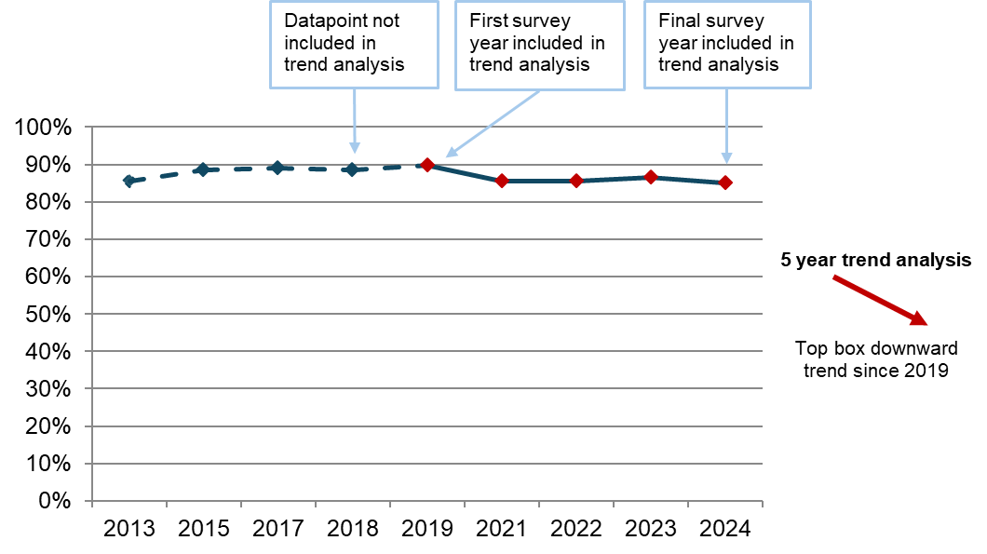

The arrow next to the graph above clearly states whether there is a trend and if that trend is upward or downward. For all trend analysis included within this report, a significant finding is classed as a p value <0.05. A statistically significant difference means that there is a less than 5% chance that we would have obtained this result if there was no real difference. Trend analysis will be reported where statistically significant differences have been found.

For questions where 5 years of data is not available, charts have been used to show results for each survey year where data is available. Statistically significant differences have been highlighted with arrows added to charts to show the direction of change. Where previous data is not described, or arrows are not used in charts, there is no statistically significant change.

Both the NHS Constitution and the Equality Act 2010 require healthcare providers to equally consider the needs, experiences, outcomes and aspirations of people with protected characteristics under equalities law. In this section, we also include some of the key results of subgroup analysis, which compares how the experiences of people vary according to their demographic or personal characteristics. These characteristics are:

- age
- parity (whether women have had a previous baby or not)
- type of delivery
- ethnicity
- religion
- sexual orientation
- gender same as assigned at birth
- Indices of Multiple Deprivation (IMD) decile
- long-term health conditions
- pregnancy-related conditions
- whether English is spoken as their main language.

Survey results are reported under the following key sections:

- care while pregnant (antenatal care)
- care during labour and the birth
- postnatal care in hospital
- postnatal care at home
- midwifery continuity of carer
- awareness of medical history
- infant feeding
- perinatal mental health
- support with communication needs
- subgroup analysis

Note: responses to questions such as ‘don't know/can’t remember’ are not shown and are excluded from percentage calculations. Other non-specific response options are also excluded, such as where the respondent does not require the experience/service, for example, not needing or wanting to be involved in decisions about their care.

Care while pregnant (antenatal care)

The survey included 8 antenatal care questions that can be analysed over a 5-year period. One of these – people being asked about their mental health – shows statistically significant improvement since 2019, while the other 7 questions show no change over a 5-year period.

Similarly, of the 15 questions for which comparison with 2023 data is available, the majority (11 questions) show no change in the past year, while 2 questions show positive change - people being asked about their mental health and being given enough support for their mental health – and 2 questions show negative change - including people having confidence and trust in staff.

Choice

NICE guidance on intrapartum care for healthy women and babies states that women must be told that they can choose any birth setting (home, freestanding midwifery unit, birthing centre, or obstetric unit) and this decision should be supported by staff. The Care Quality Commission’s (CQC) National review of maternity services in England between 2022 and 2024 reports that women should be informed about the benefits and risks of different birthing choices and treatment options.

Results from the 2024 Maternity survey show that 15% of women said they were not offered a choice about where to have their baby. The results also show that:

- most (62%) were offered a choice of hospitals
- 23% were offered a choice of birth centres
- 22% were offered a home birth
- 4% were offered ‘other’ choices.

Just over half (55%) of respondents said they ‘definitely’ received enough information from either a midwife or doctor to help them decide where to have their baby and just over a quarter (27%) said they received this information ‘to some extent’. In contrast, nearly a fifth (18%) said they did not receive enough information to help them decide where to have their baby. These results are stable compared with 2023 and the trend analysis over a 5-year period shows no statistically significant change since 2019.

Information

NICE guidance on antenatal care says healthcare professionals should ensure that women have the information they need to make informed decisions and to give consent, including information about babies’ movements and how to contact the maternity service about urgent concerns.
For the first time in the Maternity survey, respondents were asked if they were given information during antenatal care about any warning signs to look out for during their pregnancy. Three-quarters (76%) of respondents said they were ‘definitely’ given this information while a fifth (20%) said they were given this information ‘to some extent’ and 5% said they were not given this information (figure 3).

Figure 3: Thinking about your antenatal care, were you given information about any warning signs to look out for during your pregnancy?
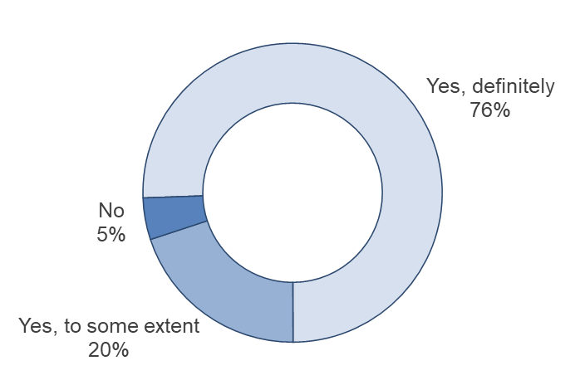
Answered by all.
Respondents who stated that they didn't know or couldn't remember have been excluded.
Total number of respondents: 18,509.

Communication and interactions

Supportive communication empowers informed decision-making and improves safety and quality of maternity care for women and their babies. NHS England’s Three-year delivery plan sets out the aim of listening to women and families, with compassion as a key theme to ensuring safer care for those using maternity and neonatal services.

NICE guidance on antenatal care outlines several key principles for supportive communication, including providing clear, understandable and timely information that considers people’s individual needs and preferences, checking that the woman understands the information and how it relates to them, and providing the opportunity to ask questions and discuss any concerns.

Most respondents (83%) said that their midwives ‘always’ listened to them, while 15% said they ‘sometimes’ felt listened to and 2% said they were not listened to. The results are the same as 2023 and the 5-year trend analysis from 2019 indicates no change.

Results of subgroup analysis for midwives listening to women during their antenatal check-ups shows poorer experiences for respondents:

- who had an emergency caesarean birth
- who speak English as their main language
- who reported their ethnicity as ‘any other White background’
- with a long-term mental health condition
- with pelvic health problems or another pregnancy-related condition.

In addition, the majority (88%) of respondents said they were ‘always’ spoken to in a way they could understand and most (80%) said they were ‘always’ given enough time to ask questions or discuss their pregnancy. These results are stable compared with 2023, as well as the 5-year trend analysis since 2019, which indicates no change.

Just under three-quarters (72%) of respondents reported ‘always’ being given the help they needed when they contacted their midwifery team, while just under a quarter (23%) reported this happened ‘sometimes’ and 3% said this did not happen. In addition, 2% said they were not given the help they needed because they were not able to contact their midwifery team. The results are in line with the 2023 results and 5-year trend since 2019 is stable.

Subgroup analysis for being given the help they needed when contacting the midwifery team during their pregnancy shows poorer than average experiences for respondents:

- who had a planned caesarean or emergency caesarean birth
- aged 16 to 26
- who speak English as their main language
- who reported their ethnicity as Pakistani
- with pelvic health problems or another pregnancy-related condition.

Respondents were asked if they felt that any concerns raised during their antenatal care were taken seriously. The majority (87%) of respondents indicated that their concerns were taken seriously. However, 13% said their concerns were not taken seriously, which is consistent with results in 2023.

Subgroup analysis for feeling whether concerns were taken seriously during antenatal care shows similar groups to those mentioned previously who reported poorer experiences, including respondents:

- who had an emergency caesarean birth
- aged 16 to 26
- who had previously given birth before their most recent pregnancy
- with pelvic health problems or with another pregnancy-related condition

Conversely, most (87%) said they were ‘always’ treated with respect and dignity (figure 4).

Figure 4: Thinking about your antenatal care, were you treated with respect and dignity? By survey year

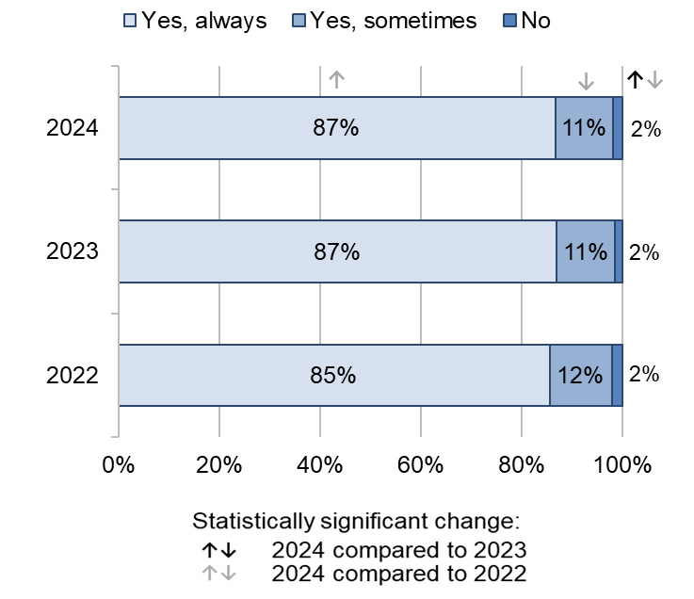
Answered by all.
Respondents who stated that they didn't know or couldn't remember have been excluded.
Total number of respondents: (2022) 20,819, (2023) 17,120, (2024) 18,854.

Results of subgroup analysis for being treated with respect and dignity during antenatal care shows poorer experiences for respondents:

- who had an emergency caesarean birth
- aged 16 to 26
- who had previously given birth before their most recent pregnancy
- who speak English as their main language
- with pelvic health problems or another pregnancy-related condition

Respondents were also asked if they had confidence and trust in the staff caring for them during their antenatal care. Less than three-quarters (70%) of respondents said they ‘definitely’ had confidence and trust in the staff during their antenatal care (a small statistically significant decrease from 71% in 2023). However, 5% said they did not have confidence and trust in the staff (figure 5).

Figure 5: Did you have confidence and trust in the staff caring for you during your antenatal care? By survey year

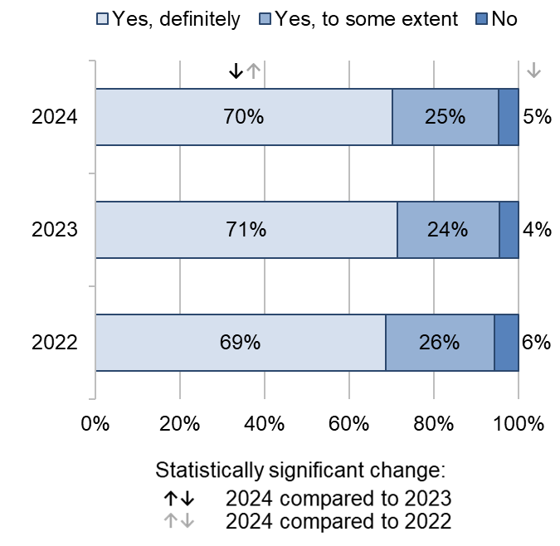
Answered by all.
Respondents who stated that they didn't know or couldn't remember have been excluded.
Total number of respondents: (2022) 20,821, (2023) 17,123, (2024) 18,810.

Subgroup analysis for having confidence and trust in the staff providing antenatal care shows similar groups to those mentioned previously who reported poorer than average experiences, including respondents:

- who had an emergency caesarean birth
- who speak English as their main language
- who reported their ethnicity as ‘any other White background’
- with pelvic health problems or another pregnancy-related condition

Involvement

As noted in NHS England’s Three-year delivery plan, involvement in decisions about maternity care and collaboration between service users and staff caring for them help to provide safer, more personalised and more equitable care that meets the needs of those using maternity services. This includes ensuring that women have clear choices supported by unbiased information and evidence-based guidelines, and open and honest dialogue with their midwives and clinicians about the care they want and any outcomes that are not as expected.

The majority (80%) of respondents said they were ’always’ involved in decisions about their antenatal care, while just under a fifth (18%) said they were ‘sometimes’ involved in decisions and 3% said they were not involved in decisions. The results are in line with results from the 2023 survey, and the 5-year trend analysis since 2019 indicates no change.

Results of subgroup analysis for being involved in decisions during antenatal care show poorer experience for respondents:

- who had an emergency caesarean birth
- aged 16 to 26
- who had previously given birth before their most recent pregnancy
- who speak English as their main language

Triage

As noted in CQC’s National review of maternity services in England 2022 to 2024, maternity triage is an important first step to get advice, assessment and risk prioritisation for women who have an emergency or concern during their pregnancy, early labour or in the post-birth period. This could include advising women to go to their chosen birthing unit because they are in labour, suggesting a call back for further review, or making sure women are seen urgently if they have an obstetric issue that needs assessment such as bleeding or if they have reduced foetal movements.

The Good Practice Paper on Maternity Triage from the Royal College of Obstetricians and Gynaecologists (published in December 2023) recommends that a brief initial assessment and prioritisation of urgency should take place within 15 minutes of the service user attending the maternity triage unit, to be undertaken by a midwife trained in a specific triage method.

For the first time in the Maternity survey, respondents were asked about their experience of maternity triage services. Seventy-nine per cent of respondents said they went through triage during their pregnancy to have their symptoms assessed. This could be either by telephone or face-to-face.

Respondents who had been through triage were then asked if they felt their concerns raised during the last time they were triaged were taken seriously by the midwife or doctor they spoke to. Three-quarters (75%) of respondents answered that their concerns were ‘definitely’ taken seriously and just under a fifth (18%) answered that their concerns were taken seriously ‘to some extent’. However, 7% answered that their concerns were not taken seriously (figure 6).

Figure 6: Thinking about the last time you were triaged, did you feel that your concerns were taken seriously by the midwife or doctor you spoke to?
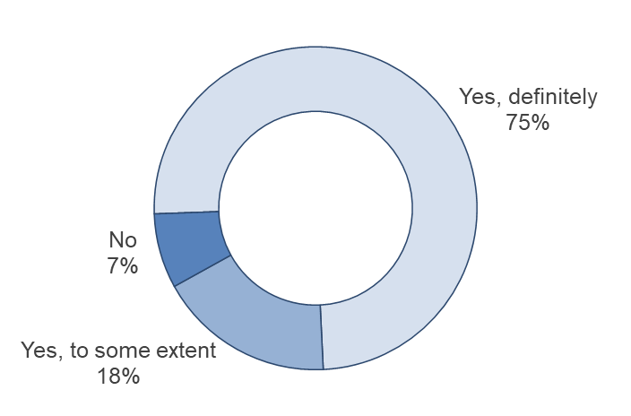
Answered by those who went through triage to have their symptoms assessed.
Respondents who stated that they didn't know or couldn't remember have been excluded.
Total number of respondents: 14,085.

Of those respondents who had a face-to-face triage, 40% said they had to wait ‘less than 15 minutes’ before they were seen by a midwife. A further 29% said they had to wait ‘16 to 30 minutes’, 15% said they had to wait ‘31 to 60 minutes’ and 15% said they had to wait ‘more than 60 minutes’.

Care during labour and birth

There were 11 questions about care during labour and birth that can be analysed over a 5-year period. Five of these – including being able to get a member of staff to help when needed – show statistically significant decline since 2019 while the remaining 6 questions show no change over the 5-year period.

There were also 15 questions for which 2023 data is available. Of these:

- 1 question shows statistically significant improvement in the past year – people being given appropriate information and advice on the risks associated with an induced labour
- 7 questions show a statistically significant decline – including people being left alone by midwives or doctors at a time when it worried them
- 7 questions show no change.

The start of labour

Women giving birth may have concerns about determining when labour has started and the right time to go to the hospital. Health professionals recommend they stay at home until contractions become frequent, therefore it is important that services provide advice and reassurance in early labour about how long they can stay at home.

Eighty-four per cent of respondents said they felt they were given appropriate advice and support when they contacted a midwife or the hospital at the start of their labour. This is a small statistically significant decrease compared with 85% in 2023. In contrast, 16% said they did not feel they were given appropriate advice and support, a small statistically significant increase compared with 15% in 2023. Trend analysis over a 5-year period since 2019 indicates no change.

A new question in the 2024 Maternity survey asked women if they were sent home during labour when they were worried about themselves or their baby. Results show that 90% of respondents who responded to this question were not sent home when they were worried about themselves or their baby. However, 10% said this happened at least once (7% ‘this happened once’ and 3% ‘this happened more than once’).

Subgroup analysis for being sent home when worried during labour shows a poorer than average experience for respondents who were aged 16 to 26. Respondents who were aged 33 and above reported a better than average experience.

Induced births

NICE guidelines on inducing labour advise that those with uncomplicated pregnancies should be given every opportunity to go into spontaneous labour. Induction should only be offered to prevent prolonged pregnancy or if there is a risk to the baby or the mother’s health. These guidelines also state that women should be given personalised information to help them make an informed decision about induction.

Forty-two per cent of respondents said they had their labour induced, which is a statistically significant decrease compared with 45% in 2023.

Of respondents who were induced, 74% said they were given appropriate information and advice on the risks associated with an induced labour. This is a statistically significant increase of 5 percentage points compared with 69% in 2023. Meanwhile, 26% said they were not given appropriate information and advice on the risks associated with an induced labour, which is a statistically significant decrease compared with 31% in 2023 (figure 7).

Figure 7: Before you were induced, were you given appropriate information and advice on the risks associated with an induced labour? By survey year

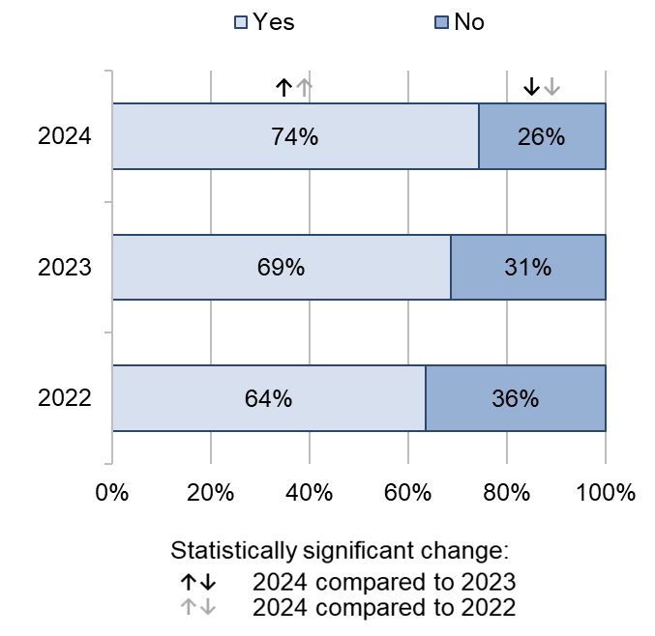
Answered by those who were induced.
Respondents who stated that they didn't know or couldn't remember have been excluded.
Total number of respondents: (2022) 6,338, (2023) 5,250, (2024) 5,265.

Fifty-nine per cent of respondents who were induced also said they were ‘definitely’ involved in the decision to be induced and 32% said they were involved in the decision ‘to some extent’. However, 9% said they were not involved in the decision to be induced (figure 8).

Figure 8: Were you involved in the decision to be induced?
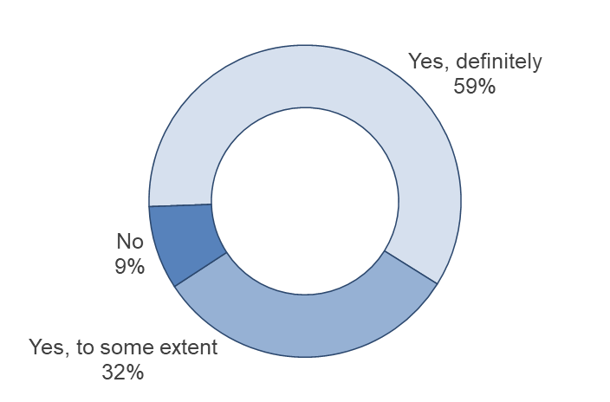
Answered by those who were induced.
Respondents who stated that they didn't know or couldn't remember or didn't want to be involved have been excluded.
Total number of respondents: 5,596.

Type of delivery

NICE guidance on intrapartum care for women and their babies states that clinical intervention should not be offered or advised if labour is progressing normally, and the mother and baby are well. An instrumental or assisted birth should only be offered if there is concern about the baby's wellbeing or is a prolonged second stage labour.

Forty-five per cent of respondents had unassisted vaginal births (without forceps or ventouse suction cups), which is a statistically significantly decrease compared with 49% in 2023. Results show that caesarean births have increased. Planned caesareans increased from 18% in 2023 to 19% in 2024, while emergency caesareans increased from 21% in 2023 to 23% in 2024.

Availability of staff

NICE guidance on intrapartum care says that people in established labour should not be left alone except for short periods or on request and one-to-one midwifery care should be provided. The Royal College of Midwives states that staff shortages may affect trusts’ ability to provide this level of care.

Respondents were asked if they and/or their partner or a companion were left alone by midwives or doctors at a time when it worried them, to which three-quarters (75%) said they were not. However, 13% said they were left alone at a time when it worried them ‘during early labour’, 7% said this happened ‘during the later stages of labour’, 3% said this happened ‘during the birth’ and 10% said ‘shortly after the birth’. For those who said they were left alone ‘during the birth’, there is a small statistically significant increase compared with 2% in 2023. The trend analysis over a 5-year period from 2019 shows no change.

Respondents who had a planned caesarean delivery reported better experiences while respondents who had an assisted vaginal or an emergency caesarean delivery reported poorer experiences. Additionally, respondents in the group aged 33 or over reported better experiences while respondents who were younger (aged 16 to 26) reported poorer experiences. This was also the case for parity, with respondents who had previously given birth reporting better experiences and respondents who gave birth for the first time reporting poorer experiences.

Respondents were also asked if, during labour and birth, they were able to get a member of staff to help them when they needed it. Results show that 64% of respondents said they were ‘always’ able to get this help and 12% said a member of staff was with them ‘all the time’. A further 19% said they were ‘sometimes’ able to get this help, which is a small statistically significant increase compared with 18% in 2023. Meanwhile, 5% said they were not able to get this help. Figure 9 shows that there has been an overall downward trend over a 5-year period since 2019 (72%).

Figure 9: During labour and birth, were you able to get a member of staff to help you when you needed it? (% Yes, always)

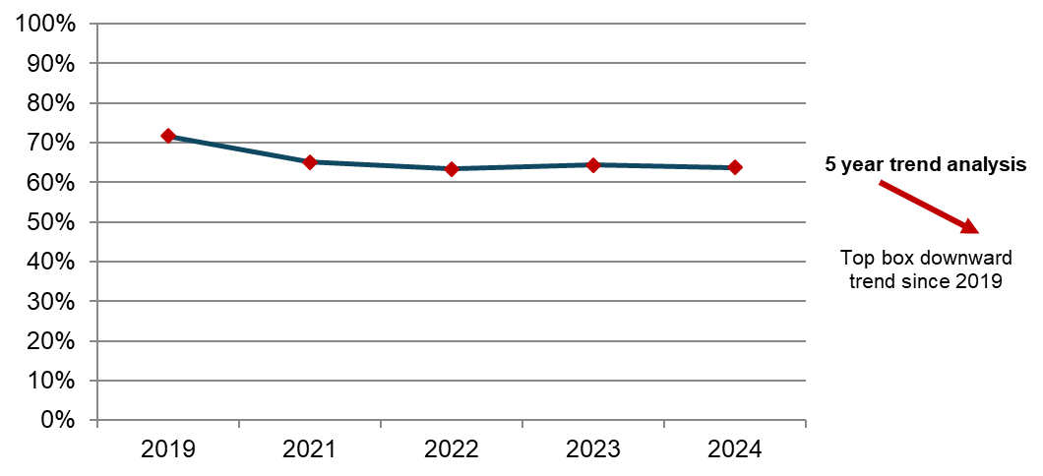
Answered by all.
Respondents who stated that they didn't know or couldn't remember or did not want or need this have been excluded.
Total number of respondents: 2019 (16,284), 2021 (22,572), 2022 (20,069), 2023 (16,515), 2024 (18,284).

Results of subgroup analysis for being able to get help when needed during labour and birth shows that respondents in the 16 to 26 age group and respondents who spoke English as their main language reported poorer experiences. This is also the case for respondents who had an emergency caesarean delivery.

Communication and interactions

NICE guidance on patient experience states that all healthcare professionals directly involved in a patient's care should introduce themselves. As labour and birth can last for a long time, there might be handovers of care between different health professionals (for example, because of shift changes) requiring them to introduce themselves to the woman in labour.

In addition, NICE highlights that staff should check for people’s concerns at all stages of birth and before any treatments or interventions. Any concerns should be discussed with the person and their companion.

Most (83%) respondents said that the staff treating and examining them introduced themselves, a significant decrease of 1 percentage point from 2023 (84%). Fifteen per cent of respondents said ‘some of the staff introduced themselves’ and 2% of respondents said ‘very few/none of the staff introduced themselves’. Trend analysis over a 5-year period since 2019 indicates no change.

Of those respondents who raised a concern during labour and birth, the majority (81%) felt their concerns were taken seriously. However, nearly a fifth (19%) said that they felt their concerns were not taken seriously. Results are in line with the 2023 results and 5-year trend analysis from 2019 indicates no change, although there have been statistically significant increases compared with 2021 and 2022 (79% and 77% respectively saying ‘yes’ concerns were taken seriously).

Women who had a vaginal (unassisted or assisted) or emergency caesarean delivery reported poorer experiences when they raised a concern, whereas women who had a planned caesarean delivery reported better experiences. Respondents who spoke English as their main language reported poorer experiences when they raised a concern, as well as those who had pelvic health problems or another pregnancy-related condition.

CQC’s National review of maternity services in England 2022 to 2024 highlights the importance of culture in maternity services in terms of positive working relationships within multidisciplinary teams. The report states that good communication between staff is essential to ensuring awareness of potential risks and delivery of compassionate care.

For the first time, the 2004 Maternity survey asked respondents if they felt that the midwives and/or doctors looking after them during labour and birth worked well together. Nearly three-quarters (74%) of respondents said the midwives and/or doctors ‘always’ worked well together, while just under a fifth (19%) said ‘sometimes’. However, 7% said they did not work well together.

Effective communication helps women to feel in control and involved in what is happening to them during childbirth. NHS England’s Three-year delivery plan sets out that maternity care should include open and honest, ongoing dialogue between women, their midwife, and other clinicians, to understand the care people want and any concerns they may have, and to discuss any outcomes that are not as expected. CQC’s National review of maternity services in England 2022 to 2024 reported that clear and transparent language and explanations help women to know what to expect from procedures and examinations and to make informed choices.

The majority (85%) of respondents answered they were ‘always’ spoken to in a way they could understand (compared with 87% in 2023), while 12% said this happened ‘sometimes’ (compared with 11% in 2023). The remaining 3% said this did not happen, compared with 2% saying this in 2023. Furthermore, figure 10 shows an overall downward trend when considering the results over a 5-year period.

Figure 10: Thinking about your care during labour and birth, were you spoken to in a way you could understand? (% Yes, always)

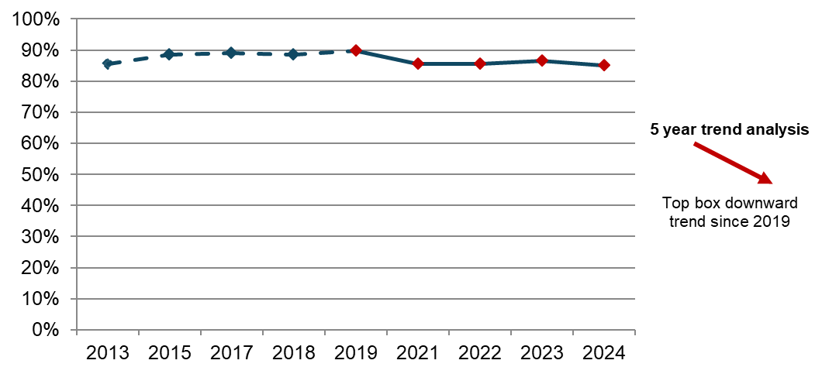
Answered by all.
Respondents who stated that they didn't know or couldn't remember have been excluded.
Total number of respondents: (2013) 22,353, (2015) 19,485, (2017) 18,139, (2018) 17,318, (2019) 16,914, (2021) 23,283, (2022) 20,740, (2023) 17,041, (2024) 18,743.

NICE guidance states that patients must be treated with kindness, compassion, understanding, courtesy and honesty. Compassionate care is at the heart of safe and high-quality maternity care where all voices are listened to and respected.

The majority (85%) of respondents said that they were ‘always’ treated with respect and dignity, same as the 2023 result. Conversely, 11% said they were ‘sometimes’ treated with respect and dignity, while 3% said they were not. Figure 11 shows that the trend analysis over a 5-year period indicates an overall downward trend since 2019.

Figure 11: Thinking about your care during labour and birth, were you treated with respect and dignity? (% Yes, always)

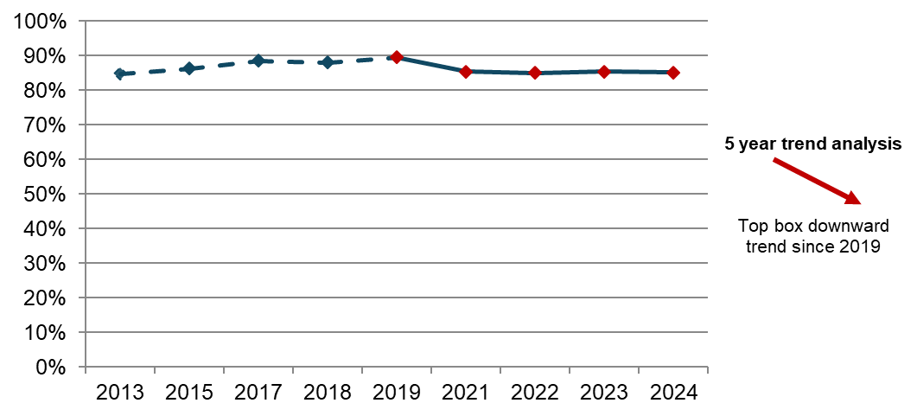
Answered by all.
Respondents who stated that they didn't know or couldn't remember have been excluded.
Number of respondents: (2013) 22,392, (2015) 19,495, (2017) 18,158, (2018) 17,339, (2019) 16,930, (2021) 23,306, (2022) 20,772, (2023) 17,079, (2024) 18,799.

Respondents who had an assisted vaginal or emergency caesarean delivery reported poorer experiences of being treated with respect and dignity during their labour and birth, as did respondents aged 16 to 26 and those who spoke English as their main language.

Respondents were asked if they had confidence and trust in the staff caring for them during their labour and birth, to which 77% said they ‘definitely’ did, a small statistically significant decrease compared with 78% in 2023. A further 18% said they had confidence and trust in staff ‘to some extent’ and 5% said they did not have confidence and trust in the staff caring for them during their labour and birth. Figure 12 shows an overall downward trend over a 5-year period since 2019 (84%).

Figure 12: Did you have confidence and trust in the staff caring for you during your labour and birth? (% Yes, definitely)

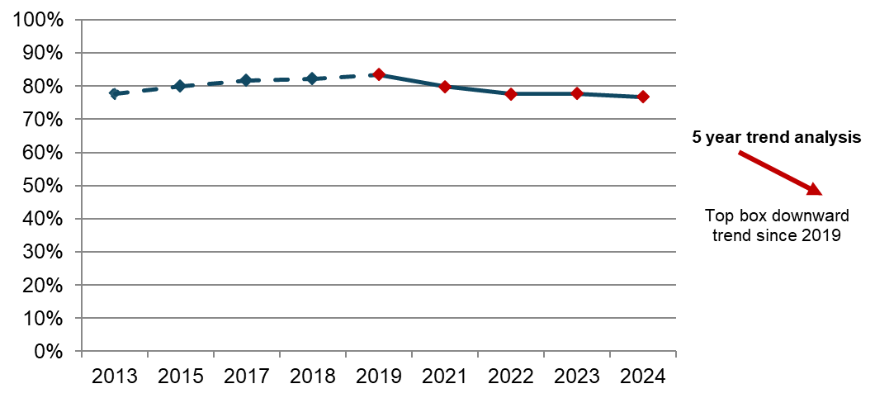
Answered by all.
Respondents who stated that they didn't know or couldn't remember have been excluded.
Total number of respondents: (2013) 22,463, (2015) 19,533, (2017) 18,194, (2018) 17,410, (2019) 16,936, (2021) 23,321, (2022) 20,803, (2023) 17,098, (2024) 18,806.

Results of subgroup analysis for having confidence and trust in the staff providing care during labour and birth shows poorer experiences for respondents:

- who had an assisted vaginal or emergency caesarean birth
- who spoke English as their main language
- who reported their ethnicity as ‘any other White background’
- with a long-term mental health condition
- with another long-term health condition or another pregnancy-related condition

Respondents were asked if they were treated with kindness and compassion during their care in labour and birth. Most (82%) answered that they were ‘always’ treated with kindness and compassion during their labour and birth (compared with 83% in 2023). Meanwhile, 15% answered they were ‘sometimes’ treated with kindness of compassion and 3% said they were not (figure 13).

Figure 13: Thinking about your care during labour and birth, were you treated with kindness and compassion? By survey year

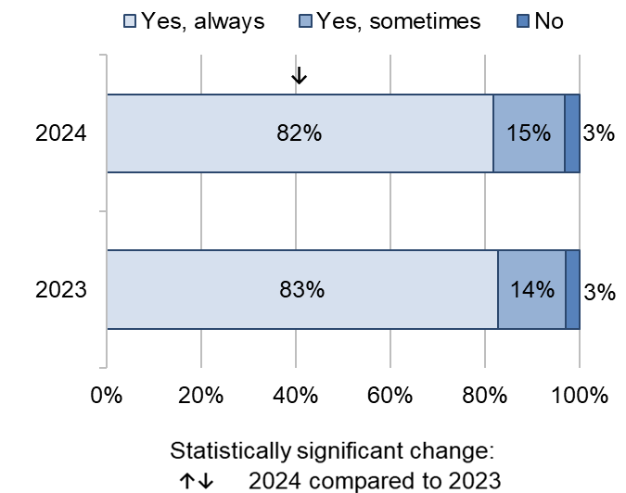
Answered by all.
Respondents who stated that they didn't know or couldn't remember have been excluded.
Total number of respondents: (2023) 17,070, (2024) 18,793.

Results of subgroup analysis for being treated with kindness and compassion during labour and birth shows poorer experiences for respondents:

- who had an assisted vaginal or emergency caesarean birth
- aged 16 to 26
- who spoke English as their main language
- with pelvic health problems or another pregnancy-related condition

Respondents were asked if they had the opportunity to ask questions about their labour and birth after their baby was born, to which just under half (49%) said ‘yes, completely’. Just over a quarter (26%) said they had the opportunity ‘to some extent’, while a further quarter (25%) said they did not have this opportunity. Figure 14 shows an overall downward trend over a 5-year period since 2019.

Figure 14: After your baby was born, did you have the opportunity to ask questions about your labour and the birth? (% Yes, completely)

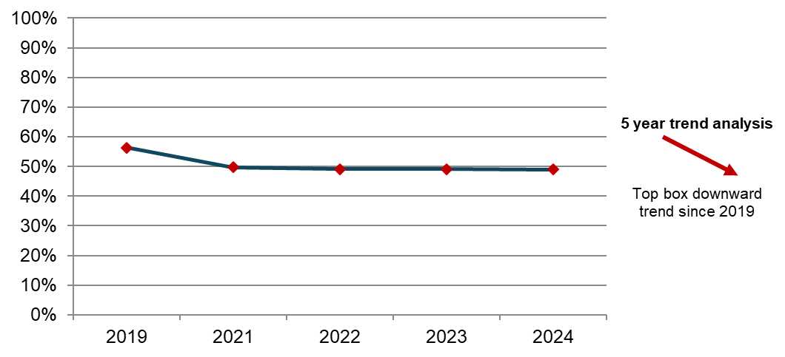
Answered by all.
Respondents who stated that they didn't know or couldn't remember or that they did not want or need this have been excluded.
Total number of respondents: (2019) 14,921, (2021) 20,840, (2022) 18,523, (2023) 15,022, (2024) 16,559.

Involvement

NICE clinical guidance states the importance of ensuring that people feel in control and involved in what is happening to them during childbirth. They should be involved in discussions and make informed decisions about their care, including decisions about their birth plan options for managing the stages of labour, and discussions around any tests or interventions.

Three-quarters (75%) of respondents said they were ‘always’ involved in decisions about their care during labour and birth and nearly a fifth (19%) said they were ‘sometimes’ involved, while 5% said they were not involved in decisions about their care. The results are in line with 2023 results and 5-year trend analysis from 2019 indicates no change.

Results of subgroup analysis for being involved in decision during labour and birth shows poorer experience for similar groups previously mentioned, including respondents who had an assisted vaginal or emergency caesarean delivery, spoke English as their main language, reported pelvic health problems or another pregnancy-related condition.

Pain management

The report of CQC’s National Maternity Inspection Programme identifies pain management during labour and birth as an issue nationally. The findings from the programme show that most trusts did not audit women’s outcomes and experiences of pain and pain relief.

Women were asked whether they thought their healthcare professionals did everything they could to help manage pain during labour and birth. Sixty-three per cent answered they ‘definitely’ did and 23% said they did ‘to some extent’, while 14% said ‘no’. Of those respondents who answered they did ‘to some extent’, there is a statistically significant decrease compared with 25% in 2023 (figure 15).

Figure 15: Do you think your healthcare professionals did everything they could to help manage your pain during labour and birth? By survey year

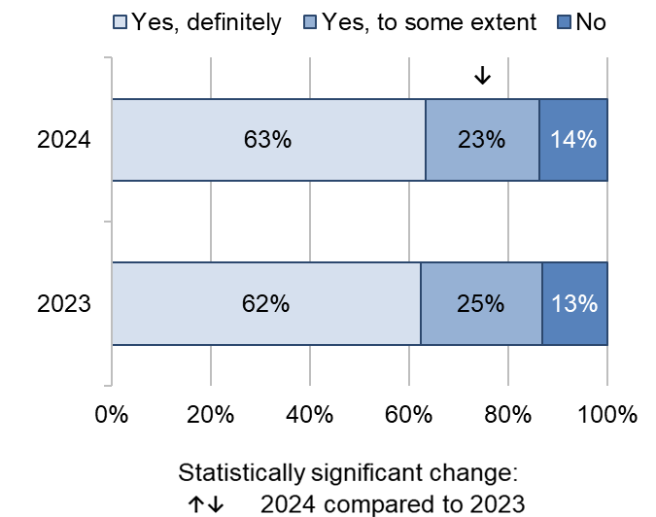

Answered by those who had a labour. Respondents who stated that they didn't know or couldn't remember, or did not need any help with pain relief have been excluded.
Total number of respondents: (2023) 12,588, (2024) 13,677.

Results of subgroup analysis for pain management during labour and birth show that respondents with pelvic health problems reported poorer experiences. This is also the case for respondents who gave birth for the first time during their most recent pregnancy or had an emergency caesarean birth. Respondents who spoke English as their main language also reported poorer experiences.

Postnatal care in hospital

There were 5 questions about care in hospital after the birth that can be analysed over a 5-year period. Three of these – people being able to get a member of staff to help them when they needed it, being given the information or explanation they needed and being treated with kindness and compassion – show a downward trend since 2019. Meanwhile, the other 2 questions indicate no change over a 5-year period – discharge from hospital being delayed and partner or someone else close being able to stay as much as the woman wanted.

There were 6 questions for which comparison with 2023 data is available. Of these, 1 question shows statistically significant improvement in the past year – partner or someone else close being able to stay as much as the woman wanted – and 5 questions show statistically significant decline – including healthcare professionals doing everything they could to help manage pain.

Information, communication, and interactions

The NHS Accessible Information Standard states that staff must provide clear, understandable and appropriate information in a format which is accessible to individual needs. Recommendations from CQC’s National review of maternity services in England 2022 to 2024 emphasised the importance of providing information following labour and birth to help women process what happened, including when a safety incident takes place, to inform decisions about future pregnancies.

Just under two-thirds (58%) of respondents said they were ‘always’ given the information or explanation they needed during their care in hospital after the birth of their baby. This is a statistically significant decrease compared with 60% in 2023. In contrast, 13% of respondents said they were not given information or explanations they needed (compared with 12% in 2023). Figure 16 shows an overall downward trend when over a 5-year period, with the percentage of respondents who answered ‘yes, always’ remaining below levels seen in 2019 (66%).

Figure 16: Thinking about the care you received in hospital after the birth of your baby, were you given the information or explanations you needed?

(% Yes, always)

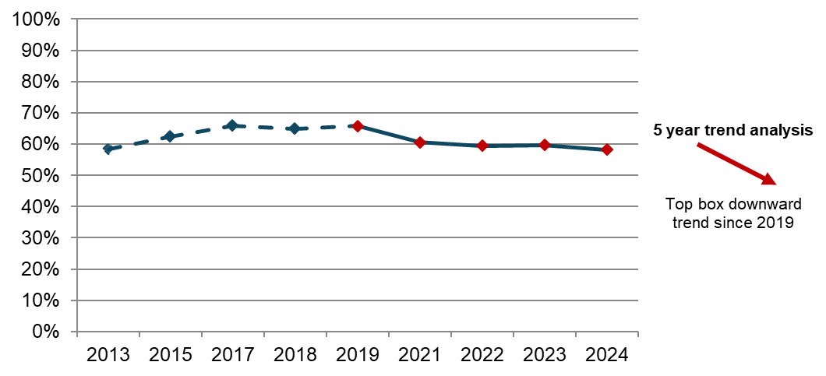
Answered by those who stayed in hospital after the birth or required hospital care after a home birth. Respondents who stated that they didn't know or couldn't remember have been excluded.
Total number of respondents: (2013) 22,056, (2015) 19,199, (2017) 17,906, (2018) 17,045, (2019) 16,490, (2021) 22,745, (2022) 20,384, (2023) 16,710, (2024) 18,448.

Respondents were asked if they were treated with kindness and understanding in hospital after the birth of their baby. Most respondents (71%) answered that they were ‘always’ treated with kindness and understanding during postnatal care in hospital (compared with 72% in 2023). Meanwhile, just under a quarter (23%) answered they were ‘sometimes’ treated with kindness and understanding. In contrast, 6% answered they were not treated with kindness and understanding. Results of 5-year trend analysis show a downward trend for the period since 2019 (figure 17).

Figure 17: Thinking about the care you received in hospital after the birth of your baby, were you treated with kindness and understanding?

(% Yes, always)

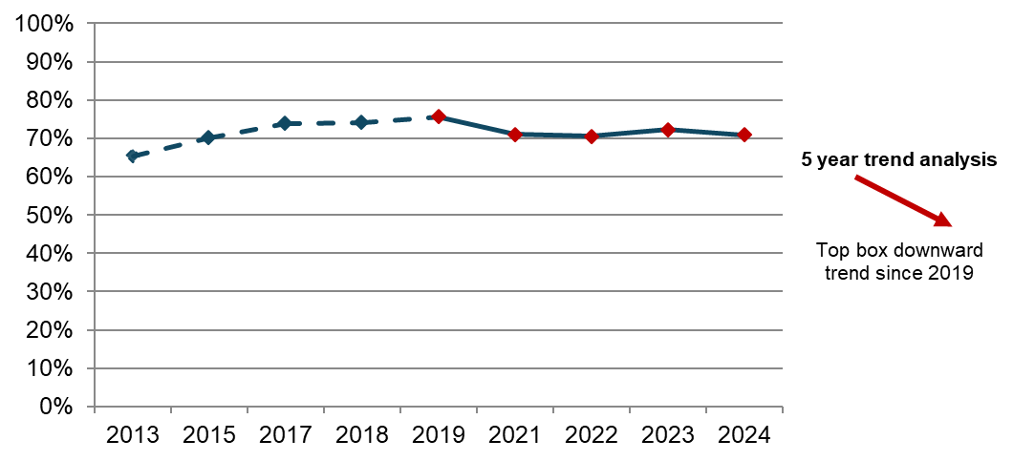
Answered by those who stayed in hospital after the birth or required hospital care after a home birth.
Respondents who stated that they didn't know or couldn't remember have been excluded.
Total number of respondents: (2013) 22,113, (2015) 19,249, (2017) 17,979, (2018) 16,985, (2019) 16,595, (2021) 22,921, (2022) 20,552, (2023) 16,828, (2024) 18,554.

Results of subgroup analysis for being treated with kindness and understanding in hospital after the birth shows poorer experiences for respondents who had a planned or emergency caesarean birth, gave birth for the first time and who spoke English as their main language.

Availability of staff

More than half (54%) of respondents said they were ‘always’ able to get a member of staff to help them while in hospital after the birth. This is a small statistically significant decrease compared with 55% in 2023. A further 34% said they were ’sometimes’ able to get this help. In contrast, 12% said they were not able to get this help (compared with 10% in 2023). When considering the results over the last 5 survey years, trend analysis shows an overall downward trend since 2019 (62%; figure 18).

Figure 18: If you needed attention while you were in hospital after the birth, were you able to get a member of staff to help you when you needed it?

(% Yes, always)

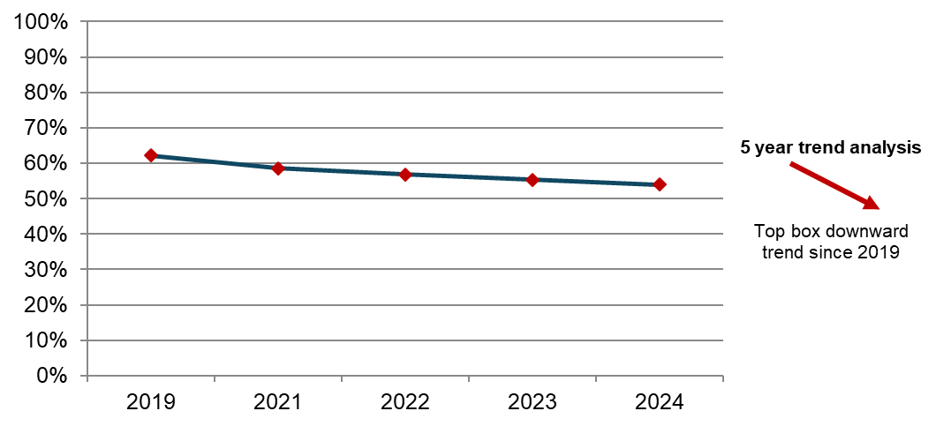
Answered by those who stayed in hospital after the birth or required hospital care after a home birth. Respondents who stated that they didn't know or couldn't remember or did not want or need this have been excluded.
Total number of respondents: (2019) 15,462, (2021) 21,588, (2022) 19,296, (2023) 15,848, (2024) 17,543.

Results of subgroup analysis shows that respondents who had planned or emergency caesarean deliveries reported poorer than average experiences of being able to get a member of staff to help then when needed it when in hospital after the birth. This is also the case for people who spoke English as their main language and who had pelvic health problems or another pregnancy-related condition.

Partner involvement

Almost two-thirds (63%) of respondents said their partner or someone else close to them was able to stay as much as they wanted in hospital after the birth, a statistically significant increase of 7 percentage points compared with 2023 (56%). Conversely, more than a quarter (28%) said their partner or someone else close to them was not able to stay as much as they wanted ‘as they were restricted to visiting hours’, a statistically significant decrease of 8 percentage points compared with 2023 (36%). Thirteen per cent said their partner or someone else close to them were not able to stay as much as they wanted ‘as there was no accommodation for them on the maternity ward’.

Pain Management

Figure 19 shows that when asked if they thought healthcare professionals did everything they could to help manage pain in hospital after birth, 64% answered ‘definitely’, a statistically significant decrease compared with 66% in 2023. Nearly a quarter (24%) said ‘to some extent’. However, 12% of respondents said ‘no’ (compared with 11% in 2023).

Figure 19: Do you think your healthcare professionals did everything they could to help manage your pain in hospital after the birth? By survey year

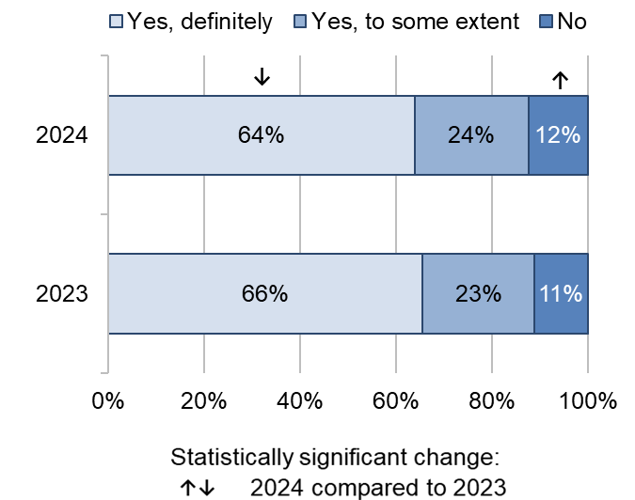

Answered by those who stayed in hospital after the birth or required hospital care after a home birth. Respondents who stated that they didn't need any help with pain relief or didn't know or couldn't remember have been excluded.
Total number of respondents: (2023) 15,565, (2024) 17,423.

Results of subgroup analysis for pain management in hospital after the birth shows the same groups as previously mentioned reporting poorer experiences: those with pelvic health problems or another pregnancy-related condition, women who had planned or emergency caesarean deliveries and those who spoke English as their main language.

Postnatal care at home

Effective postnatal support in the community is essential to support new mothers. When returning home after birth, women and their babies still need to receive care. During the 6 to 8 weeks following birth, monitoring of maternal health (including physical and mental health), infant feeding and infant health should continue.

NICE guidance on postnatal care suggests a minimum of 3 contacts with women and their baby. Postnatal care should be provided face-to-face and supplemented by virtual discussions and written formats. Certain groups may need additional support, including mothers in vulnerable circumstances and mothers and babies with medical or other complex needs.

There were 11 questions about postnatal care after leaving hospital that can be analysed over a 5-year period. Four of these – women having seen or spoken to a midwife as much as they wanted, feeling that they listened to them, confidence and trust, and personal circumstances being taken into account when giving advice – show downward trends since 2019. Conversely, the remaining 7 questions indicate no change for trend analysis over a 5-year period. In comparison with 2023, there were 15 questions for which we have 2023 data. Of these, 1 question shows statistically significant improvement in the past year – women having the same midwives postnatally as were involved in their labour and antenatal care. Ten questions show statistically significant decline – including women being involved in decisions about their care, awareness of medical history, women being given information about any changes to their mental health after having their baby and being told who they could contact if they needed advice about any changes to their mental health after the birth –, and 4 questions show no change.

Postnatal appointments

NICE guidance on postnatal care recommends that before women transfer from the maternity unit to community care, they should be given information about who to contact if they have a concern. Healthcare professionals should also discuss their physical recovery after the birth and if they have any concerns about their baby's general wellbeing, feeding or development.

Sixty per cent of respondents said they saw or spoke to a midwife as much as they wanted after birth, a statistically significant decrease compared with 63% in 2023. Meanwhile, 34% said they would have liked this ‘more often’ (compared with 32% in 2023) and 6% said they would have liked this ‘less often’ (compared with 4% in 2023). Figure 20 shows a downward trend for 5-year trend analysis, with fewer women saying they saw or spoke to a midwife as much as they wanted after the birth, from 70% in 2019 to 60% in 2024.

Figure 20: Thinking about all the times you had contact with a midwife after the birth…Would you have liked to have seen or spoken to a midwife…

(% I saw or spoke to a midwife as much as I wanted)

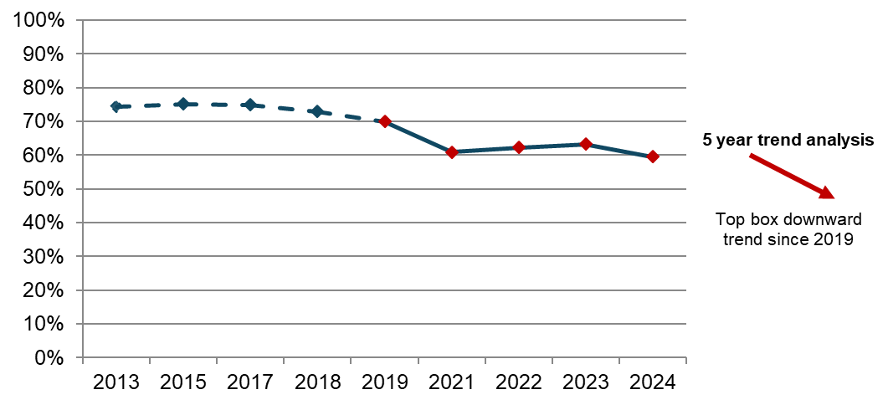
Answered by all.
Total number of respondents: (2013) 22,159, (2015) 19,240, (2017) 17,966, (2018) 17,121, (2019) 16,702, (2021) 22,585, (2022) 20,332, (2023) 16,670, (2024) 18,833.
NB: In 2021 the question wording was amended to include "… or spoken to …”. This is to account for the adaptations made to services during the COVID-19 pandemic where some mothers may have spoken to a midwife by telephone or video conference.

Results of subgroup analysis for speaking to a midwife as much as women wanted during postnatal care shows poorer than average experiences for respondents:

- aged 16 to 26
- who gave birth for the first time
- who reported their ethnicity as ‘Indian’.

Respondents were asked if they received help and advice from midwives about their baby’s health and progress in the 4 weeks after the birth. Sixty-two per cent said they ’definitely’ received this help and advice, a further 29% said they received this help and advice ‘to some extent’ and 9% said they did not receive this help and advice.

Information, communication, and interactions

NICE guidance on postnatal care states that women should have relevant information shared between healthcare professionals when transferring between services to support their care during the postnatal period. This ensures that their care is planned, and ongoing care and interventions are provided, while removing the need for women to repeat their medical history to different healthcare professionals.

Just under three-quarters (71%) of respondents reported ‘always’ being given the help they needed if they contacted a midwife or a midwifery team (figure 21). Meanwhile, nearly a quarter (23%) reported being given this help ‘sometimes’, and 6% reported not being given this help.

Figure 21: If you contacted a midwife / midwifery team, were you given the help you needed?

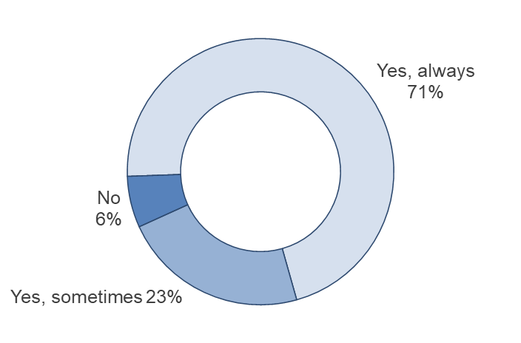
Answered by all. Respondents who stated that they did not contact a midwife or midwifery team have been excluded.
Total number of respondents: 15,728.

Results of subgroup analysis shows that respondents who had a planned or emergency caesarean delivery reported poorer than average experiences of being given the help they needed after leaving hospital. This is also the case for people who spoke English as their main language. Meanwhile, respondents who had an unassisted vaginal delivery, did not speak English as their main language and who reported their ethnicity as ‘African background’ reported better experiences.

Seventy-five per cent of respondents said their midwife or midwifery team ‘always’ listened to them, a statistically significant decrease compared with 77% in 2023. A further 21% said they ‘sometimes’ felt listened to (compared with 19% in 2023) and 4% said they were not listened to. Figure 22 shows that this continues an overall downward trend when considering the results over a 5-year period, with the percentage of respondents who answered ‘yes, always’ remaining below levels seen since 2019 (79%).

Figure 22: Did you feel that the midwife or midwifery team that you saw or spoke to always listened to you? (% Yes, always)

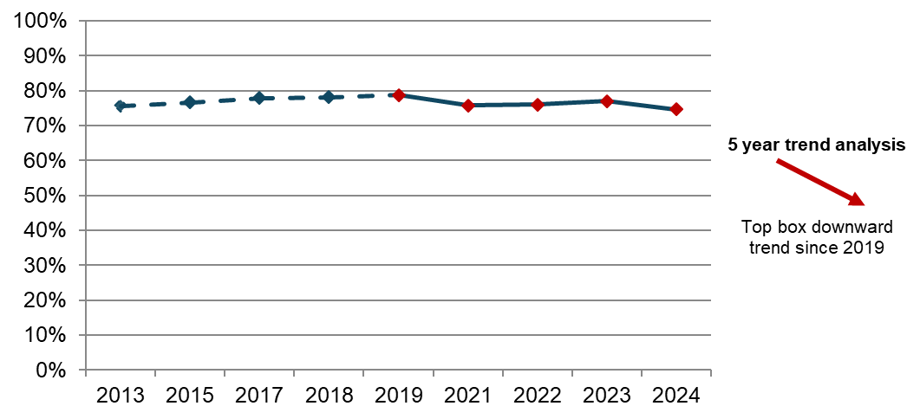
Answered by all. Respondents who stated that they didn't know or couldn't remember have been excluded.
Total number of respondents: (2013) 22,197, (2015) 19,285, (2017) 17,988, (2018) 17,167, (2019) 16,730, (2021) 22,499, (2022) 20,269, (2023) 16,600, (2024) 18,646.

Results of subgroup analysis for midwives listening to women during their postnatal care shows poorer experiences for respondents:

- who had a planned or emergency caesarean birth
- aged 16 to 26
- who spoke English as their main language
- who reported their ethnicity as ‘any other White background’ or ‘Pakistani’.

Just under three-quarters (72%) of respondents also said their midwife or midwifery team ‘always’ took their personal circumstances into account when giving them advice, a statistically significant decrease compared with 2023 (75%). Furthermore, 22% of respondents said their midwife or midwifery team ‘sometimes’ took their personal circumstances into account (compared with 20% in 2023). The remaining 6% of respondents said their midwife or midwifery team did not take their personal circumstances into account, a small statistically significant increase compared with 5% in 2023. Figure 23 shows an overall downward trend over a 5-year period since 2019 (78%).

Figure 23: Did the midwife or midwifery team that you saw or spoke to take your personal circumstances into account when giving you advice?

(% Yes, always)

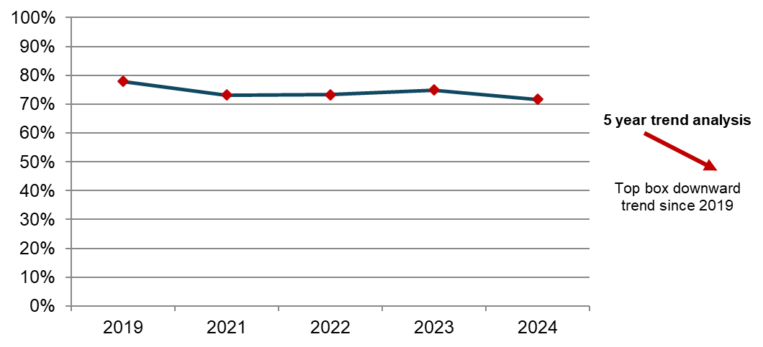
Answered by all. Respondents who stated that they didn't know or couldn't remember have been excluded.
Total number of respondents: (2019) 16,094, (2021) 21,353, (2022) 19,202, (2023) 15,713, (2024) 17,574.

Results of subgroup analysis for midwives taking personal circumstances into account when giving advice during postnatal care shows the same groups as previously mentioned reporting poorer experiences: women who had a planned or emergency caesarean birth and those who spoke English as their main language

Respondents were asked if they had confidence and trust in the midwife or midwifery team they saw or spoke to after going home, to which 69% said they ‘definitely’ did, a statistically significant decrease compared with 72% in 2023. In addition, 25% said they had confidence and trust in the midwife or midwifery team ‘to some extent’ (compared with 23% in 2023) and 6% said they did not (compared with 5% in 2023). Figure 24 shows an overall downward trend over a 5-year period since 2019 (73%).

Figure 24: Did you have confidence and trust in the midwife or midwifery team you saw or spoke to after going home? (% Yes, definitely)

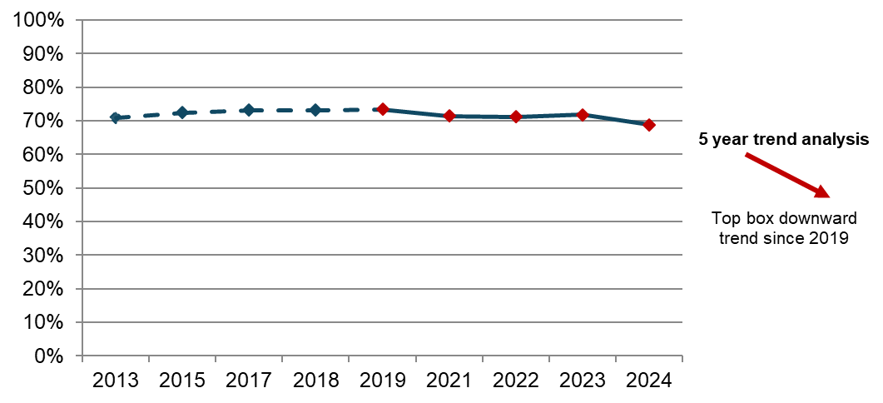
Answered by all. Respondents who stated that they didn't know or couldn't remember have been excluded.
Total number of respondents: (2013) 22,123, (2015) 19,177, (2017) 17,904, (2018) 17,037, (2019) 16,707, (2021) 22,453, (2022) 20,198, (2023) 16,578, (2024) 18,596.

Results of subgroup analysis for having confidence and trust in midwives after going home shows poorer experiences for respondents:

- who had a planned or emergency caesarean birth
- who spoke English as their main language
- who reported their ethnicity as ‘any other White background’

Involvement

Respondents were asked if they were involved in decisions about their postnatal care. Just under three-quarters (72%) reported that they were ‘always’ involved, while a fifth (20%) reported that they were ‘sometimes’ involved (figure 25). However, 8% reported that they were not involved, a statistically significant increase compared with 7% in 2023.

Figure 25: Thinking about your postnatal care, were you involved in decisions about your care? By survey year

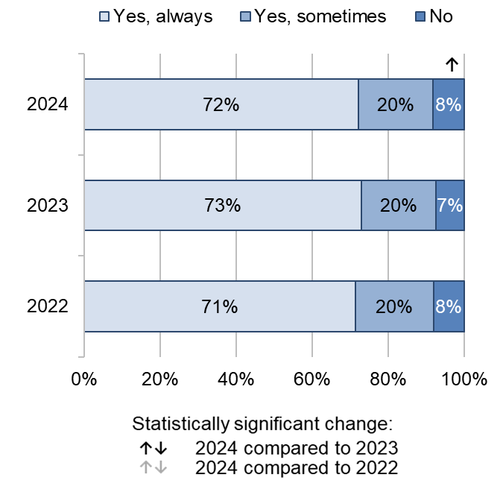
Answered by all. Respondents who stated that they didn't know or couldn't remember or did not want or need to be involved have been excluded.
Total number of respondents: (2022) 19,947, (2023) 16,331, (2024) 17,924.

Results of subgroup analysis for being involved in decision during postnatal care shows poorer experience for respondents:

- who had an assisted vaginal or emergency caesarean delivery
- who gave birth for the first time during their most recent pregnancy
- who spoke English as their main language
- with pelvic health problems or another pregnancy-related condition.

Midwifery continuity of carer

Care from the same midwife across phases of maternity is associated with better outcomes for mother and baby. Implementing midwifery continuity of carer is a key part of the Three-year delivery plan to reduce health inequalities, particularly for people from ethnic minority communities and those living in the most deprived areas.

In 2024, the Maternity survey showed that frequency of seeing the same midwife is more common during antenatal care than postnatal care. Twenty-four per cent of respondents said they saw the same midwife all the time at their antenatal check-ups compared to 16% who said they always saw the same midwife at their postnatal check-ups (Table 1). Conversely, 14% said they saw a different midwife every time at their antenatal check-ups compared with 38% who said this about their postnatal check-ups.

Our results show statistically significant decreases for respondents who spoke to the same midwife at their postnatal check-ups ‘all of the time’ (16% compared to 18% in 2023) or ‘most of the time’ (22% compared with 24% in 2023). In contrast, there are statistically significant increases for respondents who spoke to the same midwife ‘some of the time’ (23% compared to 21% in 2023) or ‘never, it was a different midwife every time’ (38% compared with 37% in 2023).

Table 1: At your antenatal check-ups, how often did you speak to the same midwife? / At your postnatal check-ups, how often did you see or speak to the same midwife?

 | Antenatal |  | 2024 vs  2023 | Postnatal |  | 2024 vs  2023
 | 2024 | 2023 | 2024 vs  2023 | 2024 | 2023 | 2024 vs  2023
All of the time | 24% | 24% |  | 16% | 18% | ↓
Most of the time | 37% | 37% |  | 22% | 24% | ↓
Some of the time | 25% | 25% |  | 23% | 21% | ↑
Never, it was a different midwife every time | 14% | 14% |  | 38% | 37% | ↑
Number of respondents | 18,786 | 17,025 |  | 18,051 | 16,220

Answered by all. Respondents who stated that they didn't know or couldn't remember or did not see or speak to a midwife have been excluded.

Respondents were also asked if any midwives who cared for them postnatally had also been involved in their labour and antenatal care. Thirteen per cent of respondents said they had the same midwives involved in their postnatal care that had also been involved in their labour and antenatal care, a statistically significant increase compared with 10% in 2023. However, 56% said they had different midwives during their postnatal care to those that had been involved in their labour or antenatal care, a statistically significant decrease compared to 59% in 2023.

Awareness of medical history

Midwifery continuity of carer can also be facilitated by the effective sharing of information within teams of midwives, or across multidisciplinary teams. Effective communication and co-ordination are linked to staff being aware of women’s medical history and preferences about their care.

In the 2024 Maternity survey, just over half (53%) of respondents said that the midwives or doctor ‘always’ appeared to be aware of their medical history during their antenatal check-ups, while over a third (35%) said this was ‘sometimes’ the case and 12% said that their midwives or doctor did not appear to be aware of their medical history (figure 26). These results remain in line with results in 2023.

Figure 26: During your antenatal check-ups, did your midwives or doctor appear to be aware of your medical history? By survey year

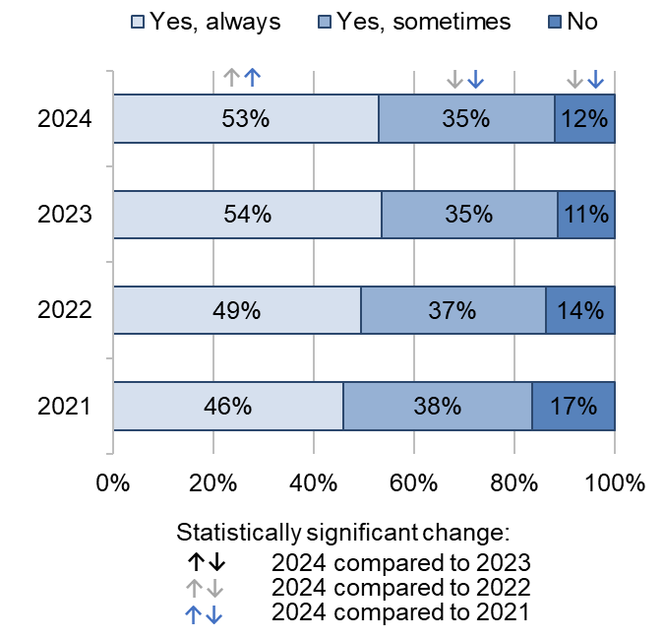
Answered by all. Respondents who stated that they didn't know or couldn't remember have been excluded.
Total number of respondents: (2021) 22,902, (2022) 20,417, (2023) 16,797, (2024) 18,556.

In comparison, a greater proportion of respondents said their midwives or doctor ‘always’ appeared to be aware of their medical history during their labour and birth than during their antenatal check-ups. Just under two-thirds (63%) said their midwives or doctor ‘always’ appeared to be aware of their medical history during the labour and birth, while just over a quarter (26%) said this was ‘sometimes’ the case and 11% said this was not the case (figure 27). Similar to antenatal care, these results remain in line with results in 2023.

Figure 27: During your labour and birth, did your midwives or doctor appear to be aware of your medical history? By survey year

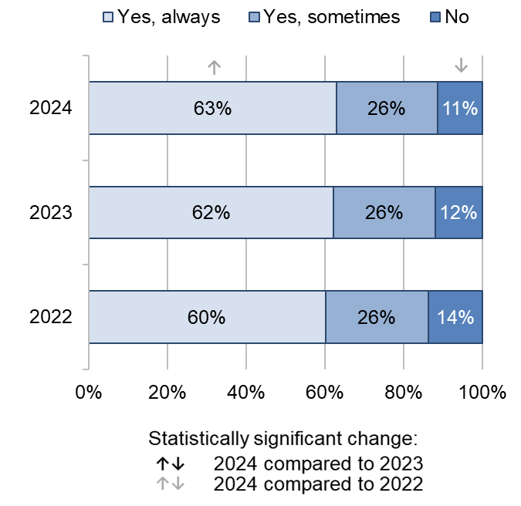
Answered by all. Respondents who stated that they didn't know or couldn't remember have been excluded.
Total number of respondents: (2022) 18,754, (2023) 15,427, (2024) 17,151.

Three-quarters (76%) of respondents said their midwife or midwifery team appeared to be aware of theirs or their baby’s medical history during postnatal care, which is a small statistically significant decrease compared with 77% in 2023. However, nearly a quarter (24%) said this was not the case, compared with 23% in 2023. Trend analysis over a 5-year period from 2019 indicates no change for awareness of medical history during postnatal care.

Infant feeding

NICE guidance on antenatal care recommends that midwives should discuss infant feeding from 28 weeks and keep providing support and advice during the antenatal period. NICE guidance on postnatal care states that breastfeeding care must be tailored to women’s individual needs, and they should be provided with information, advice, reassurance and support.

The NICE quality standard on breastfeeding recommends that women should be made aware of the benefits of breastfeeding and given breastfeeding support across all healthcare settings, including in hospital, primary and community care. However, while new parents should be informed of these benefits, women’s choices about how to feed their baby must be respected. If women make an informed decision not to breastfeed, the position of the Royal College of Midwives is that they should be supported to feed their baby with formula.

Just over half (56%) of respondents said they ‘definitely’ received relevant information from midwives during pregnancy about feeding their baby. In contrast, 14% said they did not receive relevant information about feeding their baby. The results are in line with 2023 results and the 5-year trend from 2019 indicates no change.

Results also show that most respondents (82%) said their decisions about how they wanted to feed their baby were ‘always’ respected by midwives. Thirteen per cent said their decisions were ‘sometimes’ respected and 5% said their decisions were not respected. Figure 28 shows a significant downward trend over a 5-year period since 2019 (85%).

Figure 28: Were your decisions about how you wanted to feed your baby respected by midwives? (% Yes, always)

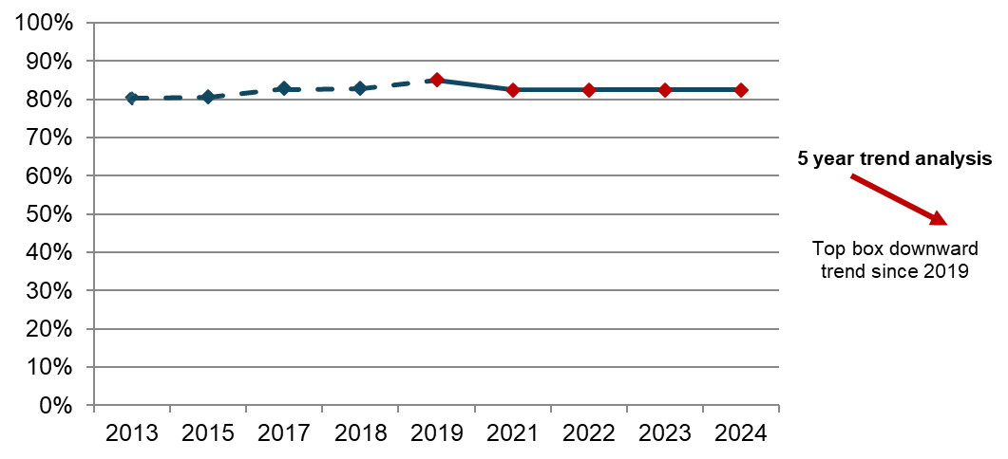

Answered by all. Respondents who stated that they didn't know or couldn't remember have been excluded.
Total number of respondents: (2013) 22,355, (2015) 19,408, (2017) 18,138, (2018) 17,376, (2019) 16,972, (2021) 23,281, (2022) 20,722, (2023) 17,043, (2024) 18,757.

Sixty per cent of respondents answered they were ‘always’ given enough support and advice by midwives about feeding their baby after birth, while 23% said 'sometimes' and the remaining 17% were not given this support and advice.

During postnatal care, respondents were asked if they received help and advice from a midwife about feeding their baby in the 4 weeks after the birth. More than half (54%) said this ‘definitely’ happened, while just over a quarter (27%) said this happened ‘to some extent’ and nearly a fifth (18%) said this did not happen.

Perinatal mental health

NICE guidance on antenatal and postnatal mental health notes that problems frequently go unrecognised and untreated in pregnancy and the postnatal period, which can affect women, their babies and their families for many years. The guidance recommends that people are asked about their emotional wellbeing throughout pregnancy and postnatal care as part of routine appointments. Furthermore, the guidance recommends that health professionals provide culturally relevant information on mental health problems in pregnancy and the postnatal period.

Results show that more than three-quarters (76%) of respondents said they were ‘definitely’ asked about their mental health during their antenatal check-ups, a small statistically significant increase compared with 75% in 2023. The proportion of respondents who said they were not asked was 5%, consistent with the results in 2023. Figure 29 shows that there has been a significant upward trend over a 5-year period since 2019 (67%).

Figure 29: During your antenatal check-ups, did your midwives ask you about your mental health? (% Yes, definitely)

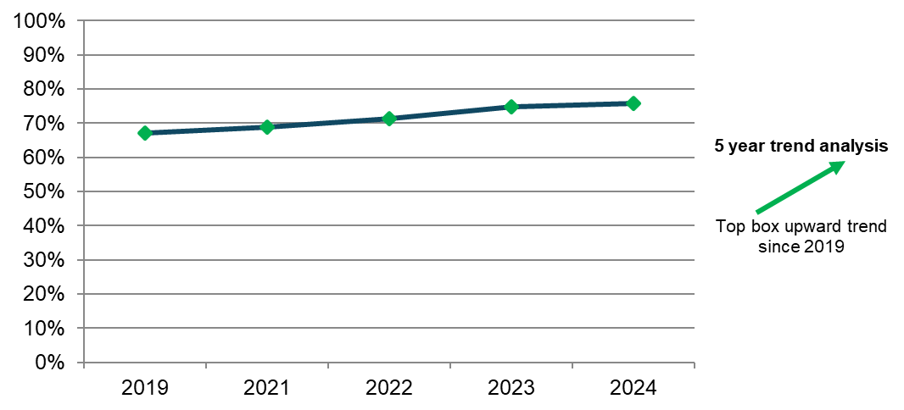
Answered by all.
Respondents who stated that they didn't know or couldn't remember have been excluded.
Total number of respondents: (2019) 16,606, (2021) 23,052, (2022) 20,585, (2023) 16,944, (2024) 18,661.

Women were also asked if they were given enough support for their mental health during pregnancy and most who needed this said they were (89%), a statistically significant increase compared with 88% in 2023 (figure 30). However, 11% said they were not given enough support (compared with 12% in 2023).

Figure 30: Were you given enough support for your mental health during your pregnancy? By survey year

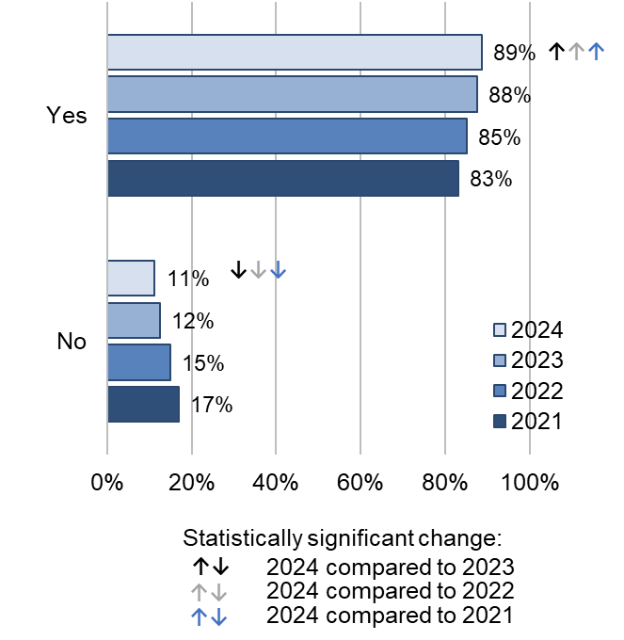
Answered by all.
Respondents who stated that they didn't know or couldn't remember or did not want or need support have been excluded.
Total number of respondents: (2021) 14,217, (2022) 12,544, (2023) 10,473, (2024) 11,784.

In terms of support with mental health postnatally, the vast majority of respondents said a midwife did ask them about their mental health (93%), while 7% said this did not happen.

More than half (58%) of respondents said they were ‘definitely’ given information about any changes they might experience to their mental health after having their baby. This is a statistically significant decrease compared with 60% in 2023. Just over a quarter (27%) received this information ‘to some extent’ and 15% said they did not receive this information, a statistically significant increase compared with 13% in 2023. Trend analysis over a 5-year period from 2019 indicates no change.

Most respondents (81%) were also told who to contact if they needed advice about any changes to their mental health after the birth, a statistically significant decrease compared with 83% in 2023. Meanwhile, nearly a fifth (19%) said this did not happen, a statistically significant increase compared with 17% in 2023. Trend analysis over a 5-year period from 2019 indicates no change.

Support with communication needs

The NHS Accessible Information Standard states that staff must provide clear, understandable and appropriate information in a format which is accessible to individual needs, for example in audio, Braille, Easy Read or Large Print. People should be supported by a communication professional at appointments if this is needed to support conversation, for example a British Sign Language interpreter, and they should get support from staff to communicate, for example to lip-read or use a hearing aid.

Respondents were asked if they had any communication needs, of which 3% said they needed translation or interpreter, 1% said they needed Easy Read materials, and 1% said they had ‘other’ communication needs.

Respondents who answered that they had any communication needs were also asked whether staff helped them with their communication needs while in the maternity unit. Most (82%) respondents answered they received this help from staff while they were in the maternity unit. However, nearly a fifth (18%) said they did not receive this help.

Subgroup analysis

We looked at how different groups of women rated their experience by using a multi-level model analysis. The analysis compares the average probability that different subgroups of women select the most positive answer to a survey question (‘theme’).

The subgroups used in the analysis are:

- age
- parity (whether respondents have had a previous baby or not)
- type of delivery
- ethnicity
- religion
- sexual orientation
- long-term conditions
- pregnancy related conditions
- Indices of Multiple Deprivation (IMD) decile
- gender same as sex assigned at birth
- whether English is spoken as a main language.

Please see the Quality & Methodology Report for more details on the methodology used for the analysis.

The following tables illustrate the findings of the subgroup analysis. Findings significantly above (B) or significantly below (W) average are shown for each survey question under each theme. There were no differences in experience found for sexual orientation, Indices of Multiple Deprivation (IMD), and gender same as sex assigned at birth; therefore, these subgroups have not been included in the tables that follow.

Differences in experience found for ethnicity represent variation from maternal and baby loss outcomes reported in the MBRRACE-UK report (2024) for maternal mortality during 2020-2022 and the MBRRACE-UK report (2024) on perinatal deaths of babies born in 2022. The Maternity survey excludes responses from certain groups of people, including those whose baby had died, people who died, those who had a concealed pregnancy and people whose baby was fostered or adopted.
2024 Maternity Survey  Subgroup Analysis  B Significantly better than  average  W Significantly worse than  average | Antenatal care |  |  |  |  |  |  |  |  |  |  |  | Labour and birth |  |  |  |  |  |  |  |  |  |  |  |  |  |  |  |  |  | Ward |  |  |  |  |  | Postnatal care
 | B8: Being listened to |  | B11: Access to help when needed |  | B13: Involved in decisions |  | B15: Confidence and trust |  | B16: Respect and dignity |  | B17: Concerns taken seriously |  | C7: Sent home when worried |  | C8: Pain management |  | C11: Left alone when worried |  | C12: Concerns taken seriously |  | C13: Access to help when needed |  | C16: Involved in decisions |  | C17: Respect and dignity |  | C18: Confidence and trust in staff |  | C21: Kindness and compassion |  | D3: Access to help when need |  | D5: Kindness and understanding |  | D7: Pain management |  | F1: Involved in decisions |  | F2: Access to help when needed |  | F4: As much contact as wanted |  | F6: Being listened to |  | F7: Personal circumstances |  | F8: Confidence and trust |  | F19: Considered a complaint
Age
16-26 |  |  | W |  | W |  |  |  | W |  | W |  | W |  |  |  | W |  |  |  | W |  |  |  | W |  |  |  | W |  |  |  |  |  |  |  |  |  |  |  | W |  | W
27-32 |  |  |  |  |  |  |  |  | B
33+ |  |  | B |  | B |  |  |  | B |  | B |  | B |  |  |  | B |  |  |  | B |  |  |  | B |  |  |  | B |  |  |  |  |  |  |  |  |  |  |  | B |  | B
Parity
Primiparous (gave birth for the first time) |  |  |  |  | B |  |  |  | B |  | B |  |  |  | W |  | W |  |  |  |  |  |  |  |  |  |  |  |  |  |  |  | W |  |  |  | W |  |  |  | W |  |  |  |  |  |  |  | W
Multiparous (have given birth previously) |  |  |  |  | W |  |  |  | W |  | W |  |  |  | B |  | B |  |  |  |  |  |  |  |  |  |  |  |  |  |  |  | B |  |  |  | B |  |  |  | B |  |  |  |  |  |  |  | B
Type of delivery
Vaginal birth | B |  | B |  | B |  | B |  | B |  | B |  |  |  |  |  |  |  | W |  | B |  | B |  | B |  | B |  | B |  | B |  | B |  | B |  | B |  | B |  | B |  | B |  | B |  | B |  | B
Assisted vaginal birth |  |  |  |  |  |  |  |  |  |  |  |  |  |  |  |  | W |  | W |  |  |  | W |  | W |  | W |  | W |  |  |  |  |  |  |  | W
Planned caesarean birth |  |  | W |  |  |  |  |  |  |  |  |  |  |  |  |  | B |  | B |  | B |  | B |  | B |  | B |  | B |  | W |  | W |  | W |  |  |  | W |  |  |  | W |  | W |  | W
Emergency caesarean birth | W |  | W |  | W |  | W |  | W |  | W |  |  |  | W |  | W |  | W |  | W |  | W |  | W |  | W |  | W |  | W |  | W |  | W |  | W |  | W |  |  |  | W |  | W |  | W |  | W
Religion
No religion
Buddhist |  |  |  |  |  |  |  |  |  |  |  |  |  |  |  |  |  |  |  |  |  |  |  |  |  |  |  |  |  |  |  |  |  |  |  |  | B
Christian |  |  |  |  |  |  |  |  |  |  |  |  |  |  |  |  |  |  |  |  |  |  |  |  |  |  |  |  |  |  |  |  |  |  |  |  |  |  |  |  |  |  |  |  | B
Hindu
Jewish
Muslim
Sikh
Other (religion)
Prefer not to say (religion) |  |  |  |  |  |  |  |  |  |  |  |  |  |  |  |  |  |  |  |  |  |  |  |  |  |  |  |  |  |  | W |  | W |  | W |  | W |  |  |  |  |  | W |  | W |  |  |  | W
2024 Maternity Survey  Subgroup Analysis (continued)  B Significantly better than average  W Significantly worse than average |  | Antenatal care |  |  |  |  |  |  |  |  |  |  |  | Labour and birth |  |  |  |  |  |  |  |  |  |  |  |  |  |  |  |  |  | Ward |  |  |  |  |  | Postnatal care
 |  | B8: Being listened to |  | B11: Access to help when needed |  | B13: Involved in decisions |  | B15: Confidence and trust |  | B16: Respect and dignity |  | B17: Concerns taken seriously |  | C7: Sent home when worried |  | C8: Pain management |  | C11: Left alone when worried |  | C12: Concerns taken seriously |  | C13: Access to help when needed |  | C16: Involved in decisions |  | C17: Respect and dignity |  | C18: Confidence and trust in staff |  | C21: Kindness and compassion |  | D3: Access to help when need |  | D5: Kindness and understanding |  | D7: Pain management |  | F1: Involved in decisions |  | F2: Access to help when needed |  | F4: As much contact as wanted |  | F6: Being listened to |  | F7: Personal circumstances |  | F8: Confidence and trust |  | F19: Considered a complaint
Ethnicity
English/Welsh/Scottish/Northern Irish/British |  |  |  |  |  |  |  |  |  |  |  |  |  |  |  |  |  |  |  |  |  |  |  |  |  |  |  |  |  |  |  |  |  |  |  |  |  |  |  |  |  | B
Irish
Any other White background |  | W |  |  |  |  |  | W |  |  |  |  |  |  |  |  |  |  |  |  |  |  |  |  |  |  |  | W |  |  |  |  |  |  |  |  |  |  |  |  |  |  |  | W |  |  |  | W |  | W
White and Black Caribbean
White and Black African
White and Asian
Any other Mixed/multiple ethnic background
Indian |  |  |  |  |  |  |  |  |  |  |  |  |  |  |  |  |  |  |  |  |  |  |  |  |  |  |  |  |  |  |  |  |  |  |  |  |  | B |  |  |  | W
Pakistani |  |  |  | W |  |  |  |  |  |  |  |  |  |  |  |  |  |  |  |  |  |  |  |  |  |  |  |  |  |  |  |  |  |  |  |  |  |  |  |  |  |  |  | W
Bangladeshi
Chinese
Any other Asian background
Caribbean
African background |  | B |  | B |  |  |  | B |  |  |  |  |  |  |  |  |  |  |  |  |  |  |  |  |  |  |  | B |  |  |  |  |  | B |  |  |  | B |  | B |  |  |  |  |  |  |  |  |  | B
Any other Black/Black British/Caribbean background |  | B |  |  |  |  |  |  |  |  |  |  |  |  |  |  |  |  |  |  |  |  |  |  |  |  |  |  |  |  |  |  |  | B |  |  |  |  |  |  |  |  |  | B |  |  |  | B
Arab
Any other ethnic group
Prefer not to say (ethnicity) |  |  |  |  |  |  |  | W
Not known (ethnicity)
2024 Maternity Survey  Subgroup Analysis (continued)  B Significantly better than average  W Significantly worse than average |  | Antenatal care |  |  |  |  |  |  |  |  |  |  |  | Labour and birth |  |  |  |  |  |  |  |  |  |  |  |  |  |  |  |  |  | Ward |  |  |  |  |  | Postnatal care
 |  | B8: Being listened to |  | B11: Access to help when needed |  | B13: Involved in decisions |  | B15: Confidence and trust |  | B16: Respect and dignity |  | B17: Concerns taken seriously |  | C7: Sent home when worried |  | C8: Pain management |  | C11: Left alone when worried |  | C12: Concerns taken seriously |  | C13: Access to help when needed |  | C16: Involved in decisions |  | C17: Respect and dignity |  | C18: Confidence and trust in staff |  | C21: Kindness and compassion |  | D3: Access to help when need |  | D5: Kindness and understanding |  | D7: Pain management |  | F1: Involved in decisions |  | F2: Access to help when needed |  | F4: As much contact as wanted |  | F6: Being listened to |  | F7: Personal circumstances |  | F8: Confidence and trust |  | F19: Considered a complaint
English main language
English main language |  | W |  | W |  | W |  | W |  | W |  |  |  |  |  | W |  |  |  | W |  | W |  | W |  | W |  | W |  | W |  | W |  | W |  | W |  | W |  | W |  |  |  | W |  | W |  | W |  | W
English not main language |  | B |  | B |  | B |  | B |  | B |  |  |  |  |  | B |  |  |  | B |  | B |  | B |  | B |  | B |  | B |  | B |  | B |  | B |  | B |  | B |  |  |  | B |  | B |  | B |  | B
Long-term health condition
Autism or autism spectrum condition
Breathing problem, such as asthma
Blindness or partial sight
Cancer in the last 5 years
Deafness or hearing loss
Diabetes
Heart problem, such as angina
Joint problem, such as arthritis
Kidney or liver disease
Learning disability
Mental health condition |  | W |  |  |  |  |  |  |  |  |  |  |  |  |  |  |  |  |  |  |  |  |  |  |  |  |  | W |  |  |  |  |  |  |  |  |  |  |  |  |  |  |  |  |  |  |  |  |  | W
Neurological condition
Physical mobility
Sickle cell anaemia
Thalassaemia
Another long-term condition |  |  |  |  |  |  |  |  |  |  |  |  |  |  |  |  |  |  |  |  |  |  |  |  |  |  |  | W
None of the above
Prefer not to say

2024 Maternity Survey  Subgroup Analysis (continued)  B Significantly better than average  W Significantly worse than average | Antenatal care |  |  |  |  |  | Labour and birth |  |  |  |  |  |  |  |  | Ward |  |  | Postnatal care
 | B8: Being listened to | B11: Access to help when needed | B13: Involved in decisions | B15: Confidence and trust | B16: Respect and dignity | B17: Concerns taken seriously | C7: Sent home when worried | C8: Pain management | C11: Left alone when worried | C12: Concerns taken seriously | C13: Access to help when needed | C16: Involved in decisions | C17: Respect and dignity | C18: Confidence and trust in staff | C21: Kindness and compassion | D3: Access to help when need | D5: Kindness and understanding | D7: Pain management | F1: Involved in decisions | F2: Access to help when needed | F4: As much contact as wanted | F6: Being listened to | F7: Personal circumstances | F8: Confidence and trust | F19: Considered a complaint
Pregnancy-related condition
Pelvic health problems | W | W |  | W | W | W |  | W |  | W |  | W |  |  | W | W |  | W | W
Another pregnancy-related health condition | W | W | W | W | W | W |  |  |  | W |  | W | W | W | W | W | W | W | W | W |  |  |  | W | W
None of the above
(pregnancy-related conditions)
Prefer not to say
(pregnancy-related conditions)

Appendix A: Survey methodology
This appendix summarises the survey methodology, covering questionnaire design, sampling, fieldwork and analysis. For more detailed information, and for information on data limitations, please see the Quality & Methodology Report.
Questionnaire design
To make sure that the questionnaire is up-to-date and in line with current policy and practice, questions are reviewed before each survey to determine whether any new questions are needed. Questionnaire development work makes sure that questions are important to people who use services and to other stakeholders who use the survey data in their work. More information on how survey stakeholders use the data is provided in Appendix D.
Wherever possible, questions remain the same over time to measure change. However, when necessary, they are updated to reflect changes in policy and methodological best practice, and to reflect feedback from stakeholders to make sure that questions stay relevant. Full details of changes are available in the Survey Development Report.
Comparability with previous years
The Maternity Survey was first run in 2007, with surveys being carried out in 2010, 2013, 2015, 2017, 2018, 2019, 2021, 2022 and 2023.
The survey questionnaire underwent a major redevelopment ahead of the 2013 survey so results for 2024 are only comparable with 2013, 2015, 2017, 2018, 2019, 2021, 2022 and 2023.
Survey methodology
The 2024 Maternity Survey used both an online and a postal questionnaire for survey data collection. People using maternity services were sent a maximum of 4 postal letters inviting them to complete the survey. In addition to the letters, they were also sent up to 3 text message (SMS) reminders containing a direct link to the online survey. This is discussed further in the Quality & Methodology Report.
The survey used a ‘push to web’ methodology, meaning that people were encouraged to complete the survey online. A paper questionnaire was enclosed in the third mailing with all other contacts providing a web link. Eighty-nine per cent of respondents took part online.
Fieldwork for the survey (the time during which respondents were invited to take part in the survey) took place between May and August 2024.
The 2024 survey offered several accessible formats of the questionnaire to ensure it followed best practice for survey accessibility. The online survey was translated into 9 non-English languages. Additionally, respondents were able to change font size and background colour of the online survey, as well as screen reader compatible. Braille, large print and Easy Read paper questionnaires were available on request.

Accessibility formats | Number of requests received
Non-English online completes | 316
Braille requests | 0
Large print requests | 0
Easy read requests | 0
Telephone assisted completes | 1
Telephone calls requiring translator | 1

Response rate
The response rate for the 2024 survey was 41%, compared to 43% for the core sample for the previous survey in 2023. The core sample is comparable to previous years and excludes the booster sample in 2023.
Sampling
Women aged 16 and over at the time of delivery were eligible to complete the survey, if they had a live birth during the month of February 2024. Trusts with sample sizes smaller than 300 were also required to include people who gave birth during January 2024, starting with deliveries on 31 January and working back across the month until the sample size of 300 was achieved or 1 January was reached. Only those receiving care from an NHS trust were eligible. The sample size was enough to allow analysis of results at individual trust level.
Certain groups of people were excluded from the survey before providers drew their samples, including those whose baby had died, people who died, those who had a concealed pregnancy and people whose baby was fostered or adopted.
All NHS trusts providing maternity services and that had enough births were eligible to take part in the survey.
No trusts were excluded from the analysis because of sampling errors.
More detailed information on the sampling for the survey is available in the instruction manual.
Analysis

Data cleaning
‘Data cleaning’ refers to all editing processes carried out on survey data once the survey has been completed and the data has been entered and collated. This is done to make sure that this is comparable across trusts. For further information please see the Data Cleaning document.

Weighting
The data presented in this report has been weighted with 2 weights:

- ‘Trust weight’ aims to weight responses from each trust to ensure each trust has an equal influence on England results. As some trusts have a higher response rate than others, they have a larger share of respondents in the total respondent’s population for England.
- ‘Population weight’, ensures responses for each individual are weighted to make sure it is representative of the trust’s own population (based on the initial eligible sample). This involves weighting based on variables that are related to how people respond. For the 2024 Maternity survey, this variable is age group.

Both sets of weights are then multiplied together to produce a single combined weight for the data tables that underpin the analysis. The demographic questions (G1-G11 and G13-G14 in the questionnaire) are not weighted, as it is more appropriate to present the real percentages of respondents to describe the profile of respondents, rather than to adjust figures.

Rounding
The results present percentage figures rounded to the nearest whole number, so the values given for any question will not always add up to 100%.

Statistical significance
Statistical tests were carried out on the data to determine whether there had been any statistically significant changes in the results for 2024 compared with the results for 2023, 2022 and 2021.
A ‘t-test’ set to 95% significance was used to compare data between 2 survey years. A statistically significant difference means that there is a less than 5% chance that we would have obtained this result if there was no real difference.

In other cases, even though there may be a visible change in the results between either 2021, 2022, 2023 compared with 2024, it is not significant. There are several reasons for this, such as:

- Rounding figures up or down makes a difference appear larger than it actually is.
- The larger the sample size, the more likely that findings will be statistically significant, and we can be more confident in the result. In contrast, the fewer people that answer a question, there has to be a greater difference to be statistically significant.

The amount of variation also affects whether the difference is significant. ‘Variation’ means the differences in the way people respond to the question. If there is a lot of variances, differences are less likely to be statistically significant.
The Quality & Methodology Report contains relevant background information to help readers to understand the survey data, including response rates, sampling errors and data limitations.

Appendix B: Other sources of data related to the key findings
There are multiple sources of data on maternity care. The information below provides links to some of these.
Note: These data sources do not measure patient experience and are therefore not directly comparable with findings presented in this report. However, they provide useful contextual information.

Breastfeeding at 6-8 weeks after the birth
Annual datasets and commentary on the number and proportion of infants who have been fully, partially or not at all breastfed at 6 to 8 weeks after birth from The Office for Health Improvement and Disparities (OHID).
For more information please see: https://www.gov.uk/government/statistics/breastfeeding-at-6-to-8-weeks-quarterly-data-for-2023-to-2024

Hospital Episode Statistics (HES data)
HES is a data warehouse from NHS England, containing details of all admissions, outpatient appointments and A&E attendances at NHS hospitals in England.
The maternity publication describes activity in England and includes national and provider level information on delivery, mother’s age, complications and more.
For more information please see: https://digital.nhs.uk/data-and-information/data-tools-and-services/data-services/hospital-episode-statistics

Live births
The Office for National Statistics (ONS) publishes annual statistics on live births by age of mother/father, sex, marital status, country of birth, socio-economic status, previous children and area.
For more information please see: www.ons.gov.uk/peoplepopulationandcommunity/birthsdeathsandmarriages/livebirths.

Maternity Services Data Set
The Maternity Services Data Set (MSDS) is a patient-level data set from NHS England, that captures information about activity carried out by maternity services relating to a mother and baby(s), from the point of the first booking appointment until mother and baby(s) are discharged from maternity services.
It was established in response to NHS England’s Better Births, which recommended that a nationally agreed set of indicators should be developed to help local maternity systems track, benchmark and improve the quality of maternity services. Data is published monthly.
For more information please see: https://digital.nhs.uk/data-and-information/data-collections-and-data-sets/data-sets/maternity-services-data-set

Friends and Family test
The Friends and Family Test (FFT) gives patients the opportunity to submit feedback to providers of NHS funded care or treatment, using a simple question which asks how likely, on a scale ranging from extremely unlikely to extremely likely, they are to recommend the service to their friends and family if they needed similar care or treatment. Data is published on a monthly basis.
For more information please see: https://www.england.nhs.uk/fft/friends-and-family-test-data/

Child and infant mortality in England and Wales
The Office of National Statistics (ONS) provides data on stillbirths, infant and childhood deaths occurring annually in England and Wales, and associated risk factors.
For more information please see: https://www.ons.gov.uk/peoplepopulationandcommunity/birthsdeathsandmarriages/deaths/datasets/infantmortalitybirthcohorttablesinenglandandwales

MBRRACE-UK surveillance data collection system
The MBRRACE-UK surveillance data collection system collects data on maternal and perinatal deaths in England, Wales and Scotland; modified arrangements are in place for Northern Ireland.
For more information please see: https://www.npeu.ox.ac.uk/mbrrace-uk/maternal-programme/maternal-data-collection

Statistics of Women’s Smoking Status at Time of Delivery: England
This NHS England dataset presents statistics on women’s smoking status at time of delivery, at Sub Integrated Care Board (Sub-ICB) Location, Integrated Care Board (ICB), and national levels.
For more information please see: https://digital.nhs.uk/data-and-information/publications/statistical/statistics-on-women-s-smoking-status-at-time-of-delivery-england

NHS Outcomes Framework
NHS England’s NHS Outcomes Framework provides national-level accountability for the outcomes that the NHS delivers, to drive transparency, quality improvement and outcome measurement throughout the NHS.
Data from the NHS Patient Survey Programme are used to monitor domain 4 ‘ensuring that people have a positive experience of care’. Data from the Maternity survey are used to populate domain 4.5 ‘women’s experience of maternity services’.
For more information please see: https://digital.nhs.uk/data-and-information/publications/clinical-indicators/nhs-outcomes-framework

Staffing
Statistics on staffing numbers are provided in NHS England’s statistical release on NHS Workforce Statistics.
Note: this data covers all trust types (not just acute trusts with maternity services).
For more information, please see: https://digital.nhs.uk/data-and-information/publications/statistical/nhs-workforce-statistics.

Appendix C: Other maternity surveys
There have previously been a number of surveys of maternity care experiences; this appendix covers only results from those surveys that have been updated since 2021.
Note: Surveys use different methodologies, questionnaires, have different aims and purposes and have been carried out at different points in time. This means that comparisons with this survey must be considered with significant caution.
However, a common theme across most surveys, including internationally, is that women tend to report more positive experiences of their antenatal care and labour and birth than their postnatal care.

Black Maternity Experience Survey
The survey was launched in April 2021 and aims to better understand the experiences of Black women using maternity services and their experiences of childbirth to facilitate change. It is run by Five X More, a grassroots organisation committed to changing Black women’s maternal health outcomes in the UK.
Using a survey designed with input from an expert panel of Black professionals, both quantitative and qualitative data was gathered from 1,340 respondents from around the UK who either identified as Black, or of Black mixed heritage, and had accessed NHS maternity services while pregnant between 2016 and 2021.
The findings caused concern. Though both positive and negative experiences were reported, negative experiences outweighed those in which people were happy with the care that they had received. These negative experiences were found to fit within a framework overarched by 3 related themes centred around the healthcare professional (HCP):

- attitudes (for example, using offensive and racially discriminatory language; being dismissive of concerns)
- knowledge (for example, poor understanding about the anatomy and physiology of Black women; poor understanding of the clinical presentation of conditions in babies of Black women)
- assumptions (for example, racially based assumptions about the pain tolerance, education level, and relationship status of Black women using maternity services).

The Black Maternity Experiences Survey report was published in May 2022. For more information please see: https://fivexmore.org/blackmereport

The National Perinatal Epidemiology Unit (NPEU)
The NPEU has conducted a survey of experiences of maternity care in 2006, 2010, 2014, 2018 and 2020. The surveys collect information on respondents’ experiences of pregnancy, labour, birth and early parenthood, which is used to improve maternity services across the country. CQC worked with NPEU to develop the first Maternity Survey in the NHS Patient Survey Programme.
For more information please see: www.npeu.ox.ac.uk/maternity-surveys

Scotland
The Maternity Care Survey carried out by the Scottish government is very similar to the NHS Maternity Survey and covers the maternity care journey from antenatal care through to care at home after the birth. The questionnaire uses many of the questions from the English survey and has a similar methodology. The survey has run in 2013, 2015 and 2018.
For more information please see: www.gov.scot/collections/maternity-care-survey/

Wales
A national review of maternity services was carried out across Wales, with phase 1 of the review from June 2019 to summer 2020. In July 2021 the decision was made not to progress with phase 2 of the review.
For more information please see: https://hiw.org.uk/national-review-maternity-services

Northern Ireland
A survey has not been carried out in Northern Ireland since 2016.
For more information please see: https://research.hscni.net/publication/birth-ni-survey-womens-experience-maternity-care-northern-ireland-2016

International surveys
This section highlights maternity surveys carried out by other countries. While results are not directly comparable because of different healthcare systems, and different survey methodologies, these other surveys may be of interest and a selection are summarised below.

Republic of Ireland
The first National Maternity Experience Survey took place in October and November 2019. It offered eligible new mothers the opportunity to share their experiences of Ireland’s maternity services — from antenatal to postnatal care — in order to improve the safety and quality of care provided to women and their babies. Further research was carried out on the 2020 National Maternity Experience Survey to identify respondents’ experience of care provided outside of hospital by general practitioners (GPs), practice nurses and midwives.
For more information, please see: https://yourexperience.ie/maternity/about-the-survey/

California – USA
The ‘listening to mothers’ surveys cover the time from before pregnancy through the postpartum and infant periods, and attitudes, beliefs, preferences and knowledge on a broad range of topics. The most recent survey took place in 2018.
For more information please see: www.nationalpartnership.org/our-work/health/maternity/listening-to-mothers.html

Appendix D: Main uses of the survey data
This appendix lists known users of data from the maternity survey and how they use the data.

Care Quality Commission (CQC)
CQC will use results from the survey to build an understanding of the risk and quality of services and those who organise care across an area. Where survey findings provide evidence of a change to the level of risk or quality in a service, provider or system, CQC will use the results alongside other sources of people’s experience data to inform targeted assessment activities. For more information please see: www.cqc.org.uk/what-we-do

Department of Health and Social Care
The government measures progress on improving people’s experiences through domain 4 of the NHS Outcomes Framework ‘ensuring people have a positive experience of care’. The Framework sets out the outcomes and corresponding indicators that the Department of Health and Social Care uses to hold NHS England to account for improvements in health outcomes.
The NHS Outcomes Framework survey indicators are based on the standardised, scored trust-level data from the survey (similar to that included in CQC’s benchmark reports), rather than the England-level percentage of respondent’s data that is contained within this report.
For more information please see: https://digital.nhs.uk/data-and-information/publications/clinical-indicators/nhs-outcomes-framework/current

NHS England
NHS England (NHSE) is a key user of data from the NHS Patient Survey Programme. Listening to people’s experiences of their maternity care plays a crucial part in delivering services that are safe, effective and continuously improving. Data from the Maternity survey are important for NHS England to understand experiences of the services across the whole maternity pathway.
Patient experience is a cross-cutting theme throughout the NHS Long Term Plan. CQC data supports NHS England to track how it is performing on user experience, understand where inequality is present and the impact that policy initiatives are having on patients.
NHS services have suffered a heavy burden from the COVID-19 pandemic, with the 2023/24 NHS priorities and operational planning guidance reconfirming the ongoing need to recover core services and improve productivity. CQC data supports NHSE to understand how they do this in an equitable way.
For more information please see: www.england.nhs.uk/statistics/statistical-work-areas/patient-surveys/
NHS England’s Three year delivery plan for maternity and neonatal services includes ‘Determining Success Measures’ that are used to monitor outcomes and progress in achieving key objectives on the plan. Determining Success Measures are organised by 4 themes underpinning the Three-year delivery plan. For Theme 1, ‘Listening to and working with women and families with compassion’, 10 Determining Success Measures are linked to the CQC Maternity Survey questions. These measures classed as outcomes include:

- Awareness of medical history during antenatal check-ups
- Involvement in antenatal care decisions
- Being listened to during antenatal check-ups
- Response to concerns during labour and birth
- Involvement in decisions during labour and birth
- Kind and compassionate treatment during labour and birth
- Adequacy of information or explanations during postnatal hospital care
- Consideration of personal circumstances during postnatal care
- Being listened to during postnatal care
- Adequacy of time discussing physical and mental health at the 6-8 weeks GP check.

The construction of each outcome measure is detailed in this technical guidance.

NHS trusts and commissioners
Trusts, and those who commission services, use the results to identify and make the changes they need to improve the experience of people who use their services.

Patient Experience Library
Data from the NHS Patient Survey Programme is added to the Patient Experience Library’s surveys tracker, which puts all survey data plus benchmark reports in one place, with cross referencing of common themes such as cleanliness and waiting. The tracker was developed based on discussions with NHS England’s Heads of Patient Experience Network, whose members find it invaluable for helping Boards and senior management of trusts to get quick and easy access to these key components of patient experience evidence. The tracker is open access, so it is also available to patient groups, health charities, policy bodies and researchers. Summaries of each survey also appear in the Library’s annual Patient Experience in England report, which is disseminated to around 2,000 individuals and organisations with an interest in patient experience and involvement.

Appendix E: Revisions and corrections
CQC publishes a Revisions and Corrections Policy relating to these statistics. Maternity Survey data is not subject to any scheduled revisions as it captures the views of women about their experiences of care at a specific point in time. All new survey results are therefore published on CQC’s website and NHS Surveys, as appropriate, and previously published results for the same survey are not revised.
This policy sets out how CQC will respond if an error is identified in a survey, and it becomes necessary to correct published data or reports.

Appendix F: Further information and feedback

Further information
This report, together with the trust level results, is available on CQC’s website. You can also find a Technical Document on the NHS Surveys website, which describes the methodology for producing trust level results, and a Quality & Methodology Report, which provides information about survey methodology.
All survey reports, instructions and documents created as part of the survey can be found on the NHS Surveys website. These include full details of the methodology for the survey, questionnaires, letters sent to people invited to take part in the survey, instructions on how to carry out the survey, and the survey development report.
There is more information on the NHS Patient Survey Programme, including results from other surveys and a programme of current and forthcoming surveys, on the NHS survey website.

Further questions or feedback
This summary has been produced by CQC’s Research Team and reflects the findings of the 2024 Maternity survey. We welcome all feedback on the survey findings and the way we have reported the results, particularly from people using services, their representatives, and those providing services. If you have any comments, questions or suggestions on how this publication could be improved, please contact Patient.Survey@cqc.org.uk.
CQC will review your feedback and use it as appropriate to improve the statistics that we publish across the NHS Patient Survey Programme.
If you would like to be involved in consultations or receive updates on the NHS Patient Survey Programme, please subscribe here: www.cqc.org.uk/surveys.

Accredited Official Statistics status
Accredited Official Statistics status means that official statistics meet the highest standards of trustworthiness, quality and public value.
All official statistics should comply with all aspects of the Code of Practice for Statistics. They are awarded Accredited Official Statistics status following an assessment by the Authority’s regulatory arm. The Authority considers whether the statistics meet the highest standards of Code compliance, including the value they add to public decisions and debate.
References

The ‘adjusted’ response rate is reported. The adjusted base is calculated by subtracting the number of questionnaires returned as undeliverable, or if someone had died, from the total number of questionnaires sent out. The adjusted response rate is then calculated by dividing the number of returned useable questionnaires by the adjusted base.
Assisted vaginal delivery is a vaginal birth assisted by forceps or ventouse suction cup.
In this report, we refer to ‘women’, but we recognise that some transgender men, non-binary people and people with variations in sex characteristics or who are intersex may also use maternity services.
The ‘adjusted’ response rate is reported. The adjusted base is calculated by subtracting the number of questionnaires returned as undeliverable, or if someone had died, from the total number of questionnaires sent out. The adjusted response rate is then calculated by dividing the number of returned useable questionnaires by the adjusted base.
This question is multiple choice so percentages will add up to more than 100%.
The Index of Multiple Deprivation (IMD) is the official measure of relative deprivation in England. This ranks neighbourhoods based on their deprivation and then divides them into 10 groups (deciles) based on their deprivation rank where 1 is the most deprived and 10 is the least deprived.
n/a in the table means that a subgroup was not included in the analysis of a theme.
Please note that some questions have been revised since 2013 and are therefore not comparable over time.
Health and Social Care Committee, Fourth Report of Session 2021–22, The safety of maternity services in England. Available online at: Safety of maternity services in England
NHS England, 2021. Equity and equality: Guidance for local maternity systems. Available online at: https://www.england.nhs.uk/publicati on/equity-and-equality-guidance-for-local-maternity-systems/
MBBRACE-UK, 2022. Saving Lives, Improving Mothers’ Care. Available online at: https://www.npeu.ox.ac.uk/assets/downloads/mbrrace-uk/reports/maternal-report-2022/MBRRACE-UK_Maternal_MAIN_Report_2022_v10.pdf
Care Quality Commission, 2023. The state of health care and adult social care in England 2022/23. Available online at: State of Care 2022/23 - Care Quality Commission (cqc.org.uk)
Midwifery, 2015 A balancing act in an unknown territory: A meta synthesis of first-time mothers׳ experiences in early labour. Available online at: http://www.midwiferyjournal.com/article/S0266-6138(14)00262-9/pdf
BMJ, 2017. Sociodemographic differences in women’s experience of early labour care: a mixed methods study. Available online at: https://bmjopen.bmj.com/content/7/7/e016351
NICE clinical guidelines, 2021. Patient experience in adult NHS services: improving the experience of care for people using adult NHS services. Available online at: https://www.nice.org.uk/guidance/cg138
NHS England, 2023. Three-year delivery plan for maternity and neonatal services. Available online at: NHS England » Three year delivery plan for maternity and neonatal services
Women and Birth, 2021. A qualitative study of first time mothers’ experiences of postnatal social support from health professionals in England. Available online at: https://www.sciencedirect.com/science/article/pii/S1871519220303693?via%3Dihub
Care Quality Commission, 2024. National review of maternity services in England 2022 to 2024. Available at: https://www.cqc.org.uk/publications/maternity-services-2022-2024/
The Royal College of Midwives, 2018. Position statement Infant Feeding. Available online at: https://www.rcm.org.uk/publications/?publicationtype=positionstatements&query=infant+feeding

