


2024 Urgent and Emergency Care Survey

Statistical release

NHS Patient Survey Programme

Independent analysis for England published: November 2024
Contents
Summary of findings 6
Positive experiences 7
Areas for improvement 8
How experience varies for different groups of patients 10
About urgent and emergency care 12
About the urgent and emergency care survey 14
Urgent and emergency care policy 16
Urgent and emergency care pathways 16
Waiting times and delayed transfers of care 17
Staffing levels 19
Same day emergency care (SDEC) 21
Health inequalities 22
Results from the survey 23
Section 1: Overall experience 25
Overall experience at A&E (Type 1) 25
Overall, treated with respect and dignity (Type 1) 25
Overall experience at urgent treatment centres (Type 3) 26
Overall, treated with respect and dignity (Type 3) 26
Section 2: Reattendance at urgent and emergency care services 27
Reattendance at A&E departments (Type 1) 27
Reattendance at urgent treatment centres (Type 3) 28
Section 3: Duration of visit 29
Duration of visit at A&E departments (Type 1) 29
Duration of visit at urgent treatment centres (Type 3) 31
Section 4: Ambulance handovers 31
Ambulance handovers to A&E staff 31
Ambulance waiting experience 32
Section 5: Waiting for first assessment (triage) 32
Waiting for first assessment (triage) at A&E (Type 1) 32
Waiting for initial assessment at urgent treatment centre (Type 3) 33
Section 6: Care for condition(s) while waiting 34
Care for condition(s) while waiting in A&E (Type 1) 34
Care for condition(s) while waiting in urgent treatment centre (Type 3) 35
Section 7: Communication about condition 35
Communicating about condition at A&E (Type 1) 35
Communicating about condition at urgent treatment centres (Type 3) 37
Section 8: Involvement in care 38
Involvement in care at A&E (Type 1) 38
Involvement in care at urgent treatment centres (Type 3) 39
Section 9: Communication support needs 40
Communication support needs at A&E (Type 1) 40
Communication support needs at urgent treatment centres (Type 3) 41
Section 10: Emotional support 41
Emotional support at A&E (Type 1) 41
Emotional support at urgent treatment centres (Type 3) 41
Section 11: Pain management 41
Pain management while in A&E (Type 1) 42
Pain management while in urgent treatment centres (Type 3) 42
Section 12: Access to food and drinks 42
Access to food and drinks in A&E (Type 1) 43
Access to food and drinks in urgent treatment centres (Type 3) 43
Section 13: Feeling safe 43
Feeling safe around other patients or visitors (Type 1) 43
Feeling safe around other patients or visitors (Type 3) 43
Section 14: Confidence and trust 44
Confidence and trust in doctors/nurses at A&E (Type 1) 44
Confidence and trust in health professionals at urgent treatment centres (Type 3) 44
Section 15: Tests 45
Tests at A&E (Type 1) 45
Tests at urgent treatment centres (Type 3) 46
Section 16: Discharge, medications and information 46
A&E: discharge, medications and information (Type 1) 47
Urgent treatment centres: discharge, medications and information (Type 3) 48
Section 17: Pathways into urgent and emergency care services 51
Pathways into accident and emergency care (Type 1) 51
Pathways into urgent treatment centres (Type 3) 54
Section 18: Care and support after leaving 57
Providing contact information if worried 57
Health or social care needs after leaving urgent and emergency care services 57
Section 19: Subgroup analysis 58
Appendix A: Survey methodology 71
Questionnaire design 71
Comparability with previous years 71
Survey methodology 71
Response rate 72
Sampling 73
Comparability between service types 74
Data analysis methodology 74
Appendix B: Demographic tables 76
Appendix C: Subgroups in analysis 79
Appendix D: Other sources of information related to survey results 81
NHS Outcome Framework 81
Quality standard for patient experience in adult NHS services 81
Staffing 81
Waiting times 82
Patient experience 82
Appendix E: Comparisons with other surveys 83
Scotland 83
Northern Ireland 83
Ireland 84
Appendix F: Main uses of the survey data 85
Care Quality Commission (CQC) 85
Department of Health and Social Care 85
NHS England 85
NHS trusts and commissioners 86
Appendix G: Revisions and corrections 87
Appendix H: Further information and feedback 88
Further information 88
Further questions or feedback 88
Accredited Official Statistics status 88
References 89

Summary of findings
Urgent and emergency care services perform a vital role in keeping millions of people healthy each year, with the number of people using these services continually rising. Anyone requiring assistance for an urgent health problem can access care, with or without an appointment or referral.

The Urgent and Emergency Care Survey has undergone significant changes to methodology, sampling and content in 2024 which will prevent comparisons to data from prior iterations. Through extensive consultations, stakeholders prioritised understanding patients’ experience of care during winter pressures and identifying factors that may account for unnecessary attendances. To this end, patients who received care in February 2024 from A&E (Type 1) or urgent treatment centres (Type 3, UTC) were invited to participate. The Type 1 survey received responses from 35,670 people – a response rate of 29%. The Type 3 survey received responses from 10,325 people – a response rate of 26%. A total of 120 NHS acute trusts in England with an A&E department (Type 1) took part in the survey, of which 70 trusts also had an urgent treatment centre (Type 3).

Overall, results from this survey show people are having poor experiences of urgent and emergency care services. This applies more so for people using A&E services, with UTC patients generally reporting more positively.

Patients with long waits to initial assessment and those whose visits lasted more than 4 hours consistently report poorer care experiences for both A&E and urgent treatment centre services. Sixty-four percent of A&E attendances lasted more than 4 hours, with patients whose visit lasted more than 4 hours reporting worse than average experiences for all areas of care included in our analysis. Similarly, A&E patients who waited more than 60 minutes for their initial assessment (triage) also reported poorer experiences in all areas of care. People’s experiences of waiting for care whilst at A&E were especially poor, with 47% of A&E patients not able to get help with their conditions or symptoms. Of those who needed help with medication for a pre-existing medical condition in A&E, over a quarter (28%) were not helped by staff.

In addition, for the first time, this survey asks why respondents attended urgent and emergency care, rather than opting to receive care from another service. Results show that a lack of timely access to other services may be contributing to unnecessary attendances at urgent and emergency care services. Of those who went directly to A&E, 20% went because they thought their GP practice would not be able to help (UTC 21%), and 26% wanted to be seen on the same day (UTC 34%). Of those who contacted another service, over a third contacted a GP (36%; UTC 48%), but 28% of those said the practice did not provide the help they needed (UTC 44%).

NHS 111 also has the ability to divert patients to other services, where appropriate, and avoid unnecessary urgent and emergency care attendances. Of those who contacted another service, the NHS 111 telephone service was most commonly contacted (A&E 40%; UTC 37%). However, 12% of A&E patients said the NHS 111 telephone service did not provide them with the help they needed (UTC 11%).

Positive experiences
Medications
A high proportion of A&E and urgent treatment centre patients were given information about the new medication they were to take home. This included information about:
- the purpose of the medication (A&E 75%; UTC 75%)
- how to take the medication (A&E 55%; UTC 62%)
- the side effects (A&E 25%; UTC 28%).
Some were given medication, but no information about them (A&E 9%; UTC 7%).

Supporting patients to care for conditions at home
Information provided on how to care for one’s condition at home was well understood by nearly all A&E and UTC respondents. Of A&E respondents who were given information on how to care for their condition at home (67%; UTC 82%), nearly all understood the information ‘very well’ or ‘fairly well’ (97%; UTC 98%). Over two-thirds of A&E patients (70%; UTC 77%) said they ‘definitely’ felt able to care for their condition at home.

Communicating about condition at urgent treatment centres
Patients at urgent treatment centres reported better than average experiences for questions about communication about their condition and treatment. Just over three-quarters ‘definitely’ had enough time to discuss their condition and treatment (76%) and 73% felt their condition and treatment was ‘completely’ explained. Eighty per cent of patients felt health professionals ‘definitely’ listened to what they had to say.

Areas for improvement
Ambulance handovers and waiting to be assessed
The NHS Standard Contract operating standards are that 95% of ambulance handovers should occur within 30 minutes and 65% of handovers within 15 minutes. Waiting times for ambulance handovers and waiting times for initial assessments are areas for improvement. While 61% of patients reported ambulance handovers happening within 15 minutes, 23% waited between 16 minutes to 1 hour and 17% waited more than 1 hour.

Waiting to be assessed
Duration of wait to initial assessment has a consistent relationship with a poorer experience of care. Initial assessments (triage) at emergency care services should take place within 15 minutes of arrival. Twenty-nine per cent of A&E patients said they assessed by a nurse or doctor within 15 minutes, whereas 28% waited for more than an hour.

A&E patients who waited over 30 minutes reported worse than average experiences for 18 of 20 questions (UTC 15 questions). Nearly half of A&E patients (49%) waited more than 30 minutes (UTC 40%).

Help with condition or symptoms while waiting
While waiting for their initial assessment, 47% of A&E patients and 54% of urgent treatment centre patients were not able to get help with their condition or symptoms.

Help with pre-existing condition(s)
Access to medication for pre-existing medical conditions was needed for some patients during their visit. Just over a quarter of A&E patients (28%) and urgent treatment centre patients (26%) were not given help to take their medications for their pre-existing medical conditions.

Communicating about condition at A&E
Doctors’ and nurses’ communication with patients is an area for improvement. When asked whether they had enough time to discuss their condition with a doctor or nurse, less than two thirds (61%) of A&E respondents said ‘definitely’ (10% said ‘no’). Similarly, less than two thirds (60%) said doctors and nurses in A&E ‘completely’ explained their condition in a way they could understand (11% said ‘no’).

Pain relief
When asked about pain relief, less than half of A&E (42%) and urgent treatment centre (47%) patients said staff ‘definitely’ helped control their pain. However, just over a quarter in both A&E (27%) and urgent treatment centres (26%) said staff did not help them.

Communication support needs
The Accessible Information Standard is a legal requirement for the NHS to meet the communication support needs of all people using services. Eleven per cent of A&E respondents had at least one communication support need. Of those, more than a quarter (27%) said they were not given help with their needs. In addition, less than half (44%) said staff ‘definitely’ provided help. Support needs included translator or interpreter (3%); easy read materials (2%), large print materials (1%) or another type (6%).

Emotional support
Taking time to discuss patients’ anxieties and fears is an area for improvement. A higher proportion of patients report the positive experience of health professionals ‘completely’ discussing their anxieties and fears in urgent treatment centres (57%) than A&Es (45%). Nevertheless, there is a significant proportion that report they were not discussed at all in both (A&E 25%; UTC 19%).

Reattending and discharge
Some patients had been discharged with an unmet need for further care or support. Of respondents who felt they needed a conversation about any further health or social care, nearly a third (31%) of A&E patients said staff did not discuss it with them, but they would have liked them to (UTC 23%). Of those who contacted any health and social care services after leaving A&E, 28% said they were not available when needed (UTC 21%).

Of those who were discharged and sent home, 79% of A&E patients were told who to contact if they were worried about their condition or treatment; however, 21% were not. Similarly, 82% of urgent treatment centre patients were told but 18% were not. For A&E patients, 44% said they were told to contact their GP (UTC 45%) and 10% to contact NHS 111 (UTC 11%).

Of the 30% who had been to A&E previously for the same condition, 13% said they did not get the help they needed on their previous visit. Communication with doctors and nurses and involvement in care were worse than average for those that had attended A&E within the prior month.

How experience varies for different groups of patients
Patients with different personal characteristics (demographics or long-term conditions) and care characteristics (such as waiting experiences) reported better or worse than average experiences for several questions. See Section 19 for questions included in the analysis and the subgroups who reported better or worse experiences. See Appendix C for a list of all patient subgroups.
Patients with a disability
A&E patients with a disability (59%) reported worse than average experiences in A&E overall and in many areas of care. For example, disabled patients were less likely to feel they were treated with respect and dignity. They also reported worse than average experiences for all communications questions, including being listened to, doctors or nurses clearly explaining their condition or treatment and being involved in decisions. They were also less likely to report that a family member, friend or carer had enough opportunity to speak to a doctor or nurse when they had wanted to. Disabled patients also reported worse than average experiences with being given enough privacy during examination and treatment and being given information on care at home.

Patients with indicators of frailty
Frail patients (11%) in A&E services reported worse than average experiences overall and across many areas of care, similar to disabled patients. For instance, frail patients reported worse experiences for all communications questions, such as having enough time to discuss their condition and treatment and to discuss their anxieties and fears. They were also less likely to feel they were treated with respect and dignity.

Patients with long-term conditions
A&E patients with dementia or Alzheimer’s (2%) reported worse than average experience of doctors or nurses listening to what they had to say.
Patients were asked how they would rate their experience overall. Those with a neurological condition (7%) reported a worse than average overall experience of A&E care.
Urgent treatment centre patients with a mental health condition (9%) reported worse than average experiences for their family, friend or carers having enough opportunity to talk to health professionals.

Patients in different age groups
Younger patients reported worse experiences in some areas of care. For example, younger patients (16-50) in A&E and UTC services reported worse than average experiences overall, with those aged 16-35 years old less likely to report being treated with dignity and respect. Confidence and trust in A&E and UTC providers was also worse for those aged 16-50. Patients in A&E aged 16-50 reported worse experiences communicating with providers about their condition or treatment, however, in UTCs, this was more so for those aged 16-35.

Patients attending at different times of day
Patients attending A&E earlier in the day report better than average experiences in some areas, whereas those attending later at night report worse experiences for the same areas. For example, those attending A&E between 09:00 and 16:59 reported a better overall experience of A&E care, whereas those attending between 21:00 and 00:59 reported a worse overall experience. Those attending between 09:00 and 12:59 reported better than average experiences of being treated with respect and dignity, having enough time to discuss their condition, doctors and nurses listening to them, and feeling safe around other patients and visitors. The converse is true for all of these questions for those who attended between 21:00 and 00:59 where worse than average experiences were reported.

About urgent and emergency care
Urgent and emergency care is made up of 3 main service types, each providing different levels of care. The Urgent and Emergency Care Survey focuses on Type 1 and Type 3 services:

Type 1: A major, consultant-led A&E department with full resuscitation facilities, operating 24 hours a day, 7 days a week.
Type 2: Consultant-led single speciality services, for example, ophthalmology or dentistry.
Type 3: Urgent treatment centre for the treatment of minor injuries and illnesses. Doctor or nurse-led, operating at least 12 hours a day and can be accessed without appointment. Also offers appointments via NHS 111 service or a GP referral.

Type 1 urgent and emergency care services include accident and emergency departments (A&E), which are also known as casualty and emergency departments. Acute trusts may also have other services alongside Type 1 services, such as same day emergency care. This service rapidly assesses, diagnoses and provides same day treatment to emergency patients who may otherwise have been admitted to hospital.

Type 3 urgent treatment centres provide urgent medical help to people when their condition is not life-threatening. Urgent treatment centres are expected to meet NHS England principles and standards, which aim to:
- provide national consistency
- reduce attendance at A&E
- improve patient access to urgent care.

In 2023, the delivery plan for recovering urgent and emergency care services set out NHS England’s expectation that, where appropriate, urgent treatment centres should be co-located with A&E departments to help ease the pressure on A&Es.

Although there is a move toward consistency for Type 3 services, other types of urgent care centres still exist, such as minor injuries units. There are only a small number of these services remaining; however, they are not required to meet the standards set for urgent treatment centres. As a recognised urgent care service, minor injuries units are included in the Type 3 element of the Urgent and Emergency Care Survey.

Although not surveyed in the Urgent and Emergency Care Survey, other sources of urgent care and advice include out-of-hours GP services, community pharmacies, mental health crisis care and NHS 111 services.

Urgent and emergency care is a key area of focus for the NHS. Issues around waiting times in A&E and overcrowding have attracted media attention, particularly in peak times, such as the winter months. There has been much policy developed to address these issues, discussed in the policy context section of this report.

About the urgent and emergency care survey
The Urgent and Emergency Care Survey asks people about their experiences of care provided by NHS A&E departments (Type 1 services) or urgent treatment centres (Type 3 services) in England.

We re-developed the survey in 2024, which included:
- Enabling the questionnaire to be completed online for the first time, as well as in a paper format.
- Changing the month trusts draw a sample of patients to February (previously September) to understand their experience during winter pressures. This means no historical comparisons are available for 2024.
- Making changes to the questionnaire: for the Type 1 services questionnaire, we added 23 new questions, removed 10 questions and amended 26 questions; for Type 3 services, we added 19 new questions, removed 9 questions and amended 27 questions.

A total of 120 NHS trusts in England took part in the survey, of which 70 trusts had both a Type 1 and a Type 3 department, and 50 trusts had only a Type 1 A&E. We used different questionnaires for each service type.

The survey was sent to people aged 16 or over who had attended a Type 1 or Type 3 urgent and emergency care service provided by an acute trust between 1 and 29 February 2024. Fieldwork (the time during which questionnaires are sent out and returned) took place between April and July 2024.

For Type 1 services, we received responses from 35,670 people – a response rate of 29%. For Type 3 services, we received responses from 10,325 people – a response rate of 26%. See Appendix B: Demographic tables for more information.

This statistical release presents the key results from the 2024 survey. Results for all questions patients were asked are published on the Care Quality Commission’s (CQC) website.

Please note that this survey only includes Type 3 departments that are run directly by participating acute trusts, and not those run in collaboration with, or exclusively by other organisations. This means we only have a partial picture of people’s experiences of Type 3 departments in England. Based on NHS England figures on attendance and admissions to urgent and emergency care services, we estimate that around 165 Type 3 urgent care services were open during the sample month for this survey.

The importance of collecting patient experience data
People’s experiences provide important insights about the quality of healthcare services across England. The NHS Constitution commits the NHS to actively encourage feedback from patients about the care they received, so that feedback can be used for the continuous improvement of services. The NHS Long Term Plan also commits to putting patients at the heart of shaping services, while the NHS outcomes framework (Domain 4) recognises the importance of patient experience in delivering high quality services.

NHS England’s Patient Experience Book highlights that positive experiences are linked to better health outcomes for people who use services and can lead to lower costs of care and improved organisational reputation for providers of services.

The Care Quality Commission (CQC) has placed people and communities at the centre of its strategy for the changing world of health and social care, stating that regulation will be driven by people’s experiences of care and focusing on what is important to them as they access and navigate services. As part of CQC's single assessment framework, people's experiences of services are a key evidence category which is used to inform the rating of health and social care services.

Urgent and emergency care policy
This section summarises some of the main policies, standards and guidelines relating to the care of adults using urgent and emergency care services in England.

Urgent and emergency care pathways
NHS England describes the effectiveness of urgent and emergency care services as being reliant on the NHS, local authorities, providers of health and social care services, and voluntary sector partners working together across the urgent and emergency care pathway. Partnership working can prevent avoidable hospital admissions, speed up discharge and improve outcomes for patients.

Integrated care is important to making patient pathways work. Integrated care systems (ICSs) are at the heart of the NHS Long Term Plan, which sets ambitions for improving care and commits to patients getting properly joined-up care at the right time in the best care setting.

In its delivery plan for recovering urgent and emergency care services, NHS England sets out its vision for a system that reduces pressure on urgent and emergency care. This includes ambitions to provide:
- more care in people’s homes
- an efficient ambulance service
- shorter waiting times at hospital.

An update on the progress of priorities within the plan, published in May 2024, reported that ICSs are continuing to build on new services in the community, which can provide an alternative to ambulance call-outs or trips to hospital. ICSs are asked to continue development and improvement of services that can help people with urgent needs get the right support in the right place, without the need for them to go to, or stay in, hospital.

NHS England’s 2024/25 priorities and operational planning guidance continues the focus on integrating and streamlining urgent and emergency care pathways, with a priority to improve patient outcomes and experience by making it easier for people to access community and primary care services, particularly general practice and dentistry. An additional priority is improving access to mental health services so that more people of all ages receive the treatment they need. The 2024 Urgent and Emergency Care Survey includes for the first time questions about access to dental services and mental health services.

CQC’s State of Care 2023/2024 report highlights that high demand for services and ongoing pressure in all parts of the system leading to a deterioration in people’s health conditions, which then need more intensive support and treatment, and results in longer stays in hospital. Urgent and emergency care services in crisis are a symptom of complex system problems that need resolving, by providing more services for people away from hospitals.

The Royal College of Emergency Medicine highlights that people who attend emergency departments frequently is a symptom of system-wide deficiency or unmet need in physical and mental healthcare, as well as social care. It suggests that case management for these people may help to identify gaps in local health and social care services, with ICSs in the unique position of responding to the systemic gaps that lead to high use of urgent and emergency care.

NHS 111 is regarded as a crucial service to direct people who need urgent care to the right care in the right place. As part of its delivery plan for recovering urgent and emergency care services, NHS England want to make NHS 111, both online and telephone services, the first port of call for accessing services, so that patients can easily access the appropriate advice and be directed to the most effective care, without having to go to A&E or call 999. This includes having more clinicians working for NHS 111 to provide advice, diagnosis and make referrals where necessary. However, despite these aims, the data shows that the percentage of answered calls to NHS 111 that were assessed by a clinician or clinical advisor has fallen from 43.6% in January 2023 to 40% in February 2024.

Waiting times and delayed transfers of care
Urgent and emergency care performance figures are important indicators of operational pressures on the NHS. In January 2023, NHS England set an improvement ambition for 2023/24 to improve waiting times at A&E and other urgent care services (such as urgent treatment centres and minor injury units) so that at least 76% of patients are admitted, transferred or discharged within 4 hours of their arrival at an A&E department by March 2024. This was a change to the operational standard for 95% within 4 hours.

In the latest priorities and operational planning guidance for 2024/25, an objective is to improve A&E waiting times further, with a minimum of 78% of patients be admitted, transferred or discharged within 4 hours by March 2025. However, for Type 1 services (A&E) the NHS has struggled to meet this objective, with waiting times of more than 4 hours still too high (figure 1).

Figure 1: Monthly percentage waiting more than 4 hours from arrival to discharge or admission in England (July 2018 to July 2024)

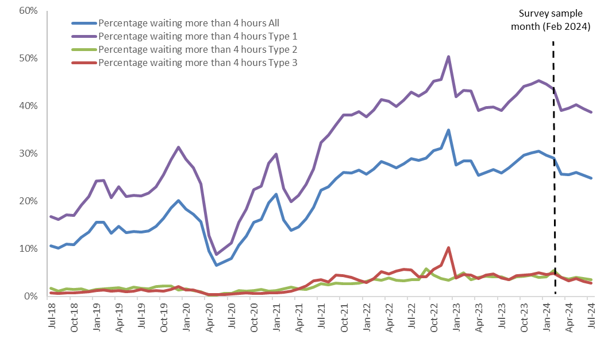

Source: NHS England

As highlighted in NHS England’s delivery plan for recovering urgent and emergency care services, waiting times in A&E are closely linked to bed occupancy rates in hospitals. Fuller hospitals mean that people needing to be admitted from emergency departments wait longer for a bed to become available.

In its delivery plan, NHS England committed to reducing waiting times by increasing hospital bed capacity, increasing ambulance capacity and improving processes and procedures. In an update on progress against the plan, the target of 5,000 additional core general and acute beds has been achieved. Maintaining the increased acute bed capacity is a priority within NHS England’s priorities and operational planning guidance for 2024/25. Figure 2 below shows emergency admissions via A&E (people admitted for inpatient care following a visit to A&E) dropped during the COVID-19 pandemic, but have since seen a general increase over time.

Figure 2: Monthly inpatient admissions from urgent and emergency care services in England (July 2018 to July 2024)

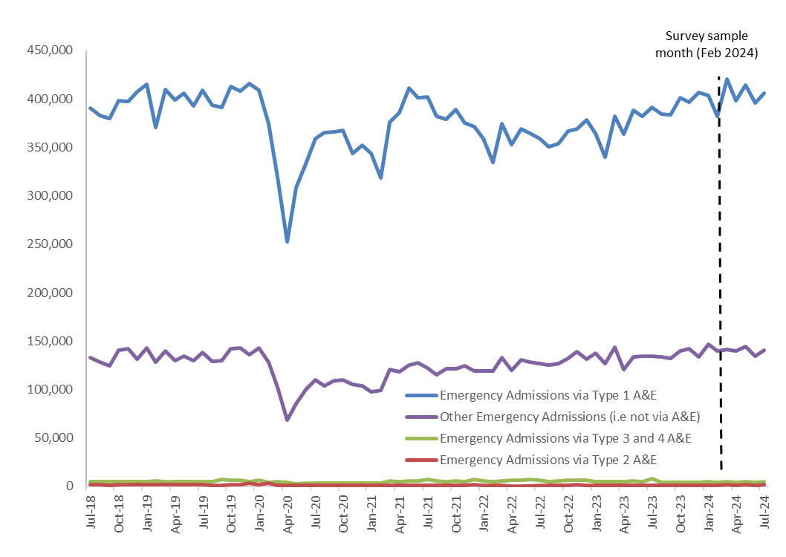

Source: NHS England

Delays to care and long waits to be admitted to hospital are associated with increased patient harm and excess death, even after leaving an emergency department.

Where waiting times deteriorate in one service, it is common for waiting times in other services to also deteriorate because of interdependencies between different parts of the health and care system. Patient flow through hospitals can be affected by the inability to move patients back into the community once they are ready to be discharged from inpatient services.

NHS England’s delivery plan for recovering urgent and emergency care services – progress update and next steps commits to continuing progress on increasing the availability of health or social care packages to help more people continue their recovery at home or in a community bed after being discharged from hospital.

Staffing levels
Urgent and emergency care services rely on the health and wellbeing of its staff to function well and provide good care to the public when they are in urgent need of help. While education and training has increased and the workforce has grown, the number of staff has not kept pace with demand for NHS services. To fill gaps in the service and ensure safe staffing levels, the NHS relies on temporary staffing and international recruitment.

In February 2024 (the sample month for the 2024 Urgent and Emergency Care Survey), NHS workforce statistics showed the number of consultants in emergency medicine in England increased by 5% since the previous year, with the total number of consultants at 2,521 (full time equivalent).

In early 2024, however, the Royal College of Emergency Medicine reported that the continued pressure on A&E departments has led to severe staff burnout and a retention crisis, threatening the safe delivery of emergency care. NHS Staff Survey 2023 results showed that 32% of medical and dental staff and 34% of nurses and midwives felt burnt out because of their work. In addition, only 32% of staff working for acute and acute & community trusts said there were enough staff at their organisation for them to do their job properly.

In 2023, NHS England published the NHS Long Term Workforce Plan, which models NHS workforce demand and supply over a 15-year period and the resulting shortfall. The plan provides a strategic direction for the long term, as well as action to be taken in the short to medium term to address current workforce challenges. The actions come under 3 priority areas:
- Train: the NHS will significantly increase education and training, including alternative routes into professional roles, resulting in more healthcare professionals working in the NHS.
- Retain: by improving culture, leadership and wellbeing, the NHS will ensure up to 130,000 fewer staff leave the organisation over the next 15 years.
- Reform: Productivity will be improved by ensuring staff have the right skills to use new technology that can free up clinicians’ time to provide the care patients need more effectively and efficiently.

NHS England will refresh the plan at least every 2 years, ensuring that the assessment of demand for staff remains up to date and consistent with the approach for wider operational planning.

Following on from the NHS Long Term Workforce Plan, in its 2024/25 priorities and operational planning guidance, NHS England acknowledged that to improve patient outcomes and experience an immediate priority must be to continue to improve staff experience and retention. The guidance sets out a national objective for 2024/25 to improve the working lives of all staff and increase staff retention through implementation of retention interventions.

Same day emergency care (SDEC)
The introduction of same day emergency care (SDEC) across England aims to support NHS England’s vision of providing the right care, in the right place, at the right time. SDEC allows specialists to assess, diagnose and treat patients on the same day of arrival into hospital without being admitted to a ward, therefore reducing waiting times and hospital admissions.

In 2024, NHS England published the SAMEDAY strategy to support the delivery of SDEC in a standardised and consistent way. The strategy has 7 priorities:
- being staffed safely, with a senior clinical-decision maker on duty during SDEC hours
- allowing direct referrals across the healthcare system
- accurately recording same day activity for consistent reporting across providers
- locating services to allow good patient flow into and out of service
- enabling direct and rapid access to diagnostics to support same day discharge
- discharging patients on the same day to their usual place of residence
- promoting the service through strong clinical and executive leadership.

The strategy promotes planning of SDEC across healthcare settings to improve patient flow between secondary, community and primary care, meaning patients can be discharged to their usual place of residence, community setting or virtual ward to get the care they need safely and conveniently without delay.

As part of the SDEC model, hospitals with a 24-hour A&E are required to provide an acute frailty service for at least 70 hours a week. The service aims to complete a clinical assessment of frail patients within 30 minutes of their arrival, identifying those who require hospital admission and those whose condition will better be managed in the community. This approach helps patients avoid unnecessary delays before their needs are identified.

NHS England’s progress update and next steps for the delivery plan for recovering urgent and emergency care services states that all hospitals with major A&Es now operate SDEC services, with 84% of them operating for over 84 hours a week. Next step actions included:
- all Type 1 providers to have an SDEC service in place for at least 12 hours a day, 7 days a week
- increasing the use of SDEC through partnerships working to increase the proportion of patients with direct access, or direct referrals from outside the emergency department (NHS 111, 999 and primary care)
- reducing the variation in the proportion of emergency department patients who are treated through the SDEC.

Health inequalities
As stated by NHS England, the enduring mission of the NHS is high quality care for all. That means tackling disparities in access to services, patient experience and healthcare outcomes. In the 2024/25 priorities and operational planning guidance, NHS England sets a national objective for 2024/25 to continue to address health inequalities and deliver on the Core20PLUS5 approach.

The Core20PLUS5 approach is designed to support integrated care systems to reduce healthcare inequalities. The approach defines a target population – the ‘Core20PLUS’ – and identifies ‘5’ focus clinical areas for improvement. The target population is the most deprived 20% of the national population, as identified by the Index of Multiple Deprivation (IMD), plus population groups identified at a local level. The 5 clinical areas of focus for improvement include maternity, severe mental illness, chronic respiratory disease, early cancer diagnosis and hypertension case-finding.

In March 2024, The King’s Fund highlighted how poverty makes it harder for people to access services and that services do not always reach those in poverty. A lack of access means people living in poverty get sicker and access services later, with A&E attendances nearly twice as high in the most deprived groups, and emergency admissions 68% higher. Furthermore, NHS systems and administration can be more challenging to navigate for more deprived patients, for example, the need to complete complex forms.

In April 2024, NHS Providers published a report on co-production and engagement with communities to assist in reducing health inequalities. Co-production can increase understanding of why particular groups face barriers in accessing healthcare services, helping trusts and providers to better understand and overcome inequalities.

Results from the survey
This section presents key results for the 2024 Urgent and Emergency Care Survey. The survey sampled people who used Type 1 services (A&E) and Type 3 services (urgent treatment centres) in February 2024 (and January 2024 for Type 3 services in smaller trusts).

The survey followed people’s journeys from decision to attend and waiting times, to treatment and discharge. Not all findings are reported in all cases, though the full results for all questions can be found in open data format on CQC’s website. Please note that 2 questionnaires were used, tailored to each service type. Some questions did not feature in both questionnaires and, for a small number of questions that did appear in both questionnaires, response options were different.

For the first time, participants of the 2024 survey were offered the choice of responding online or through paper-based questionnaires. This has provided an opportunity for us to re-develop the questionnaire in line with current policy and practice and enabling trusts to use the new questions for improvement. The sampling month also moved from September to February. As a result, the 2024 survey results are not comparable to previous years.

We report the results for Type 1 departments and Type 3 departments separately and do not directly compare them because Type 1 and Type 3 departments may be operated very differently. For example, Type 3 departments tend to have a different staff mix (they can be nurse or doctor/GP-led) and are usually not open 24 hours a day. Type 1 and Type 3 services also typically have a different patient case mix, with people attending a Type 3 department more likely to be less seriously unwell or injured.

Although we do not compare the results between service types, we note that, descriptively speaking, respondents who visited a Type 3 department were more positive than respondents who visited a Type 1 department on many aspects of their care.

All questionnaires in the NHS Patient Survey Programme are designed to reflect themes from the NHS Patient Experience Framework. The Framework identifies several elements that contribute to a person’s positive experience of NHS care:
- respect for patient-centred values, preferences and expressed needs, such as shared decision making and cultural needs
- welcoming the involvement of friends, family and those close to the patient
- emotional support
- access to care, with attention given to waiting times
- coordination and integration of care across the health and social care system.

Survey results are reported in the following sections:
- Reattendance at urgent and emergency care services
- Duration of visit
- Ambulance handovers
- Waiting for first assessment
- Care for condition while waiting
- Communicating about condition
- Involvement in care
- Communication support needs
- Emotional support
- Pain management
- Access to food and drinks
- Feeling safe
- Confidence and trust
- Tests
- Discharge, medications and information
- Pathways into urgent and emergency care
- Care and support after leaving the service
- Overall experience
- Subgroup analysis

Subgroup analysis
Within the results, we have included key results of subgroup analysis (where different groups of people consistently reported different experiences). The subgroups included 3 areas:
- Acuity of condition, attendance and care experiences
- Personal characteristics
- Pre-existing health conditions.

Complete findings from the subgroup analysis can be found in Appendix I, an external appendix published on both the NHS surveys website and Care Quality Commission’s (CQC) website.

Subgroups: Acuity of condition, attendance and care experiences
- Acuity of condition
- Reattendances: recent visit about the same condition
- Contacted another service before attending
- Duration of visit
- Time to initial assessment
- Attendance day of week
- Attendance time of day

Subgroups: Personal characteristics
- Age
- Sex
- Ethnicity
- Religion
- Gender different from sex assigned at birth
- Sexual orientation
- Index of Multiple Deprivation decile (IMD)

Subgroups: Pre-existing health conditions
- Long-term condition
- Frailty
- Disability

Section 1: Overall experience

Overall experience rating at A&E (Type 1)
Respondents were asked about their overall experience while in A&E, where a score of 0 represented a ‘very poor experience’ and a 10 a ‘very good experience’ (figure 4). Thirty-eight per cent chose a score of 9 or 10.

Figure 3: Overall, how was your experience while you were in A&E? (Q43)


Answered by all. Total number of respondents: 35,070.

Subgroups who reported a poorer overall A&E care experience (rated 0-8) included:
- respondents aged 16 to 50 or those with indicators of frailty or a disability
- patients who contacted another service before going to A&E, attended A&E between 21:00-00:59, waited more than 30 minutes for their initial assessment, or whose A&E visit lasted more than 4 hours
- those who had previously been to any A&E departments about the same condition within the previous week or between 1 week and 1 month earlier.

Overall, treated with respect and dignity at A&E (Type 1)
The NHS Constitution states that patients have the right to be treated with respect and dignity. This is also reflected in NICE Quality statement 1, which says that patients should be treated with empathy, dignity and respect, with these being fundamental to developing good relationships between patients and the staff treating them.

Seventy per cent of A&E respondents said they were treated with respect and dignity while at A&E (figure 4).

Figure 4: Overall, did you feel you were treated with respect and dignity while you were in A&E? (Q42)

Answered by all. Total number of respondents: 35,025.

Subgroups less likely to feel they were treated with respect and dignity while in A&E included:
- respondents aged 16 to 50 or those with indicators of frailty or a disability
- who attended A&E between 21:00-00:59, waited more than 30 minutes for their initial assessment or whose A&E visit lasted more than 4 hours
- who had contacted another service before their A&E visit or had previously been to any A&E departments about the same condition between 1 week and 1 month earlier.

Overall experience rating at urgent treatment centres (Type 3)
UTC respondents were asked to rate their overall experience of the care they received on a scale of 0 (very poor) to 10 (very good). Fifty-four per cent of respondents rated their care as a 9 or 10 (figure 5).

Figure 5: Overall, how was your experience while you were in the urgent treatment centre? (T40)

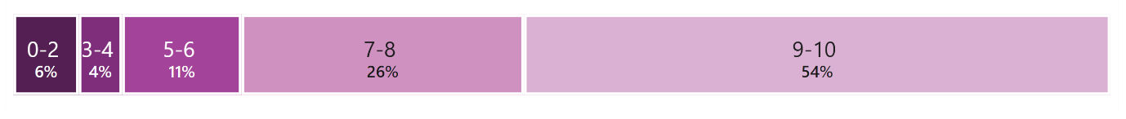
Answered by all. Total number of respondents: 10,084.

Subgroup analysis found that groups who reported poorer overall UTC care experience (rated 0-8) included:
- respondents aged 16 to 50
- those who contacted another service before going to the UTC, or who waited more than 30 minutes for their initial assessment, or whose visit lasted more than 4 hours.

Overall, treated with respect and dignity at urgent treatment centres (Type 3)

Most respondents from urgent treatment centres (UTCs) said they were treated with respect and dignity ‘all of the time’ (81%), while 15% said they were ‘some of the time’ (figure 6).
Figure 6: Overall, did you feel you were treated with respect and dignity while you were in the urgent treatment centre? (T39)
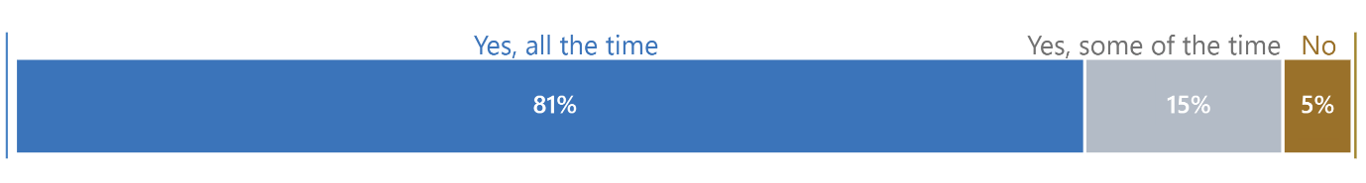Answered by all. Total number of respondents: 10,045
Those less likely to feel they were treated with respect and dignity while at the UTC included:
- respondents aged between 16 and 50
- those who contacted another service before going to the UTC, or who waited 31 minutes or more for their initial assessment, or whose UTC visit lasted more than 4 hours.

Section 2: Reattendance at urgent and emergency care services
NHS England monitors unplanned reattendance rates through the A&E quality indicators. Best practice guidance published by The Royal College of Emergency Medicine describes reattendance as the result of unmet health and care needs, with frequent attenders as potentially vulnerable and struggling to access other services. The guidance recommends that departments should be able to identify people who reattend several times, and that they should be treated with the same care and respect as other patients and may benefit from a bespoke care plan.

Reattendance at A&E departments (Type 1)
Figure 7 shows that 30% of respondents who attended a Type 1 department said that they had been to the same service previously for the same condition. Seven per cent had attended for the same reason within the previous week, 8% between one week and one month, and 14% more than 30 days prior.

Figure 7: Before your most recent visit to A&E, had you previously been to any A&E departments about the same condition? Yes, within the past [number of] days (Q8)
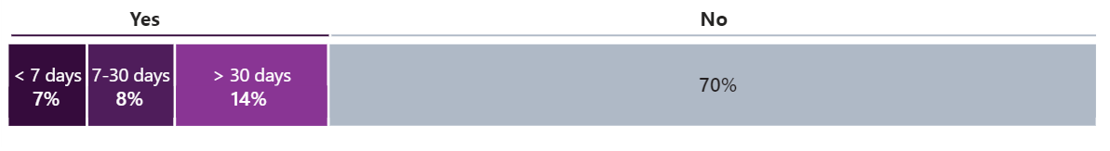

Answered by all. Respondents who stated that they didn't know or couldn't remember have been excluded. Total number of respondents: 34,075.

Of those that reattended, the most common reason was that their condition was not improving (53%) or they were advised to go back to A&E if they had concerns (31%) and 13% ‘did not get the help I needed on my last visit’ – figure 8.

Figure 8: What was your reason(s) for reattending A&E about the same condition? (Q9)
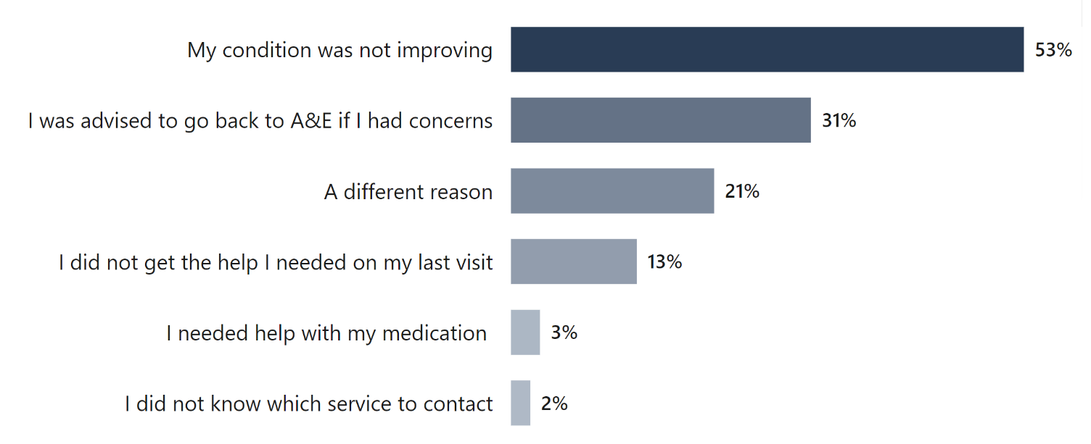
Answered by those who have previously been to any A&E department about the same condition before their most recent visit to A&E. Multiple response question: percentages may sum to more than 100. Total number of respondents: 10,146.
Patients who had been to an A&E up to 1 month prior to the current visit, reported worse than average experiences on communication with doctors and nurses: having enough time to discuss condition with doctors and nurses, doctors and nurses listening to them and feeling involved in decisions about their care and treatment. Confidence and trust in doctors and nurses, help with pain relief, and their overall rating of their care experience was worse than average for those who had been to an A&E within a month prior. Patients who had been to an A&E between 1 week and 1 month prior to the current visit, were also less likely to feel they were treated with respect.

Reattendance at urgent treatment centres (Type 3)
One in 5 (20%) respondents said that they had been to an urgent treatment centre (UTC) previously for the same condition. Five per cent said that they had been to a UTC service within the previous week, 6% between one week to one month earlier, and 9% more than 30 days earlier (figure 9).

Figure 9: Before your most recent visit to the urgent treatment centre, had you previously been to any urgent treatment centres about the same condition? (T5)
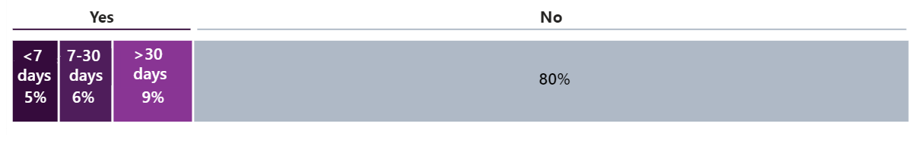
Answered by all. Respondents who stated that they didn't know or couldn't remember have been excluded. Total number of respondents: 9,732.

Section 3: Duration of visit
NHS England monitors waiting times at A&E and other urgent care services through 3 clinical quality indicators, 1 of which being the total time spent in the department. An objective in the 2024/25 NHS operational and planning guidance is for 78% of patients to be seen (admitted, transferred or discharged) within 4 hours by March 2025.

Duration of visit at A&E departments (Type 1)
Thirty-six per cent of respondents reported that their visit to A&E lasted up to 4 hours, and 64% reported that their visit lasted more than 4 hours; 29% were in A&E for 8 hours or more (figure 10).

Figure 10: Overall, how long did your visit to A&E last? (Q16)

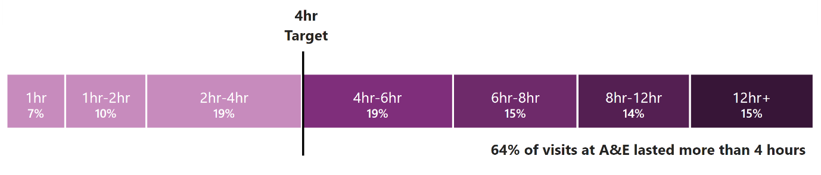
Answered by all. Respondents who stated that they couldn't remember have been excluded. Total number of respondents: 33,528.

Patient whose visit lasted over 4 hours reported worse than average experiences across all 20 questions included in the analysis. These included not having enough time to discuss their condition with doctors and nurses, doctors and nurses listening to them. See subgroup analysis here.

Duration of visit at urgent treatment centres (Type 3)
Eighty-two per cent said their visit to the urgent treatment centre lasted up to 4 hours, with 30% less than 1 hour; 18% said they were there for 4 hours or more (figure 11).

Figure 11: Overall, how long did your visit to the urgent treatment centre last? (T13)

Answered by all. Respondents who stated that they couldn't remember have been excluded. Total number of respondents: 9,752.

Those whose visit lasted more than 4 hours reported worse experiences on 16 out of 20 questions. Conversely, for these 16 questions, those who left the urgent treatment centre within 4 hours reported better than average experiences. All questions on communicating with doctors and nurses about their condition or treatment were worse than average for UTC patients whose visit lasted more than 4 hours. See subgroup analysis here.

Section 4: Ambulance handovers
The operating standards for ambulance handovers within the NHS Standard Contract are for 65% of handovers to occur within 15 minutes, 95% within 30 minutes and 100% within 60 minutes.

Ambulance handovers to A&E staff
Of the 27% of respondents who arrived at A&E by ambulance, 61% were handed over to A&E staff within 15 minutes (figure 12). All handovers should occur by 60 minutes; however, 17% of respondents reported waiting more than an hour.

Figure 12: Once you arrived at A&E, how long did you wait with the ambulance crew before your care was handed over to the A&E staff? (Q6)
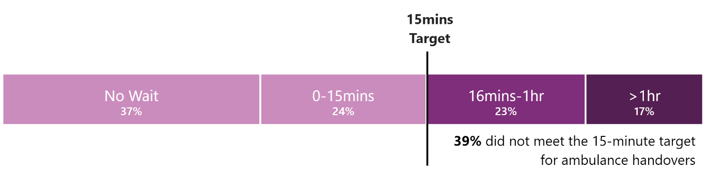
Answered by those who were taken to A&E in an ambulance. Respondents who stated that they didn't know or couldn't remember have been excluded. Total number of respondents: 8,550.

Ambulance waiting experience
Overall, 47% of respondents who had to wait in an ambulance were definitely told why they had to wait, while 27% were not. Of those who waited up to 15 minutes, 52% were ‘definitely’ informed. For those that had to wait for more than an hour, 43% were ‘definitely’ informed, 26% ‘to some extent’ and 31% were not informed at all.

Section 5: Waiting for first assessment (triage)
NHS England guidance for A&E departments states that an initial assessment should take place within 15 minutes of arrival. Time to initial assessment is also one of NHS England’s clinical quality indicators.

Waiting for first assessment (triage) at A&E (Type 1)
When asked how long they waited for their first assessment with a nurse or doctor, 29% of A&E respondents reported being seen within the 15 minutes to initial assessment. However, 49% waited for more than 30 minutes. Twenty-eight per cent were seen more than 60 minutes after arrival.

Figure 13: How long did you wait for your first assessment with a nurse or doctor? (Q11)
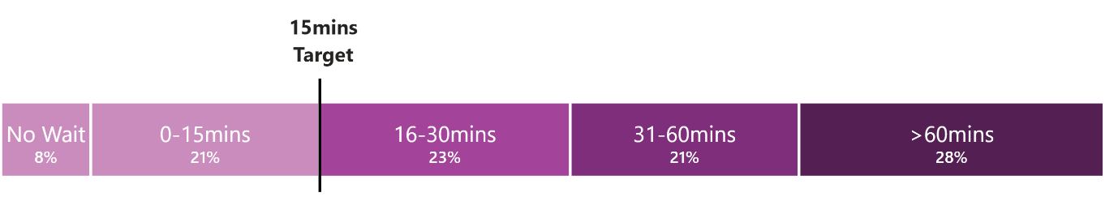
Answered by all. Respondents who stated that they did not have a first assessment, or they didn't know or couldn't remember have been excluded. Total number of respondents: 32,235.

Those who waited more than 60 minutes for initial assessment reported worse than average experiences on all 20 questions included in the analysis, while those who waited 31 to 60 minutes for initial assessment reported worse than average experiences on all questions except two: being given information on how to care for their condition at home and being told who to contact if they were worried about their condition or treatment after they left urgent and emergency care services.

In addition, respondents were asked whether they were informed how long they would have to wait to be examined or treated. Twenty-six per cent said they were informed how long they would have to wait to be examined or treated, whereas 74% were not. Respondents who reported longer attendance times at A&E were less likely to say they were informed on how long their wait would be (figure 14).

Figure 14: Duration of A&E visit (Q16) and whether you were informed how long you would have to wait to be examined or treated (Q13)
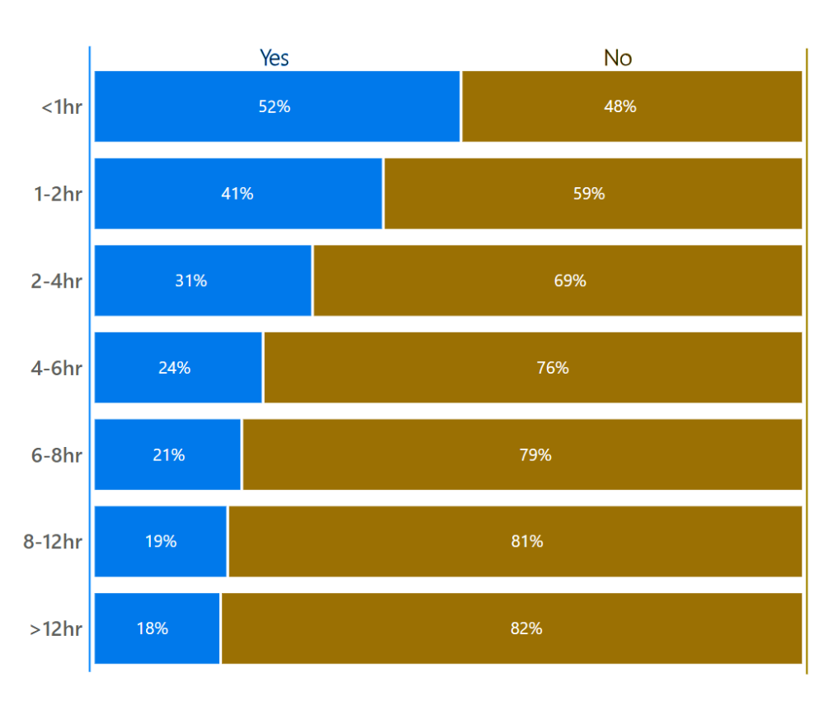
Answered by all. Respondents who stated that this was not necessary, or didn't know or couldn't remember have been excluded from q13. Respondents who stated that they couldn't remember have been excluded from q16. Total number of respondents: duration of visit up to 1 hour (1,574); 1-2 hours (2,536), 2-4 hours (5,462), 4-6 hours (5,564), 6-8 hours (4,614), 8-12 hours (4,232), more than 12 hours (4,362).
Subgroups who reported worse than average experiences of being told how long they would have to wait to be examined included:
- those who waited for more than 30 minutes for their initial assessment
- those whose visit lasted for more than 4 hours.

Waiting for initial assessment at urgent treatment centre (Type 3)
NHS England principles and standards for urgent treatment centres, states that patients who walk-in to an urgent treatment centre should have an initial assessment within 15 minutes of arrival. Following this assessment, they will be given an appointment slot, which will not be more than 2 hours after the time of arrival. Patients who have a pre-booked appointment should be seen and treated within 30 minutes of their appointment time. However, protocols should be in place to ensure that any more seriously ill or injured patients are seen sooner.

Just under 1 in 5 (19%) respondents said that they had an appointment on their most recent visit to the urgent treatment centre.

For those who walked into a UTC without an appointment, 34% were assessed within 15 minutes.

Figure 15: How long did you wait for your first assessment with a health professional? Patients without appointments (T8)

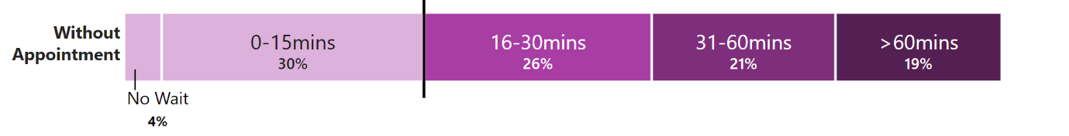
T8_no appointment - Respondents who stated they did not have an appointment at t6. Respondents who stated that they didn't know or couldn't remember have been excluded from t8. Respondents who did not have a first assessment have been excluded from t8. Total number of respondents: 7,318.

For those who had an appointment, 64% were assessed within 30 minutes. Nearly 1 in 5 (19%) respondents without an appointment said they waited more than 60 minutes to be assessed by a health professional, while 18% of those with an appointment said this.

Urgent treatment centre patients that did not wait or whose wait was less than 15 minutes for initial assessment reported better than average experiences on all 20 questions included in the analysis. Conversely, those who waited more 60 minutes reported worse than average experiences on all 20 questions.

UTC respondents were asked whether they were kept informed about how long they would have to wait to be examined and treated. For all UTC attendances, 39% were informed how long they would have to wait, whereas 61% were not. Not being informed increased with duration of visit.

Section 6: Care for condition(s) while waiting

Care for condition(s) while waiting in A&E (Type 1)
Sixty-four percent of respondents reported that they were in A&E for longer than 4 hours. Twenty-eight of respondents reported waiting longer than one hour to be assessed. To better understand people’s experiences of these waits, we asked if they got help with their condition or symptoms from a member of staff while they waited. Just over half (53%) of A&E respondents said they were able to get help, whereas 47% said they were not.

In addition, of those who needed help with medication for a pre-existing medical condition, nearly three-quarters (72%) of respondents were given help, while over a quarter (28%) were not given it.

Care for condition(s) while waiting in urgent treatment centre (Type 3)
Eighteen percent of respondents visits to an urgent treatment centre lasted more than 4 hours and 20% waited more than an hour for their initial assessment. Less than half (46%) said they were able to get help with their conditions or symptoms while they were waiting.

Just over a quarter (26%) of respondents who needed help to take medications for a pre-existing health condition were not provided with help.

Section 7: Communication about condition
The National Institute for Health and Care Excellence (NICE) quality statement for Patient experience in adult NHS services includes 2 statements describing how patients’ care and treatment should be tailored to their needs and preferences, and the importance of involving them in shared decision making. To enable people to make informed choices about their care, it is important that health and care professionals have effective communication skills.

Communicating about condition at A&E (Type 1)
A&E respondents were asked if they had enough time to discuss their condition with doctors and nurses, whether they listened to what they had to say, and whether they explained their condition and treatment in a way the respondent could understand.

Sixty-one per cent of respondents said they ‘definitely’ had enough time to discuss their condition with the doctor or nurse, while 29% said they did ‘to some extent’. Similarly, 69% of respondents felt they were ‘definitely’ listened to by doctors and nurses and a further 23% said to some extent. Sixty per cent of respondents felt that a doctor or nurse ‘completely’ explained their condition or treatment in a way that they would understand, with just over a quarter (28%) saying they did ‘to some extent’.

Figure 16: Communication about condition and treatment at A&E (Q17, Q18, Q19)

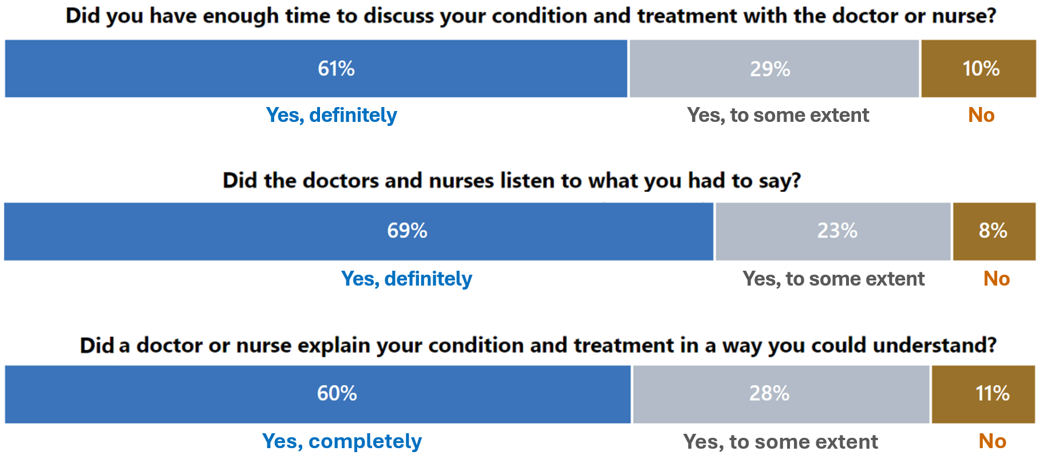

Q17 - Answered by all. Total number of respondents: 35,277.
Q18 - Answered by all. Respondents who did not need an explanation have been excluded. Total number of respondents: 33,734.
Q19: Answered by all. Total number of respondents: 35,216.

Analysis was carried out to look at the experiences of different subgroups with regard to having enough time to discuss conditions and treatments with a doctor or nurse. Subgroups who reported worse than average experiences included:
- those aged between 16 and 50, or those with indicators of frailty or a disability
- patients who attended A&E between 21:00-00:59, those who waited more than 30 minutes for their initial assessment, or whose A&E visit lasted more than 4 hours
- those who had previously been to any A&E departments about the same condition within the previous week or between one week and one month earlier.

Subgroups who reported poorer experiences for being listened to included:
- those aged between 16 and 50, or those with a disability, dementia or Alzheimer’s disease, or indicators of frailty
- patients who contacted another service before going to A&E, or attended between 21:00-00:59, or waited more than 30 minutes for their initial assessment, or whose A&E visit lasted more than 4 hours
- those who had previously been to any A&E departments about the same condition within the previous week or between one week and one month earlier.

Subgroups who reported poorer experiences of doctors and nurses explaining their condition in a way they could understand included:
- respondents aged between 16 and 50, those with indicators of frailty or a disability
- those who contacted another service before going to A&E, patients who waited more than 30 minutes for their initial assessment, or whose A&E visit lasted more than 4 hours.

Communicating about condition at urgent treatment centres (Type 3)
Urgent treatment centre (UTC) respondents were also asked questions about their experiences of communication about their condition.

When asked if they had enough time to discuss their condition with the health professional, 76% said ‘definitely’ and 19% ‘to some extent’. Four out of 5 (80%) respondents felt the health professional ‘definitely’ listened to them. A further 15% felt so only ‘to some extent’. Just under three-quarters (73%) of respondents felt a health professional ‘completely’ explained their condition or treatment in a way they could understand, whereas 7% felt they did not.

Figure 17: Communicating about your condition and treatment at a UTC (T14, T15, T16)

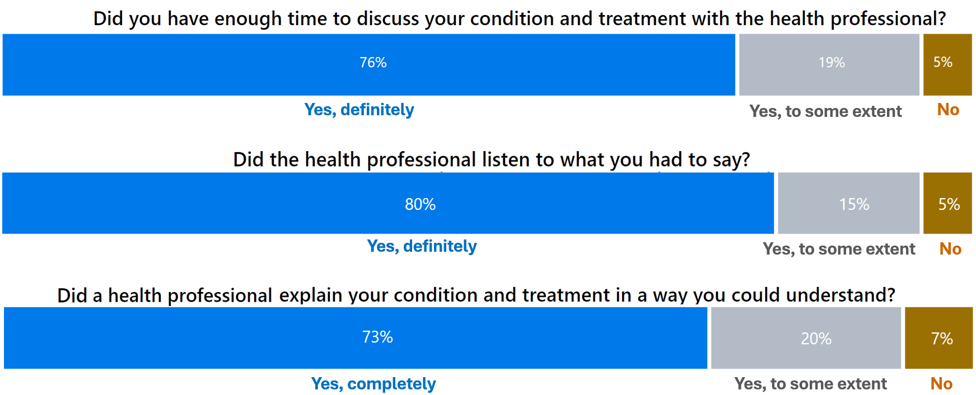

T14 - Answered by all. Total number of respondents: 10,116.
T15 - Answered by all. Respondents who did not need an explanation have been excluded. Total number of respondents: 9,700.
T16 – Answered by all. Total number of respondents: 10,129.

Subgroups reported worse than average experiences on having enough time to discuss their condition and treatment with a heath professional included:
- those aged between 16 and 50, or who have a disability
- patients who attended the urgent treatment centre between 21:00-00:59, those who waited more than 30 minutes for their initial assessment, or whose UTC visit lasted more than 4 hours.

Subgroups who reported poorer experiences for being listened to included:
- those aged between 16 and 35
- those who contacted another service before going to the UTC, who waited more than 30 minutes for their initial assessment, or whose visit lasted more than 4 hours.

Subgroups who reported poorer experiences of health professionals explaining their condition in a way they could understand included:
- they were aged between 16 and 35
- they had contacted another service before going to the UTC, waited more than 60 minutes for their initial assessment, or their visit lasted more than 4 hours.

Section 8: Involvement in care
NICE guidance describes how shared decision making should be part of everyday care, with a joint process empowering people to make decisions about the care that is right for them. NHS Patient Experience Framework has also identified the involvement of friends, family and those close to the patient as contributing to a person’s positive experience of NHS care.

Involvement in care at A&E (Type 1)
As shown in figure 18, 58% of respondents said they were ‘definitely’ involved as much as they wanted to be in decisions about their care and treatment, and 29% were ‘to some extent’, whereas 13% said they were not involved.

Figure 18: Were you involved as much as you wanted to be in decisions about your care and treatment? (Q27)
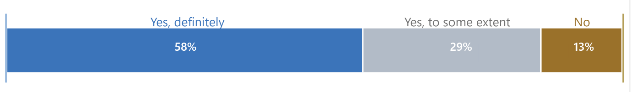Answered by all. Respondents who were not well enough to be involved in decisions about their care have been excluded. Total number of respondents: 33,206.

Subgroups reporting worse than average experiences of involvement in decisions about their care and treatment included:
- those aged between 16 and 50, and those with a disability or indicators of frailty
- patients who had contacted another service before attending A&E, who waited more than 30 minutes for their initial assessment, or whose A&E visit lasted more than 4 hours
- those who had previously been to any A&E departments about the same condition within the previous week or between one week and one month earlier.

While over half (54%) of family, friends and carers ‘definitely’ had enough opportunities to talk to a doctor or nurse, 19% did not.

Involvement in care at urgent treatment centres (Type 3)
For urgent treatment centres (UTC), 71% of respondents said they were ‘definitely’ involved in decisions, with a further 20% saying ‘to some extent’ (figure 19).

Figure 19: Were you involved as much as you wanted to be in decisions about your care and treatment? (T24)
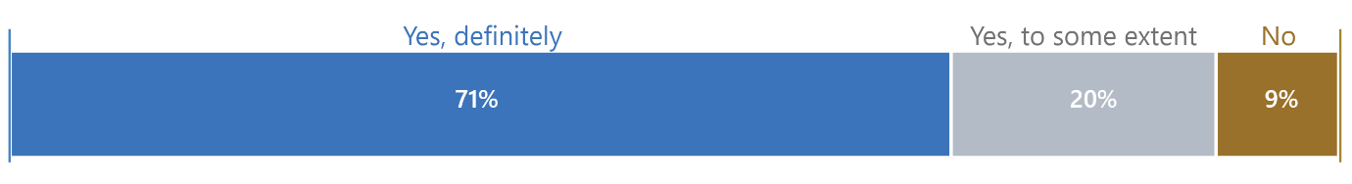Answered by all. Respondents who did not want to be involved in decisions about their care have been excluded. Total number of respondents: 9,599.

Subgroups reporting worse experiences on involvement in decisions about their care and treatment included:
- aged between 16 and 35
- who had waited more than 30 minutes for their initial assessment, or their visit lasted more than 4 hours.

UTC respondents were asked if their family, friends or carers wanted to talk to a health professional, were they given enough opportunity to do so. While two-thirds (66%) felt they had been, 15% did not (figure 20).

Figure 20: If a family member, friend or carer wanted to talk to a health professional, did they have enough opportunity to do so? (T19)

Answered by all. Respondents who stated that the question was not applicable have been excluded. Total number of respondents: 4,546.

Subgroups reporting worse experiences on family, friend or carer having an opportunity to talk to health professionals included:
- those with a mental health condition
- those who had contacted another service before going to the UTC, waited more than 60 minutes for their initial assessment, or whose UTC visit lasted more than 4 hours.

Section 9: Communication support needs
The Accessible Information Standard is a legal requirement for all NHS organisations to meet the communication support needs of all patients, people using services, carers and parents with a disability, impairment or sensory loss.

Respondents were asked if they have any communication needs, including language needs related to translation support, a disability, sensory loss or impairment.

Communication support needs at A&E (Type 1)
Most respondents said that they did not have communication needs (89%); however, 11% said they needed communication support (figure 21).

Figure 21: Do you have any communication needs? (Q23)
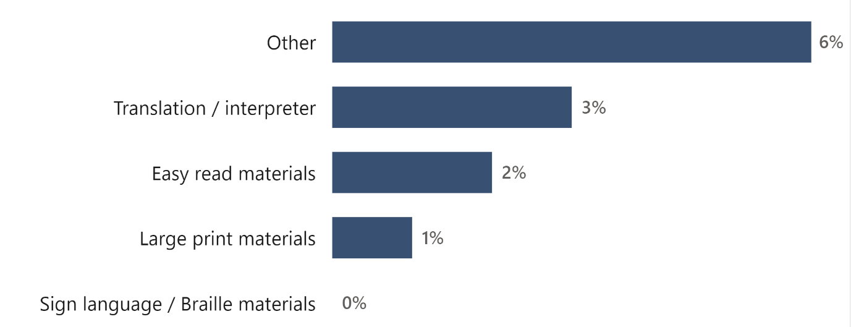Answered by all. Multiple response question: percentages may sum to more than 100. Total number of respondents: 34,717.

Of A&E respondents who had communication support needs, 44% said staff ‘definitely’ helped, however, more than a quarter (27%) said they were not helped.

Communication support needs at urgent treatment centres (Type 3)
Respondents were asked if they have any communication needs, including language needs related to translation support, a disability, sensory loss or impairment. Eight per cent said they had communication support needs, while 92% said they did not. Three per cent needed support with translation or an interpreter, 2% easy read materials, 1% large print materials and 3% had another communication support need.

Section 10: Emotional support
The emotional needs of a patient should be considered alongside their physical needs. NICE Quality statement 4 recommends patients are regularly asked if they need extra support with issues such as anxiety. The associated NICE guidance states that staff should “…listen to and discuss any fears or concerns the patient has in a non-judgemental and sensitive manner”.

Emotional support at A&E (Type 1)
Patients who had anxieties and fears were asked whether a doctor or nurse discussed these with them. While 45% said they did, 30% said only ‘to some extent’ and a quarter said they were not discussed at all (25%).

[insert subgroup results

Emotional support at urgent treatment centres (Type 3)
More than half of urgent treatment centre (UTC) respondents felt the health professional ‘completely’ discussed their anxieties and fears about their condition and treatment (57%) and 24% said they were discussed ‘to some extent’. However, nearly 1 in 5 (19%) said that they were not discussed.

Section 11: Pain management
According to The Royal College of Emergency Medicine pain management is a core component of care and that ‘recognition and alleviation of pain should be a priority when treating the ill and injured’. This process should be started at triage or initial assessment, be monitored throughout the patients’ time in the department, and appropriate pain relief provided at discharge if needed. NICE Quality Statement 4 also says that staff should regularly check if patients need any extra support with issues including pain relief.

Pain management while in A&E (Type 1)
When asked about pain management, only 42% of A&E respondents said staff ‘definitely’ helped control their pain, while over a quarter (27%) of respondents said they did not.

Subgroups reporting worse experiences for hospital staff helping them control their pain included:
- respondents aged 16 to 50
- those who are frail or disabled
- those whose time to initial assessment was more than 30 minutes, or duration of visit was over 4 hours
- those that attended within the previous week, as well as those who reattended between 1 week and 1 month earlier.

Pain management while in urgent treatment centres (Type 3)
For urgent treatment centres (UTC), just 47% said staff ‘definitely’ did everything they could to control their pain, while 26% said they did not.

Subgroups reporting worse experiences of hospital staff helping them to control their pain included:
- respondents aged 16 to 35 or those with a disability
- those who contacted another service before going to the UTC, those who waited more than 30 minutes for their initial assessment, or whose UTC visit lasted more than 4 hours.

Section 12: Access to food and drinks
NICE guidance on patient experience in adult NHS services describes nutrition as an essential requirement of good care. While the guidance notes that attention to such fundamental needs applies particularly to inpatient settings, they should also be addressed in other settings where healthcare is provided.

CQC’s inspection framework for urgent and emergency care services includes guidance that arrangements should be in place in terms of food and drink for patients (and accompanying friends and family) who are in the urgent and emergency care department for any length of time, and that healthy food and drink options should be available.

Access to food and drinks in A&E (Type 1)
Of those people who wanted something to eat or drink, only 44% of respondents who attended A&E said that they were ‘always’ able to get food or drinks, while just over a quarter (26%) said they were not able to.

Access to food and drinks in urgent treatment centres (Type 3)
For urgent treatment centre respondents, 47% said that they were ‘always’ able to get food or drinks, while a third (33%) said they were not.

Section 13: Feeling safe
Ensuring patients feel safe in waiting areas, particularly during busy periods, is a vital area of patient experience at a time when the patient may be already anxious and nervous about their health.

Feeling safe around other patients or visitors (Type 1)
For respondents who attended A&E, 61% said they ‘always’ felt safe around other patients or visitors, while 11% said ‘no’.

Subgroups who reported poorer experiences on feeling safe around other patients or visitors in A&E included:
- female respondents and those who are frail or disabled
- who attended between 17:00 and 00:59, who waited more than 30 minutes for their initial assessment, or whose visit lasted more than 4 hours.

Feeling safe around other patients or visitors (Type 3)
More than three-quarters (77%) of patients who visited urgent treatment centres said they ‘always’ felt safe around other patients or visitors, while 5% said ‘no’.

Subgroups who were more likely to say they did not feel safe around other patients or visitors in the UTC included:
- female respondents
- those who waited 31 minutes or more for their initial assessment, or whose UTC visit lasted more than 4 hours

Section 14: Confidence and trust

Confidence and trust in doctors/nurses at A&E (Type 1)
When asked if they had confidence and trust in the doctors and nurses examining and treating them, just two-thirds (67%) of A&E respondents said they ‘definitely’ did and around a quarter (24%) said ‘to some extent’ (figure 22). Ten per cent said they did not have confidence and trust in the doctors and nurses treating them.

Figure 22: Did you have confidence and trust in the A&E doctors and nurses examining and treating you? (Q21)
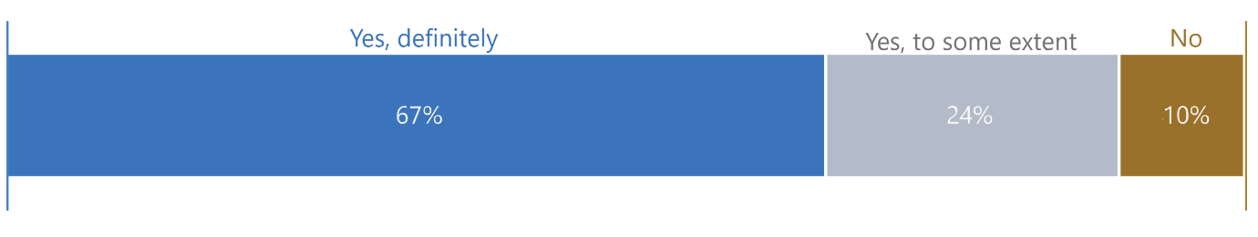Answered by all. Total number of respondents: 35,195

Subgroups who reported worse experiences for having confidence and trust in doctors and nurses examining and treating them included:
- respondents aged 16 to 50
- those with a disability or indicators of frailty
- those who waited more than 30 minutes for their initial assessment, or whose A&E visit lasted more than 4 hours
- those who had previously been to any A&E departments about the same condition within the previous week or between 1 week and 1 month earlier.

Confidence and trust in health professionals at urgent treatment centres (Type 3)
People who attended an urgent treatment centre were also asked if they had confidence and trust in the health professional examining and treating them. Three-quarters (75%) said they ‘definitely’ did (figure 23).

Figure 23: Did you have confidence and trust in the health professional examining and treating you? (T18)

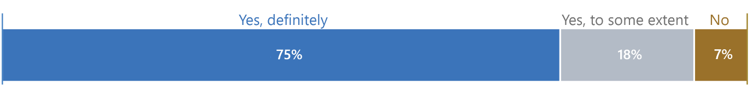Answered by all. Total number of respondents: 10,109.

Subgroups reporting worse experiences for having confidence and trust in the health professionals examining and treating them included:
- respondents aged 16 to 50
- those who contacted another service before going to the UTC, those who waited more than 30 minutes for their initial assessment, or whose UTC visit lasted more than 4 hours.

Section 15: Tests
Providing people with information about any tests they may need will help them to be fully involved in decisions about their care and treatment. The NHS Constitution says that people have the right to be given information about the test and treatment options available to them, what they involve and their risks and benefits. NICE Quality statement 6 says that patients should be supported by healthcare professionals to make informed choices about investigations, treatment and care that reflect what is important to them.

Tests at A&E (Type 1)
As shown in figure 24 below, two-thirds (66%) of respondents said staff ‘completely’ explained why they needed tests, whereas 10% said they were not. Before leaving A&E, 60% of respondents said staff ‘definitely’ explained the results of the tests in a way they could understand, while 14% said this did not happen.

Figure 24: Did A&E staff explain why tests were needed (Q28) and explain the results of tests (Q29) in a way that patients could understand

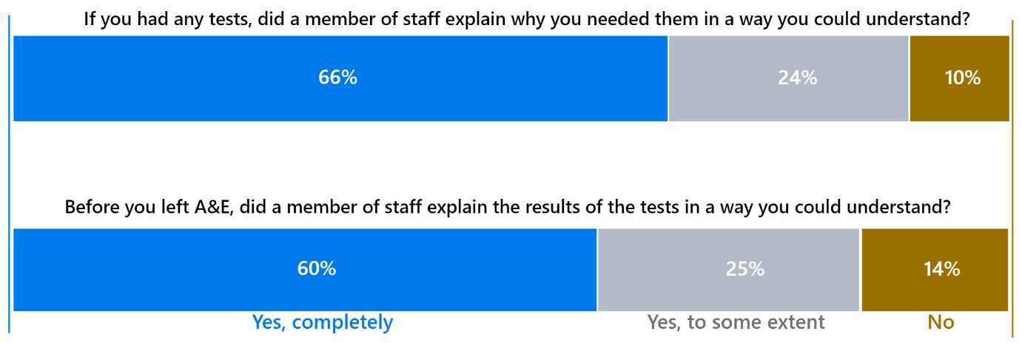
Q28 - Answered by all. Respondents who did not have any tests have been excluded. Total number of respondents: 29,541.
Q29 - Answered by those who had tests. Respondents who stated that they were given the results after they left A&E or were not sure or couldn't remember have been excluded. Total number of respondents: 26,557.

Subgroups who reported worse experiences for staff explaining why tests were needed included:
- respondents aged 16-50, those with a disability or indicators of frailty
- respondents who waited more than 30 minutes for their initial assessment, or whose A&E visit lasted more than 4 hours
- those who had previously been to any A&E departments about the same condition between 1 week and 1 month earlier.

Tests at urgent treatment centres (Type 3)
For respondents who had a test at an urgent treatment centre (UTC), just over three-quarters (76%) said that a member of staff ‘completely’ explained why they needed the tests in a way they could understand (figure 25). When asked if a member of staff explained the results of these tests in a way they could understand, 72% said that they ‘definitely’ did, with 1 in 10 (10%) saying they did not.

Figure 25: Did urgent treatment centre staff explain why tests were needed (T25) and explain the results of tests (T26) in a way that patients could understand

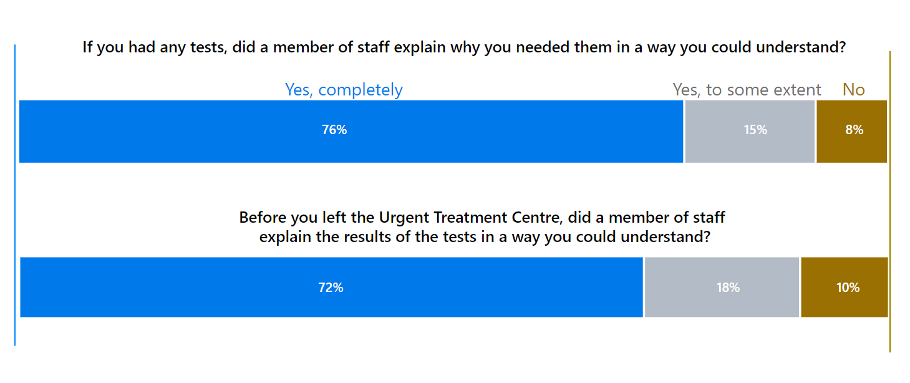T25 - Answered by all. Respondents who did not have any tests have been excluded. Total number of respondents: 5,682.
T26 - Answered by those who had tests. Respondents who stated that they were given the results after they left the urgent treatment centre or were not sure or couldn't remember have been excluded. Total number of respondents: 5,201.

Subgroups reporting worse experiences on staff explaining why tests were needed included those who:
- waited more than 60 minutes for their initial assessment, had a UTC visit that lasted more than 4 hours
- who contacted another UTC service or previously.

Section 16: Discharge, medications and information
NICE Quality statement 6 highlights the importance of giving people information to empower them to look after themselves at home. This can improve patient experience and reduce repeat attendances. Best practice guidance from the Royal College of Emergency Medicine also notes the importance of providing bespoke written and verbal advice on discharge.

To help ensure that people take their medication correctly, NICE guidance on medicines adherence emphasises the importance of including people in the decision-making processes through effective communication and providing information. It also states that people should be given information about taking medication and side effects.

A&E: discharge, medications and information (Type 1)
A&E: Discharge
Results for people who visited an A&E department show that nearly three-quarters (73%) were discharged at the end of their visit, rather than being admitted to hospital.

The following questions on medications and caring for their condition at home were only asked of those who were discharged and sent home after their A&E visit.

A&E: Medication
More than a third (35%) of respondents who attended a Type 1 department said that they were prescribed new medication.

As shown in figure 26, 25% of those who were prescribed new medication were not given information on the purpose of the medication. Nine per cent were given medication but no information.

Figure 26: Thinking about any new medication you were to take at home, were you given any of the following …? (Q35)

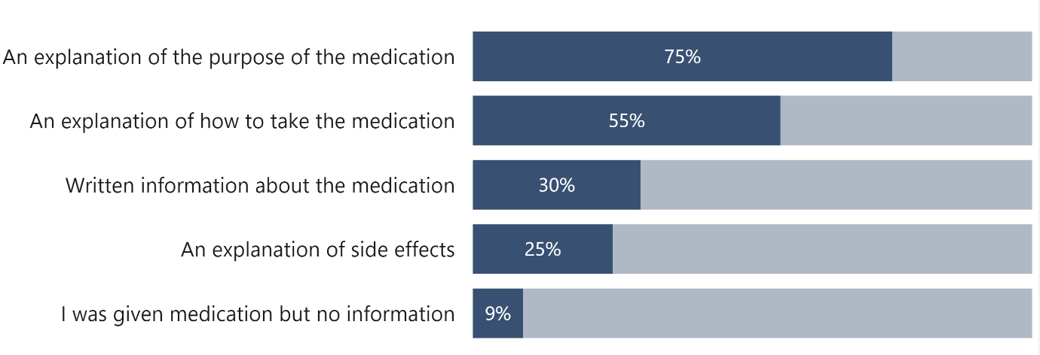
Answered by those who were discharged and sent home, or to their place of residence at the end of their visit to A&E and who were prescribed any new medications before they left A&E. Multiple response question: percentages may sum to more than 100. Total number of respondents: 9,025.

A&E: Providing information on caring for a condition at home
A&E respondents were asked whether they were provided information on how to care for their condition at home, how well they understood the information and how able they felt they could care for their condition.

When asked if hospital staff gave them information on how to care for their condition at home, two-thirds said they were given information (67%), a third said they were not (33%). Of those who were given information, 70% said they understood it ‘very well’ and 27% said ‘fairly well’ (figure 27). Only 3% said they didn’t understand it very well or not at all.

Figure 27: To what extent did you understand the information you were given on how to care for your condition at home? (Q37) 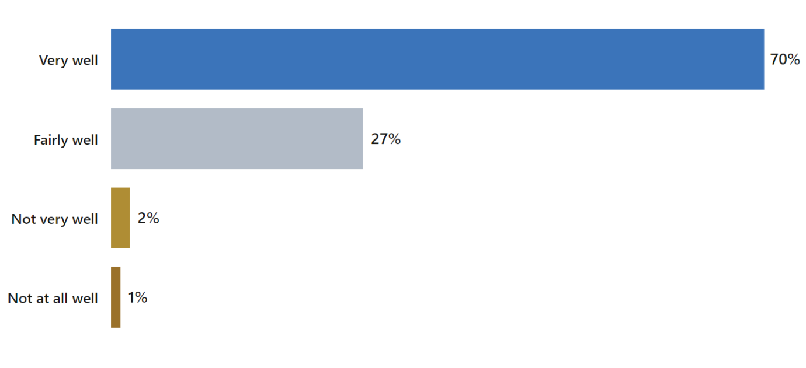
Answered by those who were discharged and sent home or to their place of residence at the end of their visit to A&E and given information on how to care for their condition at home. Respondents who stated that they didn't know or couldn't remember have been excluded. Total number of respondents: 15,986.
Subgroups reporting worse experiences of hospital staff providing information about care for their condition at home before leaving A&E included:
- respondents with a disability
- those who contacted another service before going to A&E, who waited more than 60 minutes for their initial assessment, or whose A&E visit lasted more than 4 hours.

Similarly, of those who were given information, 70% said they ‘definitely’ felt able to care for their condition at home, 27% said ‘to some extent, and 3% said they did not.

Urgent treatment centres: discharge, medications and information (Type 3)
Urgent treatment centre: discharge
Urgent treatment centre (UTC) respondents were asked what happened at the end of their visit. An overwhelming majority (88%) were discharged home

Those respondents were subsequently asked about their experiences with prescribed medications, monitoring symptoms and where to seek help after discharge.
Urgent treatment centres: medication
Of those who were sent home at the end of their visit, 37% said that they were prescribed new medication. Of those who were prescribed medication, three-quarters (75%) said that the purpose of the medication was explained to them, while 7% were not given any information at all.

Figure 28: Thinking about any new medication you were to take at home, were you given any of the following? (T32)
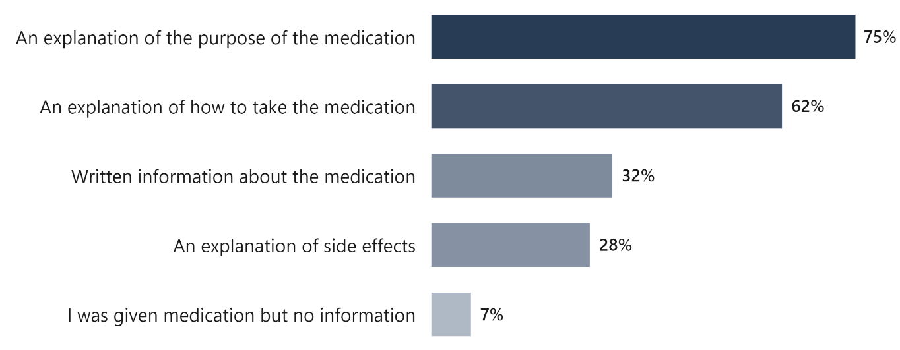
Answered by those who were discharged and sent home or to their place of residence at the end of their visit to the urgent treatment centre, and who were prescribed any new medications before they left the urgent treatment centre. Respondents who stated that they didn't know or couldn't remember have been excluded. Multiple response question: percentages may sum to more than 100. Total number of respondents: 2,869.

Urgent treatment centres: providing information on caring for a condition at home
Respondents were also asked whether they were given information on how to care for their condition at home, how well they understood the information and how able they felt they could care for their condition.
More than 4 in 5 (82%) were provided information on caring for their condition at home, while nearly 1 in 5 (18%) were not (figure 29).

Figure 29: Before you left the urgent treatment centre, did health professionals give you information on how to care for your condition at home? (T33)
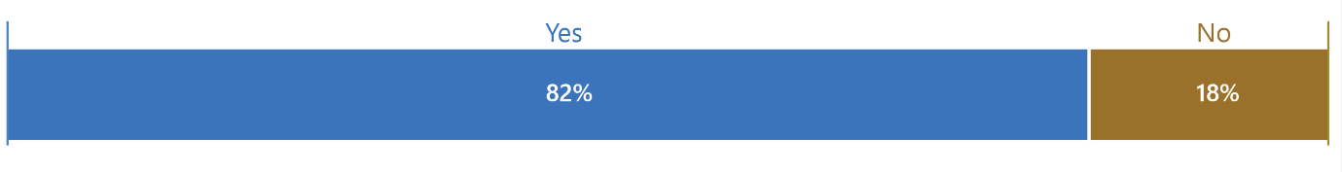Answered by those who were discharged and sent home or to their place of residence at the end of their visit to the urgent treatment centre. Respondents who stated that they didn't know or couldn't remember have been excluded. Total number of respondents: 8,416.

Respondents who were more likely to say that hospital staff did not give them information on how to care for their condition at home before they left the UTC included:
- those who contacted another service before going to the UTC, or who waited more than 60 for their initial assessment, or whose UTC visit lasted more than 4 hours.

Over three-quarters of UTC respondents (77%) understood information on how to care for their condition at home ‘very well’, 21% ‘fairly well’, whereas only 2% said ‘not very well’ (figure 30 below).

Figure 30: To what extent did you understand the information you were given on how to care for your condition at home? (T34)

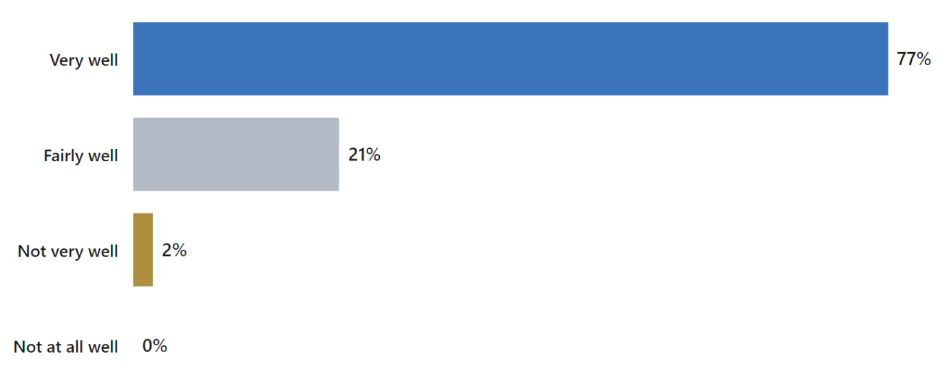
Answered by those who were discharged and sent home, or to their place of residence at the end of their visit to the urgent treatment centre and given information on how to care for their condition at home. Respondents who stated that they didn't know or couldn't remember have been excluded. Total number of respondents: 7,031.

Over three-quarters of respondents ‘definitely’ felt they were able to care for their condition at home from the information health professionals provided (figure 31). A further 20% felt able ‘to some extent’ and only 3% did not feel able to care for their condition.

Figure 31: From the information you were given by health professionals, did you feel able to care for your condition at home? (T35)
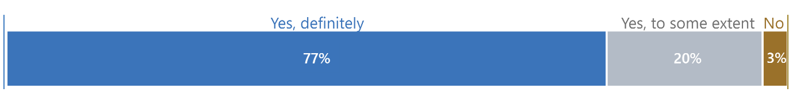
Answered by those who were discharged and sent home, or to their place of residence at the end of their visit to the urgent treatment centre and given information on how to care for their condition at home. Total number of respondents: 7,074.

Section 17: Pathways into urgent and emergency care services
Since publication of the NHS Long Term Plan, there has been a focus on reforming urgent and emergency care to help patients get the care they need, when they need it. This includes receiving care from the most appropriate service, which in turn helps to relieve pressure on A&E departments. In its delivery plan for the recovery of urgent and emergency services, NHS England describes NHS 111 services as critical in ensuring patients have access to appropriate advice and are directed to the service that will best be able to meet their needs.xvii

To help understand how and why patients access urgent and emergency care services, the survey included questions on whether people contacted other services for help with their condition before attending A&E or urgent treatment centres. Respondents were also asked why they attended the urgent and emergency care service.

Pathways into accident and emergency care (Type 1)
Two thirds (66%) of A&E respondents said they contacted another service before attending A&E, while a third (34%) of respondents went directly to A&E (figure 32).

Figure 32: Before attending A&E, did you go to or contact any other service for help with your condition? (Q1)



Answered by all. Total number of respondents: 35,091.

Of those who went to A&E first, 16% said ‘my condition was life threatening’ (figure 33). One in 5 said they did not think their GP would be able to help (20%) and 26% wanted to be seen on the same day. Ease of access to the A&E department (9%) and not knowing where else to go (9%) were also factors influencing their decision to go directly to A&E for help with their condition.

Figure 33: What was your reason(s) for attending A&E first for help with your condition? (Q2)
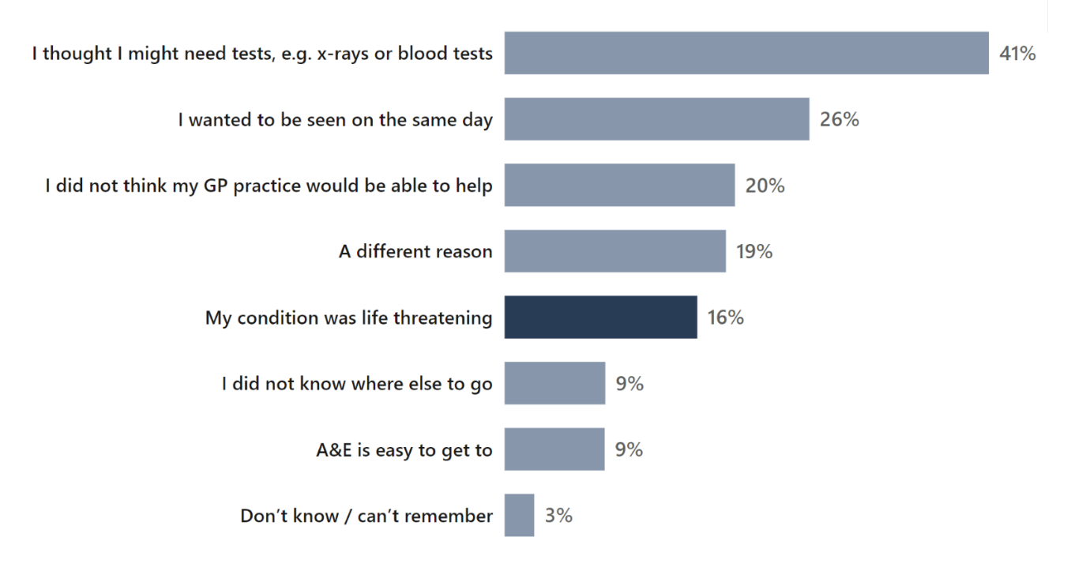
Answered by those who did not go to or contact any other service for help with their condition before attending A&E. Multiple response question: percentages may sum to more than 100. Total number of respondents: 12,057.

Patients who contacted another service before attending A&E reported worse than average experiences across nearly all questions concerning communication with doctors or nurses. These included doctors and nurses listening, condition or treatment clearly explained, any anxieties and fears discussed and being involved in decisions about care and treatment. They were less likely to feel they were treated with respect and dignity and rated their overall experience worse than average.

Respondents who had contacted another service first before going to A&E were most likely to say they contacted NHS 111 (telephone service 40%, online service 6%), followed by their GP practice (36%) or 999 emergency service (22%, figure 34).

Figure 34: Before going to this A&E department, where did you go to, or contact, for help with your condition? (Q3)

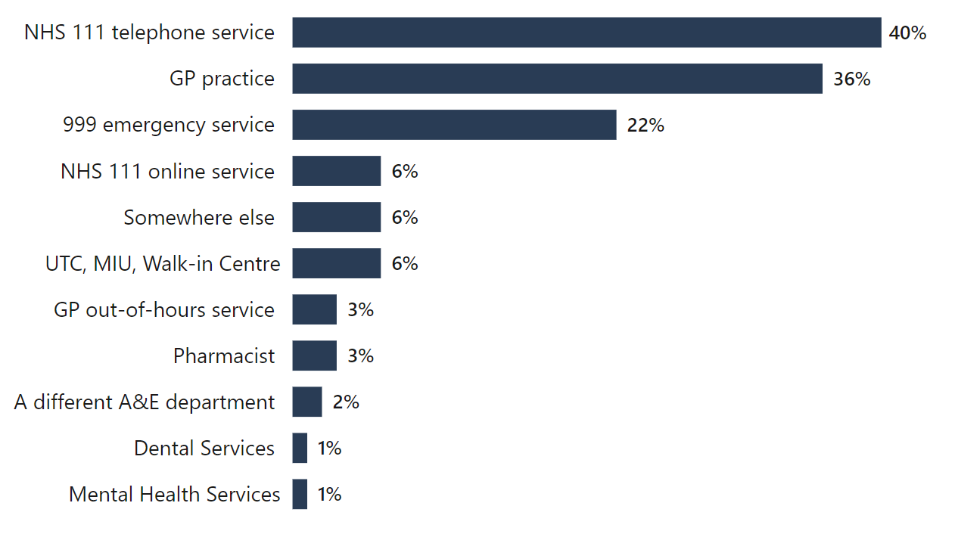
Answered by those who did go to or contact another service for help with their condition before attending A&E. Multiple response question: percentages may sum to more than 100. Total number of respondents: 23,150.

Of those respondents who contacted another service before attending A&E, 68% reported the main reason they attended A&E was that the service took them or told them to go to A&E (figure 35). The second most common reason was that their condition became worse (20%).

Figure 35: What was the MAIN reason for going to A&E following your contact with these service(s)? (Q4)
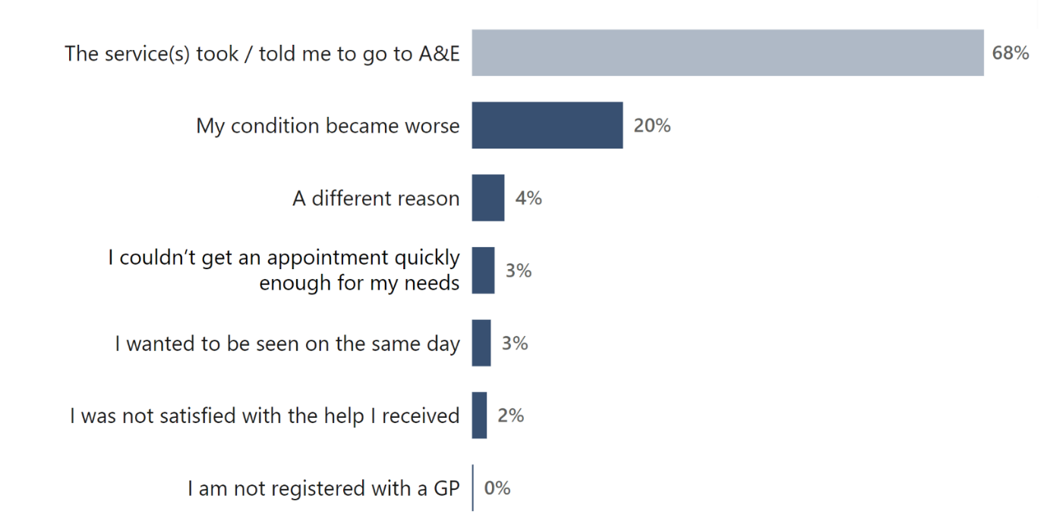
Answered by those who did go to or contact another service for help with their condition before attending A&E. Total number of respondents: 22,742.

Pathways into urgent treatment centres (Type 3)
Respondents were asked whether they attended the urgent treatment centre (UTC) first or contacted another service beforehand. Half (50%) of respondents who used a UTC said it was the first service that they went to or contacted for help, and half reported contacting another service first.

Patients at urgent treatment centres who contacted another service before attending reported worse experiences with most questions on communication with health professionals, including those concerning their condition and treatment, discussing anxieties and fears, and being given information on caring for condition at home. Their overall experience rating, being treated with respect and dignity and confidence and trust in health professionals was also worse than average. Those who did not contact another service before attending an urgent treatment centre, reported better than average experiences for the same questions.

Of respondents who went to a UTC first, 51% went because their condition was urgent and 16% reported they didn’t want to go to A&E (figure 36). Twenty-one per cent thought their GP practice would not be able to help and 34% wanted to be seen on the same day. Also, 20% reported that the UTC is easy to get to and 7% did not know where else to go.

Figure 36: What was your reason(s) for attending this urgent treatment centre first for help with your condition? (T2)
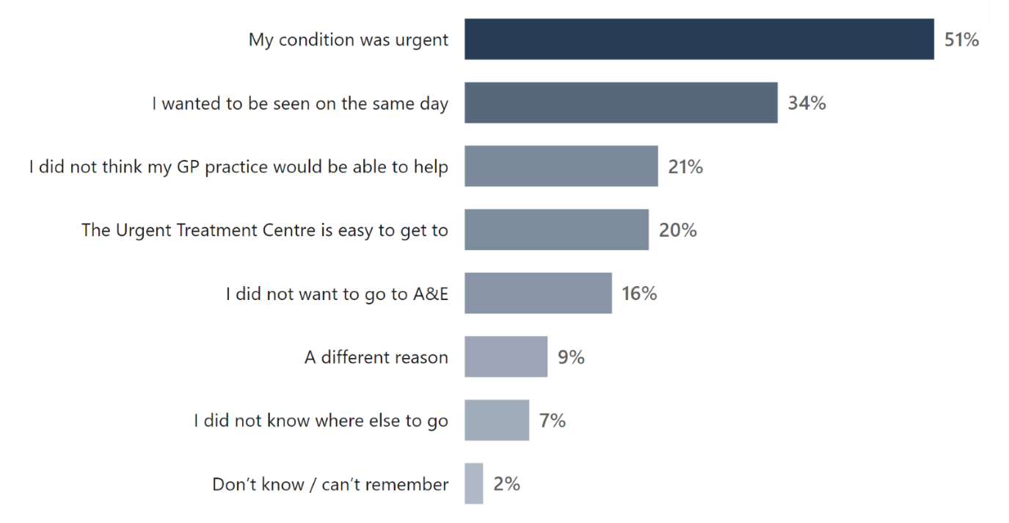

Answered by those who did not go to or contact any other service for help with their condition before attending the urgent treatment centre. Multiple response question: percentages may sum to more than 100. Total number of respondents: 5,212.

As shown in figure 37 below, respondents who had contacted another service first before going to the UTC were most likely to say they contacted a GP practice (48%), followed by NHS 111 (telephone service 37%; online service 8%), a pharmacist (9%), or another urgent treatment centre/urgent care centre/minor injuries unit service (8%). Five per cent contacted 999 before attending the UTC.

Figure 37: Before attending this urgent treatment centre, did you go to or contact any other service for help with your condition? (T3)
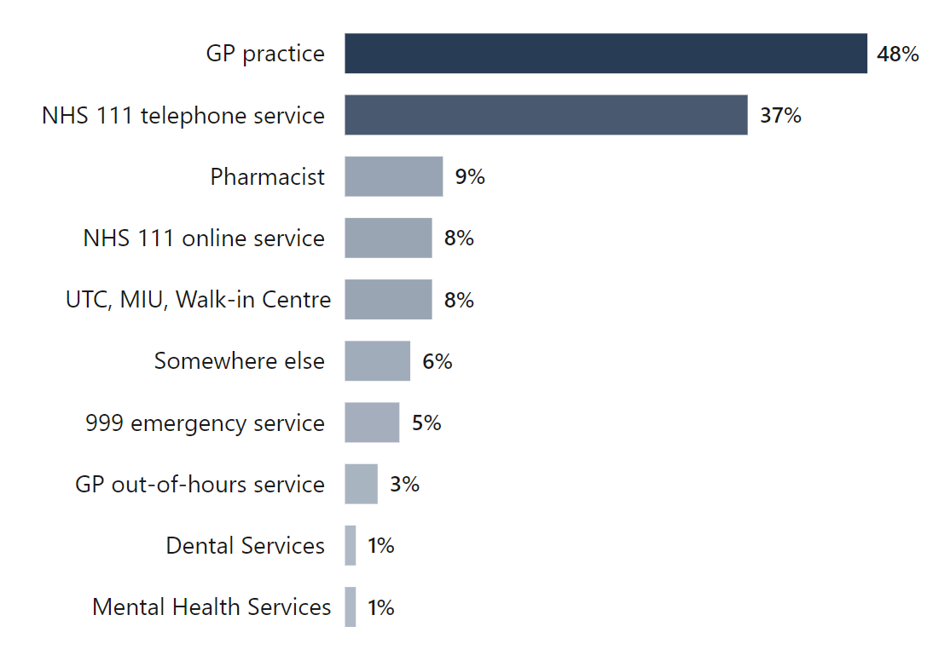
Answered by those who did go to or contact another service for help with their condition before attending the urgent treatment centre. Multiple response question: percentages may sum to more than 100. Total number of respondents: 4,817.

Respondents were asked what their main reason was for attending the UTC after contacting another service (figure 38). Being told to go to an UTC was the most common reason (56%), followed by their condition became worse (17%). More than 1 in 10 said they couldn’t get an appointment quickly enough for their needs (13%) and 6% wanted to be seen on the same day.

Figure 38: What was the MAIN reason for going to the urgent treatment centre following your contact with these service(s)? (T4)

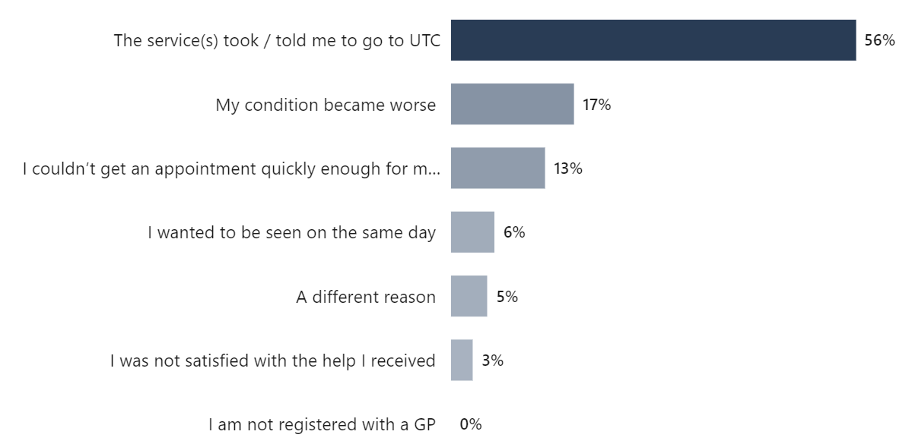

Answered by those who did go to or contact another service for help with their condition before attending the urgent treatment centre. Total number of respondents: 4,764.

Section 18: Care and support after leaving

Providing contact information if worried
NICE Quality Statement 2 states that patients must be given information about contacting healthcare professionals, which should include telling them who to contact, how to contact them and when to make contact about their ongoing healthcare needs.

Respondents were asked whether a member of staff told them who to contact if they were worried about their condition or treatment after they left urgent and emergency care services.

Providing contact information if worried after leaving A&E (Type 1)
Of those who were discharged and sent home, 79% were told who to contact if they were worried about their condition or treatment, whereas 21% were not told. GPs were the most recommended (44%), followed by A&E (23%), 111 service (10%), and 999 service. (6%).

Providing contact information if worried after leaving UTC (Type 3)
Respondents were asked whether a member of staff told them who to contact if they were worried about their condition or treatment after they left the UTC: 82% were told who to contact, while 18% were not. Staff most often recommended patients contact their GP (45%), followed by an UTC (18%), NHS 111 (11%), and A&E (11%).

Health or social care needs after leaving urgent and emergency care services
The aim of Integrated care systems (ICSs) is to join up local partners providing health and social care to improve the service provided to people and lead to better outcomes.

Health or social care needs after leaving A&E (Type 1)
Results in 2024 suggest patients have been discharged with an unmet need for further care and/or support. Respondents were asked if hospital staff discussed whether they may need any further health or social care services after leaving A&E and whether that need was met.

Of respondents who felt they needed a conversation about any further health or social care, nearly a third (31%) of A&E patients said staff did not discuss it with them, but they would have liked them to. Of those who contacted health and social care after leaving A&E, 41% said it was ‘definitely’ available when they needed it, 31% only ‘to some extent’, and 28% said it was not available.

Health or social care needs after leaving UTC (Type 3)
Respondents were asked if staff discussed whether they may need any further health or social care services after leaving the urgent treatment centre (UTC). Excluding those who did not feel this was necessary, 77% of respondents said staff did discuss further health or social care services with them. However, 23% said that staff did not, but they ‘would have liked them to’. Of respondents who contacted health and social care services after leaving the UTC, 50% felt they were ‘definitely’ available when they needed it, 29% ‘to some extent’, and 21% said they were not available.

Section 19: Subgroup analysis
Subgroup analysis compares, controlling for other characteristics, the average probability that different subgroups of people using urgent and emergency care services select the most positive answer to a survey question. The subgroups used in the analysis include the following:

Subgroups: Acuity of condition, attendance and care experiences
- Acuity of condition
- Reattendances: recent visit about the same condition
- Contacted another service before attending
- Duration of visit
- Time to initial assessment
- Attendance day of week
- Attendance time of day

Subgroups: Personal characteristics
- Age
- Sex
- Ethnicity
- Religion
- Gender different from sex assigned at birth
- Sexual orientation
- Index of Multiple Deprivation decile (IMD)

Subgroups: Pre-existing health conditions
- Long-term condition
- Frailty
- Disability

Separate subgroup analysis is carried out for A&E and urgent treatment centre (UTC) services. Due to the smaller sample for urgent treatment centres, it was not possible to include the full range of questions in the UTC subgroup analysis that were included in the A&E analysis.

The table below shows the questions used in the A&E analysis and, of those questions, those used in the UTC analysis (shown by the urgent treatment centre survey question number):

A&E questions in the subgroup analysis | UTC
WAITING
Privacy
Were you given enough privacy when discussing your condition with the receptionist? (Q10) | (T7)
Communication
Were you informed how long you would have to wait to be examined or treated? (Q13) | (T10)
Were you kept updated on how long your wait would be? (Q14) | (T11)
Getting help with condition or symptoms
While you were waiting, were you able to get help with your condition or symptoms from a member of staff? (Q15) | (T12)
CARE AND TREATMENT
Privacy
Were you given enough privacy when being examined or treated? (Q25) | (T22)
Quality of communication about condition
Did you have enough time to discuss your condition and treatment with the doctor or nurse? (Q17) | (T14)
While you were in A&E, did a doctor or nurse explain your condition and treatment in a way you could understand? (Q18) | (T15)
Did the doctors and nurses listen to what you had to say? (Q19) | (T16 ‘health professionals’)
Emotional support
If you had any anxieties or fears about your condition or treatment, did a doctor or nurse discuss them with you? (Q20) | (T17)
Involvement
Were you involved as much as you wanted to be in decisions about your care and treatment? (Q27) | (T24)
If a family member, friend or carer wanted to talk to a health professional, did they have enough opportunity to do so? (Q22) | (T19)
Pain management
Do you think the hospital staff did everything they could to help control your pain? (Q30) | (T27)
Confidence and trust
Did you have confidence and trust in the doctors and nurses examining and treating you? (Q21) | (T18)

Tests
If you had any tests, did a member of staff explain why you needed them in a way you could understand? (Q28) | (T25)
Hospital environment
While you were in A&E, did you feel safe around other patients or visitors? (Q31) | (T28)
While you were in A&E, were you able to get food or drinks? (Q32) | (T29)
DISCHARGE
Continuing care at home
Before you left A&E, did hospital staff give you information on how to care for your condition at home? (Q36) | (T33)
Did hospital staff tell you who to contact if you were worried about your condition or treatment after you left A&E? (Q39) | (T36)
OVERALL
Respect and dignity
Overall, did you feel you were treated with respect and dignity while you were in A&E? (Q42) | (T39)
Overall experience
Overall experience (Q43) | (T40)

Appendix I: Subgroup analysis, separate from this report, contains more details on the methodology used to compute the analysis.

Summary of A&E subgroup analysis

Disabled patients
Disabled patients (59%) in A&E services reported worse than average experiences in A&E overall and in many areas of care. For example, disabled patients reported worse experiences for all communications questions, including being listened to, doctors or nurses clearly explaining their condition or treatment and being involved in decisions. They were also less likely to report that a family member, friend or carer had enough opportunity to speak to a doctor or nurse when they had wanted to. Disabled patients also reported worse than average experiences with being given enough privacy during examination and treatment and being given information on to care for their condition at home.

Frail patients
Frail patients (11%) in A&E services reported worse than average experiences overall and across many areas of care, similar to disabled patients. For instance, frail patients reported worse experiences for all communications questions, such as having enough time to discuss their condition and treatment, and to discuss their anxieties and fears. They were also less likely to feel they were treated with respect and dignity.

A&E patients with long-term conditions
A&E patients with dementia or Alzheimer's (2%) reported worse than average experience of doctors or nurses listening to what they had to say.
Patients were asked how they would rate their experience overall. Those with a neurological condition (7%) reported a worse than average overall experience of A&E care.

Experiences of different age groups at A&E
Younger A&E patients aged 16-50 (25%) reported worse than average experiences overall and in many areas of care (16 of 20 questions). Confidence and trust in doctors and nurses was worse than average, as were most questions on communication with doctors and nurses.

Emergency care acuity level (A&E)
A&E patients whose condition was classified at a higher acuity emergency care level, had better experiences that those at lower acuity levels in some areas. Patients overall experience rating was better than average for those assigned a higher emergency care level (‘very urgent’) and worse for those whose condition was classified as lower acuity (‘urgent’ or ‘standard’). Patients requiring ‘immediate’ or ‘very urgent’ emergency care reported better than average experiences on being helped with pain relief, while those at lower acuity emergency care levels (‘urgent’ or ‘standard’) reported worse experiences. Those at ‘standard’ or ‘low’ emergency care requirements also reported worse than average experiences of being helped with conditions or symptoms while waiting.

Time to initial assessment at A&E departments
A&E patients who waited more than 60 minutes for initial assessment reported worse than average experiences on all 20 questions included in the analysis, while those who waited 31 to 60 minutes for initial assessment reported worse than average experiences on 18 questions.

Duration of A&E visit
Patients whose visit lasted over 4 hours reported worse than average experiences across all questions included in our analysis.

Reattended A&E for the same condition previously
Patients who had been to an A&E up to 1 month before their current visit reported worse than average experiences on communication with doctors and nurses, including having enough time to discuss their condition with doctors and nurses feeling doctors or nurses listened to them and feeling involved in decisions about their care and treatment. Confidence and trust in doctors and nurses and their overall rating of their care experience was also worse than average.

Summary of urgent treatment centres subgroup analysis

Urgent treatment centre patients with a disability
Patients with a disability reported worse than average experiences for two communications with health professionals’ questions, having enough time to discuss their condition or treatment and to discuss their anxieties and fears. In addition, they reported worse than average experience with staff helping with pain relief.

Urgent treatment centre patients with long-term conditions
Urgent treatment centre patients with a mental health condition (9%) reported worse than average experiences on their family, friend or carers having enough opportunity to talk to health professionals.

Experiences of different age groups at urgent treatment centres
Patients aged 16-35 reported poorer overall experience of urgent treatment centre care for over half of the questions included in the analysis (12 of 20), including being treated with respect and dignity and all questions concerning communications with health professionals.

Time to initial assessment at urgent treatment centre
Urgent treatment centre patients that waited less than 15 minutes (or not at all) for an initial assessment reported better than average experiences on all 20 questions in our analysis. Conversely, those who waited more than 60 minutes reported worse than average experiences on all 20 questions. Those who waited for 31-60 minutes had worse than average experiences for 15 of the 20 questions, including being told how long the wait would be, getting help with conditions or symptoms, and communicating with health professionals (enough time to discuss condition, health professionals listening to them, condition and treatment explained clearly, any anxieties and fears discussed, involvement in decisions).

Duration of visit at urgent treatment centres
Those whose visit lasted more than 4 hours reported worse experiences on 16 out of 20 questions. Conversely, for the same questions, those who left the urgent treatment centre within 4 hours reported better than average experiences.

Subgroup analysis tables

The following tables contains the findings of the subgroup analysis. Findings significantly above (B) or significantly below (W) average are shown for each subgroup category. Subgroups with no significant differences are not included in the tables that follow.

Subgroups for which no significant differences were found:
- A&E (Type 1): gender, sexual orientation, ethnicity, day of attendance.
- Urgent treatment centre (Type 3): religion, sexual orientation, ethnicity, frailty, day of attendance or Index of Multiple Deprivation decile.

Appendix A: Survey methodology
This appendix summarises the survey methodology, covering questionnaire design, sampling, fieldwork and analysis. For more detailed information, and for information on data limitations, please see the Quality and Methodology report.

Questionnaire design
The questionnaires used in the urgent and emergency care survey (A&E/Type 1 and UTC/Type 3 services) are reviewed for each iteration of the survey to ensure questions are still relevant and in line with current policy and practice. Questionnaire development work makes sure that questions are important to people who use services and to other stakeholders who use the survey data to monitor, evaluate and improve care. More information on how survey stakeholders use the data is provided in Appendix D: Comparisons with other surveys.

Wherever possible, the questions remain the same over time to measure change. However, the change from a paper-based to mixed-mode data collection methodology and the change in sample month for the 2024 Urgent and Emergency Care Survey necessitated a break in trends. The 2024 questionnaire was fully reviewed with large-scale changes made. Full details of this change are available in the Survey Development Report. When necessary, questionnaires are updated to reflect changes in policy and methodological best practice, and to reflect feedback from stakeholders to make sure that questions stay relevant. All changes are detailed in full in the Survey Development report.

Comparability with previous years
Results from the 2024 survey are not comparable with those from previous survey years due to the change in mode of data collection and sample month (the month for which participating trusts draw a sample of patients), as well as significant changes made to the questionnaire.

The change in mode of data collection and sample month did not negatively affect response rates, with response rates for the 2024 survey higher compared with the previous survey in 2022 (29% for Type 1 services compared with 23%; 26% for Type 3 services compared with 22%).

Survey methodology
The urgent and emergency care survey used both an online and a postal questionnaire for survey data collection.

Patients were sent up to 3 letters and 3 text messages (SMS). The letters contained a URL for the online survey and login details, while the SMS reminders included a personalised URL that took participants directly into the online survey without a login required, to encourage online completion. The second letter (first reminder) was sent 5 working days after the first contact letter and the third letter (second reminder) was sent 10 working days after the second letter. Each SMS reminder was sent 3 days after the letter was sent. SMS reminders were sent at different times of day to reach different groups. The first SMS was sent between 4pm and 5pm, the second SMS was sent between 2pm and 3pm and the third between 9am and 10am.

All sent letters included a leaflet offering guidance on options for completing the questionnaire in 20 different languages (multi-language sheet). The third and final letter included a paper questionnaire and freepost return envelope.

Fieldwork for the survey (the time during which questionnaires were sent out and returned) took place between April and July 2024.

The 2024 survey offered several accessible formats of the questionnaire to ensure it followed best practice for survey accessibility. The online survey was translated into 9 non-English languages and British Sign Language. Additionally, participants were able to change font size, background colour of the online survey and it was tested to ensure screen reader compatibility. A paper Braille, large-print and easy read questionnaire were available on request.

Accessibility formats | Type 1 | Type 3
Non-English online completes | 248 | 95
BSL online completes | 6 | 1
Braille requests | 0 | 0
Large print requests | 11 | 1
Large print completes | 8 | 1
% of Large print completes | 73% | 100%
Easy read requests | 3 | 1
Easy Read completes | 0 | 0
% of Easy Read completed | 0% | 0%
Phone calls | 2,646 | 643
Emails | 347 | 115
Telephone assisted completes | 113 | 40
Telephone calls requiring translator | 1 | 2

Response rate
The 2024 survey included 120 NHS trusts. Of these trusts, 70 had both a Type 1 department and eligible Type 3 department. The remaining 50 trusts took part in the Type 1 survey only. Responses were received from 35,670 people who attended a Type 1 department, an adjusted response rate of 29%. For Type 3 services, 19,325 responses were received, an adjusted response rate of 26%.

Sampling
People aged 16 and over were eligible to take part in the survey if they attended a Type 1 or Type 3 urgent and emergency care department in an NHS trust between 1 and 29 February 2024. Trusts with eligible Type 3 services unable to draw their full required sample from February were able to include January, sampling backwards consecutively from 31 January to 1 January 2024 until the required sample size is reached.

The Urgent and Emergency Care Survey uses a stratified random sample, as opposed to a random sample, to better represent trust population characteristics. Trusts are required to sort their population file by department type, sex, year of birth and Sub-Integrated Care Board (Sub ICB) location ahead of randomly selecting their sample. This ensures the sample includes both Type 1 and Type 3 departments, where applicable, and also representation across sex, age groups and sub ICB locations.

Trusts responsible for only Type 1 departments drew a stratified random sample of 1,250 patients. Trusts that also directly ran Type 3 departments sampled 950 patients from Type 1 departments and 580 patients from Type 3 departments totalling 1,530 patients. The sample size, and the achieved response rate is sufficient to allow analysis of results at individual trust level.

Type 3 departments were only eligible for inclusion in the survey if they were run directly by the acute trust. Services run by another provider, or in collaboration with another provider, were excluded.

Certain groups of people were excluded from the survey before providers drew their samples, including:

- anyone who was a current inpatient
- anyone who attended a walk-in centre
- any patients who were admitted to hospital through medical or surgical admissions units and therefore did not visit the urgent and emergency care department
- anyone who had a planned attendance at an outpatient clinic run within the department (such as a fracture clinic)
- patients attending primarily to obtain contraception (for example, the morning after pill), patients who suffered a miscarriage or another form of abortive pregnancy outcome while at the hospital, and patients with a concealed pregnancy.

For more detailed information on the sampling instructions, and inclusion and exclusion criteria, please see the survey Sampling Instructions document.

Comparability between service types
Results for Type 1 departments and Type 3 departments are detailed separately and are not directly compared because Type 1 and Type 3 departments may be operationally very different. For example, Type 3 departments tend to have a different staff mix (they can be nurse or doctor/GP-led) and are usually not open 24 hours a day, whereas A&E departments operate 24 hours, 7 days a week. Type 1 and Type 3 services also typically have a different patient case mix, with people attending a Type 3 department less likely to be seriously unwell or injured, whereas A&E patients’ conditions are more likely to be life threatening or serious.

Data analysis methodology
Data cleaning
‘Data cleaning’ refers to all editing processes carried out on survey data once the survey has been completed and the data has been entered and collated. This is done to ensure data quality and make sure that it is comparable across trusts. For further information please see the data cleaning guidance document.

Weighting
Two weights were calculated for the England level data for the 2024 Urgent and Emergency Care survey:
- A ‘population weight’, which aims to weight the results for each individual trust to that trust’s eligible sample profile, intended to make each trust’s results representative of their own population. This involved weighting by gender and age group so that the weighted proportions in each gender and age group in the respondent population match those in the sampled population. Therefore, increased weight is given to groups that had a lower propensity to respond.
- A ‘trust weight’ (separate trust weight for each question), which aims to weight responses from each trust to make sure that they have an equal influence over the England average. This means that the 120 Type 1 trusts and 70 Type 3 trusts that participated contribute equally to the overall results for England regardless of differences in response rates.

Both sets of weights are then multiplied together to produce a single combined weight for the data tables that underpin the analysis.

This weighting has been applied to all questions except for demographic questions. The demographic questions are presented without weights applied, as it is more appropriate to present the real percentages to describe the profile of respondents, rather than adjust figures.

Rounding
The results present percentage figures rounded to the nearest whole number, so the values given for any question will not always add up to 100%. Please note that rounding up or down may make differences between survey years appear bigger or smaller than they actually are.

Appendix B: Demographic tables
The tables below show the demographic characteristics of respondents to the 2024 Urgent and Emergency Care Survey, for both Type 1 and Type 3 questionnaires.

Do you have any of the following?
 | Type 1 | Type 3
Autism or autism spectrum condition | 2% | 2%
Breathing problem, such as asthma | 22% | 17%
Blindness or partial sight | 3% | 2%
Cancer in the last 5 years | 9% | 6%
Dementia or Alzheimer's disease | 2% | 1%
Deafness or hearing loss | 15% | 11%
Diabetes | 15% | 10%
Heart problem, such as angina | 20% | 9%
Joint problem, such as arthritis | 29% | 25%
Kidney or liver disease | 7% | 3%
Learning disability | 2% | 2%
Mental health condition | 11% | 9%
Neurological condition | 7% | 4%
Physical mobility condition | 16% | 9%
Stroke (which affects your day-to-day life) | 3% | 1%
Another long-term condition | 20% | 15%
I do not have any long-term conditions | 21% | 33%
I would prefer not to say | 3% | 4%
Number of respondents | 33,158 | 9,317
Answered by those with a long-standing condition.
Multiple response question - percentages may not sum to 100.

Do any of these reduce your ability to carry out day-to-day activities?
 | Type 1 | Type 3
Yes, a lot | 35% | 22%
Yes, a little | 40% | 40%
No, not at all | 25% | 38%
Number of respondents | 25,508 | 6,229
Answered by those with a long-standing condition.

Have you experienced any of the following in the last twelve months?
 | Type 1 | Type 3
Problems with your physical mobility, such as difficulty getting about your home | 33% | 20%
Two or more falls that have needed medical attention | 10% | 6%
Feeling isolated from others | 12% | 7%
None of these | 59% | 73%
Number of respondents | 34,362 | 9,928
Answered by all.
Multiple response question - percentages may not sum to 100.

At birth were you assigned as...
 | Type 1 | Type 3
Male | 43% | 39%
Female | 57% | 60%
Intersex | 0% | 0%
I would prefer not to say | 1% | 1%
Number of respondents | 35,670 | 10,325
Answered by all (sample data used if response data was missing).

Is your gender the same as the sex you were registered as at birth?
 | Type 1 | Type 3
Yes | 98% | 98%
No | 0.5% | 0.5%
I would prefer not to say | 1% | 1%
Number of respondents | 31,662 | 9,096
Answered by all.

Proportion of respondents by age
 | Type 1 | Type 3
16-35 | 11% | 15%
36-50 | 14% | 17%
51-65 | 25% | 30%
66-80 | 33% | 29%
>81 | 17% | 9%
Number of respondents | 35,670 | 10,325
Answered by all (sample data used if response data was missing).

What is your religion?
 | Type 1 | Type 3
No religion | 25% | 28%
Buddhist | 1% | 1%
Christian (including Church of England, Catholic, Protestant, and other Christian denominations) | 62% | 59%
Hindu | 1% | 1%
Jewish | 0.4% | 0.3%
Muslim | 4% | 4%
Sikh | 1% | 1%
Other | 2% | 2%
I would prefer not to say | 4% | 5%
Number of respondents | 34,993 | 10,124
Answered by all.

Which of the following best describes your sexual orientation?
 | Type 1 | Type 3
Heterosexual / straight | 91% | 90%
Gay / lesbian | 2% | 2%
Bisexual | 1% | 1%
Other | 1% | 1%
I would prefer not to say | 5% | 6%
Number of respondents | 34,458 | 10,007
Answered by all.

What is your ethnic group?
 | Type 1 | Type 3
White | 88% | 87%
Multiple ethnic groups | 2% | 2%
Asian or Asian British | 6% | 6%
Black or Black British | 4% | 4%
Arab or other ethnic group | 1% | 1%
Number of respondents | 34,289 | 9,895
Answered by all.

Appendix C: Subgroups in analysis
Subgroups: Acuity of condition, attendance and care experiences
Acuity of condition
  Immediate care level emergency care
  Very urgent level emergency care
  Urgent level emergency care
  Standard level emergency care
  Low acuity level emergency care
Reattendances: recent visit about the same condition
  Within the previous week / Between 1 week and 1 month earlier / More than 1 month earlier / No /
  Don’t know or can’t remember
Contacted another service before attending
  Yes / No
Duration of visit
  Less than 4 hours / More than 4 hours
Time to initial assessment
  Up to 60 minutes / More than 60 minutes
Duration of visit
  Less than 4 hours / More than 4 hours
Attendance day of week
  Sunday / Monday / Tuesday / Wednesday / Thursday /
  Friday / Saturday
Attendance time of day
  0900-1259 / 1300-1659 / 1700-2059 / 2100-0059 /
  0100-0459 / 0500-0859

Subgroups: Personal characteristics
Age
  16-35 / 36-50 / 51-65 / 66-80 / 81+
Sex
  Male / Female / Prefer not to say (sex)
Ethnicity
  White / Multiple ethnic groups / Asian or Asian British /
  Black or Black British / Arab or other ethnic group / Not known
Religion
  No religion / Buddhist / Christian / Hindu / Jewish / Muslim /
  Sikh / Other / Prefer not to say
Gender
  Gender same as assigned at birth
  Gender different from assigned at birth
  I would prefer not to say (gender)
Sexual orientation
  Heterosexual / straight
  Gay / lesbian
  Bisexual
  Other (sexual orientation)
  I would prefer not to say
Index of Multiple Deprivation decile (IMD)
  1st decile to 10th decile

Subgroups: Pre-existing health conditions
Long-term condition
  Autism or autism spectrum condition
  Blindness or partial sight
  Breathing problem, such as asthma
  Cancer in the last 5 years
  Deafness or hearing loss
  Dementia or Alzheimer’s disease
  Diabetes
  Heart problem, such as angina
  Joint problem, such as arthritis
  Kidney or liver disease
  Learning disability
  Mental health condition
  Neurological condition
  Physical mobility condition
  Stroke (which affects your day-to-day life)
  Another long-term condition
Frailty
  Frail / Not frail
Disability
  Disabled / Not disabled

Appendix D: Other sources of information related to survey results
This section summarises other sources of data related to urgent and emergency care in England.

Note: These data sources do not measure patient experience and are therefore not directly comparable with findings presented in this report. However, they provide useful contextual information.

NHS Outcome Framework
The NHS Outcomes Framework provides national-level accountability for the outcomes that the NHS delivers and to drive transparency, quality improvement and outcome measurement throughout the NHS.

The framework sets out the national outcome goals that the Secretary of State uses to monitor the progress of NHS England. It does not set out how these outcomes should be delivered.

Data from the NHS Patient Survey Programme are used to monitor Domain 4 ‘Ensuring that people have a positive experience of care’. This looks at the importance of providing a positive experience of care for patients, people who use services and carers.

Quality standard for patient experience in adult NHS services
The National Institute for Health and Care Excellence (NICE) has a Quality Standard for patient experience in adult NHS services, which outlines 6 quality statements about patient experience. The standard aims to provide the NHS with clear commissioning guidance on the components of a good patient experience. The quality standard gives evidence-based statements for commissioners that provide the foundation for an 'NHS cultural shift' to a patient-centred service.

Staffing
Statistics on staffing numbers are provided by NHS England’s monthly publication of NHS workforce statistics. Please note this data covers all trust types, such as acute and community trusts, as well as mental health providers.

Waiting times
Data on waiting times are published by NHS England. Trusts should also publish this information on their website. There are 3 sets of statistics relating to waiting times, which are based on 2 data sources, and are published in slightly different ways:

A&E Attendance and Emergency Admissions are weekly and monthly A&E attendances and emergency admissions, which includes minor injuries units and walk-in centres, and, of these, the number discharged, admitted or transferred within 4 hours of arrival. Also included are the number of emergency admissions, and any waits of over 4 hours for admission following decision to admit. Data is shown at organisation level, for NHS trusts, NHS foundation trusts and independent sector organisations. Providers submit this data to NHS England in aggregate form, rather than from patient level data.

A&E Quality Indicators for England are a set of clinical quality indicators introduced to measure the quality of care delivered in A&E departments in England. The data used in these indicators is sourced from provisional A&E HES data (Hospital Episode Statistics) and also include more detail about A&E activity such as demographic information.

NHS England also publishes more detailed data on A&E attendances, which is broken down by age and diagnosis. Hospital Accident and Emergency Activity is an annual publication and uses two data sources: Hospital Episode Statistics (HES) and A&E Attendances and Emergency Admissions Monthly Situation Reports. The latest data available is for 2023/24.

Patient experience
Emergency Care Data Set (ECDS) was designed to provide greater information about the patient journey and trusts began using this in a phased implementation from 2018. It provides extra detail including patient demographics, how and why people are accessing services and information on what happens when they leave (onward care, referrals etc).

NHS England publish results from the Friends & Family Test (FFT). This is a single question survey, which asks patients whether they would recommend the service they have received to friends and family who need similar treatment or care.

Appendix E: Comparisons with other surveys
Scotland, Northern Ireland and the Republic of Ireland have programmes of patient surveys, but they do not currently include surveys on urgent and emergency care services. However, inpatient surveys include a limited number of questions on A&E. There is currently no similar survey carried out in Wales.

The surveys in Scotland, Northern Ireland and the Republic of Ireland reflect people’s experiences of different healthcare systems. Therefore, direct comparisons to this survey are not recommended because of the differences in methodology, the questions, and the periods over which the surveys were administered. Also, the questions are phrased differently, use different scale lengths, and different report and rating type scales. Each of these factors is associated with differences in responses. Furthermore, as the questions are included in a questionnaire covering inpatient services, these surveys only include people who went on to be admitted from A&E (and are therefore more likely to be more seriously ill or injured).

Scotland
The Scottish Care Experience Survey Programme currently consists of 4 surveys: The Health & Care Experience Survey (covers GP services, out-of-hours care, social care and caring responsibilities), and surveys of inpatient, maternity and cancer patient experiences. Though there is not one specifically on urgent and emergency care services, their inpatient survey includes questions on time spent in A&E.

The Inpatient Experience Survey was put on hold due to COVID-19 pressures and remains on hold at time of writing. Therefore, the most recent results are from the 2018 survey, which were previously mentioned in the 2018 Urgent and Emergency Care statistical release. The results from the 2018 Inpatient Survey are available on the Scottish Government website.

Northern Ireland
The Inpatient Patient Experience Survey includes questions on time spent in A&E. The most recently published results are from the 2017 inpatient survey which was sent to all eligible inpatients, aged 16 and over, that had been discharged from a hospital in Northern Ireland during a 6-week period in September and October 2017. Results from the 2017 survey were previously mentioned in the 2018 Urgent and Emergency Care statistical release. More information on the inpatient survey carried out in Northern Ireland is available on the Northern Ireland Department for Health website.

Ireland
The patient experience programme in Ireland currently consists of 2 surveys: the national patient experience survey, which covers acute hospitals, and the national care experience survey. which covers health and social care services. The National Inpatient Patient Experience Survey includes questions on time spent in A&E.

The most recently published results from the 2022 National Patient Experience Survey were previously mentioned in the 2022 Urgent and Emergency Care statistical release. More information on the survey can be found on the National Care Experience Programme website.

Appendix F: Main uses of the survey data
This appendix lists known users of data from the urgent and emergency care survey and how they use the data.

Care Quality Commission (CQC)
CQC will use results from the survey to build an understanding of the risk and quality of services and those who organise care across an area. Where survey findings provide evidence of a change to the level of risk or quality in a service, provider or system, CQC will use the results alongside other sources of data on people’s experience to inform targeted assessment activities.

For each provider, the CQC survey results are reviewed alongside other data sources before inspection. Key themes and findings from the survey, which may warrant further follow up with providers, are highlighted to the inspection teams.

For more information please see: www.cqc.org.uk/what-we-do.

Department of Health and Social Care
The government measures progress on improving people’s experiences through Domain 4 of the NHS Outcomes Framework ‘ensuring people have a positive experience of care’. The Framework sets out the outcomes and corresponding indicators that the Department of Health and Social Care uses to hold NHS England to account for improvements in health outcomes. The Outcomes Framework survey indicators are based on the standardised, scored trust level data from the survey (similar to that included in the CQC benchmark reports), rather than the England level percentage of respondent’s data that is contained within this report.

NHS England
NHS England is a key user of data from the NHS Patient Survey Programme. Listening to patients’ experiences of their care plays a crucial part in delivering services that are safe, effective and continuously improving. Data from the survey programme is important for NHS England to understand patient experiences of the services they are receiving from acute and community settings.

Patient experience is a cross-cutting theme throughout the NHS Long Term Plan. CQC data supports NHS England to track how it is doing on user experience, understand where inequality is present and the impact that policy initiatives are having on patients.

NHS trusts and commissioners
Trusts, and those who commission services, use the results to identify and make the changes they need to improve the experience of people who use their services. Each participating trust receives a benchmark report, which provides the trust with a score for each evaluative question in the survey and how this compares to all trusts.

Data from the CQC patient surveys is added to the Patient Experience Library’s surveys tracker, which puts all survey data plus benchmark reports in one place, with cross referencing of common themes such as cleanliness, waiting, etc. The tracker was developed based on discussions with NHS England’s Heads of Patient Experience Network, whose members find it invaluable for helping Boards and senior management of Trusts to get quick and easy access to these key components of patient experience evidence. The tracker is open access, so it is also available to patient groups, health charities, policy bodies and researchers. Summaries of each survey also appear in the Library’s annual Patient Experience in England report, which is disseminated to around 2,000 individuals and organisations with an interest in patient experience and involvement.

Appendix G: Revisions and corrections
CQC publishes a Revisions and Corrections Policy relating to these statistics. Urgent and Emergency Care Survey data is not subject to any scheduled revisions as it captures the views of people about their experiences of care at a specific point in time. All new survey results are therefore published on CQC’s website and NHS Surveys, as appropriate, and previously published results for the same survey are not revised.

This policy sets out how CQC will respond if an error is identified in any survey, and it becomes necessary to correct published data or reports.

Appendix H: Further information and feedback

Further information
This report, together with the trust level results, is available on CQC’s website. You can also find a ‘technical document’ there, which describes the methodology for analysing trust level results, and a ‘quality and methodology’ document, which provides information about the survey development and methodology.

All survey reports, instructions and documents created as part of the survey can be found on the NHS Surveys website. These include full details of the methodology for the survey, questionnaires, letters sent to people who use services, instructions on how to carry out the survey and the survey development report.

There is more information on the NHS Patient Survey Programme, including results from other surveys and a programme of current and forthcoming surveys on the NHS Surveys website.

Further questions or feedback
This summary has been produced by CQC’s Research Team and reflects the findings of the 2024 Urgent and Emergency Care Survey. We welcome all feedback on the survey findings and the way we have reported the results, particularly from people using services, their representatives, and those providing services. If you have any comments, questions or suggestions on how this publication could be improved, please contact Patient.Survey@cqc.org.uk.

CQC will review your feedback and use it as appropriate to improve the statistics that we publish across the NHS Patient Survey Programme. If you would like to be involved in consultations or receive updates on the NHS Patient Survey Programme, please subscribe here: www.cqc.org.uk/surveys.

Accredited Official Statistics status
Accredited Official Statistics status means that official statistics meet the highest standards of trustworthiness, quality and public value.

All official statistics should comply with all aspects of the Code of Practice for Statistics. They are awarded Accredited Official Statistics status following an assessment by the Authority’s regulatory arm. The Authority considers whether the statistics meet the highest standards of Code compliance, including the value they add to public decisions and debate.

References

For Type 3 services, smaller trusts that were unable to achieve the required sample size from February only were able to sample back into January.
We report the ‘adjusted’ response rate. The adjusted base is calculated by subtracting the number of questionnaires returned as undeliverable, or if someone had died, from the total number of questionnaires sent out. The adjusted response rate is then calculated by dividing the number of returned useable questionnaires by the adjusted base.
Where a respondent’s long-term condition reduces their ability to carry out day-to-day activities either ‘a lot’ or ‘a little’, they are defined as disabled. Where a respondent selects ‘No, not at all’ they are defined as not disabled.
All respondents are asked whether they have problems with mobility, two or more falls that needed medical attention or felt isolated from others. Where a respondent selects 2 or more of these (excluding ‘None of these’) they are defined as ‘frail’. Where a respondent selects ‘None of these’ or 1 response option only they are defined as ‘not frail’.
Trusts that had an eligible Type 3 service and could not achieve the required sample size of 580 Type 3 patients in February could also sample back to January 2024.
The ‘adjusted’ response rate is reported. The adjusted base is calculated by subtracting the number of questionnaires returned as undeliverable, or if someone had died, from the total number of questionnaires sent out. The adjusted response rate is then calculated by dividing the number of returned useable questionnaires by the adjusted base.
Figure is based on full-time equivalent, rather than headcount. Full-time equivalent (FTE) is a standardised measure of the workload of an employed person and allows for the total workforce workload to be expressed in an equivalent number of full-time staff.
Unplanned reattendance is when a patient returned within 7 days of the previous attendance.
Answered by all. Respondents who stated that this was not necessary or didn't know or couldn't remember have been excluded.
Answered by all. Respondents who stated that this was not necessary, or didn't know or couldn't remember have been excluded.
Answered by all. Respondents who did not need any help with their condition or symptoms have been excluded. Total number of respondents: 22,759.
Answered by all. Respondents who were told not to take medication, did not need help to take medication, or stated not applicable have been excluded. Total number of respondents: 8,550.
Answered by all. Respondents who stated that the question was not applicable have been excluded.
For UTCs, we did not report on whether communication needs were met due to low base sizes.
Answered by all. Respondents who stated that they were not in pain while in A&E or didn't know or couldn't remember have been excluded. Total number of respondents: 24,043.
The adjusted base is calculated by subtracting the number of questionnaires returned as undeliverable, or if someone had died, from the total number of questionnaires sent out. The adjusted response rate is then calculated by dividing the number of returned useable questionnaires by the adjusted base.
Frailty is defined using question 50 from the Type 1 questionnaire and question 47 from the Type 3 questionnaire. Where a respondent selects 2 or more response options (excluding ‘None of these’) they are defined as frail. Where a respondent selects ‘None of these’ or 1 response option only they are defined as not frail.
Disability is defined using question 49 from the Type 1 questionnaire and question 46 from the Type 3 questionnaire. Where a respondent’s long-term condition reduces their ability to carry out day-to-day activities either ‘a lot’ or ‘a little’, they are defined as disabled. Where a respondent selects ‘No, not at all’ they are defined as not disabled.
Royal College of Emergency Medicine, Initial assessments of emergency department patients. February 2017.
NHS England, Emergency Care Department Type, NHS Data Model and Dictionary.
NHS England, A&E Attendances and Emergency Admissions 2022-23.
Department of Health and Social Care, NHS Constitution for England, March 2012.
NHS England, The Patient Experience Book, 2013.
NHS England, Domain 4: Ensuring that people have a positive experience of care, May 2013.
Care Quality Commission. New CQC strategy champions regulation driven by people’s experiences of care, May 2021
NHS England, Urgent and emergency care recovery plan year 2: building on learning from 2023/24, May 2024.
NHS England, Delivery plan for recovering urgent and emergency care: progress update and next steps, 2024.
Royal College for Emergency Medicine, Frequent Attendance in the Emergency Department: Delivery interventions and services for high intensity use, March 2024.
Royal College of Emergency Medicine, RCEM Explains: NHS Recovery Plan: One Year On, March 2024.
Royal College of Emergency Medicine, RCEM Explains: Long waits and excess deaths, 2024.
Royal College of Emergency Medicine, RCEM Explains: Long waits and excess deaths, 2024.
The King’s Fund, NHS waiting times: how are different service waiting times linked?, June 2024.
Royal College of Emergency Medicine, Burnout and retention crisis in Emergency Medicine threatens the safe delivery of emergency care, January 2024.
NHS England, NHS Long Term Workforce Plan, June 2023.
NHS England, NHS Workforce Statistics, February 2024.
The Royal College of Emergency Medicine, Frequent attenders in the ED: Best Practice Guideline, August 2017.
NHS England, Priorities and operational planning guidance 2024/25, March 2024.
Royal College of Emergency Medicine, Management of pain in adults: Best Practice Guideline, June 2021.
National Institute for Health and Care Excellence, Clinical guideline [CG138]: Patient experience in adult NHS services: improving the experience of care for people using adult NHS services, February 2012. Updated June 2021.
Care Quality Commission, CQC Inspection framework: NHS and independent acute hospitals. Core service: urgent and emergency services, December 2019.
Healthwatch, Let’s be honest and address patient experience of A&E, February 2024.
Royal College of Emergency Medicine, Patient Care in the ED: Best Practice Guidelines, November 2021.
NICE, Medicines adherence: involving patients in decisions about prescribed medicines and supporting adherence, January 2009.

