

Evaluation of the role split

Final report

October 2024

Marina Leoni, Michael Lawrie

23-089472-01 | Public | This work was carried out in accordance with the requirements of the international quality standard for Market Research, ISO 20252, and with the Ipsos Terms and Conditions which can be found at https://ipsos.uk/terms. © CQC

Contents

Executive summary 5

1 Introduction and background 11

1.1 Evaluation aims, objectives and scope 11

1.1.1 CQC’s strategic context 11

1.1.2 Evaluation aims and objectives 11

1.1.3 Evaluation scope 12

1.2 Operational changes to the role split during the evaluation 13

1.3 Structure of this report 13

2 Methodology 14

2.1 Scoping phase 14

2.2 Main phase of data collection 14

2.2.1 Analysis of CQC colleagues’ feedback forms 14

2.2.2 Qualitative interviews with assessors and inspectors 15

2.2.3 Qualitative interviews with CQC colleagues from the wider team 15

2.2.4 Survey of CQC operational colleagues 15

2.2.5 Analysis of management information 16

2.3 Limitations 16

3 Background and development of the role split 17

3.1 Context and rationale 17

3.2 Development and set-up 17

3.2.2 Staff engagement, training and guidance 19

4 Rollout of the role split and its early outcomes 23

4.1 Early outcomes of the role split 23

4.1.1 Assessor and inspector understanding of the roles 23

4.1.2 Assessors, inspectors and IAITs working in line with the intended design 25

4.1.3 Tools and systems 28

5 Expected outcomes of the role split over the medium term 32

5.1 Inspector and assessor activities 32

5.1.1 Inspectors’ activities 32

5.1.2 Assessors’ activities 33

5.2 Assessor and inspector confidence, job satisfaction and wellbeing at work 36

5.3 The IAIT as an enabler to the roles 38

5.4 Assessment completion and consistency 41

5.5 Perceived benefits and disadvantages 42

6 Conclusions and recommendations 44

6.1 Conclusions 44

6.2 Recommendations 47

Appendix 1: Theory of Change for the role split 49

Appendix 2: Evaluation framework 50

Appendix 3: Evaluation methods 54

##### List of figures

Figure 3.1: Assessor and inspector characteristics 19

Figure 3.2: Clarity of training and guidance on the roles 21

Figure 3.3: Clarity of training and guidance on new ways of working 21

Figure 4.1: Assessment process and assessor and inspector responsibilities 23

Figure 4.2: Assessors’ understanding of roles and ways of working 24

Figure 4.3: Inspectors’ understanding of roles and ways of working 25

Figure 4.4: Respondents’ role in practice 26

Figure 4.5: Hybrid working activities 27

Figure 4.6: Views on the Regulatory Platform 28

Figure 4.7: Views on the SAF 30

Figure 4.8: Positive views of Regulatory Platform and SAF by length of service 30

Figure 5.1: Change in inspector activities since the role split 32

Figure 5.2: Change in number of data sources used for assessments 34

Figure 5.3: Assessor use of new data sources 34

Figure 5.4: Assessor and inspector confidence 36

Figure 5.5: Assessor and inspector job satisfaction and wellbeing at work 37

Figure 5.6: Views on IAIT resourcing 39

Figure 5.7: Knowledge- and information-sharing in IAITs 41

Figure 5.8: Views on impact of new roles on future assessment efficiency 42

##### List of tables

Table 2.1: Sampling criteria for initial assessor and inspector interviews 15

Table 3.1: Suggested improvements to future training and guidance 22

Table 4.1: Suggested solutions for tools and systems 31

Table 5.1: Barriers to new ways of working 35

## Executive summary

### Introduction

In December 2023, the Care Quality Commission (CQC) commissioned Ipsos to undertake an evaluation of the split of the previous role of inspector into the two new roles of assessor and inspector (referred to hereafter as ‘the role split’).

The role split formed one element of a wider transformation of CQC’s assessment and inspection processes for health and social care providers. The assessor role was designed to focus on remotely collating and assessing a wide range of evidence about provider services and planning assessment activities. The inspector role was designed to focus on on-site evidence gathering activities. Together, the roles would be responsible for an overall effective assessment of quality and risk. In August 2024 (after evaluation fieldwork with CQC colleagues had been completed), CQC took the decision to revert to a single inspector role.

The evaluation was underpinned by three key objectives, which were agreed by all internal parties, including CQC’s Assessor and Inspector Role Evaluation Group and Trade Union representatives:

* + - * 1. Did the role split of inspector achieve the intended outcome of the design?
        2. Did the role split of assessor achieve the intended outcome of the design?
        3. Do the roles require any revisions or reversions?

### Purpose of this report

This is the final report for this evaluation, produced for CQC. The evaluation examined the implementation and early outcomes of the role split. Evaluation fieldwork took place between January and July 2024. Findings from this report are based on: evaluation scoping activities, carried out with a wide range of internal stakeholders to develop a theory of change for the role split and the evaluation framework; analysis of CQC colleagues’ feedback forms; qualitative interviews with assessors, inspectors, and colleagues from the wider team; a survey of CQC operational colleagues; and analysis of CQC management information (MI). There are some limitations to the study, most notably that, throughout the initiative, many assessors and inspectors were operating in a hybrid role, taking on responsibilities outside those originally intended for their nominal role.

### Background and development of the role split

#### Context and rationale

The role split formed part of CQC’s broader strategic shift towards a more data-driven and risk-based approach to regulating health and social care services in England. This was influenced by CQC’s 2021 strategy and a need to align with Integrated Care Systems. Development of remote monitoring and inspection methods during the Covid-19 pandemic further accelerated this shift. Operationally, the role split aimed to increase the number of assessments completed, and address concerns about inspector workload and wellbeing, shifting risk management away from individual colleagues to the team level. However, the evaluation found a lack of a clearly communicated business case or stated objectives for the role split, creating confusion and uncertainty among the operational colleagues.

#### Development and set-up

The lack of a widely communicated rationale for the change created challenges. The simultaneous introduction of the Regulatory Platform and the Single Assessment Framework (SAF) added complexity to the rollout of the role split. A lack of clarity about the roles and their responsibilities influenced colleagues’ choice of new role, often driven by personal circumstances rather than a clear understanding of the new roles.

#### Staff engagement, training and guidance

Feedback on the training and guidance on the new roles indicated that it failed to adequately prepare inspectors and assessors for their new roles. Interviewees reported that training primarily focused on the use of the Regulatory Platform, with insufficient focus on practical application to the new roles and ways of working. Some assessors and inspectors found the primarily online format did not suit their learning style. Participants felt guidance documents were unclear and lacked detail and specificity about the assessment process and the interplay between the roles.

Participants’ suggestions for improvement included: clearer communication of the rationale for the role split; more detailed job descriptions and process maps; sector-specific case-study based training; and a blended learning approach incorporating in-person elements.

### Rollout of the role split and its early outcomes

#### Assessor and inspector understanding of the roles

Evidence gathered by the evaluation suggests that there was a widespread lack of clarity about the roles and how they should work together in practice. Interviewees could describe the basic, high-level idea of the new roles – that is, the assessor role being focused on remote assessment activities, and the inspector role focused on “crossing the threshold” and gathering data about services on-site. However, interviewees in both roles consistently described a lack of understanding about both the rationale for the role split and how the roles should work together effectively in practice to complete assessments.

#### Assessors, inspectors and Integrated Assessment and Inspection Teams (IAITs) working in line with the intended design

As noted, many inspectors and assessors were operating in a hybrid role, and CQC made several operational decisions regarding the role split which amended the original plans during the evaluation. Survey responses indicated that roughly a third of assessors and inspectors identified that they were working in each of the three types of role – i.e. as an assessor, inspector, or in a hybrid role. Interviews with assessors highlighted that for some, the reasons for not taking on a hybrid role echoed their reasons for choosing the assessor role in the first place – concerns about the frequency of travel and on-site visits, and balancing this with their personal circumstances and/or caring responsibilities.

As the relationship owner function was not in the remit of either role, portfolios and risk could be described as held at the IAIT level, rather than by individual inspectors or assessors. However, across all evaluation activities, CQC colleagues raised concerns about the oversight of risk. These concerns stemmed from the shift away from having designated relationship owners, the lack of a consistent approach to implementing the role split across different teams, and technical problems with the Regulatory Platform.

#### Tools and systems

Data gathered across evaluation activities indicated that, at that time, the Regulatory Platform was not working in a way that was fit for purpose. Both assessors and inspectors consistently felt that it was not enabling them, but instead making their roles harder. The lack of a functional system forced operational colleagues to develop their own workarounds, using spreadsheets and shared documents outside the Regulatory Platform, to manage information and planning of assessment activities.

Data gathered suggested that while theoretically a promising initiative, the SAF was not enabling inspectors and assessors to carry out their roles effectively. Three main challenges emerged from interviews: the SAF’s current lack of practical usability within the Regulatory Platform; the large number of evidence categories; and a lack of sector-specific guidance about how to apply the SAF in practice.

Participants’ suggested solutions for the Regulatory Platform included: improving upload speeds, data quality and search functionality; simplifying the user interface; and increasing system flexibility to allow users to navigate the assessment process more easily.

Participants’ suggested solutions for the SAF included: streamlining the number of evidence categories to simplify the process and reduce duplication; and developing sector-specific training and guidance, including what ‘good’ looks like for different specialisms and services.

Other tools participants felt they would benefit from included: developing templates to support consistency in report writing; and improving planning tools to support the flow of information between colleagues preparing for and carrying out an assessment.

### Expected outcomes of the role split over the medium term

#### Inspector and assessor activities

One of the aims of the role split design was to minimise the time inspectors spend reviewing documentary evidence, allowing more time for on-site observations of care and engagement. The majority of inspectors reported decreased time spent on-site observing care and engaging with service users or staff, and increased time collating and reviewing documents. This contradicts the intended design of the role split. This finding was supported by CQC management information on the number of hours spent on-site. Whilst challenges with the Regulatory Platform have undoubtedly had a negative effect on the delivery and completion of assessment activities, qualitative data gathered by the evaluation also suggested the role split has contributed to the reduction in on-site inspection activities.

The role split design also aimed to increase the number of data sources used as part of assessments, with a longer-term goal of increasing data-driven decision making within CQC regulation. While some assessors reported using more data sources for assessments than in previous inspections, these were not necessarily new sources of data (as was assumed when the roles were designed).

CQC MI indicated that the percentage of time spent on gathering evidence remotely (i.e. documentary evidence) was broadly similar between the roles. This suggests the allocation of remote evidence gathering exclusively to the assessor role (in the role split’s design), did not align with the real-world context or requirements of the assessment process. Alongside the challenges associated with the Regulatory Platform, participants described the barriers to the new ways of working under five themes: the uneven distribution of tasks; process bottlenecks; overlap and duplication of effort; the assessment backlog; and limited availability and low-quality data.

#### Assessor and inspector confidence, job satisfaction and wellbeing at work

Overall, nearly two thirds (63%) of assessors and inspectors that responded to the survey felt not very or not at all confident in carrying out their responsibilities for assessments. This proportion was consistent across roles, sector specialisms, geographical networks, length of time working at CQC, and for respondents with disabilities or long-term health conditions, and caring responsibilities.

Survey responses on job satisfaction and wellbeing at work were also poor. Interview data strongly supported these findings: both assessors and inspectors expressed concerns about becoming deskilled due to the narrower focus of their new roles. Some inspectors were unhappy that assessor colleagues, who are their peers, were now responsible for allocating tasks to them. These factors, coupled with the overall frustration with the other implementation challenges, contributed to low morale and job dissatisfaction.

Some participants raised particular concerns about the wellbeing of colleagues in the assessor role. These concerns were not only due to their workload, but also the nature of the work they were responsible for in managing incoming cases and notifications. Participants noted the risk of elevated stress levels through reading ‘bad news’ all day, and the additional challenge of accessing emotional wellbeing support when home working and feeling isolated.

#### The IAIT as an enabler to the roles

Interview data indicated that the new IAIT structures and resourcing were not enabling inspectors and assessors to effectively perform their roles. Four key themes emerged: inadequate resources; geographic challenges; an imbalance between the sector specialisms; and inconsistent processes.

The primary solution suggested by participants across evaluation activities was to increase staffing levels in the IAITs. Beyond this, participants reported that improved processes to support more efficient, productive working would be the most valuable additional resource for their team.

#### Assessment completion and consistency

The intended outcomes relating to assessors’ and inspectors’ activities and the function of the IAITs were expected to result in assessments being completed for an increased volume of services. There is no evidence that these outcomes have been realised.

Interviewees described the assessment process as having “ground to a halt”, with tasks taking significantly more time than before the role split. MI provided by CQC supported this. The evaluation found no evidence to suggest that the role split had enabled any efficiencies. Data gathered across the other evaluation activities indicated that the role split did not result in quicker response to risk, more timely identification of good practice, or access to more recent ratings and information for provider services. Potential efficiencies from having IAITs focused on specific local areas were not observed. This is likely due to staffing shortages requiring CQC colleagues to cover assessment activities across wider geographical footprints.

Increased consistency in assessments across teams and specialisms was another expected outcome of the role split – primarily through the use of the SAF, However, qualitative data suggested there was wide variation in how assessments were being completed, with individuals and teams adopting different workarounds to the technological and staffing challenges they faced. MI demonstrating any indicators of assessment consistency was not available in the timeframe of the evaluation.

### Conclusions and recommendations

This report has documented the delivery and early outcomes of the role split of the inspection workforce into assessors and inspectors. The role split of the inspection workforce into assessors and inspectors has faced significant delivery challenges and did not deliver the expected outcomes. These delivery challenges relate to:

* + - * 1. The lack of a clear, and clearly communicated, case for change. This meant assumptions about how the role split would work were not tested, and the staff affected did not feel consulted.
        2. Delivering the change, over a relatively short space of time, in a very challenging organisational context, with resourcing gaps and other major change initiatives (facing their own challenges) impacting on the role split.
        3. Some significant issues with the design of the role split affected the experience of many assessors and inspectors.

The evidence compiled in this evaluation therefore supports the CQC decision to revert to a single role.

CQC should consider the following steps in future change initiatives:

* + Conduct detailed assessments of the case for change, ensuring the considerations are widely communicated. As part of this, it is necessary to balance the strategic, economic and quality case for change, alongside the benefits for CQC colleagues. Consult widely with those affected in developing this case. Establish a small number of measurable objectives for the initiative, and consult on these. Consider the practicalities of delivering the change, including support for colleagues, at this first stage. Communicate a consistent message on the case for change throughout.
  + Use theories of change (or similar approaches) to interrogate the logic, feasibility and evidence, underpinning the design of future initiatives. Such an approach can identify design issues / logic gaps early. Engage with operational colleagues to ensure the logic and processes accurately reflect the realities of their day-to-day work.
  + Carefully consider the scheduling of any future staffing restructures alongside policy changes and the introduction of new tools or technologies. Establish the dependencies each has on the other in this scheduling process.
  + Future training offers relating to change initiatives should include: a focus on the case for change; a face-to-face element, particularly if the initiative has set out to move people into new teams; a high degree of tailoring of content to colleagues’ sector specialisms; and, a strong focus on new processes, and how staff should interact to deliver these.
  + Schedule a more measured rollout of change. Pilot the approach in small areas, and study the outcomes closely; use this to develop the next phase of rollout, and so on.

CQC should consider the following steps to learn from the role split, and any future initiatives with similar aims:

* + Conducting a formal review of what aspects of the role split should remain under consideration for CQC’s future strategy. This evaluation report provides the basis for this exercise and would suggest the following:
    - Continuing to explore whether a predominantly desk (and / or home) based assessment role, with more manageable expectations, greater transition support, and a review of skill requirements, is suitable to CQC’s objectives. This should interrogate whether and how such a role can contribute to a recovery in assessment numbers and efficiency, and improve staff wellbeing. A thorough assessment of people’s suitability and level of preparedness for the role as defined should be conducted.
    - Considering which elements of the end-to-end assessment process could be supported by another role or roles, without introducing double-handling of information or other duplication of effort.
    - Examining other ways to introduce risk sharing, while maintaining the consistency of relationship ownership.
  + In relation to any future role linked to the original assessor role:
    - Clarify the additional data, data flows, usage, purpose of data collection, use and analysis in any new role. Develop practical tools, reports and training to support its collection, analysis and integration into assessments.
    - Consider carefully the accessibility and training needs of the assessor role, and its day-to-day requirements.
    - Consider assessment-related responsibilities holistically. This includes workload (for example, the management of incoming cases and notifications), and risks of elevated stress.

1. Introduction and background

In December 2023, the Care Quality Commission (CQC) commissioned Ipsos to undertake an evaluation of the split of the previous role of inspector into the two new roles of assessor and inspector (referred to hereafter as ‘the role split’).

* 1. Evaluation aims, objectives and scope
     1. CQC’s strategic context

In 2023, CQC embarked on a new approach to assessment and inspection processes for health and social care providers. The ambition of this approach involves greater targeting of inspection and regulatory activity, being data-led, focusing on systems as well as providers of care, and focusing on improvement activities. It aims to assess care quality more regularly, with evidence coming from a wider range of sources beyond the direct inspection activity.

One element of this transformation was the split of the previous role of inspector into two new roles: assessor and inspector. Both roles are situated within newly structured Integrated Assessment and Inspection Teams (IAITs). The assessor role was designed to focus on remotely collating and assessing a wide range of evidence about provider services and planning assessment activities. The inspector role was designed to focus on on-site evidence gathering activities. Together, the roles would be responsible for an overall effective assessment of quality and risk.

The organisational changes required to deliver the role split included producing a job description for the new role of assessor, revising the existing job description for the inspector role, and offering inspectors the opportunity to select their preferred new role. It is in this context that a recommendation was made, through the Advisory, Conciliation and Arbitration Service (ACAS) mediation process, to conduct an evaluation of the change as it was implemented.

* + 1. Evaluation aims and objectives

The evaluation was underpinned by three key objectives, which were agreed by all internal parties, including CQC’s Assessor and Inspector Role Evaluation Group and Trade Union representatives:

* + - * 1. Did the role split of inspector achieve the intended outcome of the design?

Detail strengths of the role design?

Detail any weaknesses of the role identified?

* + - * 1. Did the role split of assessor achieve the intended outcome of the design?

Detail strengths of the role design?

Detail any weaknesses of the role identified?

* + - * 1. Do the roles require any revisions or reversions?

These objectives guided the focus of the evaluation and associated data collection. During the evaluation’s initial scoping stage, a theory of change (TOC) for the role split was developed (see section 2.1 and Appendix 1 for further details). The TOC informed the development of the evaluation framework (see Appendix 2), linking the intended outcomes of the role split to a more detailed set of evaluation questions, and the methods planned to address them. The detailed set of evaluation questions were:

* + - * 1. Did the role split of inspector achieve the intended outcome of the design?

Are inspectors clear on the responsibilities and expectations of their role, and how it relates to the role of assessor?

Do the tools and systems in place enable inspectors to carry out their role?

What are inspectors’ views on the extent to which the IAIT structure and resourcing enables their role?

Are inspectors able to spend more time (compared to before the role split) on-site observing care and engaging with service users, their families and/or staff?

Does the role split support increased job satisfaction for inspectors?

* + - * 1. Did the role split of assessor achieve the intended outcome of the design?

Are assessors clear on the responsibilities and expectations of their role, and how it relates to the role of inspector?

Do the tools and systems in place enable assessors to carry out their role?

What are assessors’ views on the extent to which the IAIT structure and resourcing enables their role?

Are assessors able to use a wider range of data sources for assessments, compared to inspections before the role split?

Does the role split support increased job satisfaction for assessors?

* + - * 1. Do the roles require any revisions or reversions?

What are the perceived benefits and disadvantages of the role split, compared to the previous role of inspector?

To what extent has progress in implementing the role split aligned with expectations, and why?

* + - * 1. What are service providers’ initial experiences of the role split?
        2. To what extent is there evidence to suggest the role split enables efficiencies?
    1. Evaluation scope

The role split formed one element within a wider set of strategic organisational changes being made by CQC. It was not within the scope of the evaluation to focus on the full set of changes. However, it was necessary to recognise the interactions between the different changes, and the consequences of these. For example, individuals in the new roles were reliant on relevant CQC tools and systems which had also recently been updated. The formation of the IAITs was also not a focus for the evaluation, though the functioning of the new team structure was assessed in relation to the new assessor and inspector roles. The evaluation therefore considered these other changes insofar as they impacted on the delivery and outcomes of the role split. In the timeline of the evaluation, it was not designed to deliver a detailed assessment of the impact of the role split on the quality of care, although the evaluation brought together perspectives on how the role split affected the way quality of care is assessed under the new approach.

* 1. Operational changes to the role split during the evaluation

During the evaluation, CQC made three operational decisions in relation to the new assessor and inspector roles:

* + In **March 2024**, CQC's assessment handbook was amended to allow inspectors to undertake a ‘hybrid’ role, carrying out some assessor activities in exceptional circumstances, until a review of this decision at the end of June 2024.
  + In **April 2024**, CQC made a second decision to give operational managers autonomy to work with their teams to decide how best to deliver planned work, using the skills and experience in their teams. This decision was to be reviewed at the end of July 2024.

Whilst these changes did not alter the underpinning theory of change for the role split (which was designed with these possibilities in mind), they were important contextual factors for the evaluation to consider.

Finally, in **August 2024** (after evaluation fieldwork with CQC colleagues had been completed), CQC took the decision to revert to a single inspector role. This decision was informed by the evaluation’s interim findings, reported in July 2024. Whilst this change has not yet been implemented at the time of writing, this final report is presented with this in mind.

* 1. Structure of this report

The report is structured as follows:

* + **Chapter 2:** Summary of the methodology
  + **Chapter 3:** Findings on background and development of the role split
  + **Chapter 4:** Findings on rollout of the role split and its early outcomes
  + **Chapter 5:** Findings on expected outcomes of the role split over the medium term
  + **Chapter 6:** Conclusions and recommendations.

The main report is supported by three detailed appendices:

* + **Appendix 1:** Theory of Change for the role split (logic model diagram)
  + **Appendix 2:** Evaluation framework
  + **Appendix 3:** Evaluation methods.

1. Methodology

This report is based on findings from the following strands of data collection and analysis (see Appendix 3 for further details).

* 1. Scoping phase

The scoping phase of the evaluation took place between January and March 2024. Scoping activities included:

* + A review of documents relating to the role split and the wider organisational context at CQC.
  + A Theory of Change workshop, attended by 20 representatives from the Assessor and Inspector Role Evaluation Group, Equality Networks, Trade Unions, Leadership team, HR and evaluation project support.
  + Interviews with ten stakeholders, including representatives from the Assessor and Inspector Role Evaluation Group, Equality Networks, Trade Unions, Staff Forum and Leadership team.
  + Engagement with CQC colleagues during five network calls and updates.
  + Two consultation meetings, sharing the TOC with the Assessor and Inspector Role Evaluation Group and Trade Union representatives.

These scoping activities were used to: define and understand the role split; identify the key questions and needs the evaluation should address; and understand the most appropriate evaluation approaches to do so. The outputs of the scoping phase were the TOC (Appendix 1) and the evaluation framework (Appendix 2). These outputs were agreed and signed off by the CQC team responsible for oversight and governance of the evaluation, following review by trade union representatives.

* 1. Main phase of data collection

The main phase of the evaluation was comprised of five separate data collection and analysis tasks, which were delivered over four months. Two interim reports were delivered (May 2024, July 2024) which provided findings to CQC in a timely manner.

* + 1. Analysis of CQC colleagues’ feedback forms

From November 2023 to April 2024, CQC colleagues were invited by CQC to provide feedback on the role split via an online form. They were informed that the data collected would be used by the Ipsos evaluation team. CQC’s online form included two questions about the role split:

* + - * 1. Please use this space to give any feedback you wish to share about things that are working well about the split in assessor and inspector roles.
        2. Please use this space to share any feedback you have about areas for improvement in how things are working in the split of assessor and inspector roles.

The Ipsos team analysed **335 responses** to this feedback form. Most of the colleagues who provided feedback were inspectors or assessors, but a small number of CQC colleagues in other roles also completed the form.

* + 1. Qualitative interviews with assessors and inspectors

In-depth interviews were carried out with a total of **55 assessors and inspectors**. Interviews lasted approximately 45 minutes and were carried out online. The sample for the first 40 interviews is set out in Table 2.1.

* + - * 1. Sampling criteria for initial assessor and inspector interviews

| Criterion | Sample (total 40) |
| --- | --- |
| Role | Assessor – 20  Inspector – 20 |
| Sector specialism | Adult social care – 10  Primary and community care – 10  Secondary care – 10  Mental health – 10 |
| Length of employment at CQC | Less than five years – 20  Five years or more – 20 |
| Network[1] | London and East of England – 11  Midlands – 10  North – 10  South – 9 |

Following the launch of the survey of operational colleagues (see section 2.2.4 below), a further 15 interviews with assessor and inspectors were carried out. These interviews were carried out with survey respondents who had opted-in to being recontacted about taking part. Using the survey responses, sampling for these interviews was focused on recruiting **assessors and inspectors with disabilities or long-term health conditions and/or caring responsibilities**. These interviews were undertaken to ensure the evaluation understood the experiences of this key part of the CQC workforce, and in response to feedback from CQC’s equality networks.

* + 1. Qualitative interviews with CQC colleagues from the wider team

In addition to the interviews with assessors and inspectors, the evaluation carried out **10 interviews with CQC colleagues from the wider team**. These online interviews also lasted 45 minutes and were conducted with colleagues across the following roles: regulatory coordinators, operations managers, deputy directors and directors, and senior specialists.

* + 1. Survey of CQC operational colleagues

An online survey of all CQC operational colleagues was live from 21 June to 9 July 2024. The survey was designed by Ipsos based on the agreed evaluation framework. The survey contained both closed and open-ended questions. Potential respondents (n=2,002) were each sent a unique link to ensure an accurate response rate could be calculated. The final response rate was **45%**, with a total of **902 responses** submitted.

* + 1. Analysis of management information

The report also draws on analysis of CQC-held management information (MI), provided by CQC to the Ipsos team. This included information across four main categories:

* + HR summary data on employee well-being, sickness, turnover and retention rates
  + Information on service provider sentiment
  + Information on training pathways
  + Performance data on time utilisation and the assessment process.
  1. Limitations

The reader should be aware of the following limitations to the methodology:

* + Planned fieldwork with service providers did not take place. It was scheduled for later in the evaluation (to maximise the likelihood that they would have views on the role split). However, by this point in the evaluation schedule, the decision to revert to a single role had been made. Given this, the perspective of service providers has not been directly collected.
  + Samples for both interviews were self-selected (based on an invitation to take part shared to all operational colleagues). Given this, there may be biases in the responses. However, all CQC operational colleagues had an opportunity to take part and sampling criteria were established. As the interviews progressed, it became clear that the sample had reached saturation across most of the questions posed.
  + The survey responses were self-selected (based on an invitation to take part shared to all operational colleagues). Given this, there may be biases in the responses. However, all CQC operational colleagues had an opportunity to take part, and the response rate was high for a survey of this nature.
  + In most cases, stakeholders who engaged in the evaluation scoping phase were unable to comment on the rationale for the role split. This was due to limited involvement in the design of, and decision-making about, the role split. Several of the stakeholders involved in the design of the role split were reported to be no longer working at CQC.
  + Management information provided by CQC did not allow comparison of performance on key indicators pre- and post-implementation of the role split. This was partly due to the role split occurring in tandem with changes to the assessment method and IT system (the new Single Assessment Framework and Regulatory Platform, respectively).

1. Background and development of the role split

This chapter outlines findings on the background and development the role split, against key elements of the TOC (Appendix 1).

* 1. Context and rationale

CQC regulates all health and care organisations registered to deliver regulated activities in England. It does this through establishing a framework for the regulation of the quality and safety of care; monitoring, inspecting and rating services; and, where necessary, taking enforcement action where standards are not met.

The role split formed one element of CQC’s evolving approach to its assessment and inspection processes. At a broad, organisational level, CQC faces an increasing need to assess health and social care services in a way that aligns with, and can provide oversight to, Integrated Care Systems.

Alongside this, in its 2021 strategy CQC highlighted its ambition to make “smarter use of data”. By using a wider range of evidence sources, CQC aims to focus its resources and regulatory activity to be more flexible, targeted and proportionate to risk. The assessor role was designed to support this aim, through its focus on collating and making use of data and evidence about provider services.

Prior to 2021, the Covid-19 pandemic contributed to this intent to move to a more data-driven, risk-focused regulatory approach. During the periods of stringent infection control measures and social distancing, CQC rapidly developed several new methods to continue fulfilling its regulatory function. These included a move towards some of its regulatory activities being delivered through remote monitoring and inspection. This response provided some learning about which inspection activities may be best carried out in person in services, and which can be successfully completed remotely.

At the operational level, the role split was reported to have been informed by a need to improve inspectors’ wellbeing and workloads. This aim of supporting its colleagues to work more flexibly was articulated by senior stakeholders. The role split was also reported to be part of an aim to move the burden of risk away from individual inspectors (as relationship owners) to the IAIT level.

Another significant driver behind the role split, identified in scoping interviews, was that CQC identified a need to complete assessments for more service providers than in previous years. To improve effectiveness and efficiency, the role split was originally conceived of, and designed to, enable assessors to focus on collating and assessing a wide range of data and documentary evidence. The intent was that this would allow inspectors to focus on on-site evidence-gathering activities such as observing care and engaging with service users, their families and staff.

Although several participants offered perspectives on it, **the evaluation was not provided with an original business case, or stated objectives for the role split**.

* 1. Development and set-up

The decision to split the previous role of inspector into the two new roles of assessor and inspector was made by CQC’s Executive Team Design Authority (ETDA). This decision was made alongside a decision to reorganise operational teams into cross-specialism IAITs. This was the structure chosen to support the new operational model; the evaluation team is not aware of whether other models were considered.

A range of other inputs to the development of the role split included the time and expertise of the Business Change team, the existing cohort of inspectors (part of the time of this group was reassigned), the wider group of CQC colleagues and Trade Union representatives.

Two other significant changes to CQC’s ways of working occurred over a similar time period, as part of a wider regulatory transformation programme. The Regulatory Platform was introduced as the new IT system in November 2023. The Single Assessment Framework (SAF) was introduced, also in November 2023, as the new framework or methodology for assessments. Findings on how they have affected the new roles are presented in section 4.1.3.

CQC carried out an initial modelling exercise to establish the estimated number of assessors and inspectors required in each IAIT and geographical area. While an assessment of this modelling exercise was not within the scope of this evaluation, a small number of participants raised that from their perspective, the methods used had not resulted in an accurate model of staffing numbers to cover the work required.

Internal communications and information about the new roles and assessment process were produced. Resource was set aside (in the form of operational colleagues’ time, and a small team focused on leading the change) to communicate plans and objectives to the wider organisation. Feedback throughout the evaluation suggested the absence of a widely communicated, clear case for change and associated objectives was an issue for many of the colleagues directly affected by the role split.

The existing pool of inspectors were asked to state a preference on whether they wanted to become an assessor or remain an inspector (with a revised job description). This preference exercise led to a number of grievances being submitted and contributed to a dispute with the Trade Unions, which resulted in ACAS mediation and a recommendation for this evaluation. Analysis of the feedback form completed by CQC colleagues from November 2023 to April 2024 evidenced that many colleagues felt that CQC leadership did not listen to their concerns about the rationale and design of the role split.

Assessors and inspectors that participated in the evaluation felt that the information available on the new roles and their respective responsibilities as part of the preference exercise was unclear and lacked sufficient detail to enable them to make an informed decision. Whilst the preference exercise did not fall within the evaluation’s scope, assessors’ and inspectors’ understanding of their new roles and responsibilities was an important outcome, as were outcomes surrounding job satisfaction and wellbeing at work (see sections 4.1 and 5.2).

Interviewees explained how their choice of role was influenced by the lack of clarity about how the roles would work in practice. Some individuals chose the inspector role because they hoped it would be the most like their previous role, or they especially enjoyed the on-site elements of their job. Others, particularly those with caring responsibilities, disabilities or long-term health conditions, chose the assessor role due to concerns about the frequency of travel and on-site visits that would be required of inspectors. Colleagues who were especially interested in working with data and report writing generally opted for the assessor role. The evaluation is not aware of whether a thorough assessment of the suitability of colleagues took place for each role.

“When I came here six years ago, I came to inspect. So, I thought about it, I looked at the two roles, although to be honest I don't think they ever felt clear in terms of what the split would be and how [the role] could be split… I'm an inspector, that's why I came to CQC, so I preferred to stick with the inspector role.”

“One of the reasons I chose the assessor role was because of my own personal circumstances. I've got caring responsibilities for my kids [who have additional needs]. I chose the assessor role intentionally so that I didn't have to be going out on-site and working out how to support my children at the same time… My skills are that I'm quick at absorbing a lot of information and picking out themes. So, it was partly personal circumstances and partly that's where my skills are best.”

These interview findings were supported by the survey results. A greater proportion of assessors than inspectors reported having a disability or long-term condition that affects their day-to-day activities, or being a single parent or guardian to a child aged under 16 years.

* + - 1. Assessor and inspector characteristics

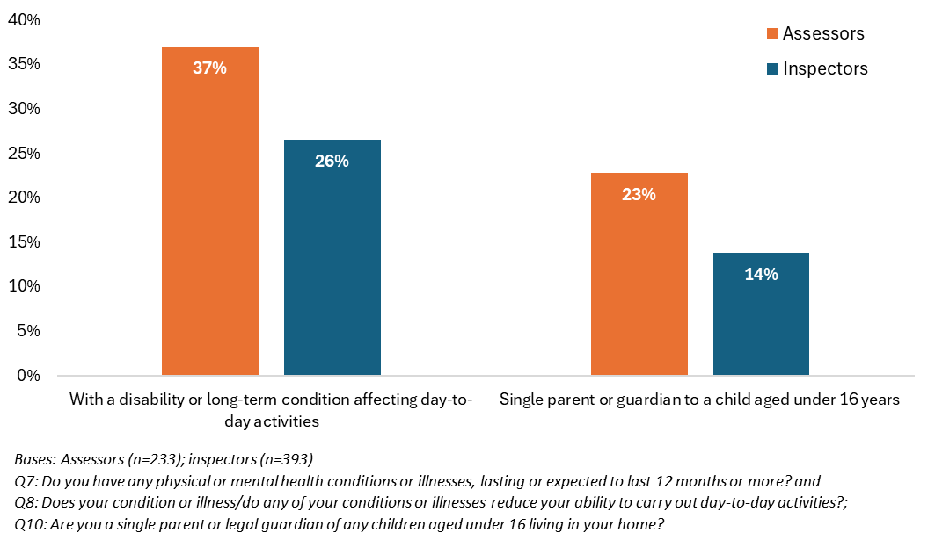

Development of the IAITs, in which the assessor and inspector roles sit, included the addition of two new roles – regulatory coordinator and regulatory officer. Recruitment to these roles was described as an ongoing activity by contributors to the TOC development, as well as ongoing recruitment to vacant assessor, inspector and operations manager positions.

* + 1. Staff engagement, training and guidance

CQC also aimed to support the role split by collecting colleagues’ feedback. This was carried out through feedback forms, regular colleague surveys, engagement meetings and other forums. To provide an additional mechanism for colleagues’ feedback, the Assessor and Inspector Role Evaluation Group was formed. This group’s membership was open to assessors, inspectors, equality network representatives and supporting stakeholders involved in the transformation (e.g. HR and legal colleagues). The group was also linked into a separate Trade Union working group.

Training materials on the new tools, roles and ways of working were developed and delivered. In addition to this training, wraparound support included upskilling colleagues to roles such as “superusers” and “change champions”. These roles were implemented to provide additional support to colleagues during the transition to new ways of working.

Feedback on the training and guidance on the new roles indicated that it **failed to adequately prepare assessors and inspectors for their new roles**. Interviewees reported that the training they received was primarily online. It was also reported to be heavily focused on usage of the Regulatory Platform, with insufficient emphasis on the practical application of CQC’s tools and systems to the new roles and ways of working. Some assessors and inspectors felt the format of the training provided did not suit their learning style. This was particularly challenging for those with specific needs relating to a disability or long-term condition.

“We criticise providers for using e-learning but then actually not checking their knowledge. If somebody's done infection control e-learning, we will then say, 'Oh okay, so all your staff have done that, but your audits are showing that actually four staff don't know how to wash their hands properly. So, you need to stop relying on e-learning’… But that's what we've been expected to do in this role. It's too much all at once, it's too overwhelming to be learning a new system, a new job, while you're dealing with providers that are so high risk. They should've allowed us maybe to do a beginning to end with just a good provider where the support was there each step of the way along.”

MI provided by CQC provides supportive evidence to this assessment. It demonstrates that there were a range of ‘mandatory modules’, focused on CQC’s new regulatory model and how to complete assessments on the new Regulatory Platform. These mandatory modules had to be completed for colleagues to gain access to the live system, and were generally completed between November 2023 and January 2024. Information on the high-level learning approach to the regulatory transformation programme highlighted that all learning would take place online, with encouragement for teams to come together to complete this in groups as well as individually. Managers were expected to influence the way they wanted to deliver the learning for their team. The MI acknowledged that online learning would not address all learning styles and needs, and proposed that additional support could be provided to those who needed it as a mitigation.

“There's a lot of training courses. I wouldn't call them training, I would call them guidance, a lot of videos to watch. There was no practical training… We'd requested it, there were a few sessions that were put on but then the Sandbox system wasn't working, so we couldn't actually do the training.”

The findings from the survey of operational colleagues suggest that the training and guidance offer represent a missed opportunity. A majority of respondents suggested the training had failed to offer the clarity required for their new roles and team configuration. Overall, assessors reported a slightly more negative view of the training or guidance they received (Figures 3.2 and 3.3 below). Findings were comparable between respondents with a disability or long-term condition affecting their day-to-day activities, and those without.

* + - 1. Clarity of training and guidance on the roles

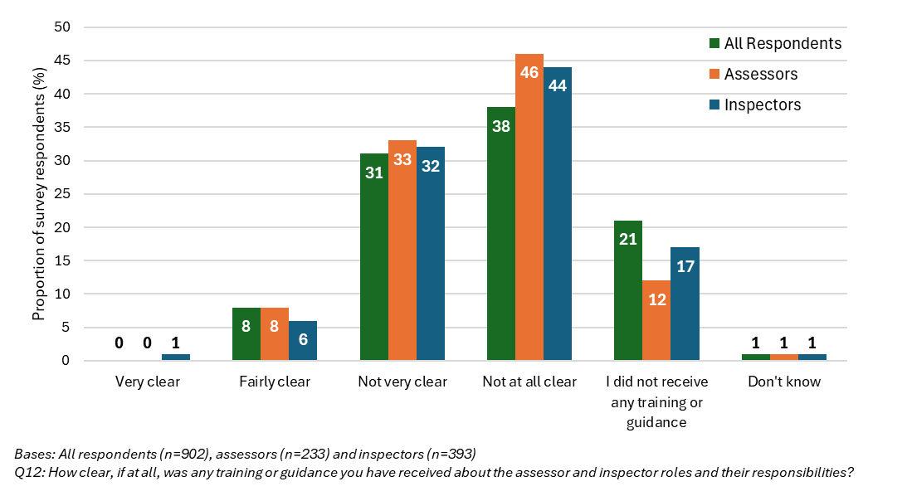

* + - 1. Clarity of training and guidance on new ways of working

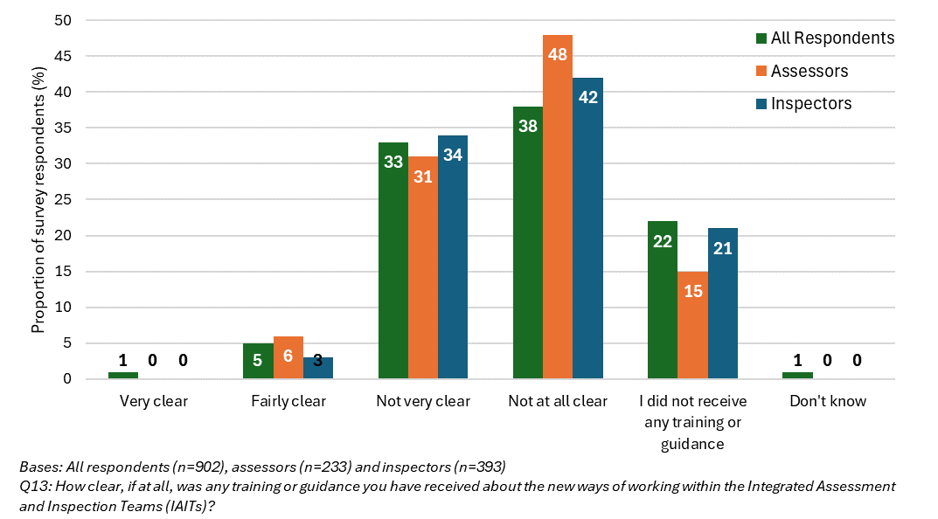

Assessors and inspectors who participated in the evaluation felt guidance documents were unclear and lacked **detail and specificity about the assessment process and the interplay between the roles**. Interviewees also noted that the frequency of changes to the guidance (once implemented) contributed to confusion in their teams.

“I think people are probably feeling down. Demotivated because there's only so much guidance you can read and the guidance changes and the guidance is [saved online] in about 14 different places. So, you're always never quite sure if you've got the right guidance.”

Based on interview and survey responses, the table below summarises **suggested improvements to future training and guidance** for CQC colleagues:

* + - * 1. Suggested improvements to future training and guidance

| Suggested improvement | Description |
| --- | --- |
| Clearly communicate the “why” | Providing clearer information about the **rationale and objectives** of the role split would have enabled CQC colleagues to understand the intended benefits to them, the organisation, service providers and ultimately service users. |
| Detailed job descriptions and process maps | Creating detailed and specific role descriptions, outlining **individual responsibilities at each stage of the assessment process**. Visual aids like process maps could further clarify the assessment workflow and **interactions between different roles in the team**. |
| Sector-specific, case-study based training | Developing training materials that use **real-life case studies** to demonstrate how different roles effectively collaborate throughout the assessment process. Tailoring training content to address the **specific needs and nuances of each sector specialism**. This approach aims to bridge the gap between theoretical and practical application of new ways of working and tools. |
| Blended learning approach | **Offering a mix** of online modules and in-person workshops, catering to different learning stylesand preferences. Opportunities for **on-the-job shadowing or mentoring** were highlighted as having the potential to be beneficial and supportive, particularly for colleagues who are new to their role or the organisation. |

1. Rollout of the role split and its early outcomes

Throughout the first quarter of 2024, CQC operational network colleagues moved into their new roles in a phased approach. This began with the South network in December 2023, with the other networks following in January and February 2024. Whilst assessors and inspectors were then nominally performing their new roles, a number of contributors noted that many were operating in a hybrid role, taking on responsibilities outside those originally intended for their nominal role.

This section assesses whether the early desired outcomes of the role split, described in the TOC, began to emerge, and the reasons for the results.

* 1. Early outcomes of the role split

At the outset of the evaluation, CQC colleagues set out that were the role split to work as planned, evidence would begin to emerge of:

* + Assessors and inspectors understanding their new roles, and working in line with the intended design of their roles;
  + IAITs operating in line with the intended design;
  + Tools and systems enabling assessors and inspectors to perform their roles; and
  + Portfolios and risk being held at the IAIT level, not by individuals..
    1. Assessor and inspector understanding of the roles

The immediate outcome of assessors and inspectors clearly understanding their new roles and responsibilities, and working in line with this, was considered to be a key first step towards achieving the desired medium- and longer-term outcomes of the role split.

Discussion with CQC data colleagues during the early stages of the evaluation enabled the Ipsos team to produce Figure 4.1 below. It outlines the assessment process as measured within CQC management information at that time (April 2024). Key assessor and inspector responsibilities are noted at each stage.

* + - 1. Assessment process and assessor and inspector responsibilities as measured within CQC management information

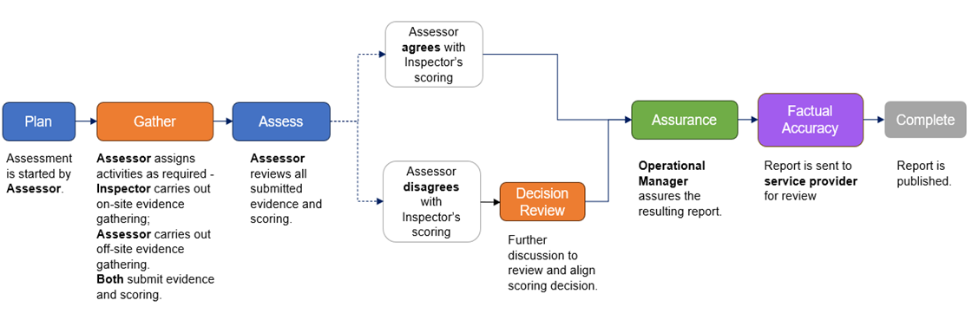

Evidence gathered by the evaluation suggests that there was a widespread **lack of clarity about the roles and how they should work together in practice**. Initial internal feedback from CQC colleagues during the early stages of implementation (November 2023 to April 2024) demonstrated that many felt the job descriptions lacked detail and clarity. Some felt that overlap between the two job descriptions had contributed to a sense of confusion in their teams, resulting in duplication of effort and difficulty allocating tasks effectively.

Later interviews with assessors and inspectors indicated that the lack of clarity described in the initial feedback continued. **Interviewees could describe the basic, high-level idea of the new roles** – that is, in the generalised words of the interviewees, the assessor role was focused on remote assessment activities, and the inspector role focused on “crossing the threshold” and gathering data about services on-site. However, interviewees in both roles consistently described a lack of understanding about both **the rationale for the role split and how the roles should work together effectively in practice** to complete assessments.

“When they split this [role into] inspector and assessor, they told us this will make us more efficient and safer… but they're not telling us *why* that works.”

Survey responses aligned with this observation. Respondents reported a better understanding of the individual roles and poorer understanding of how the roles should work together and how the team should work as a whole.

Overall, the inspector role was better understood than the assessor role, with 58% and 48% of all respondents (respectively) reporting they understood the roles very or fairly well. Those who were inspectors or assessors reported a better understanding of their own role than the alternate role, as might be expected. A third (33%) of assessors and inspectors (combined) reported understanding how the two roles should work together. Less than a quarter (24%) of respondents reported understanding how the different roles in the IAIT should work together as a whole. These proportions were comparable across both assessors and inspectors.

* + - 1. Assessors’ understanding of roles and ways of working

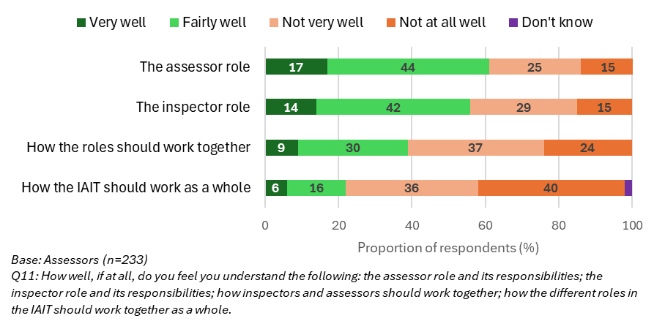

* + - 1. Inspectors’ understanding of roles and ways of working

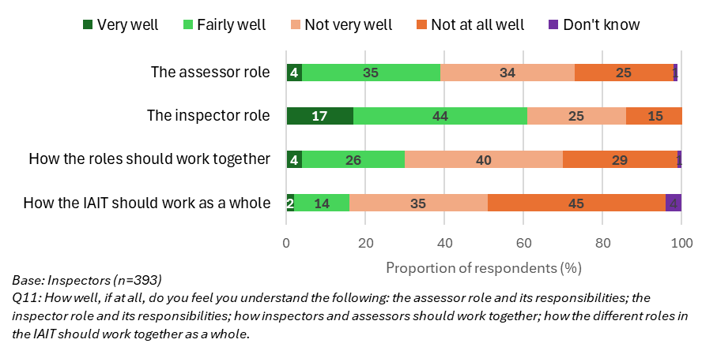

Respondents’ understanding of the roles was also comparable across the geographical networks. Those whose primary sector specialism was primary and community care reported a poorer understanding of the inspector and assessor roles; these results were similar across the other three sector specialisms.

* + 1. Assessors, inspectors and IAITs working in line with the intended design

As noted above, many assessors and inspectors were operating in a hybrid role, and CQC made several operational decisions regarding the role split during the evaluation (see section 1.2).

Survey responses indicated that roughly a third of assessors and inspectors identified that they were working in each of the three types of role – i.e. as an assessor, inspector, or in a hybrid role. A greater proportion of inspectors perceived that they had taken on a hybrid role than assessors. A greater proportion of respondents with a disability or long-term condition affecting their day-to-day activities and those who reported being a single parent or guardian described themselves as working in the assessor role (as opposed to as an inspector or in a hybrid role).

* + - 1. Respondents’ role in practice

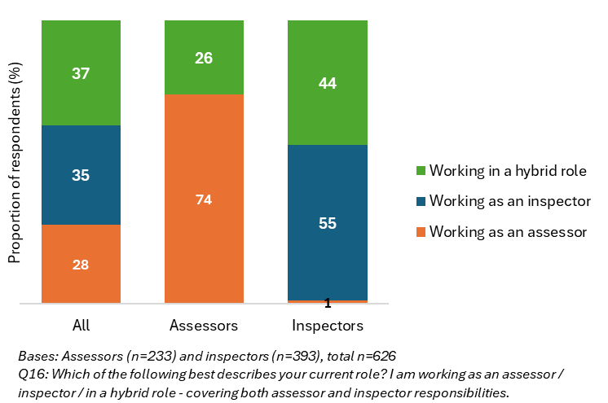

Interviews with assessors highlighted that for some, the reasons for not taking on a hybrid role echoed their reasons for choosing the assessor role in the first place. This included– concerns about the frequency of travel and on-site visits, and balancing this with their personal circumstances and/or caring responsibilities.

“I'm sticking to the assessor part of the role [instead of hybrid working], just because of my own personal circumstances, because I can't go out all the time. I have a child with disability, so I can't just go out, I've got caring responsibilities. I also have my own health issues as well, which restricts me.”

Around four in ten (41%) survey respondents working in a hybrid role reported spending more time carrying out assessor activities than inspector activities (Figure 4.5). Nearly a quarter (23%) indicated they spend about the same amount of time on assessor activities as inspector activities. These findings suggest that the distribution of tasks is more heavily weighted on the assessor role, or that there are insufficient assessors in post.

* + - 1. Hybrid working activities

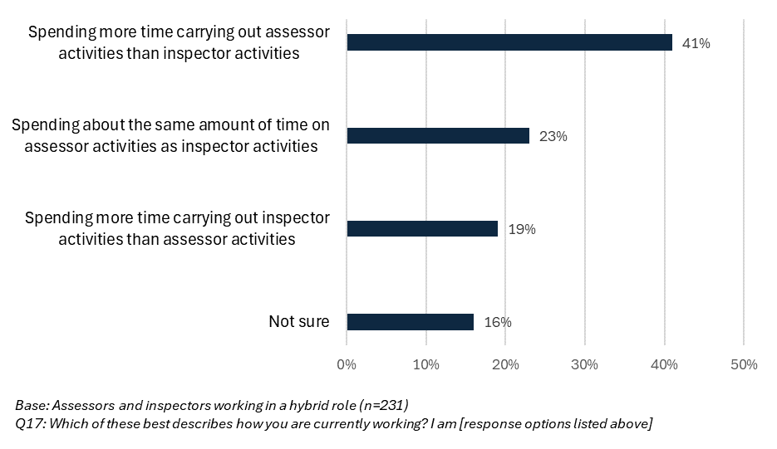

As the relationship owner function was not in the remit of either role, portfolios and risk could be described as held at the IAIT level, rather than by individual inspectors or assessors. Several interviewees from the smaller specialisms, particularly mental health, described covering a much wider geographical patch than their IAIT in practice, due to staffing shortages in other areas. This poses challenges to the theorised ownership of risk at the local, IAIT level.

“If I could sit here and just do my patch, I think it would be quite manageable and containable, but I think because we're having to work more widely… it just makes things a bit more difficult. For example, I highlighted a risk and said, 'You know, we need to go out at some point to this [service].' Couldn't get a team together… I had to pull in all these people from all over the shop, which isn't helpful to us or the provider really.”

“There's not enough of us unfortunately, and maybe certain areas are busier than others so that's an added complication… I think some sort of compromise and trying to work within closer proximity to our geographical areas would help with wellbeing, but also managing risk. I think that we'd be able to manage the risk better and have oversight.”

Across all evaluation activities, CQC colleagues raised concerns about the oversight of risk. Both assessors and inspectors expressed anxiety about **missing risks due to the new roles and processes**. The shift away from having inspectors familiar with specific services raised concerns about gaps in understanding and oversight. The **lack of a consistent approach** to implementing the role split across different teams, coupled with technical problems with the Regulatory Platform (see section 2.2.3 below), further amplified concerns about risk management and escalation.

“Before in our role as a relationship owner… we’d also get through a lot of soft intelligence. If it just comes through on its own, we can't use that alone, but all gathered together [by the relationship owner], it does help have that oversight of risk.”

* + 1. Tools and systems

Full evaluation of the tools and systems in place at CQC, including those that were introduced around the same time as the role split, was beyond the scope of this evaluation. However, the extent to which these tools and systems enabled assessors and inspectors to carry out their new roles within new teams was assessed. The main tools and systems explored were the Regulatory Platform and the SAF.

A key assumption in the design of the role split, captured in the TOC, was that the Regulatory Platform would enable colleagues to complete assessment activities efficiently. Data gathered across evaluation activities indicated that, at that time, the **Regulatory Platform was not working in a way that was fit for purpose**. Both assessors and inspectors consistently felt that it was not enabling them, but instead making their roles harder.

Among survey respondents, a slightly higher proportion of assessors than inspectors reported that it enabled them in their role. This, perhaps, reflects the more data-focused nature of the assessor role. However, as shown in Figure 4.6, the majority of the respondents felt it was not enabling them to carry out their role.

* + - 1. Views on the Regulatory Platform

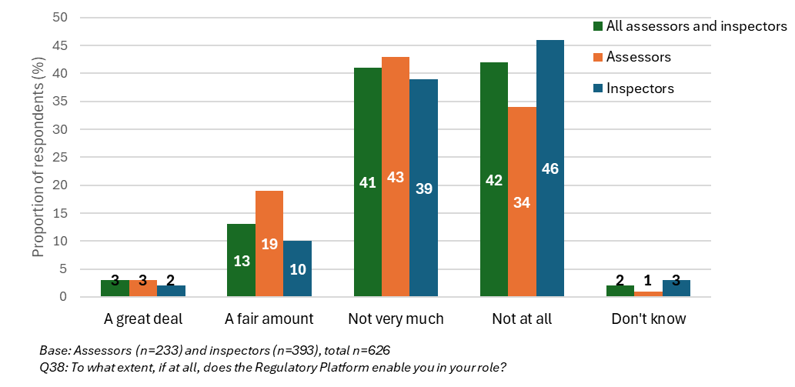

Although assessors and inspectors overwhelmingly described frustration with the Regulatory Platform as a whole, two specific tasks within the assessment process emerged as key challenges: the time required to upload evidence, and issues with reporting entries ‘disappearing’ from view. These challenges resulted in frustration and a lack of trust in the new system. The lack of a functional system forced CQC colleagues to develop their own workarounds. Interview participants reported using spreadsheets and shared documents outside the Regulatory Platform, to manage information and planning of assessment activities. Whilst these workarounds offered a temporary fix, interviewees noted that they are not sustainable solutions and contribute to inconsistencies in working practices across teams.

A small minority of interviewees noted that the Regulatory Platform showed improvement for **managing and overseeing cases** compared to the previous system. However, all described the current challenges outlined above.

Another assumption made in the design of the role split, and captured in the TOC, was that the SAF was understood and in use by assessors and inspectors. Data gathered suggested that **while theoretically a promising initiative, the SAF was not enabling assessors and inspectors** to carry out their roles effectively. Three main themes emerged from interviews:

* + **Current lack of practical usability**: While some interviewees thought the SAF could be a useful tool for consistent regulation across health and social care services, applying the SAF in practice remained challenging. Practical problems with the Regulatory Platform contributed to this.
  + **Large number of evidence categories**: The number of evidence categories under each quality statement was seen as a barrier to the assessment process, particularly for the comprehensive assessments required in services with outdated ratings.

“I think they need to remove the evidence categories. We've got these quality statements, which we can use our intelligence, as inspectors, to upload the relevant evidence to those categories to demonstrate the point and the scores that we're giving. The evidence categories are just slowing us down and making things more cumbersome.”

“I might write something that applies to seven quality statements, but the assessor will have to pick out the bits that relate to quality statement 1 and put that in, and then pick out the bits to quality statement 2 and put that in, in the right evidence category… It's just onerous. Frustrating, you know, if you speak to people, they just feel they can't do the job.”

* + **Lack of sector-specific guidance**: Participants reported needing clearer guidance on how to practically apply the SAF to different types of services and specialisms. They felt the SAF did not adequately account for the nuances of each sector.

“We needed to do 'What's in this quality statement?’, ‘What does this quality statement mean for people?', 'What does good look like for this quality statement?'… All we got was process guides for how to drive the system.”

Survey responses about the SAF supported these interview findings, with the majority of assessors and inspectors reporting that it did not enable them to carry out their role much, or at all (Figure 4.7).

* + - 1. Views on the SAF

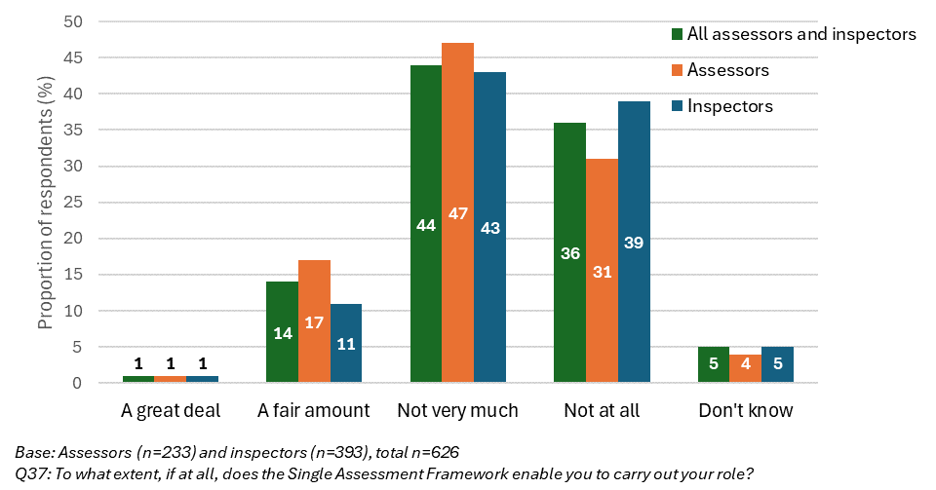

Although the sizes of the respective subgroups of survey responses were not large enough to test for statistical significance, assessors and inspectors who had worked at CQC for less time reported a more positive view of both the Regulatory Platform and the SAF.

* + - 1. Positive views of Regulatory Platform and SAF by length of service

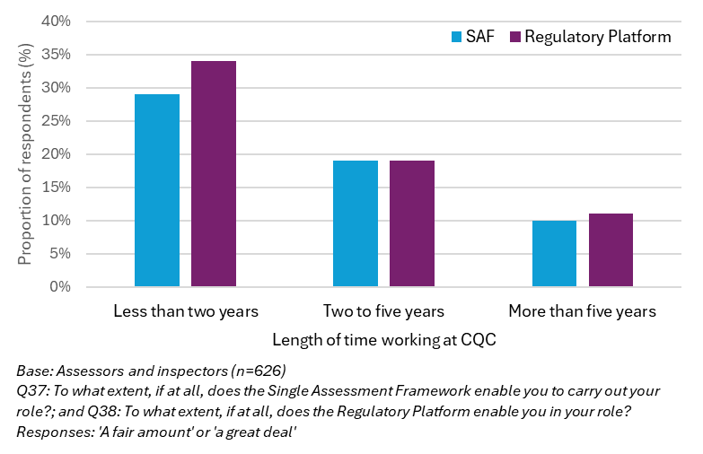

Solutions that interview and survey participants suggested would enable them in their roles are outlined in the table below:

* + - * 1. Suggested solutions for tools and systems

| Tool or system | Suggested solutions |
| --- | --- |
| Regulatory Platform | Improvetechnical performance – including: improving **upload speeds** to reduce frustration and increase efficiency; and enhancing **data quality and search functionality** to enable users to find current, correct information about service providers quickly.  Improve usability and workflow – **simplifying the user interface** for a more intuitive experience; and **increasing system flexibility** to allow users to navigate the assessment process more easily. |
| Single Assessment Framework | Streamline the **number of evidence categories** to simplify the assessment process and reduce duplication (both in practice and on the Regulatory Platform).  Develop **sector-specific training and guidance** explaining how to apply the SAF within different specialisms and services, including what ‘good’ looks like. |
| Other tools | Develop **templates** to support consistency in report writing.  Improve **planning tools** to support the flow of information between colleagues preparing for and carrying out an assessment.  Note: During the process of finalising this report, the evaluation was informed by CQC that these two tools have since been produced and made available to operational colleagues. |

1. Expected outcomes of the role split over the medium term

Within the original design of the role split, captured in the TOC (Appendix 1), a set of outcomes were expected to emerge as the role split matured. These outcomes related to: activities undertaken by assessors and inspectors; their confidence, job satisfaction and wellbeing at work; the function of the IAITs; and assessment completion and consistency. All of the evidence gathering for the evaluation took place while the role split was formally in place, including with many working in hybrid roles. This chapter presents the findings from these activities, although it is noted that, in many geographies and teams, the role split had not been implemented as initially planned over this period (and the decision to revert to a single role has since been made).

* 1. Inspector and assessor activities
     1. Inspectors’ activities

First, the report will consider how the inspectors’ roles have changed, as one of the aims of the role split design, captured in the TOC, was to minimise the time inspectors spend reviewing documentary evidence, allowing more time for on-site observations of care and engagement. The intention was for the assessor role to pick up more of this desk-based work. There is limited evidence gathered through this evaluation that this has occurred over the period the initiative was in operation. Around two thirds (66%) of survey respondents working as inspectors or in a hybrid role reported that the amount of time they spent in services **observing care and engaging with service users or staff had decreased**, compared to before the role split (Figure 5.1).

* + - 1. Change in inspector activities since the role split

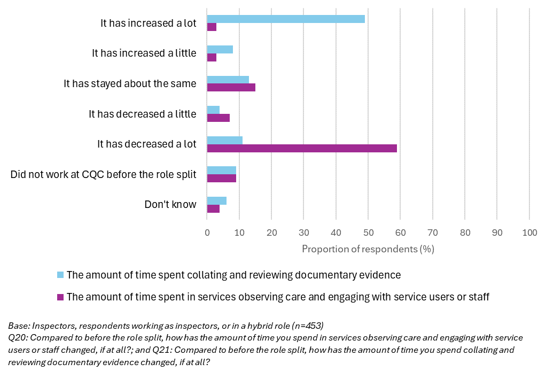

Nearly three in five respondents (57%) reported the amount of time they spend **collating and reviewing documentary evidence had increased**. Survey responses from operations managers supported these findings. Summary timesheet data also supported this narrative. It showed a substantial decrease in the number of hours spent on-site – from over 11,600 hours in July 2023 (pre-role split), to approximately 5,000 hours in July 2024. This decrease was observed across all specialisms. Whilst challenges with the Regulatory Platform have undoubtedly had a negative effect on the delivery and completion of assessment activities, qualitative data gathered by the evaluation also suggested the role split has contributed to the reduction in on-site inspection activities.

“Assessors seem to be doing everything, inspectors waiting for instruction. As an inspector I feel hugely deskilled, I am waiting for allocation of an inspection, when I could have completed at least four this year if I was able to set up my own assessments and work through them. I could be working on cases, but this is not my role. But assessors are drowning, which may cause information [to be] missed.”

* + 1. Assessors’ activities

The role split design also aimed to increase the number of data sources used as part of assessments, with a longer-term goal of increasing data-driven decision making within CQC regulation. While some assessors reported using more data sources for assessments than in previous inspections, these were not necessarily new sources of data (as was assumed when the roles were designed).

“Unfortunately I am able to use [data] less… because, we always had systems that were presenting our portfolios, or our set of services in a certain way, before we moved to new teams. I have less overview of data now, I need to put more manual effort to try to find any patterns, trends…

I think that the principle was be more analytical and have better tools, but it's at early stages of development of those tools, and they haven't been available throughout that process, despite us working in different roles. So, I don't think it's any more analytical, we still review the same information, but in a much more basic level than we used to.”

Around four in ten (41%) survey respondents working as assessors or in a hybrid role reported the **number of data sources they use for assessments had increased**, compared to before the role split (Figure 5.2). A quarter (26%) reported that it had stayed about the same. This is potentially a positive sign that those who had taken up the assessor role were working as intended. However, more than half (56%) reported they were **not making use of** ***new* data sources** for assessments much or at all (Figure 5.3). Responses from operations managers also aligned with these findings. Relevant system data or MI to demonstrate the number of data sources used in assessments were not available at the time of analysis. Training pathway information for the assessor role did not identify any data-related or analytical training support. Collectively, this indicates that further clarity and support is needed to identify and enable the integration of additional data into assessments.

* + - 1. Change in number of data sources used for assessments

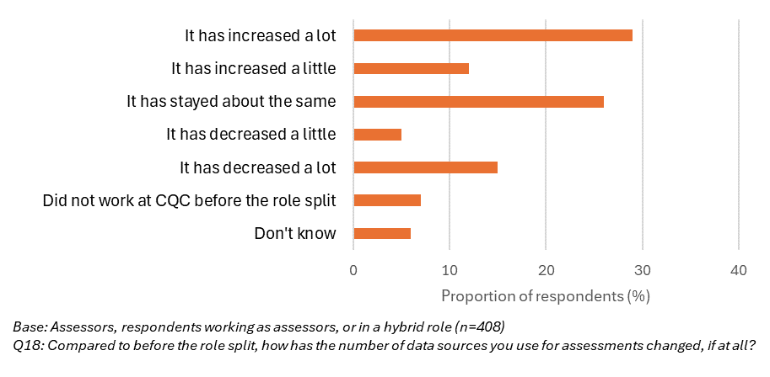

* + - 1. Assessor use of new data sources

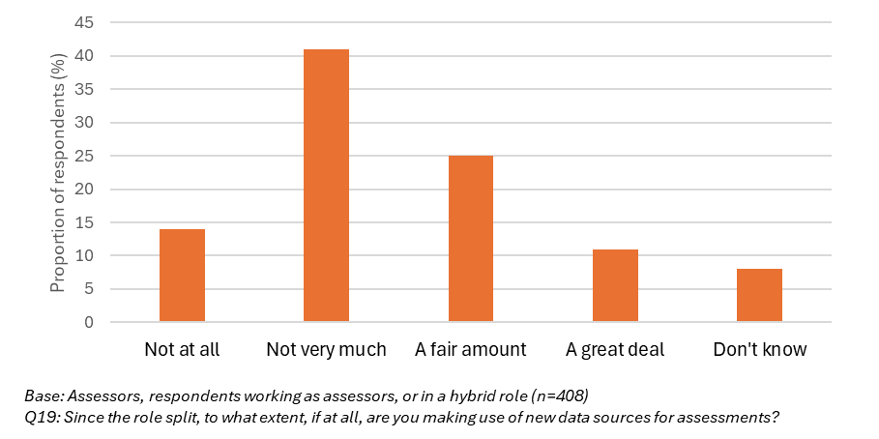

CQC MI indicated that, across all networks, inspectors spent more of their time gathering evidence on site than assessors, while assessors spent more time on ‘plan’ and ‘assess’ activities. The percentage of time spent on other activities, including gathering evidence remotely (i.e. documentary evidence) appeared to be broadly similar between the roles. This suggests the allocation of remote evidence gathering exclusively to the assessor role (in the role split’s design), did not align with the real-world context or requirements of the assessment process.

Alongside the challenges associated with the Regulatory Platform’s functionality (described in section 4.1.3), feedback form, interview and survey data provided information on several other barriers to the new roles working as designed:

* + - * 1. Barriers to new ways of working

| Barrier | Detail |
| --- | --- |
| Uneven distribution of tasks | Overall, the allocation of tasks was reported to be **unevenly weighted on the assessor role**. Assessors described being overwhelmed with incoming cases and notifications, struggling to initiate, plan, and write reports on assessments alongside this. |
| Process bottlenecks | Inspectors reported that waiting for assessor colleagues to **initiate an assessment** caused delays, leaving them unable to schedule and plan on-site evidence gathering activities.  Assessors experienced delays to collating all evidence and report writing, as they were reliant on inspectors being able to **upload the evidence gathered on-site** before doing so. The Regulatory Platform did not enable inspectors to efficiently transfer this information. |
| Overlap and duplication of effort | Participants highlighted that **communication and coordination** between colleagues in the two roles was critical, but very challenging in the absence of clear guidance.  Potential overlap and duplication of effort was identified in four main areas:   * contact with and requesting evidence from service providers; * planning of the whole assessment alongside planning the respective on-site visits; * gathering documentary evidence (e.g. policies and records), particularly when new issues were observed during on-site assessment activities; and * report writing. |
| Assessment backlog | Some participants highlighted that they supported, in principle, the idea of shorter, more focused assessment activity that is proportionate and responsive to risk. However, they noted that this would only be possible **if the assessment backlog were cleared**, as they felt services that have not been assessed for several years first require more comprehensive assessment. |
| Data availability and quality | Overall, assessors and inspectors did not feel that any additional data or information was available to them. Changes to CQC systems meant that **accessing information via reports or dashboards** was more difficult than before, and sometimes required navigating multiple systems to find accurate information. The loss of relationship owners was also highlighted as contributing to a loss of ‘soft intelligence’ about provider services. |

“The problem is that inspection to regulation is a thread, not a staircase. So, you wouldn't be looking at a case and deciding to escalate, and then not doing the work to escalate it, investigate it, and then go to enforcement. You wouldn't start a process without finishing a process…

There is a huge overlap and there is a huge duplication of process. I will make a decision, document a decision, and then, theoretically an assessor needs to read all the information, and make a decision. So, we do double the work for no benefit.”

Solutions to several of these barriers, such as the assessment backlog and data availability, were beyond the control of individual inspectors, assessors, and IAITs. However, several participants described **solutions or practices within their teams** that were helping to mitigate for the uneven distribution of tasks, bottlenecks and duplication of effort. These practices centred chiefly on **more flexible allocation of tasks between the roles**, including inspectors leading on report writing for the services they had visited.

* 1. Assessor and inspector confidence, job satisfaction and wellbeing at work

Given the limitations to the operational colleagues’ understanding of the roles and new ways of working (documented in section 4.1.1), it is unsurprising that overall, nearly two thirds (63%) of assessors and inspectors that responded to the survey felt **not very or not at all confident in carrying out their responsibilities** for assessments. This proportion was consistent across roles, sector specialisms, geographical networks, length of time working at CQC, and for respondents with disabilities or long-term health conditions, and caring responsibilities.

* + - 1. Assessor and inspector confidence

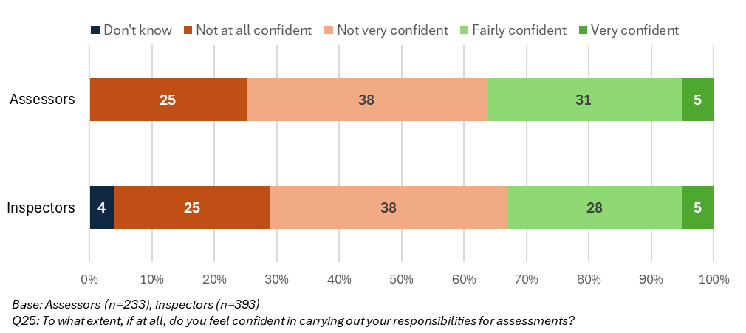

Survey responses on job satisfaction and wellbeing at work were poor. Nearly seven in ten (69%) respondents described their job satisfaction as a lot worse since the role split; 58% described their wellbeing at work as a lot worse (Figure 5.5). These results were also consistent across respondent subgroups.

* + - 1. Assessor and inspector job satisfaction and wellbeing at work

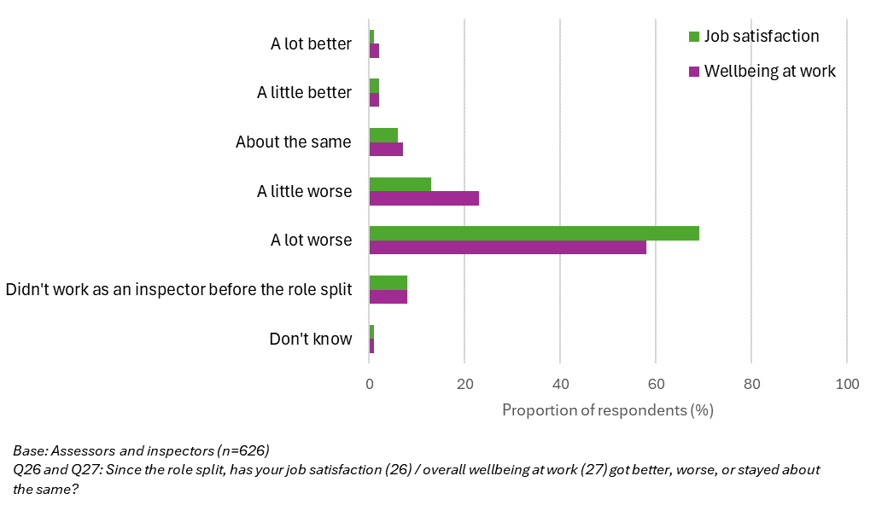

Interview data strongly supported these findings. Both assessors and inspectors expressed **concerns about becoming deskilled** due to the narrower focus of their new roles. Some inspectors were unhappy that assessor colleagues, who are their peers, were now responsible for allocating tasks to them. These factors, coupled with the overall frustration with the other implementation challenges, contributed to low morale and job dissatisfaction.

“As an assessor, quite often you feel like a glorified admin person. The bulk of your role is actually doing the bureaucratic parts of making sure that we are moving the assessment process, and trying to find a way forward… rather than actually reviewing evidence to make sure we support providers to improve, or we take appropriate enforcement.”

“As an inspector, I feel like I don't have as much control over what I'm doing… I feel like the work that I am doing is, sort of, given to me. Whereas before, I had a portfolio, I had more of an awareness of the risk on my portfolio, where I needed to inspect, what I needed to inspect. Whereas now, all those decisions are made before it gets to me.”

Some participants **raised particular concerns about the wellbeing of colleagues in the assessor role**. These concerns were not only due to their workload, but also the nature of the work they were responsible for in managing incoming cases and notifications. Participants noted the risk of secondary trauma through reading ‘bad news’ all day, and the additional challenge of accessing emotional wellbeing support when home working and feeling isolated.

“It's quite intense to just be looking at bad things all day because nobody's sending us a case in that says, 'This care home is great', and if they do, it gets shut down before we even see it. It's quite a lot in terms of an emotional toll of just reading negative things and working in silo from home. I think a lot of us reach out to colleagues … but it's not the same as being in an office and turning around and saying, 'Oh, my god, this is awful,' and having that immediate debrief.”

“As an assessor I have spent consecutive days just picking off high and extreme risk cases and speaking to distressed and unhappy people. I might have done that a couple of times a week in my role previously. Two to three times in a day, day after day is stressful.”

While CQC’s People survey did not directly ask CQC colleagues about their job satisfaction, summary results shared with the evaluation presented an alternative view of employee wellbeing to that gathered in this evaluation. When comparing results from October 2022 to January/February 2024, the percentage of assessors and inspectors (Grade B colleagues in the networks) who agreed that they had a **manageable workload** had remained broadly the same across each of the networks. The percentage of respondents who agreed that CQC supports the **health and wellbeing** of staff increased across all networks. The proportion who disagreed with these statements decreased across all areas – except for the South network, where there was a 6% increase in people who believed that CQC does not support staff health and wellbeing. These data indicate potential regional differences in CQC colleagues’ experiences.

MI provided on vacancy, retention and sickness rates presented a mixed picture. When comparing the reported 12-month turnover rate for Operations between March 2022 and May 2024, turnover has decreased from 10% to 8.8%. However, these figures notably also include operational colleagues outside the geographical networks, whose roles have not been changed by the role split.

Data from May 2024 indicated that, by network, the highest vacancy rate was in London and East of England (9.3%), and the lowest in the Midlands (1.7%). The vacancy rates in the North and South were both 6.6%. By specialism, vacancies were reported to be highest in adult social care and secondary care, and lowest in mental health. The data reviewed also detailed the specialisms where the ratio of assessors to inspectors is not in line with staffing targets – however, it is important to note that these targets may not accurately reflect staffing needs.

Additional MI showed the retention rate for assessors and inspectors by network, comparing March 2023 (pre-role split) to May 2024 (post). This demonstrated a small decrease across all networks, except for a marginal increase in the London and East of England network (89% to 91%). **Retention appeared to be higher for inspectors than assessors** (92% vs 84% respectively). Turnover and retention rates were broadly similar across sector specialisms. This MI also compared assessor and inspector sickness rates. These data indicated that **sickness rates have increased**, across all networks (from an average of 5.1% to 6.4%). When reviewed by specialism, the sickness rate was highest in mental health (10%)–substantially higher than the sickness rate for colleagues in both secondary care (5%) and adult social care (5.8%). For colleagues covering primary and community care, sickness was 7.4%. The sickness rate reported was similar across the assessor and inspector roles (6.1% and 6.3% respectively).

* 1. The IAIT as an enabler to the roles

Interview data indicated that the new IAIT structures and resourcing were not enabling assessors and inspectors to effectively perform their roles. Four key themes emerged:

* + **Inadequate resources**: The majority of assessors and inspectors, along with other members of the IAITs, felt their teams lacked adequate resources to complete their work (Figure 5.6).
    - 1. Views on IAIT resourcing

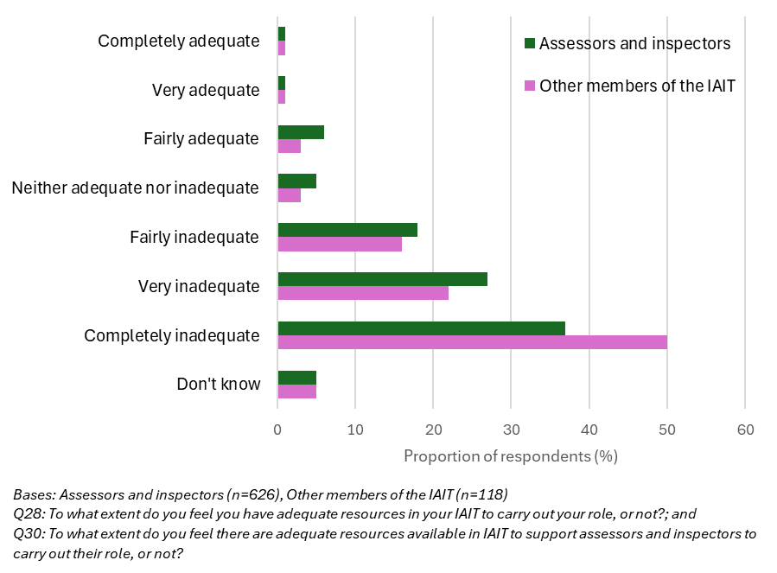

* + **Geographic challenges**: Participants reported that staffing shortages, particularly in the smaller specialisms, made it difficult for inspectors to work within their designated geographical areas. This challenge was exacerbated by the loss of the relationship owner function, which previously provided more localised knowledge of services and providers. Dilution or loss of service- or provider-specific knowledge was noted as a risk in the theory of change for the role split. The evaluation has been informed that, in the design of the IAITs, it was recognised that there would not always be a sector specialist in each team.

“The IAIT doesn't work in the way that it should in the way that it should… because there's only me, one other PCC assessor/inspector and somebody else who lives in [area A] but covers [area B] and works three days a week. [That’s for] all your GP practices and everything else. So, in its current format, with the staffing numbers that we have, it just doesn't work. I have to use an assessor from [area C]. We've only got two assessors that cover the whole area.”

* + **Imbalance of sector specialisms**: The higher number of adult social care assessors and inspectors in each IAIT created a sense of isolation for those in the other, smaller specialisms. Assessors and inspectors also noted that having a line manager without specific knowledge of their specialism could be difficult, particularly when seeking advice or escalating concerns. The intent of the IAIT model was for sector specialists (within the Regulatory Leadership team) to provide sector-specific advice to support assessors, inspectors and operations managers. Dilution or loss of specialism-specific knowledge was also noted as a risk in the theory of change.

“Within these cross-sector teams what we're finding is about 80%, 90% of the team is made up of adult social care colleagues. Most teams don't have an inspector and an assessor from the same sector [within the smaller specialisms] … I think that has been a massive challenge for some people, because they’ve lost that immediate peer support they had previously.”

* + **Inconsistent processes**: The lack of consistent processes and reliance on individual team workarounds raised concerns about risk oversight and management, and service providers’ perceptions of CQC’s credibility (particularly for providers with services across multiple IAIT areas or networks).

“What [colleagues] are having to do at the moment is everybody's gone off and started creating Excel spreadsheets for risk, here there, and they're being stored all over the Commission, on personal drives, on individual laptops, and it's a mess. So, again, [we need] a bit of consistency. Even a one-page policy to say, 'This is what you need to look at every week, in terms of IAIT oversight.”

The primary solution suggested by participants across evaluation activities was to **increase staffing levels** in the IAITs. Beyond this, participants reported that **improved processes** to support more efficient, productive working would be the most valuable additional resource for their team. Some interviewees from the wider team suggested that more guidance on, and consistency in, collaborative working with the regulatory coordinator role could also be an enabler for assessors and inspectors.

Another key feature of the IAITs’ design was the intention that it would encourage **knowledge- and information-sharing across specialisms** and increased **input to assessments from cross-specialist teams**. In practice, there is limited evidence that this aim has been realised. Survey findings indicated that nearly three quarters (73%) of colleagues in the IAITs reported that knowledge- and information-sharing within their team happened not very much, or not at all (Figure 5.7). Moreover, many interviewees considered these outcomes to have little relation to their current day-to-day role and context. Interviewees reported that they were dealing with far more basic challenges in trying to set up, plan and complete assessments and manage incoming data on risks to consider the potential benefits of learning from colleagues in other specialisms through the IAIT structure.

* + - 1. Knowledge- and information-sharing in IAITs

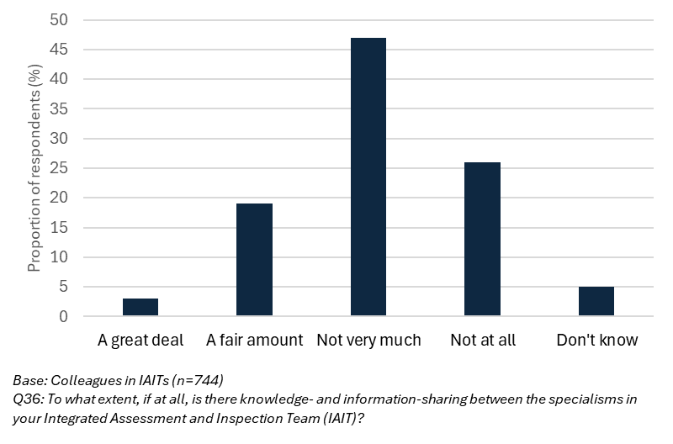

Although interviewees reported that this cross-specialism learning and working was not happening in practice, several noted that the opportunity to learn more from each other and work more collaboratively could be beneficial.

“We've been put together as a team, but we're not following a patient pathway from the beginning. GP, primary care, to somebody who then goes into hospital, and comes out into a care home. We're not looking at that pathway, which would be amazing if we did, but it's not happening. We're all so focused in dealing with our own risk, and our own issues, that nobody is thinking holistically.”

* 1. Assessment completion and consistency

The intended outcomes relating to assessors’ and inspectors’ activities, and the function of the IAITs, were expected to result in assessments being completed for an increased volume of services, and with increased frequency for each service. There is no evidence that these outcomes have been realised.

Interviewees described the assessment process as having “ground to a halt”, **with tasks taking significantly more time than before** the role split. MI provided by CQC supported this: the average time taken per inspection was recorded as 24.7 hours in 2021/22, and 38 hours in 2022/23. A snapshot of data on 4,521 assessments completed from November 2023 to July 2024 indicated the **average time taken per assessment increased** to 55.35 hours. Due to data limitations, it was not possible to compare the average time taken per inspection or assessment by type (e.g. comprehensive or focused inspection/assessment activity). Overall, these findings on the efficiency of operational performance align with the interim findings of the independent review into the operational effectiveness of CQC published in July 2024.[2]

“In the time it's taken me to get one report pushed through this system, working in this strange way, I could've done maybe eight [inspections]. And that's seven places we've not been to that we should've been to.”

The evaluation found no evidence to suggest that the role split had enabled any efficiencies. Potential efficiencies from having IAITs focused on specific local areas were not observed. This is likely due to staffing shortages requiring CQC colleagues to cover assessment activities across wider geographical footprints.

The survey findings support these observations. Most survey respondents felt the role split would have a negative impact on the efficiency of assessments; fewer than one in ten could see efficiencies in the future. This finding was consistent across geographical networks and sector specialisms.

* + - 1. Views on impact of new roles on future assessment efficiency

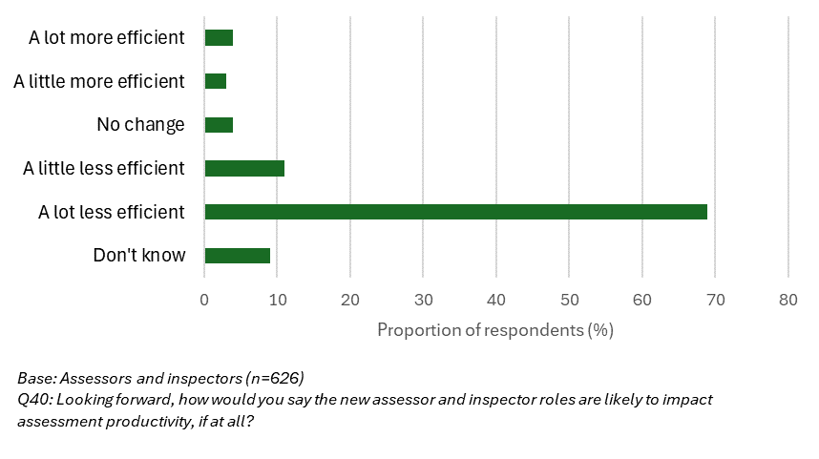

Increased consistency in assessments across teams and specialisms was another expected outcome – primarily through the use of the SAF, However, qualitative data suggested there was wide variation in how assessments were being completed, with individuals and teams adopting different workarounds to the technological and staffing challenges they faced (documented in section 5.3). MI demonstrating any indicators of assessment consistency was not available in the timeframe of the evaluation.

* 1. Perceived benefits and disadvantages

Participants in all strands of the fieldwork, both prompted and unprompted, highlighted the number and significant disadvantages of the role split. Many of these stemmed from the implementation challenges outlined earlier in this report – unclear responsibilities and processes, reduced productivity and concerns about becoming deskilled. Higher-level concerns centred around risks to service users, poor workforce morale, strained relationships with service providers, and damage to CQC's credibility.

Participants struggled to envision any longer-term benefits of the role split; the prevailing sentiment was that the challenges outweighed any benefits. Some acknowledged the potential for *aspects* of the role split to be beneficial, but these were conditional on significant improvements being made. For example, clearing the backlog of assessments and aged ratings, to enable shorter, more focused assessments and a more proportionate and responsive approach to risk, was cited in a few interviews.

Over the longer-term (and beyond the lifetime of the role split and its evaluation), several potential benefits to service provider experience were theorised. These included the benefits of improved identification and quicker response to risk; more timely identification of good practice in provider services; and providers having access to more recent ratings and information.

As noted in section 2.7, interviews with service providers did not take place as initially planned. As a result, **it was not possible to develop a comprehensive understanding of service providers’ initial experiences of the role split**. However, analysis of MI provided by CQC highlighted a reported lack of confidence and trust in CQC among service providers, stemming from concerns about the loss of local relationship management and inconsistencies in the operational approach to the SAF. This MI also indicated service providers felt that CQC colleagues **lacked confidence and adequate resources** to effectively apply the SAF in their assessments. Whilst these issues do not specifically or solely relate to the role split, they do support the findings outlined in section 4.1 and earlier in this chapter about tools and systems, data availability, assessor and inspector confidence, and IAIT resourcing.

Although the removal of the relationship owner function was not a direct result of the role split, it was a consequence of the new IAIT structure, of which the assessor and inspector roles were a key part. CQC colleagues that were interviewed described the lack of relationship owner responsibility within the new rolesas the biggest issue for service providers.

“It's about our presence, it's about them understanding who we are and seeing that we're not just a faceless organisation. It is about working relationships. It's also good to be in the service because when they contact me, I think, “Okay, that's the way that's laid out, and these are the staff that they've got, and that's how their systems work” … I can give them very specific guidance that I know will either work in their service or they can implement effectively in their service.”

“Service providers don't like not having a relationship owner… A hospice that I used to be a relationship owner of in a different area, they needed to slightly amend their registration because they needed to bring in a younger person for end-of-life care. And because our systems are so jam-packed, by the time they got it through that child would have died. So, they came to me, I addressed it for them. They knew who I was, and I'd been with them for a long time. If I wasn't here, where would they have gone to get that addressed quickly?”

Data gathered across the evaluation activities indicated that the role split **did not result in quicker response to risk, more timely identification of good practice, or access to more recent ratings and information** for provider services.

1. Conclusions and recommendations

|  |
| --- |
| This report has documented the delivery and early outcomes of the role split of the inspection workforce into assessors and inspectors. The role split of the inspection workforce into assessors and inspectors has faced significant delivery challenges and did not deliver the expected outcomes. These delivery challenges relate to:  (1) The lack of a clear, and clearly communicated, case for change. This meant assumptions about how the role split would work were not tested, and the colleagues affected did not feel consulted.  (2) Delivering the change, over a relatively short space of time, in a very challenging organisational context, with resourcing gaps and other major change initiatives (facing their own challenges) impacting on the role split.  (3) Some significant issues with the design of the role split affected the experience of many assessors and inspectors.  The evidence compiled in this evaluation therefore supports the CQC decision to revert to a single role.  The remainder of this section expands on these concluding remarks and casts an eye forward to consider which aspects of the role split might provide opportunities for learning in future change initiatives in CQC. |

* 1. Conclusions

**A clear case for the change was not communicated widely, or to those directly impacted. This hampered the role split from its outset**. While the evaluation has gathered some testimony about the *potential* value of *aspects* of the role split, an original business case, stating these points and the objectives, has not been made available. This contributed to widely held lack of understanding among operational colleagues about why the role split was taking place (or they had developed or heard several explanations). This gap in understanding was quite stark given the scale of the change (both in terms of the numbers of colleagues affected, and the impact it would have on people’s professional identity, skills and – in some cases – work-life balance). This also represents a potential missed opportunity as some features of the case for change (as articulated in the TOC development process), such as supporting home-based working, were seen as a potential positive among some respondents.

The **role split was delivered in a highly challenging CQC context**. Restructuring the core workforce at the same time as other major change initiatives had a very significant impact on its end outcomes. Other changes happening at the same time, such as introduction of the Single Assessment Framework and – in particular – the Regulatory Platform, which were, ostensibly, not part of the role split, heavily impacted on the role split. In addition, a perceived lack of staffing resource for the new IAITs was a very common theme in interviews (especially in the smaller specialisms). Partly as a result of this, there is evidence that the IAITs could not work as intended, with colleagues sticking to their geographic patches. During a significant restructure, in which extra slack would have helped people settle into their roles, the opposite was commonly the case.

Given these circumstances, **the role split could not be delivered in the planned way**. There was a high degree of hybrid working and there was no sense that this was reducing as the initiative progressed (and, indeed, was endorsed by leadership part way through the role split). Operational colleagues described how they were doing their best to patch up gaps and design workarounds for challenges with systems and tools.

The **scheduling of the rollout was also questioned**. The evaluation is aware that there was a period of preparation for the rollout which lasted more than a year (through 2023 and earlier). However, the pace of implementing the changes was fast, with colleagues transitioning into new roles and team structures over a few months. This left limited time for gathering learning from those who changed first and contributed to a sense of urgency and stress which surrounded the initiative.

Throughout the evaluation, it has been clear that **the Ops Change team has been working hard to maximise the chances of success**. There is evidence of frequent staff engagement; regular consultation with union representatives; and consideration of the needs of colleagues with protected characteristics. The commissioning of this evaluation, and the way it has been managed by CQC, also represents a commitment to understand the role split in an objective way. However, there is also **evidence that other aspects of the support for change have not worked effectively**.

Issues with the **training and guidance delivered to operational colleagues to support the role split was a common refrain**. The mode of delivery of training was considered to be overly focused on remote delivery. This is striking given the new structures of the IAITs may have worked better if teams had closer personal relationships. The focus of the training was seen to be overly focused on other elements of the transformation programme, such as the new Regulatory Platform, rather than the ‘how’ of the new ways of working. There was worry that the training did not pick up the nuances of different sector specialisms / services.

While there is evidence that assessors and inspectors **began to understand their direct roles, there remained a gap in their understanding of how they were to work together, and how the wider IAIT was designed to function**. In interviews, a common theme was that there was a lack of clarity provided on who does what in the process and how to effectively collaborate to complete assessments. There were instances reported of two people working on the same task, and a perceived risk of tasks being missed. Finally, while the evaluation is aware of a sustained programme of communications about the role split, led by senior colleagues, efforts to offer clarity and purpose to operational colleagues were hampered by any original case for change not being widely communicated, and limited communications on the role split in its early phases. This contributed to confusion and – at its worst – suspicion about the motives.

The evaluation has compiled evidence to assess the design of the role split, including which of its features were particularly problematic, and those which might be useful for future. At a high level, **the role split sought to reduce the amount of desk-based work that inspectors were spending time on** (principally, data gathering, analysis, and assessment) so that more time could be spent on-site. This **logical step was not evidenced during the evaluation period**.

There is also a sense, compiled across the evaluation, that the **balance of responsibilities fell more heavily on the assessors**. This is potentially because it is the ‘new’ role, and those colleagues were responsible for managing incoming cases and notifications alongside assessments. Resourcing challenges seem to have affected those in this role more, too. There were also more fundamental challenges about the assessor role identified, including it being **a difficult role for colleagues, as they continuously had to review difficult evidence and emotive stories**, with limited respite.

The role split, delivered alongside restructuring colleagues into IAITs, also **sought to bring colleagues from different specialist areas into blended teams**. This was partly done to ensure CQC’s teams and structures matched the systems and pathways of care that it regulates. The **evaluation has not found evidence to support this decision at this stage.** A sentiment expressed in different ways across the evaluation is that ‘specialisms matter’ (in training, management, team building, and regulation) and that the IAITs – for many reasons – had not been able to function in a way that maintained that over the course of the evaluation.

Moving towards blended teams which share risk raised the question of **relationship ownership, which was a common feature of interviews with CQC colleagues**. While there was some acknowledgement of the logic of sharing risk across teams, it was not possible to assess whether this was working during the evaluation period. Indeed, there were several examples cited of **relationship ownership informally continuing, and it was seen as crucial in maintaining some degree of regulatory oversight** during a challenging period.

Finally, in the original design of the role split, the aim was to increase the insights derived from data (allowing, for example, inspection teams to more accurately target more risky providers). The **evaluation has not been able to establish what additional data sources have been made available to assessors**, whether there is any benefit to the specialisation of assessor colleagues focusing on desktop activities, and whether any new analysis or insight generation has taken place.

Given the difficulties faced in delivering this role split, and the decision to revert to a single role, the **results of the outcome assessment documented in this report are challenging to interpret**. Many of the original medium and longer-term outcomes of the role split became invalid as the decision to revert to a single role was made. In other cases, the role split progressed in ways that were not captured in the original evaluation framework (such as the high degree of hybrid working). However, the following conclusions should be considered.

* + The role split took place over a period in which **the amount of inspection activity significantly reduced**. The **operational challenges faced due to instability caused by the role split are likely to have contributed to this reduction**.
  + There were instances where interviewees described their **worries about quality and safety issues being missed**. These were most closely linked to the challenges with the new Regulatory Platform, but were also described in connection to the role split (with its requirement that assessments of complex services were divided up, and delivered separately). As referenced, colleagues commonly developed workarounds to address these challenges.
  + **CQC colleagues’ wellbeing and satisfaction has been significantly affected by the role split**. There are several causes, including perceived lack of confidence to deliver their new roles, feeling overworked, struggling with new tools and systems, worry about quality and safety issues in the services they are regulating, and not feeling listened to by CQC leadership.

The evidence compiled in this evaluation supports the CQC decision to revert to a single role. Indeed, as the evaluation progressed, participants in the interviews often observed that they felt that decision was inevitable. With this in mind, the evaluation will conclude with recommendations to CQC in two areas: learning and actions on how to undertake future transformations; and what can be learned from the role split specifically for any future changes to CQC’s operational staffing.

* 1. Recommendations

CQC should consider the following steps in future change initiatives:

* + Conduct detailed assessments of the case for change, ensuring the considerations are widely communicated. As part of this, it is necessary to balance the strategic, economic and quality case for change, alongside the benefits for CQC colleagues. Consult widely with those affected in developing this case. Establish a small number of measurable objectives for the initiative, and consult on these. Consider the practicalities of delivering the change, including support for colleagues, at this first stage. Communicate a consistent message on the case for change throughout.
  + Use theories of change (or similar approaches) to interrogate the logic, feasibility and evidence, underpinning the design of future initiatives. Such an approach can identify design issues / logic gaps early. Engage with operational colleagues to ensure the logic and processes accurately reflect the realities of their day-to-day work.
  + Carefully consider the scheduling of any future staffing restructures alongside policy changes and the introduction of new tools or technologies. Establish the dependencies each has on the other in this scheduling process.
  + Future training offers relating to change initiatives should include: a focus on the case for change; a face-to-face element, particularly if the initiative has set out to move people into new teams; a high degree of tailoring of content to colleagues’ sector specialisms; and, a strong focus on new processes, and how colleagues should interact to deliver these.
  + Schedule a more measured rollout of change. Pilot the approach in small areas, and study the outcomes closely; use this to develop the next phase of rollout, and so on.

CQC should consider the following steps to learn from the role split, and any future initiatives with similar aims:

* + Conducting a formal review of what aspects of the role split should remain under consideration for CQC’s future strategy. This evaluation report provides the basis for this exercise and would suggest the following:
    - Continuing to explore whether a predominantly desk (and / or home) based assessment role, with more manageable expectations, greater transition support, and a review of skill requirements, is suitable to CQC’s objectives. This should interrogate whether and how such a role can contribute to a recovery in assessment numbers and efficiency, and improve colleagues’ wellbeing. A thorough assessment of people’s suitability and level of preparedness for the role as defined should be conducted.
    - Considering which elements of the end-to-end assessment process could be supported by another role or roles, without introducing double-handling of information or other duplication of effort.
    - Examining other ways to introduce risk sharing, while maintaining the consistency of relationship ownership.
  + In relation to any future role linked to the original assessor role:
    - Clarify the additional data, data flows, usage, purpose of data collection, use and analysis in any new role. Develop practical tools, reports and training to support its collection, analysis and integration into assessments.
    - Consider carefully the accessibility and training needs of the assessor role, and its day-to-day requirements.
    - Consider assessment-related responsibilities holistically. This includes workload (for example, the management of incoming cases and notifications), and risks of elevated stress.

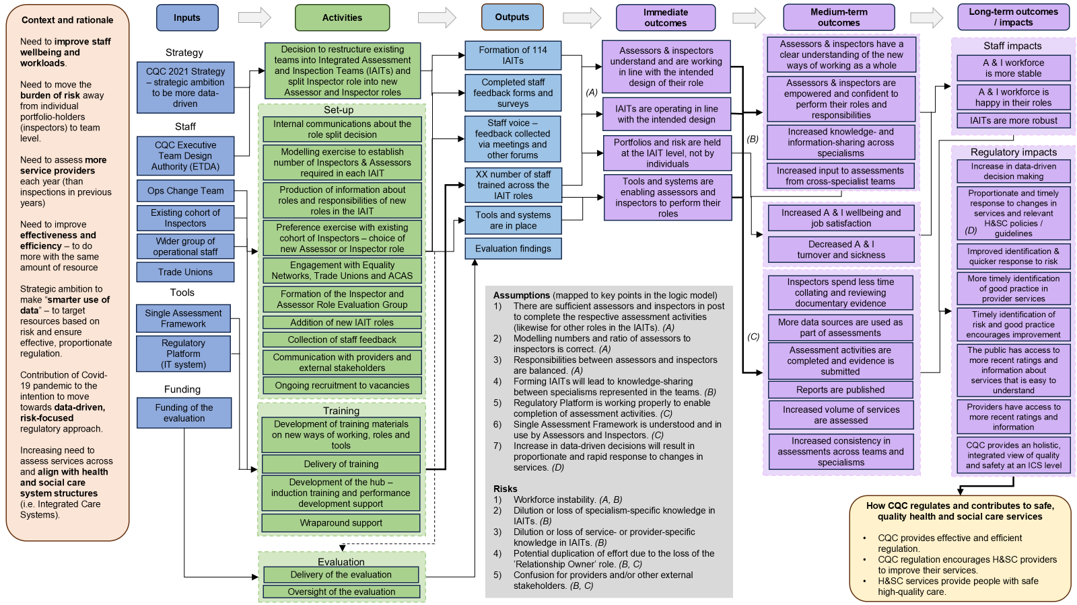Appendix 1: Theory of Change for the role split

Appendix 2: Evaluation framework

| Relevant evaluation question | Element of logic model | Data source | Indicator description  (for quantitative data) | Reporting timeline  (for quantitative data) |
| --- | --- | --- | --- | --- |
|  |  |  |  |  |
|  | **Immediate outcomes** |  |  |  |
| 1.1. Are inspectors clear on the responsibilities and expectations of their role, and how it relates to the role of assessor?  2.1. Are assessors clear on the responsibilities and expectations of their role, and how it relates to the role of inspector? | Assessors and inspectors understand and are working in line with the intended design of their role;  IAITs are operating in line with the intended design;  Portfolios and risk are held at the IAIT level, not by individuals. | * Review of staff feedback forms * Review of MI * Fieldwork with inspectors / assessors * Survey | From **MI**:   * Number of staff trained across the IAIT roles.   From **survey**:   * N and % of inspectors / assessors who report a good understanding of their responsibilities * N and % of inspectors / assessors who report a good understanding of how their role relates to the other role   (with further context provided from qualitative fieldwork) | TBC  Single point in time (phase 3) |
| 1.2. Do the tools and systems in place enable inspectors to carry out their role?  2.2. Do the tools and systems in place enable assessors to carry out their role? | Tools and systems are enabling assessors and inspectors to perform their role. | * Review of staff feedback forms * Fieldwork with inspectors / assessors; wider staff * Survey | From **survey**:   * N and % of inspectors / assessors who report that tools and systems in place enable them to carry out their respective role.   (with further context provided from qualitative fieldwork) | Single point in time (phase 3) |
|  | **Medium-term outcomes** |  |  |  |
| 1.3. What are inspectors’ views on the extent to which the IAIT structure and resourcing enables their role?  2.3. What are assessors’ views on the extent to which the IAIT structure and resourcing enables their role?  3.2. To what extent has progress in implementing the role split aligned with expectations, and why? | Assessors and inspectors have a clear understanding of the new ways of working as a whole;  Assessors and inspectors are empowered and confident to perform their roles and responsibilities;  Increased knowledge- and information-sharing across specialisms;  Increased input to assessments from cross-specialist teams. | * Review of staff feedback forms * Fieldwork with inspectors / assessors; wider staff. * Survey | From **survey** – indicator(s) to be developed based on further qualitative fieldwork. | Single point in time (phase 3) |
| 1.4. Are inspectors able to spend more time (compared to before the role split) on-site observing care and engaging with service users, their families and/or staff?  5. To what extent is there evidence to suggest the role split enables efficiencies? | Inspectors spend less time collating and reviewing documentary evidence;  Increased volume of services is assessed;  Reports are published. | * Review of MI * Fieldwork with inspectors; wider staff and service providers * Survey | From **MI**:   * % of inspector time spent on-site (not reviewing documentary evidence), compared to previous levels * N of assessments that have taken place, compared to previous levels * N of reports published, compared to previous levels.   From **survey**:   * N and % of inspectors who report spending more time while on-site observing care and engaging with service users, families and staff than previously   (with further context provided from qualitative fieldwork) | TBC  Single point in time (phase 3) |
| 2.4. Are assessors able to use a wider range of data sources for assessments, compared to inspections before the role split? | More data sources are used as part of assessments;  Increased volume of services is assessed;  Reports are published. | * Review of MI * Fieldwork with assessors and wider staff * Survey | From **MI**:   * N of data sources used in assessments, compared to previous levels * N of assessments that have taken place, compared to previous levels * N of reports published, compared to previous levels.   From **survey**:   * N and % of assessors who report utilising new or a wider range of data sources than in previous inspections.   (with further context provided from qualitative fieldwork) | TBC  Single point in time (phase 3) |
| 1.5. Does the role split support increased job satisfaction for inspectors?  2.5. Does the role split support increased job satisfaction for assessors? | Increased assessor and inspector wellbeing and job satisfaction;  Decreased assessor and inspector turnover and sickness. | * Review of staff feedback forms * Review of MI * Fieldwork with inspectors / assessors * Survey | From **MI**:   * Assessor and inspector wellbeing scores – overall, by role type, by IAIT and geographical area, compared to previous levels. * Assessor and inspector turnover and sickness rates, compared to previous levels. * Assessor and inspector retention, compared to previous levels.   From **survey**:   * N and % of assessors and inspectors who report improved job satisfaction and wellbeing   (with further context provided from qualitative fieldwork) | TBC  Single point in time (phase 3) |
| 3.1. What are the perceived benefits and disadvantages of the role split, compared to the previous role of inspector? | Increased consistency in assessments across teams and specialisms. | * Review of MI * Fieldwork with inspectors / assessors; wider staff and service providers * Survey | From **MI** – any markers of consistency across assessments.  (with further context provided from qualitative fieldwork) | TBC |
|  | **Long-term outcomes** |  |  |  |
| 4. What are service providers’ initial experiences of the role split? | Improved identification and quicker response to risk;  More timely identification of good practice in provider services;  Providers have access to more recent ratings and information. | * Review of MI * Service provider interviews | From **MI** (to explore) – possible data on assessment numbers / regularities / rating changes.  (with further context provided by qualitative fieldwork) | TBC |

Appendix 3: Evaluation methods

This appendix provides a detailed description of the methods used in the evaluation. Appendix 2 maps these methods to the evaluation questions they were used to address.

### Analysis of CQC colleagues’ feedback forms

From November 2023 to April 2024, CQC colleagues were invited by CQC to provide feedback on the role split via an online form. They were informed that the data collected would be used by the Ipsos evaluation team. CQC’s online form included two questions about the role split:

* + - * 1. Please use this space to give any feedback you wish to share about things that are working well about the split in assessor and inspector roles.
        2. Please use this space to share any feedback you have about areas for improvement in how things are working in the split of assessor and inspector roles.

The tables below outline the number of responses received by role and network:

|  |  |
| --- | --- |
| Role | Number of responses |
| Assessor | 147 |
| Inspector | 170 |
| Other roles | 18 |
| Total | **335** |

|  |  |
| --- | --- |
| Network | Number of responses |
| London and East of England | 41 |
| Midlands | 61 |
| North | 91 |
| South | 135 |
| Other network/role group | 7 |
| Total | **335** |

CQC colleagues provided feedback on the form between November 2023 and April 2024, with most of the feedback submitted between January and March 2024.

The Ipsos evaluation team developed a detailed codeframe, based on the agreed evaluation framework, to analyse the feedback form data. These data were then coded and thematically analysed using NVivo software.

### In-depth interviews with assessors and inspectors

In-depth interviews were conducted with a sample of 55 assessors and inspectors. Interviews lasted approximately 45 minutes and were carried out online.

All CQC operational colleagues were invited to express interest in taking part in an interview by completing an online form. Interviewees were then selected at random by the Ipsos team, against agreed sampling criteria. This process ensured the anonymity of both the CQC colleagues that expressed interest in participating, and those selected for interview. The agreed sampling criteria were:

* + Role: to ensure the evaluation explored the experience of those involved in both of the new roles.
  + Sector specialism: to explore variation in experience between those with a focus on different parts of the health and care system.
  + Employment at CQC: to understand variation in experience between those with a longer service time compared to those with a shorter tenure.
  + Geography: to understand whether there was variation by region; this also enabled a comparison of experience between those who had been in their new role for a longer period.

A topic guide was developed, based on the agreed evaluation framework. Interviews were carried out in three stages, described in detail below.

#### Pilot interviews (May 2024)

Six pilot interviews were conducted with assessors and inspectors in May 2024. These interviews were intentionally carried out with assessors and inspectors from the South and London and East of England regions. As these were the first CQC networks to ‘go live’ with the role split, interviewees could offer perspectives that were based on several months’ experience in their new roles.

The pilot interviews provided a key opportunity to test and refine the interview structure, flow and questions for assessors and inspectors. Following the pilot interviews, the Ipsos evaluation team made minor revisions to the topic guide, ahead of further interviews. In summary, the changes centred on:

* + Reordering questions to better establish interviewees’ understanding of how the assessor and inspector roles were intended to work together, particularly where some interviewees were working in a hybrid role.
  + Improving the sequencing of questions on the training, tools, systems and structures in place around the new roles, to support a more natural flow of discussion.
  + Removal of a question about how teams outside the IAIT (e.g. the Hub, National Operations and Regulatory Leadership) enable assessors and inspectors in their roles. Pilot interviewees were unable to comment on this, and there was a need to prioritise other questions in the time available.
  + Addition of a final question to generate solutions that interviewees feel could enable assessors and inspectors to carry out their roles.

Data from the pilot interviews was combined with the data from the mainstage and opt-in interviews (see below) for analysis purposes.

#### Mainstage interviews (June-July 2024)

Following the minor revisions to the topic guide, further interviews were carried out with 34 assessors and inspectors. The table below describes the sample of interviewees (for the pilot and mainstage interviews combined, total 40) against the agreed sampling criteria:

|  |  |
| --- | --- |
| Criterion | Sample (total 40) |
| Role | Assessor – 20  Inspector – 20 |
| Sector specialism | Adult social care – 10  Primary and community care – 10  Secondary care – 10  Mental health – 10 |
| Length of employment at CQC | Less than five years – 20  Five years or more – 20 |
| Network | London and East of England – 11  Midlands – 10  North – 10  South – 9 |

Although the sampling criteria initially aimed to achieve 10 interviewees per network, the other characteristics and responses of those willing to be interviewed meant that this was not possible. The substitute for a tenth interviewee in the South was therefore drawn from the London and East of England network, as these were the first networks to implement the role split.

#### Opt-in interviews following the survey (July 2024)

Following the launch of the survey (described below), a further 15 interviews with assessors and inspectors were carried out. These interviews were carried out with survey respondents who had opted-in to being recontacted about taking part. Using the survey responses, sampling for these interviews was focused on recruiting assessors and inspectors with disabilities or long-term health conditions and/or caring responsibilities. These interviews were undertaken to ensure the evaluation understood the experiences of this key part of the CQC workforce, and in response to feedback from CQC’s equality networks.

All interviews were audio-recorded, transcribed, coded (using NVivo software) and thematically analysed against the evaluation framework. To support this, two analysis sessions were held with the team of Ipsos interviews.

### Survey of all CQC operational colleagues

An online survey of all CQC operational colleagues was live from 21 June to 9 July 2024. The survey was designed by Ipsos based on the agreed evaluation framework. The survey contained both closed and open-ended questions. Potential respondents (n=2,002) were each sent a unique link to ensure an accurate response rate could be calculated. This included bank colleagues who had recently been involved in assessment activity and could therefore also provide insight on the role split in practice. The unique links to the survey were distributed by CQC.

The survey achieved a 45% response rate overall, with 902 responses. The response rate for assessors (72%) was higher than for inspectors (52%). The CQC team responsible for oversight of the evaluation noted that due to a number of internal secondments to other/project-based roles, these response rates may underestimate the number of assessors and inspectors that completed the survey. The table below presents respondent characteristics:

|  |  |  |
| --- | --- | --- |
| Respondent group | N= | % (of total responses) |
| All respondents | 902 | 100% |
| Role |  |  |
| Assessor | 233 | 26% |
| Inspector | 393 | 44% |
| Regulatory coordinator | 25 | 3% |
| Regulatory officer | <10 | - |
| Operations manager | 85 | 9% |
| Director or deputy director | 28 | 3% |
| Senior specialist | <10 | - |
| Other role | 110 | 12% |
| Sector specialism |  |  |
| Adult social care | 433 | 48% |
| Primary and community care | 115 | 13% |
| Secondary care | 94 | 10% |
| Mental health | 83 | 9% |
| No primary specialism / Other | 170 | 19% |
| Network |  |  |
| North | 201 | 22% |
| Midlands | 153 | 17% |
| South | 205 | 23% |
| London and East of England | 194 | 22% |
| National / Other teams | 130 | 14% |
| Length of time working at CQC |  |  |
| Less than two years | 119 | 13% |
| Two to five years | 122 | 14% |
| More than five years | 643 | 71% |
| Disability or long-term condition affecting day-to-day activities |  |  |
| Yes | 170 | 19% |
| No | 647 | 72% |
| Carer |  |  |
| Yes | 275 | 30% |
| No | 585 | 65% |
| Single parent or guardian to child(ren) aged under 16 years |  |  |
| Yes | 147 | 16% |
| No | 723 | 80% |

Quantitative survey data were analysed in Excel using descriptive analysis. Open-ended responses were coded thematically and summarised using Excel. Sub-group analyses were conducted based on role; sector specialism; geographical network; length of time working at CQC; reported current role in practice (assessor/inspector/hybrid); disability or long-term health condition(s); and caring responsibilities.

### In-depth interviews with CQC colleagues from the wider team

In July 2024, 10 CQC colleagues from the wider team were sampled, based on their role, from those who had completed the earlier expression of interest form (described above). These interviews were conducted with colleagues in the following roles: regulatory coordinators, operations managers, deputy directors and directors, and senior specialists. Participants were sampled from different networks. Whilst most of these roles (excluding senior specialists) did not have a designated sector specialism, interviewees held a range of experience of the health and social care sector.

These interviewees were asked a similar set of questions to those in the assessor and inspector interviews, although tailored to their specific roles. Interviews were audio-recorded, transcribed, coded using NVivo software, and thematically analysed against the evaluation framework.

### Analysis of CQC-held management information (MI)

During development of the evaluation framework, the Ipsos team produced a specification of suggested indicators that, if available in existing CQC-held MI, could be useful secondary data for analysis. Following discussions with relevant data colleagues at CQC, MI was provided across the following categories:

* + HR summary data on employee wellbeing (People survey), sickness, vacancy, turnover and retention rates;
  + information on training pathways
  + information on service provider sentiment; and
  + performance data on time utilisation and the assessment process.

These secondary data sources were analysed to provide additional context, assess outcomes where possible (as outlined in the evaluation framework), and offer a ‘check’ on qualitative / perception-based findings. Where feasible, indicators were compared pre- and post-role split.

Our standards and accreditations

Ipsos’ standards and accreditations provide our clients with the peace of mind that they can always depend on us to deliver reliable, sustainable findings. Our focus on quality and continuous improvement means we have embedded a “right first time” approach throughout our organisation.

|  |  |
| --- | --- |
|  | ISO 20252  This is the international specific standard for market, opinion and social research, including insights and data analytics. Ipsos UK was the first company in the world to gain this accreditation. |
|  | Market Research Society (MRS) Company Partnership  By being an MRS Company Partner, Ipsos UK endorse and support the core MRS brand values of professionalism, research excellence and business effectiveness, and commit to comply with the MRS Code of Conduct throughout the organisation & we were the first company to sign our organisation up to the requirements & self-regulation of the MRS Code; more than 350 companies have followed our lead. |
|  | ISO 9001  International general company standard with a focus on continual improvement through quality management systems. In 1994 we became one of the early adopters of the ISO 9001 business standard. |
|  | ISO 27001  International standard for information security designed to ensure the selection of adequate and proportionate security controls. Ipsos UK was the first research company in the UK to be awarded this in August 2008. |
|  | **The UK General Data Protection Regulation (UK GDPR)  and the UK Data Protection Act 2018 (DPA)**  Ipsos UK is required to comply with the UK General Data Protection Regulation (GDPR) and the UK Data Protection Act (DPA). These cover the processing of personal data and the protection of privacy. |
|  | HMG Cyber Essentials  Cyber Essentials defines a set of controls which, when properly implemented, provide organisations with basic protection from the most prevalent forms of threat coming from the internet. This is a government-backed, key deliverable of the UK’s National Cyber Security Programme. Ipsos UK was assessed and validated for certification in 2016. |
|  | Fair Data  Ipsos UK is signed up as a “Fair Data” company by agreeing to adhere to twelve core principles. The principles support and complement other standards such as ISOs, and the requirements of data protection legislation. . |



For more information

3 Thomas More Square  
London  
E1W 1YW

t: +44 (0)20 3059 5000

[www.ipsos.com/en-uk](http://www.ipsos.com/en-uk)  
<http://twitter.com/IpsosUK>

About Ipsos Public Affairs

Ipsos Public Affairs works closely with national governments, local public services and the not-for-profit sector. Its c.200 research staff focus on public service and policy issues. Each has expertise in a particular part of the public sector, ensuring we have a detailed understanding of specific sectors and policy challenges. Combined with our methods and communications expertise, this helps ensure that our research makes a difference for decision makers and communities.

1. Although the sampling criteria initially aimed to achieve 10 interviewees per network, the other characteristics and responses of those willing to be interviewed meant that this was not possible. The substitute for a tenth interviewee in the South was therefore drawn from the London and East of England network, as these were the first networks to implement the role split.
2. [Review into the operational effectiveness of the Care Quality Commission: interim report, published 26 July 2024](https://www.gov.uk/government/publications/review-into-the-operational-effectiveness-of-the-care-quality-commission/review-into-the-operational-effectiveness-of-the-care-quality-commission-interim-report)