Appendix I: Subgroup analysis charts
Methodology and interpretation

Results for each demographic subgroup were generated as estimated marginal means using a mixed effects model allowing for a binary outcome, featuring a random trust effect (an effect allowing clusters of observations to vary randomly) and fixed effects of measured demographic and care characteristic factors (effects measured at the individual level).

For analyses of single questions, the modelled binary outcome was whether the respondent selected the most positive answer (“top box”) for that question (i.e. selected most positive = 1; did not select the most positive = 0).

The results generated by these analyses can be interpreted as: the average probability that people with this characteristic, controlling for other characteristics in the model, selected the most positive answer for the question.

In this report, subgroup differences are considered reportable where a demographic or care characteristic overall (e.g. age) is significantly associated with experience and where the estimated marginal mean for the specific subgroup (e.g. 16 to 35) is significantly different from the overall mean. For further technical information on the subgroup analysis please see the Quality and Methodology report.

The analysis modelled the responses of different subgroups by sex, gender, age, ethnicity, religion, sexual orientation, route of admission, length of stay, medical or surgical treatment type, diagnosis, frailty, Indices of Multiple Deprivation (IMD) decile, disability and long-term health conditions.

Graphs

The graphs in this section highlight better than average experiences that are significant in green. Significantly worse than average experiences are highlighted in orange.

Worse than average experience
Average experience
Better than average experience

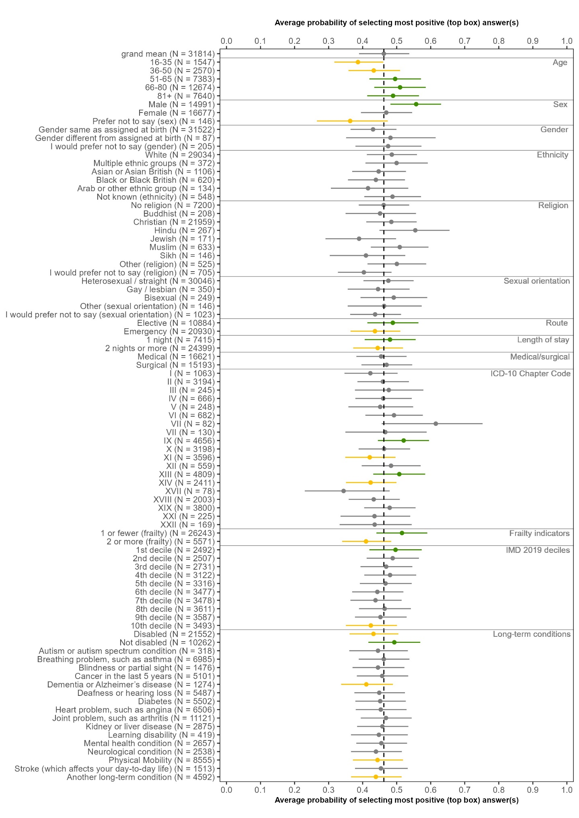
Q10. Did you get enough help from staff to wash or keep yourself clean?
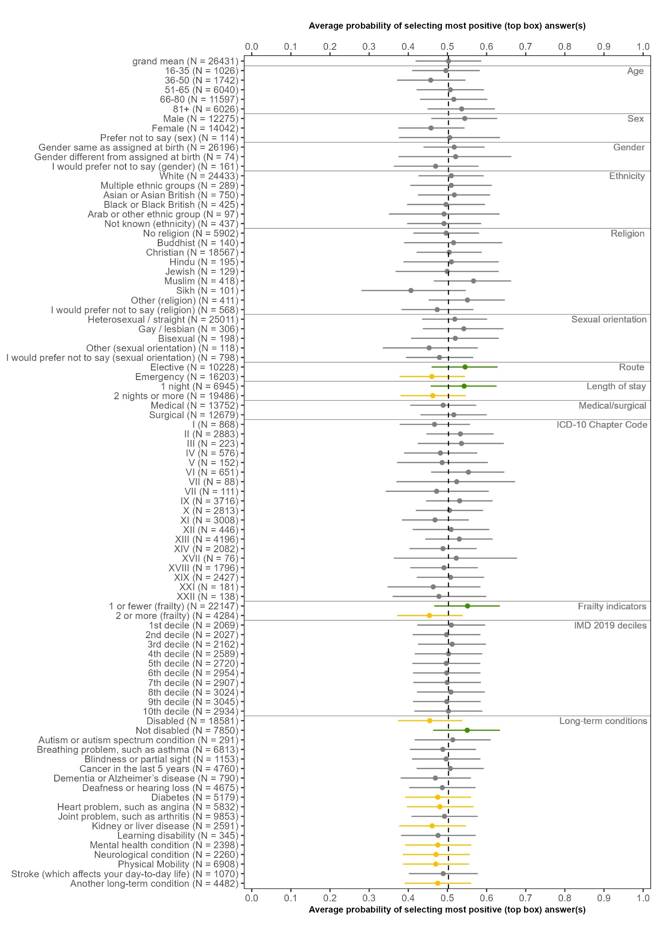
Q11. If you brought medication with you to hospital, were you able to take it when you needed to?
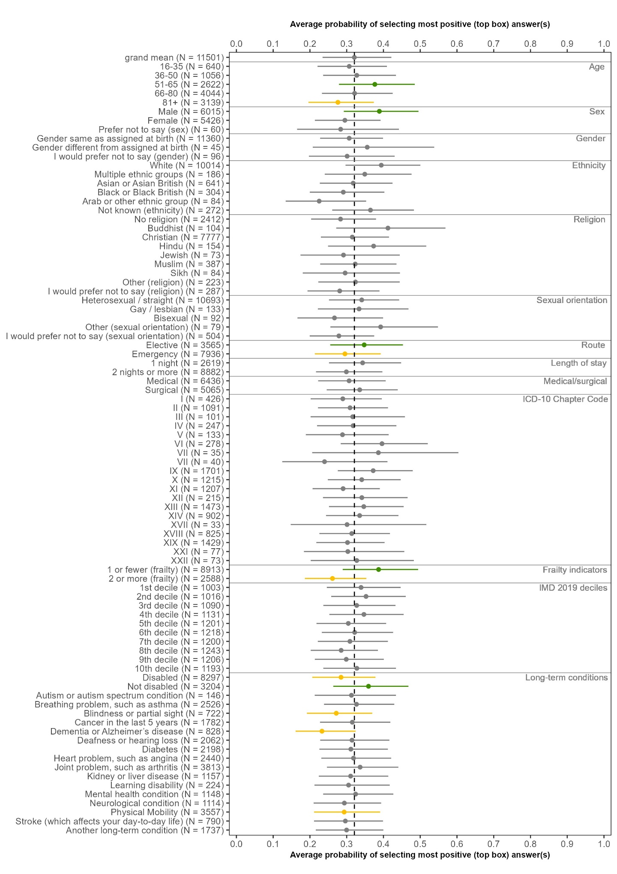
Q14: Did you get enough help from staff to eat your meals?

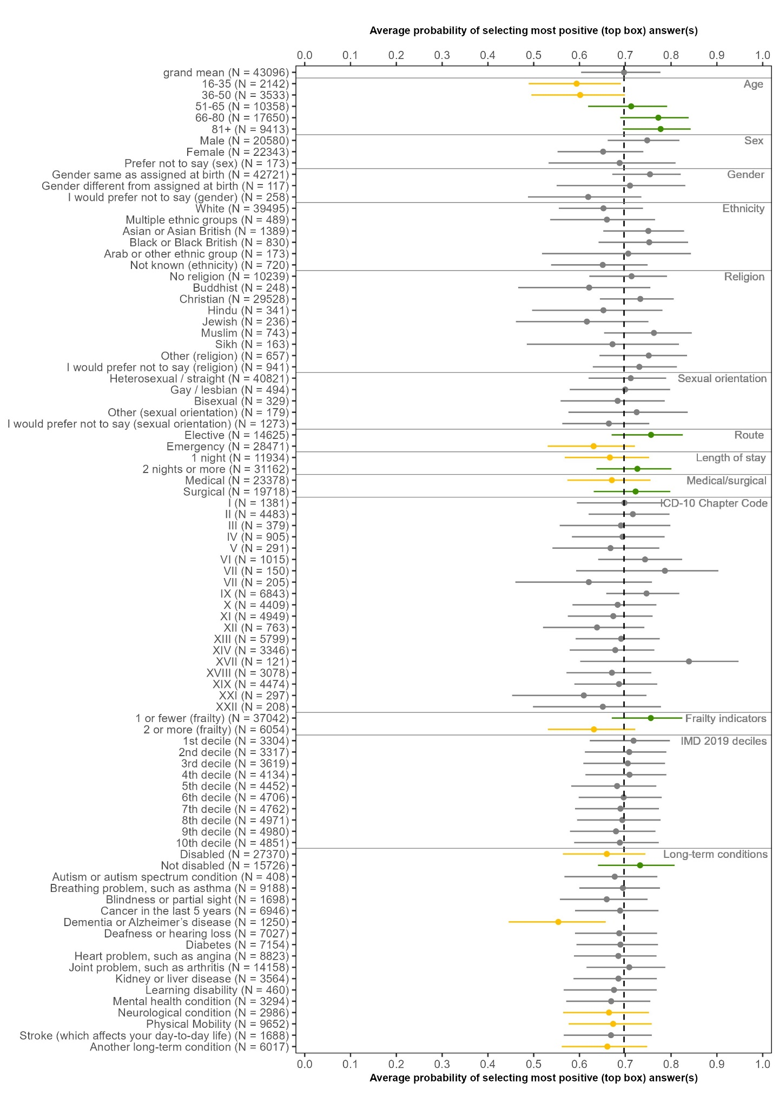
Q16: During your time in hospital, did you get enough to drink?

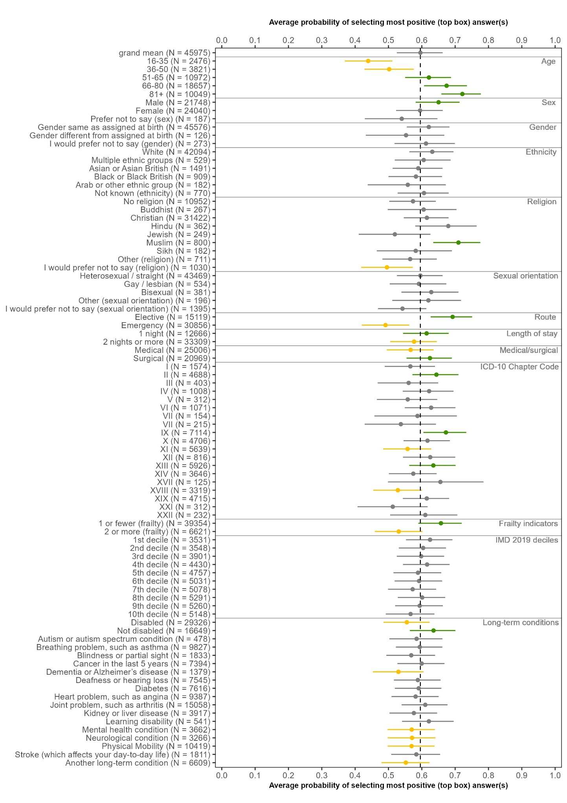
Q18: Did you have confidence and trust in the doctors treating you?

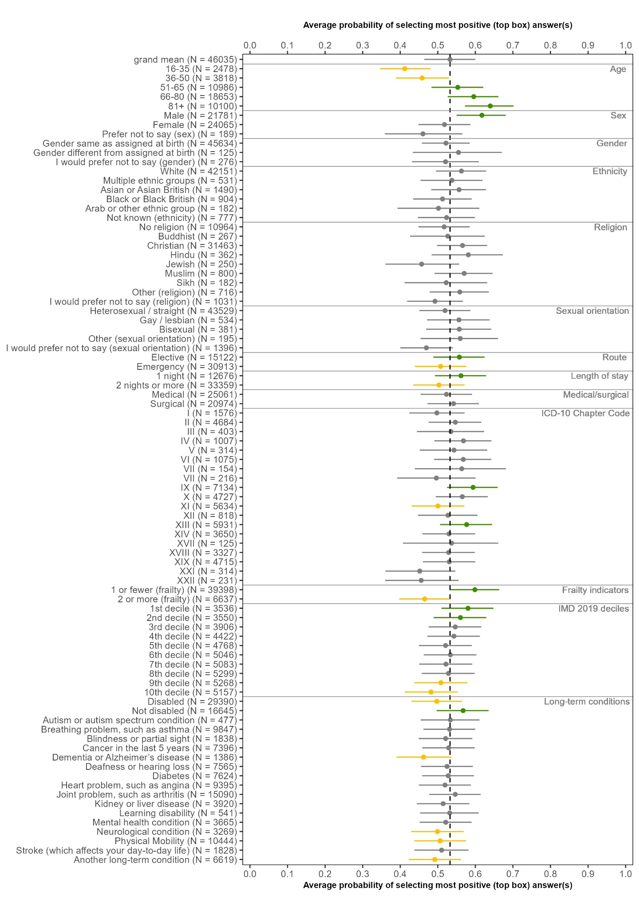
Q21: Did you have confidence and trust in the nurses treating you?

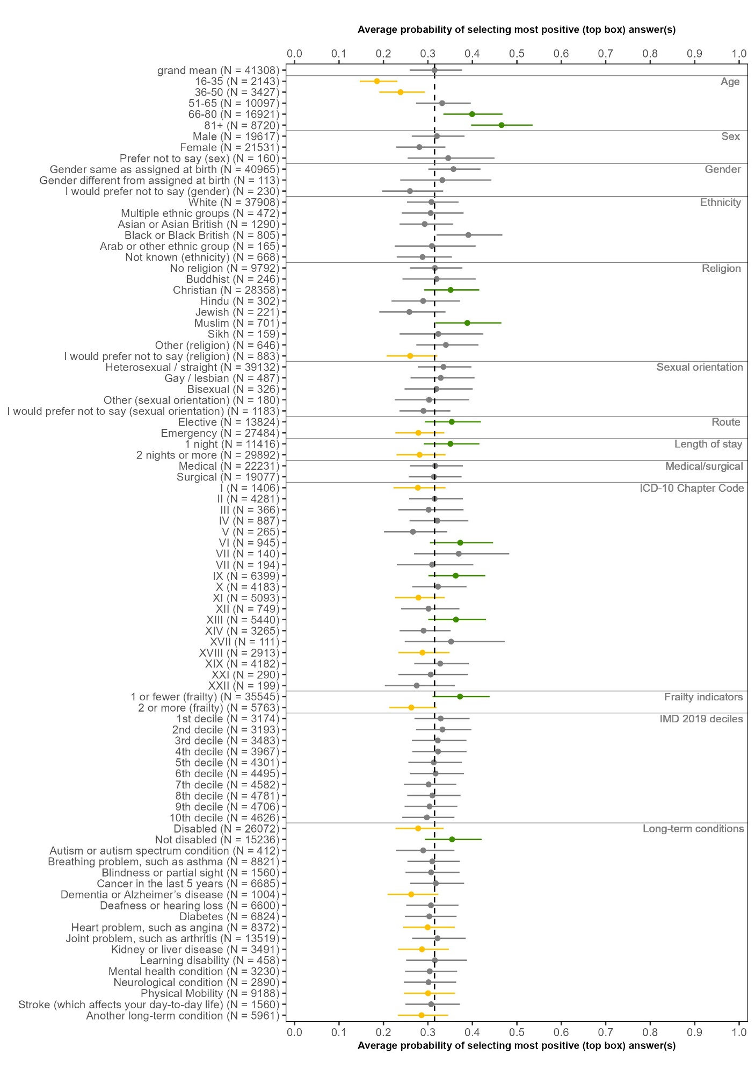
Q24: Thinking about your care and treatment, were you told something by a member of staff that was different to what you had been told by another member of staff?
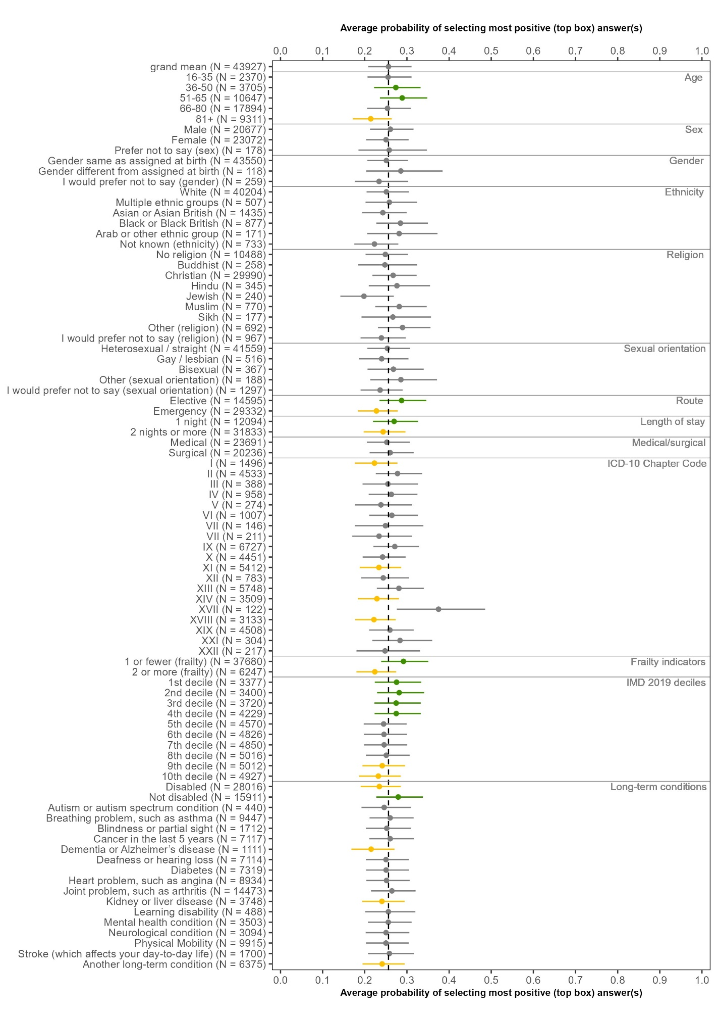
Q25: To what extent did staff looking after you involve you in decisions about your care and treatment?
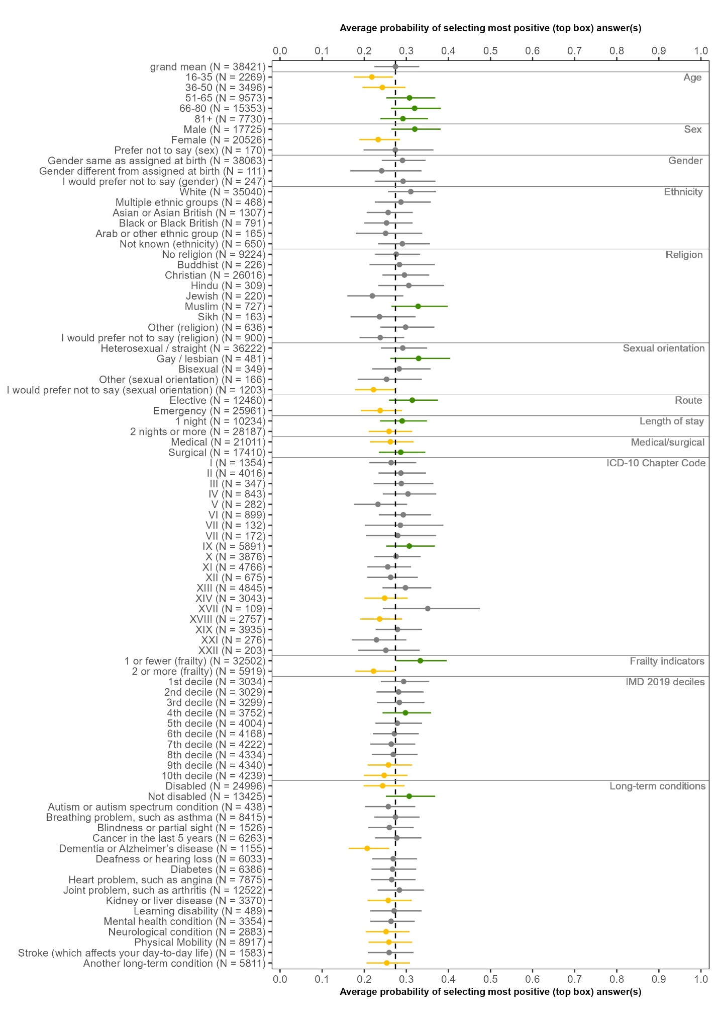
Q27: Did you feel able to talk to members of hospital staff about your worries and fears?
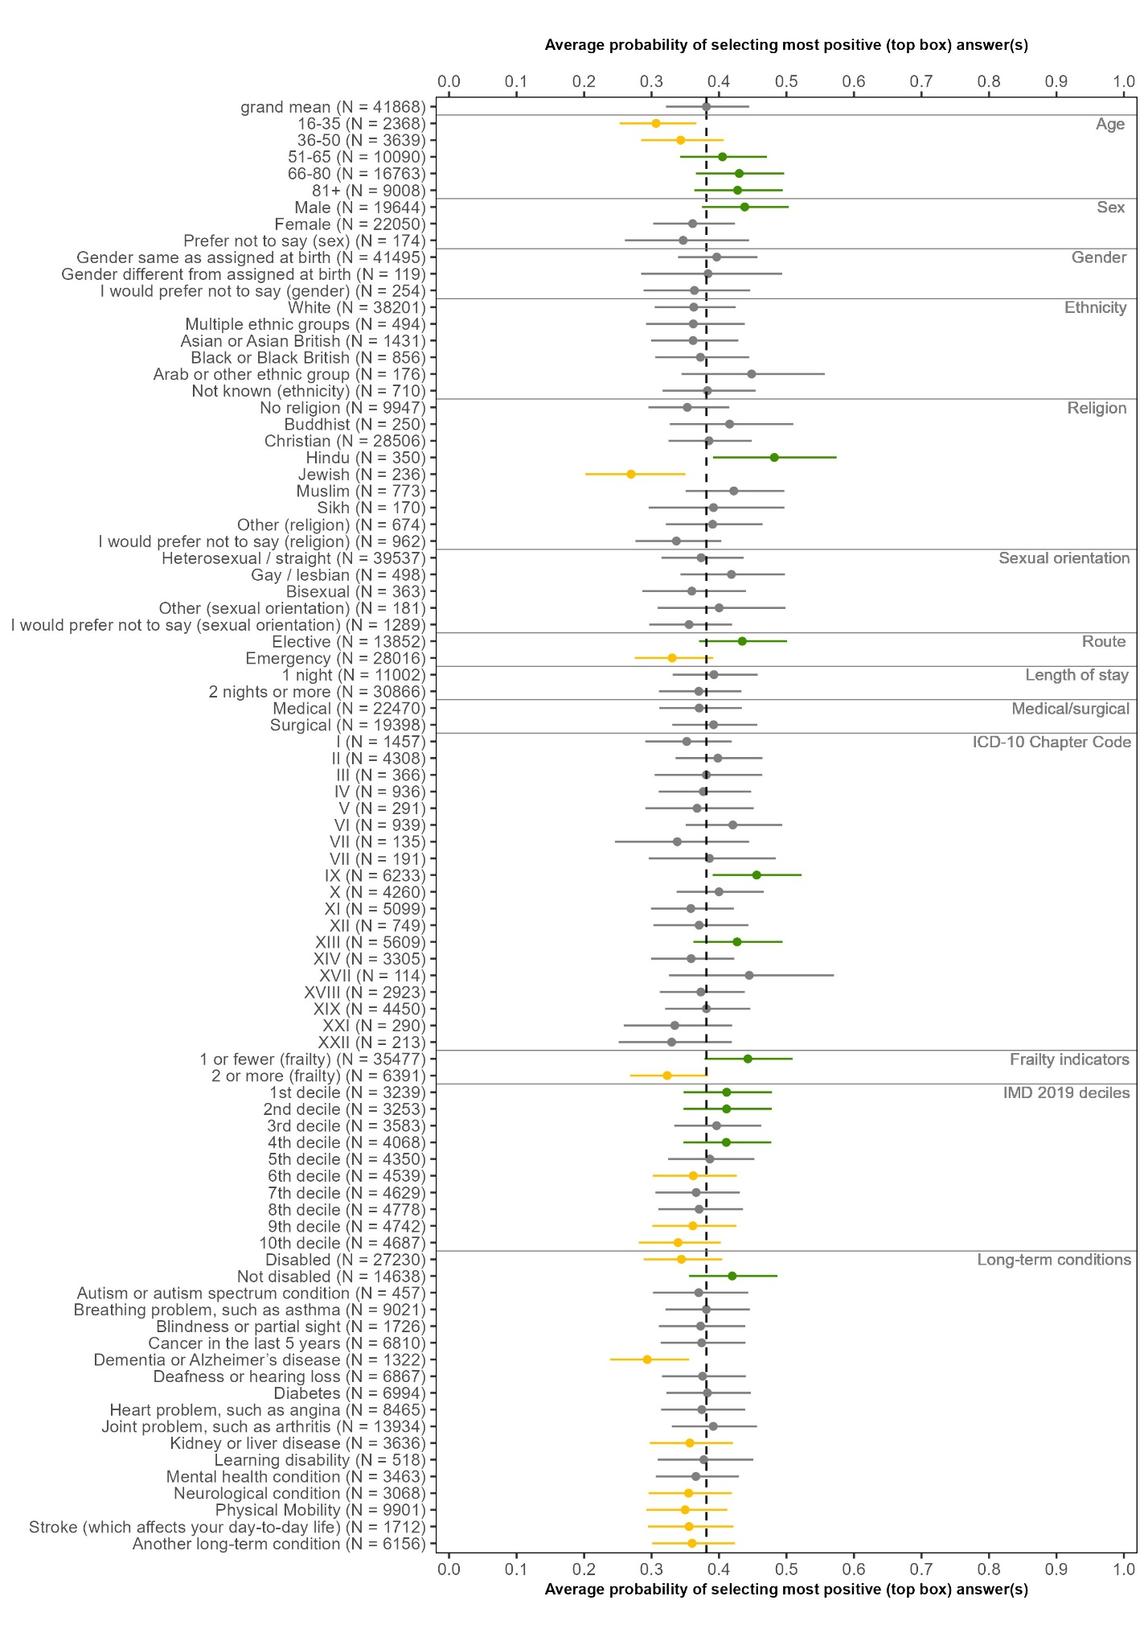
Q30: Were you able to get a member of staff to help you when you needed attention?
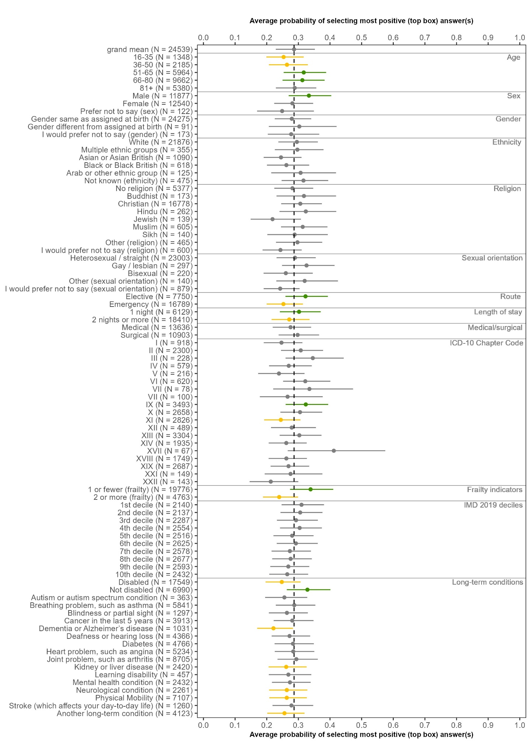
Q31: Did the hospital staff take into account your existing individual needs?

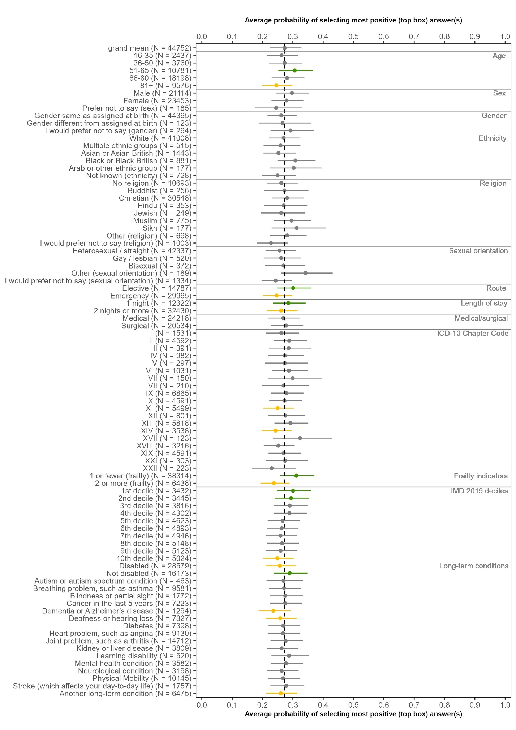
Q35: To what extent did staff involve you in decisions about you leaving hospital?
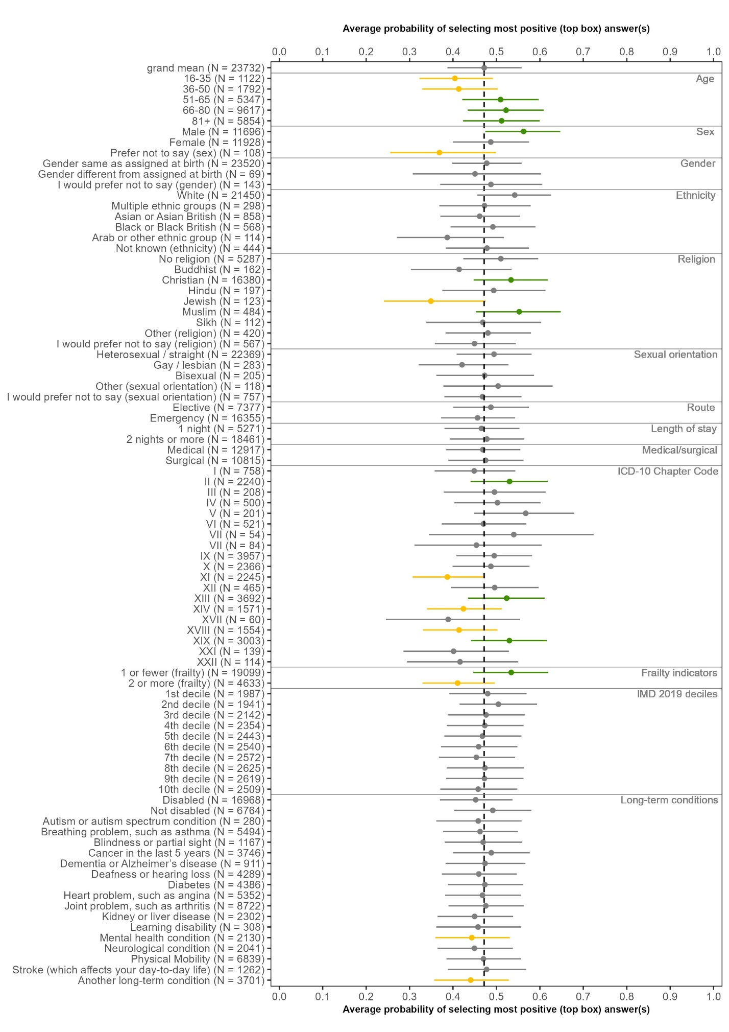
Q44: Did hospital staff discuss with you whether you may need any further health or social care services after leaving hospital?
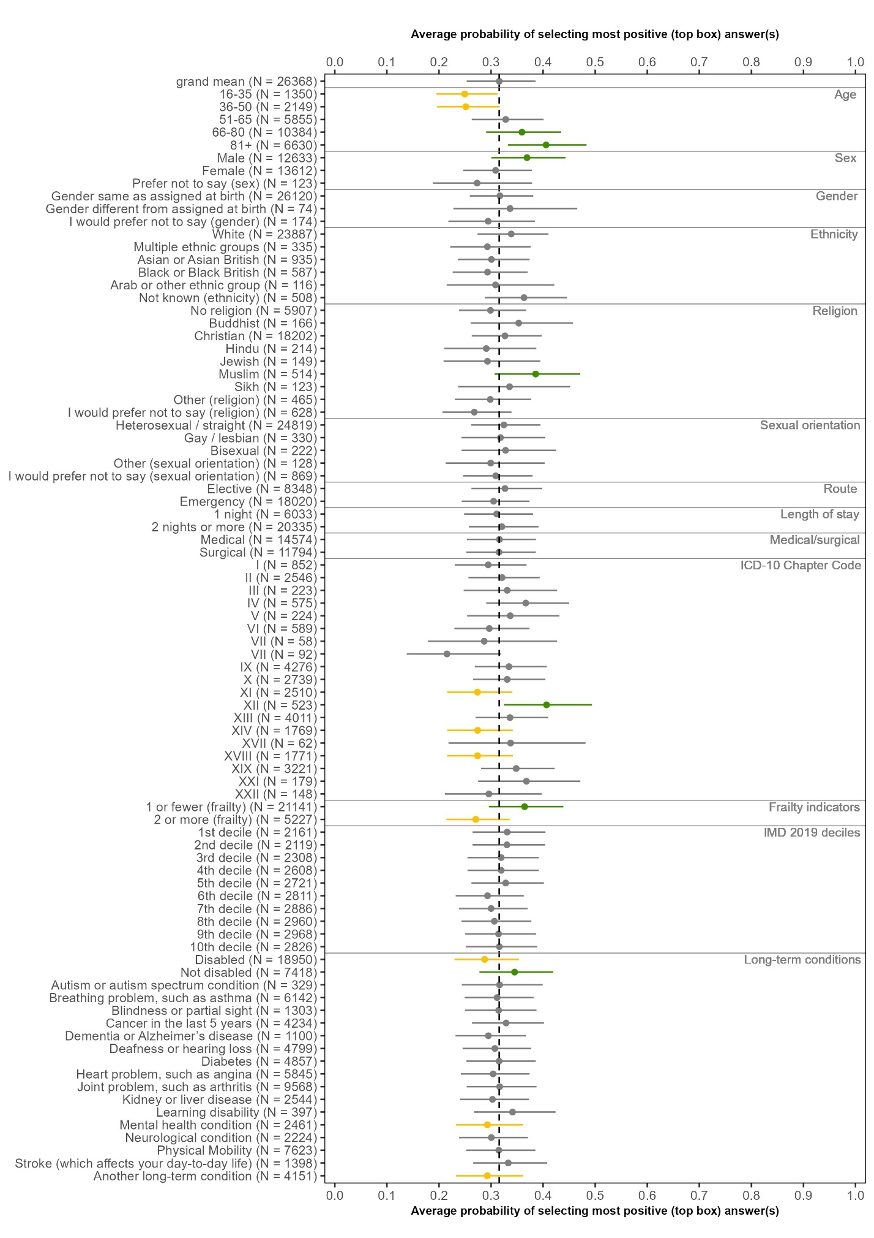
Q46: After leaving hospital, did you get enough support from health or social care services to help you recover or manage your condition?
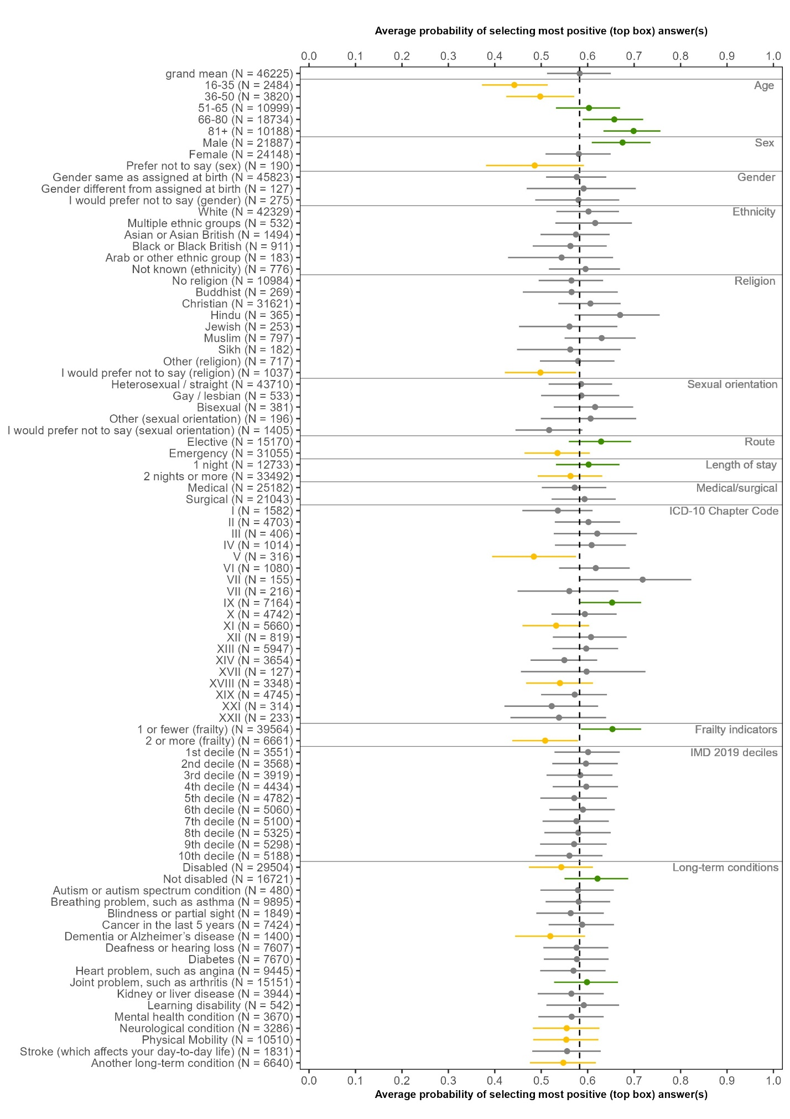
Q47: Overall, did you feel you were treated with kindness and compassion while you were in the hospital?
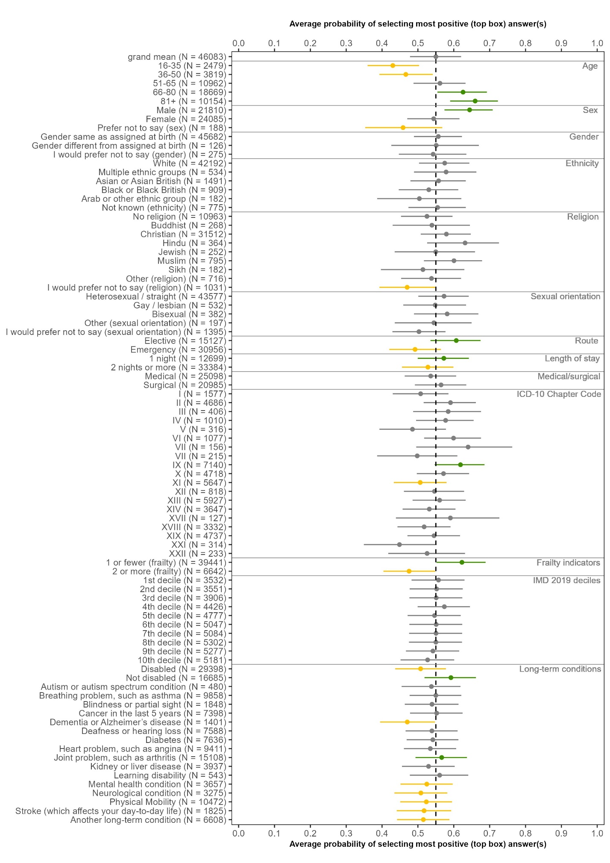
Q48: Overall, did you feel you were treated with respect and dignity while you were in the hospital?
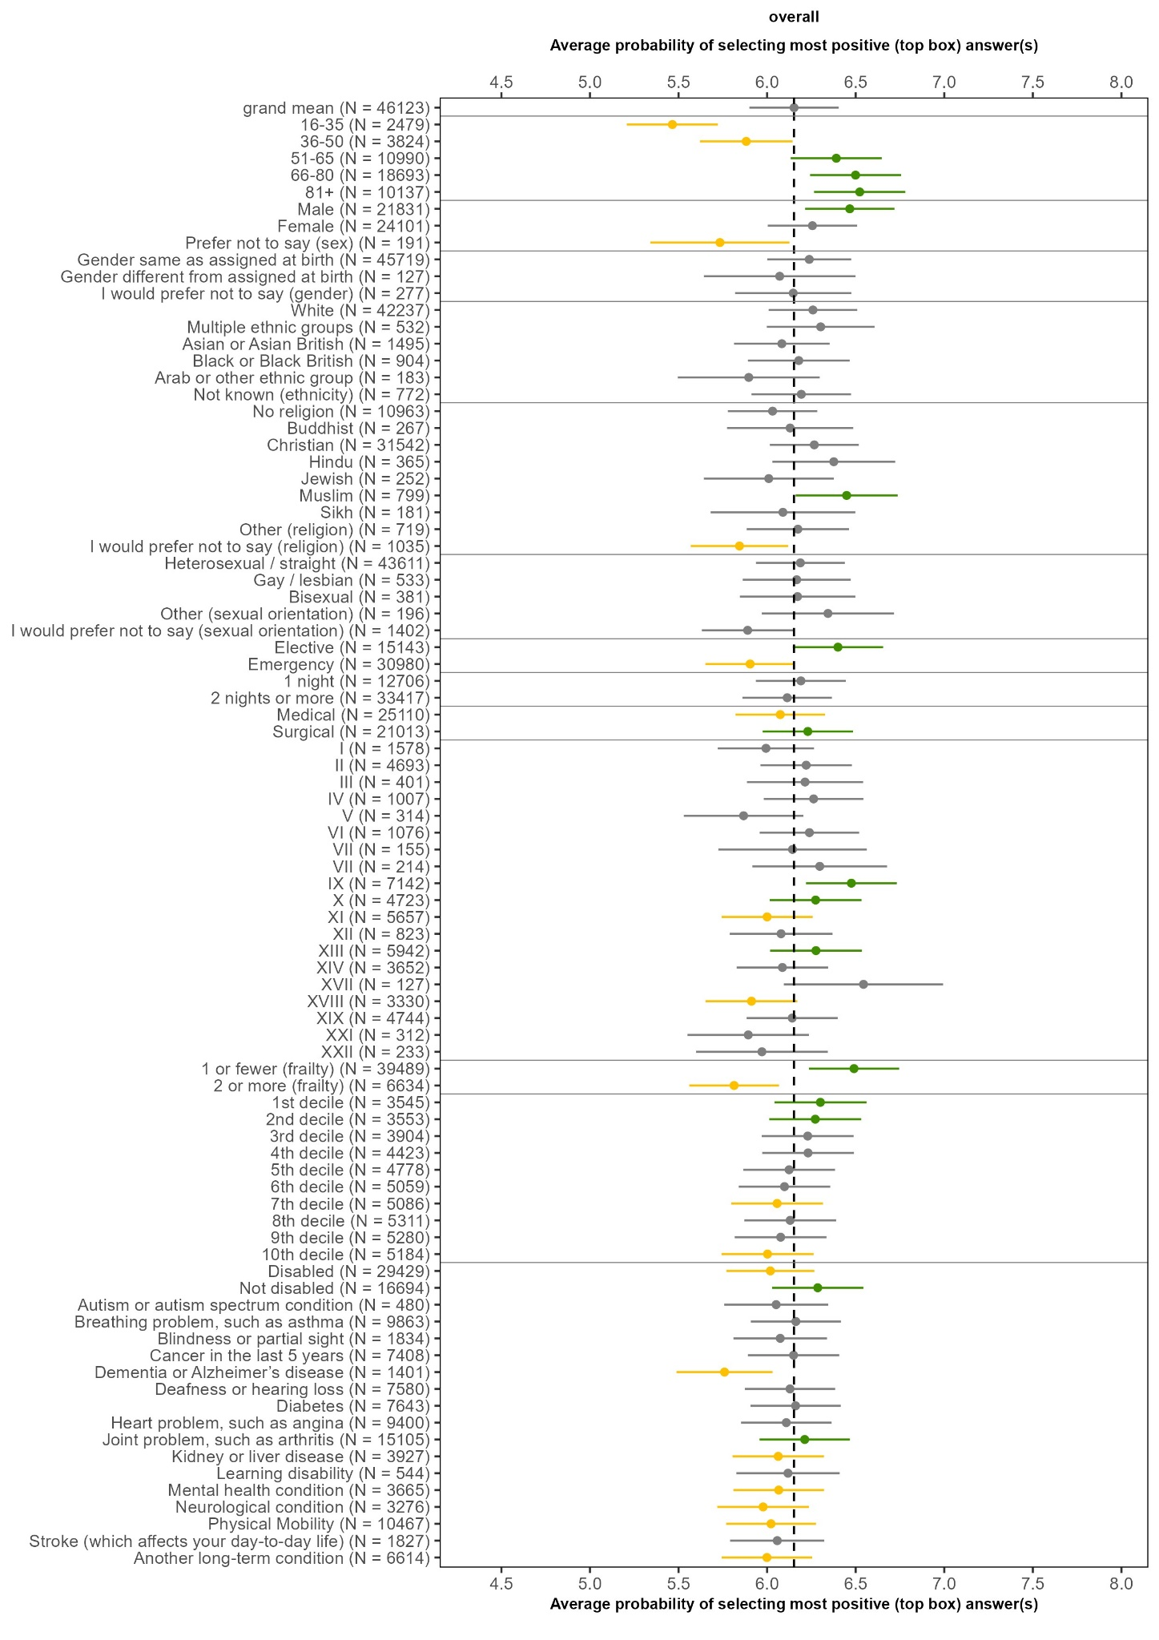
Q49: Overall, how was your experience while you were in the hospital?

For the analysis of the overall experience question, with responses from 0 (I had a very poor experience) to 10 (I had a very good experience) the mixed effects model instead allowed normally distributed responses. The modelled outcome was the approximately normally distributed 0 to 10 response.

