June 24
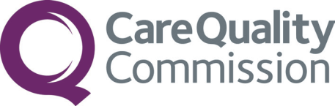

Listening, Learning and Responding to Concerns Review- 12-month evaluation overview
Research and Evaluation Team,
Policy and Strategy

Summary
In Spring 2023, CQC committed to improving the way we listen, learn and respond to concerns (LLRC). The review identified cultural and procedural improvements required to the way we respond to external concerns, listen to colleagues, and manage employment tribunal cases. There were 10 review aims and these were mapped to 84 recommendations (Appendix A). Work was allocated to be managed against five ‘workstreams’ (WS), covering recommendations for whistleblowing (WS1), freedom to speak up (WS2), learning from the employment tribunal (WS3), listening to our staff (WS4) and expectations and experiences of people who raise concerns with us (WS5). There was also a sixth workstream with a small number of organisational recommendations (WS6).
The 12-month evaluation considered (a) progress against each of the workstreams to inform subsequent performance and delivery, (b) the achievements of implementation and (c) early impact. This was presented to Independent Panel Members involved in the LLRC review and an internal Evaluation Reference Group.
LLRC progress at 12 months
- Performance and Delivery
There has been progress to deliver on the LLRC recommendations. However, this is not to the extent CQC originally anticipated:
- 42 of 84 recommendations (50%) are complete or close to completion
- 12 (14%) are very far from completion or yet to start
- 11 (13%) recommendations have stalled

Table 1: Recommendation progress and RAG status*

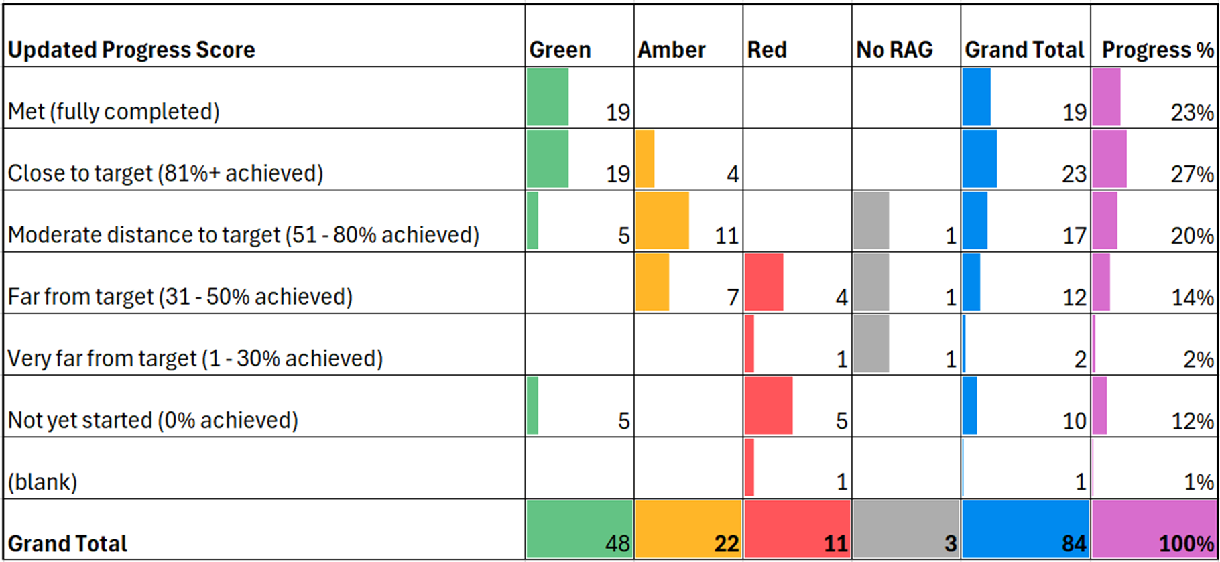
*Table 1 summarises delivery of recommendations and the outcome of a ‘RAG’ status review. This determines whether recommendations can continue to progress (green), can continue with risks (amber) or are ‘blocked’ (red).

Progress at 12 months, across 5 workstreams:
The recommendations were grouped into 5 workstreams for delivery. In counting recommendations,
- Most progress is reported against ‘learning from the tribunal’ (WS3) and ‘how we listen to our staff’ (WS4)
- Least progress is reported against ‘whistleblowing concerns’ (WS1), ‘freedom to speak up’ (WS2), and responding to the ‘expectations and experiences of people who raise concerns with us’ (WS5) (Figure 1).

Figure 1: Progress with recommendations across workstreams
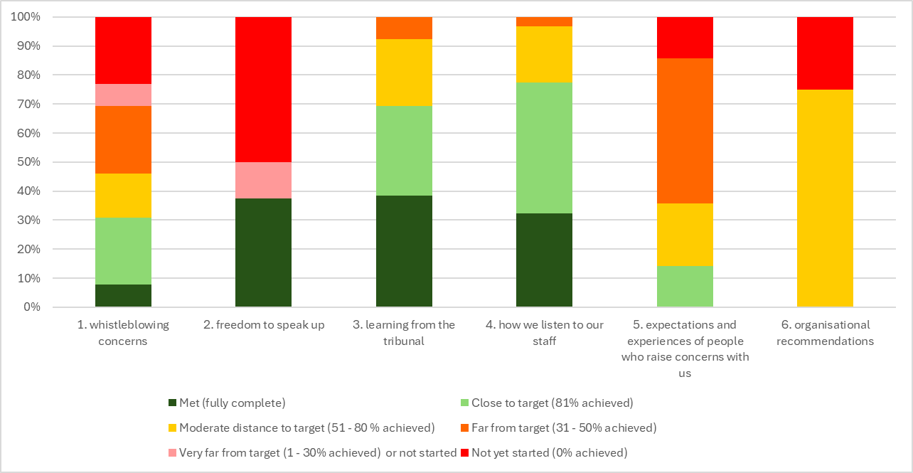
Completing the recommendations is not the same as achieving the ten aims of the LLRC. To understand this, we need to look at what we have implemented and achieved and the impact we have had.
- Implementation and Achievements
The recommendations achieved tended to be where work was either already underway or could be delivered through one team and/or involved reviews of policy, guidance or training. Those requiring cross organisational collaboration or relating to more complex cultural change are yet to be completed, as are those that are necessary for LLRC aims to be realised.
There have been key delivery achievements over the past year, and these include:
- Implementation of an end-to-end process to deal with information about whistleblowing by workers in services
- Development of a Reasonable Adjustments library and workplace passports
- Securing in-house employment law expertise
- Appointment of two new FTSU guardians with development sessions held with the Executive Team and Board
- Independent Race and racism training delivered to CQC Board.
Examples of some key areas that remain outstanding include,
- Further guidance and training for colleagues on handling information of concern and ensuring our systems are consistently working well
- Meeting the expectations and improving the experiences of people when they raise concerns with us
- Capturing appropriate equality data through our systems from people who contact us and share information
- Ensuring barriers to speaking up are identified and reported to ET and Board
- Timely use of Equality Impact Assessments during change processes
- Recording where people raising concerns say they have experienced victimisation
- CQC wide race and anti-racism training
- Capacity review to enable response to provider risk
- Continued work to ensure effective management of change

Where recommendations have not yet made anticipated progress, many challenges resulted from the scale of transformation CQC has been undergoing since 2019. Over this period, CQC simultaneously overhauled its regulatory approach, workforce, and underlying systems and new technology. In this context, colleagues described difficulties managing cross-organisational interdependencies, securing resources and prioritising LLRC work. The new technology was also a significant barrier to the delivery of recommendations around how CQC responds to care concerns.
The scale of implementation was also a challenge. Although 84 recommendations were accepted, they were implemented with insufficient planning and sequencing. Setting realistic expectations from the outset would have allowed for a more appropriate pace, recognising that achieving all LLRC aspirations would take longer than 12 months.
“This place is full of good people that want to make change – and it’s tough,
because there’s lots to do and lots of competing priorities. […] In areas where we
don’t make progress, it’s because we’ve been working on something else. […] We
have scarce resources – so we need to focus on things that are right to focus on,
with the intent for which we were created.”
[Interviewee]

The lack of structured management, leadership, and communication has hindered LLRC work in a complex organisation. Over time, without coherent programme management, oversight became fragmented at the individual recommendation level, leading to a disconnect from the 10 review aims. Changes to the overall leadership and governance of LLRC should help address these challenges moving forward.
“I have found it quite difficult to grasp the progress of the LLR actions associated
with my work – there are other very relevant actions… I would have appreciated more central oversight/active & transparent communication of progress (or lack of), depending on recommendation.”
[Interviewee]

- Impact

Expecting visible impact within 12 months was ambitious, especially given the challenges to the speed of delivery. Despite delivery of some recommendations, LLRC is a significant culture change programme. Half of the completed recommendations were fully implemented after January 2024 and will therefore require more time to demonstrate measurable impact. It will take time for these to be fully embedded and for the impact to be felt by colleagues.

Evidence suggests that we have not yet achieved the aims of the LLR review, particularly in developing a culture where colleagues feel listened to. Despite making progress against recommendations, we are not making progress against the aims. For example, while we are making progress in strengthening our approach to how we listen to our colleagues (WS4), our 2024 People Survey results indicate that most colleagues do not feel psychologically safe at work. They do not feel listened to, feel unsafe raising concerns, and believe their concerns are not considered inclusively. Colleagues perceive a culture of defensiveness and inadequate infrastructure to address their concerns appropriately. Psychological safety is essential for an organisation to deliver quality and improvement. Communicating plans in response to the 2024 People Survey should strengthen the impact of recommendations related to Freedom to Speak Up and listening to colleagues. There is some evidence of progress, as colleagues do anticipate a positive impact from some actions and key achievements that will be launched soon, such as the reasonable adjustments library.

“I feel that whilst I have opportunities to raise concerns about the way we are working in the organisation, and so are colleagues, there is a lack of meaningful change made in response to these.’’
[CQC People Survey Respondent]

Most recommendations regarding care concerns are still being actioned and we are not meeting the expectations of those raising concerns about care. Stakeholder surveys indicate that we can still improve experiences for people when they raise concerns with us. For example, results from the most recent Public Awareness Survey suggest more people are now dissatisfied with our response to care concerns raised with CQC.

Ensuring recommendations remain aligned with LLRC aims is necessary to achieve cultural change. CQC should look more holistically at the aims that need to be achieved through LLR and consider what needs to be done to support their realisation, rather than the granularity of completing 84 recommendations. This is particularly evident where recommendations have been delivered as independent pieces of work, making it unclear to colleagues that they are part of the wider LLRC portfolio. Improved communication and engagement with colleagues and the public around achieving the aims of the review may accelerate the impact and improve visibility of progress.
Feedback from Independent Panel Members involved in the review stated we should have made more progress over the last 12 months, though acknowledged the impact of large-scale transformation on our ambitions. Key feedback included:
- Disappointment that the initial enthusiasm and focus was not maintained resulting in an impression of de-prioritisation
- Concerns around listening to colleagues and an unsafe culture at CQC
- Lack of senior leadership and accountability for the ongoing work
- More progress needed on the approach to racism and becoming an anti-racist organisation
- Cross organisational working, forward planning, governance, and leadership needs to be clarified going forward
“There are pockets of good work that should be commended... Overall, the outcome of
the 12- month evaluation is disappointing. The organisational competence and commitment demonstrated by the initial conduct of the LLRC seems to have waned.’’
[Independent Panel Member]
“The LLRC seems to have lacked a sound governance framework, consistent sponsorship, leadership to champion it...’’.
[Independent Panel Member]

Key areas to improve
To support future progress, we recommend:
- Focus the LLRC on the 10 aims. Recommendations need to be streamlined for delivery. There is a need to identify what is necessary to have impact against the aims and to plan the investment of time and resources in an appropriate sequence
- Prioritise aims and recommendations. Prioritisation needs to be undertaken across all aims and recommendations, with cross CQC consensus as to actions to be undertaken over the next year, and targets for when subsequent recommendations will be delivered
- Ensure appropriate leadership and support. The LLRC sponsorship at ET level and through senior leadership should continue. Workstream leaders and senior delivery owners need to be reinstated to monitor progress and implementation of recommendations. Leads should ensure aims and recommendations are articulated appropriately, are assigned to the right people and in collaboration with senior delivery owners, ensure that implementation happens in a way that supports realisation of LLRC aims. A delivery manager should be assigned to support the LLRC sponsor
- Regular performance reports. Performance management information needs to be reported monthly and in full. Performance reports should be simplified (based on RAG status) and should support the prioritisation of recommendations. The start and finish dates for delivery should be clear to support evaluation of impact
- Appropriate governance. LLRC progress should report into the Strategic Oversight Prioritisation and Improvement Committee (SOPIC) to support prioritisation against other CQC requirements and ensure appropriate resource allocation, enabling greater collaboration and co-ordination across activity going forward
- Increased transparency and communications. A communications approach should be developed to consistently update CQC colleagues on progress against LLRC, provide transparency as to prioritisation decisions and to support understanding of the cultural change LLRC intends to deliver
- Implement LLRC recommendations into business planning. LLRC aims and recommendations around listening to colleagues and Freedom to Speak Up are integrated into CQC Business Planning where appropriate, ensuring these become integrated in the operations of the organisation.

The LLRC review signalled a commitment to significant cultural change at CQC, and this will take time to fully embed so that positive impact can be demonstrated. CQC has committed to undertaking an impact evaluation against the 10 LLRC aims at 18-months but should consider whether an evaluation at 24-months will better reflect impact.
Contents

Summary 1
Background 8
Key findings 9
Overall progress 9
Performance overview 13
Listening, acting on and responding to concerns about care 13
Listening, acting on and responding to concerns about CQC and HR processes 16
Learning from the employment tribunal 19
Organisational recommendations 20
Conclusion 21
Next steps 22

Background
In 2023 two reviews were conducted to understand how CQC learns from, responds to, and acts on concerns shared with us. The Listening, Learning and Responding to Concerns Review (LLRC) was initiated in response to the tribunal case of Mr Kumar and subsequently encompassed several other areas where CQC fell short of its obligation to support people who were speaking up and raising concerns about care or working at CQC. The review focused on five key areas (taken forward by CQC as workstreams) including:
- How well we listen to whistleblowing concerns
- Our Freedom to Speak Up policy
- Learning from the tribunal case
- How we listen to our staff
- Expectations and experiences of people who raise concerns with us.
A sixth workstream includes a small number of cross organisational recommendations.
The review sought to understand how policy, processes and culture could be improved and how to encourage continuous learning and improvement. A total of 84 recommendations were made, mapped to 10 review ‘aims’ (see more information about the aims on our website). CQC committed to action and evaluating the impact of changes resulting from the delivery of the recommendations.
The 12-month evaluation followed a mixed-methods approach, aiming to understand the progress and impact of recommendations alongside barriers and enablers that have influenced success to date. The evaluation covered the following:
(a) progress against recommendations and workstreams to inform subsequent performance and delivery
(b) the achievements of implementation
(c) early impact.
Data collection took place between August 2023 and April 2024 and data sources included the CQC People Survey, CQC Annual Provider and Stakeholder Surveys, interviews with colleagues, and recommendation performance tracking data.
This report fulfils a commitment to evaluate 12 months after publication of LLRC, with the 18-month report evaluating against the 10 aims anticipated in early 2025. The report provides an update on the status of recommendation delivery as of May 2024 against workstreams, enablers, and barriers to delivery and explores any potential early impact.
Detailed analysis informing this evaluation summary was presented to Independent Panel Members, part of the original LLRC review, and an internal Evaluation Reference Group.

Key findings

Overall progress
- Performance and Delivery

There has been progress to deliver on the LLRC recommendations. However, not to the extent CQC originally anticipated:
- 42 of 84 recommendations (50%) are complete or close to completion
- 12 (14%) are very far from completion or yet to start
- 11 (13%) recommendations have stalled

Detailed progress can be seen in the recommendations report in Appendix B.
Most progress has been reported in ‘learning from the tribunal’ (WS3) and ‘how we listen to our staff’ (WS4), where key achievements include securing in-house employment law expertise to provide expert oversight on employment litigation and work to deliver improvements in reasonable adjustments, including development of a reasonable adjustments' library and staff passports. There has been less progress in response to ‘whistleblowing concerns’ (WS1), ‘freedom to speak up’ (WS2) and responding to the ‘expectations and experiences of people who raise concerns with us’ (WS5).
Figure 1. Recommendations progress across workstreams (repeat from p.2)
Completing the recommendations is not the same as achieving the ten aims of the LLRC. To understand this, we need to look at what we have implemented and achieved and the impact we have had.

- Implementation and Achievements
The recommendations achieved tended to be where work was either already underway or could be delivered through one team and/or involved reviews of policy, guidance or training. Those requiring cross organisational collaboration or relating to more complex cultural change are yet to complete, as are those that are necessary for LLRC aims to be realised.
Achievements over the past year against each workstream will be described later in the report. Some of the greatest challenges to progression straddle the entire LLRC and meant momentum has not been possible to sustain.
Challenges which have impeded LLRC delivery include:
CQC Transformation: Our comprehensive transformation activity has included reshaping our workforce and ways of working, implementing a new digital infrastructure, a new regulatory approach and assessment framework, and new responsibilities for assessing care in a local area. These large-scale organisational changes were committed to before the LLRC review but the scale of change across the entire organisation has impacted resourcing and capacity to simultaneously advance both agendas. A new Strategic Oversight, Prioritisation and Improvement Committee (SOPIC) is expected to be a positive catalyst to tackling some of the cross organisational barriers to delivering recommendations, ensuring cross CQC buy-in and prioritisation alongside competing transformation and organisational demands.
Organisational approach and governance: Our organisational approach to managing activity could have been improved from the outset. Where leadership oversight and delivery responsibility sat was unclear for a period. More progress might have been possible if aims and recommendations had been set out under a discrete and coherent programme of work focused on delivery of the aims, and where dependencies could be clearly mapped. Understanding the necessary sequencing of delivery of activity could have allowed better management of expectations around the scale of change possible at 12 months.
Changes of ownership and coordination: The change in delivery ownership from an initial workstream approach to individual recommendation delivery owners contributed to fragmentation and disconnect across related recommendations. However, work is now underway to adapt how recommendations are tracked, and progress is measured to support cross-organisational coordination, resource planning, prioritisation and sequencing. A new sponsor is providing leadership across LLRC activity and reporting into SOPIC. It will be important to ensure Delivery Owners feel that the articulation of recommendations matches the post transformation landscape and will still support achievement of review aims.
Capacity: Delivery of recommendations has been absorbed into business as usual, mostly without extra budget or staff capacity to implement the actions necessary to satisfy recommendations or recognise how this fits with other Directorate priorities. It has therefore been hard for colleagues to prioritise progress against other demands from their day jobs and transformation. It was proposed that having roles with protected time would have supported momentum.
Feedback from Independent Panel Members involved in the LLRC review suggested we should have made more progress over the last 12 months, though acknowledged the impact of large-scale transformation on our ambitions. They called for clarity of governance, leadership, and greater collaboration and co-ordination across activity going forward. CQC was asked to undertake greater scrutiny of progression and importantly, to ensure that the work we do on LLRC will lead to cultural change, rather than merely ‘tick-off’ recommendations. The following quote resonated with Panel Members from our evaluation research,

‘it [LLRC] should be woven into everything we do and how we do it. Listening to LLR and responding is not delivering widgets, it’s we’ve seen, we’ve heard, and we do this differently as a response. The only successful outcome from LLR should be the culture change, everything else is not enough. It should be better communicated, it should run through everything we say and do...’
[Interviewee]
Informed by the 12-month evaluation, challenges impacting progress have been reviewed to support a more streamlined and focused approach guiding delivery. Work has already started to ensure appropriate leadership, governance and prioritisation; however, sequencing of activities will be influenced not only by determining the areas where the most impact will be felt but also by what is achievable against a backdrop of ongoing transformation and available resources.
- Impact to date
LLRC represents a significant culture change programme which will take time to be fully embedded and felt by colleagues. An evaluation of impact at 12-months, alongside ongoing delivery, was always an ambitious goal, particularly when there have been challenges to the speed of delivery. Half of the fully implemented recommendations were completed after January 2024 and will require longer to demonstrate measurable impact.
However, colleagues shared that despite progress made in delivering a new Freedom to Speak Up process and policy, and recommendations completed against ‘listening to staff’ (WS4), CQC’s culture does not yet support psychological safety. The 2024 People Survey results show colleagues are looking for reassurance in this area; ensuring that concerns are listened to openly and constructively, and that they know what has happened based on their feedback.
In areas where more progress has been made, this has not always been communicated effectively, which has limited colleague awareness of progress and not demonstrated CQC’s continued commitment to LLRC. This could impact the ability of colleagues to benefit from these changes.
Given that most recommendations related to the way care concerns are responded to are still being actioned, we would not yet expect to see any positive impact in this area. Responses to the most recent Public Awareness and Stakeholder surveys reflect this, with static results compared to 2022. For example, 63% of respondents feel CQC effectively responds to concerns raised by professionals and just over half (51%) feel this is done in a timely manner.
However, despite impact not yet being evident, qualitative feedback highlighted positive anticipation of planned actions. Several colleagues emphasised the value of an upcoming reasonable adjustments library to support a consistent and meaningful approach to implementing reasonable adjustment requests across the organisation. This has been developed in collaboration with staff networks as an example of a learning approach from the organisation. Some colleagues have also shared that they have observed a ‘positive shift’ in conversations about ethnicity emboldened by LLRC, although further data is needed to see whether this is fully embedded in CQC’s culture.
Ensuring recommendations remain aligned with LLRC aims is necessary to achieve cultural change. CQC should look more holistically at the aims that need to be achieved through LLR and consider what needs to be done to support their realisation rather than the granularity of completing 84 recommendations. This is particularly evident where recommendations have been delivered as independent pieces of work, making it unclear to colleagues that they are part of the wider LLRC portfolio. Improved communication and engagement with colleagues and the public around achieving the aims of the review may accelerate the impact and improve visibility of progress.

Performance overview

Listening, acting on and responding to concerns about care
Two workstreams aim to enhance trust in the way we act on concerns raised by people using services, those working in services and other partners and stakeholders.
Workstream 1: How well we listen to whistleblowing concerns
Of the 14 recommendations in this workstream, only 4 (28%) are complete or close to target and 4 (28%) are currently very far from target or have not started (Table 2). Almost a third of recommendations cannot currently progress (red status).
Table 2: Progress on whistleblowing concerns (WS1) recommendations and RAG status
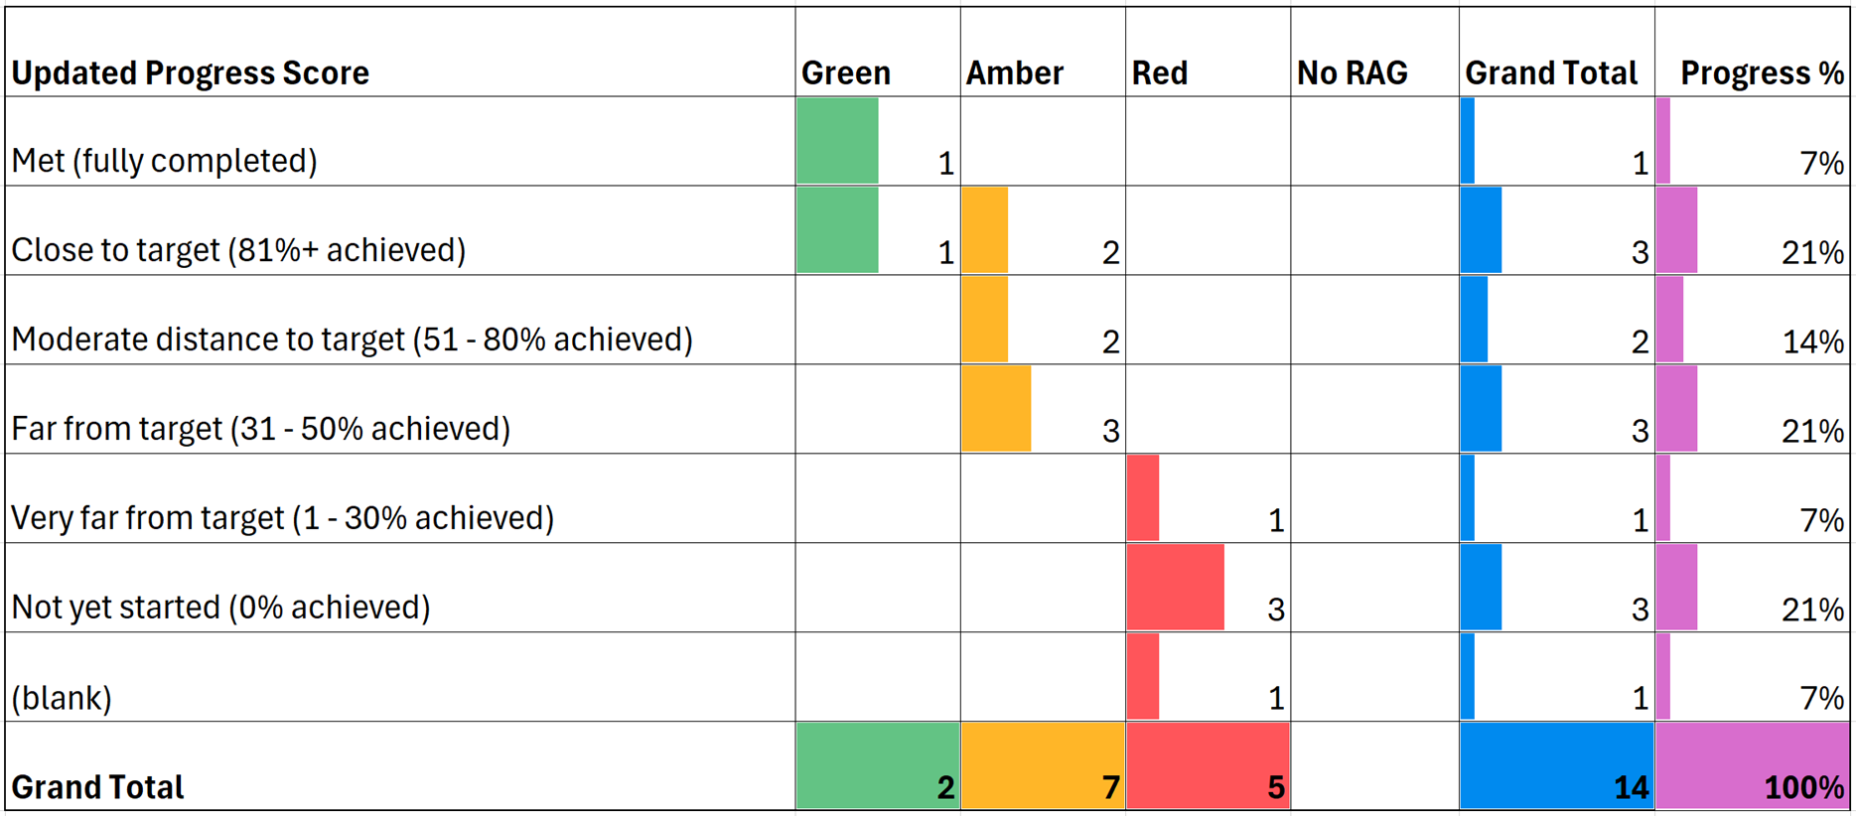
The key areas of progress within this workstream include:
- the delivery of a new end-to-end process for whistleblowing
- development of an organisational definition, standard operating procedures for dealing with information of concern and a quality management framework.
Recommendations not yet complete include:
- Further guidance and training for colleagues on handling information of concern and ensuring our systems are consistently working well
- Capturing appropriate equality data through our systems from people who contact us and share information
- Recording where people raising concerns say they have experienced victimisation
- Undertaking a capacity review to enable response to provider risk
- Reviewing staff resources to effectively monitor and respond to risks in services.

Workstream 5: Expectations and experiences of people who raise concerns with us
Of the recommendations in this workstream, none are complete and only 2 (14%) are close to target, 9 (64%) are currently far from target or have not begun (Table 3). Just under half, are impacted by barriers to completion, with 6 currently unable to progress (Red Status).
Table 3: Progress on the expectations and experiences of people who raise concerns with us (WS5) recommendations and RAG status

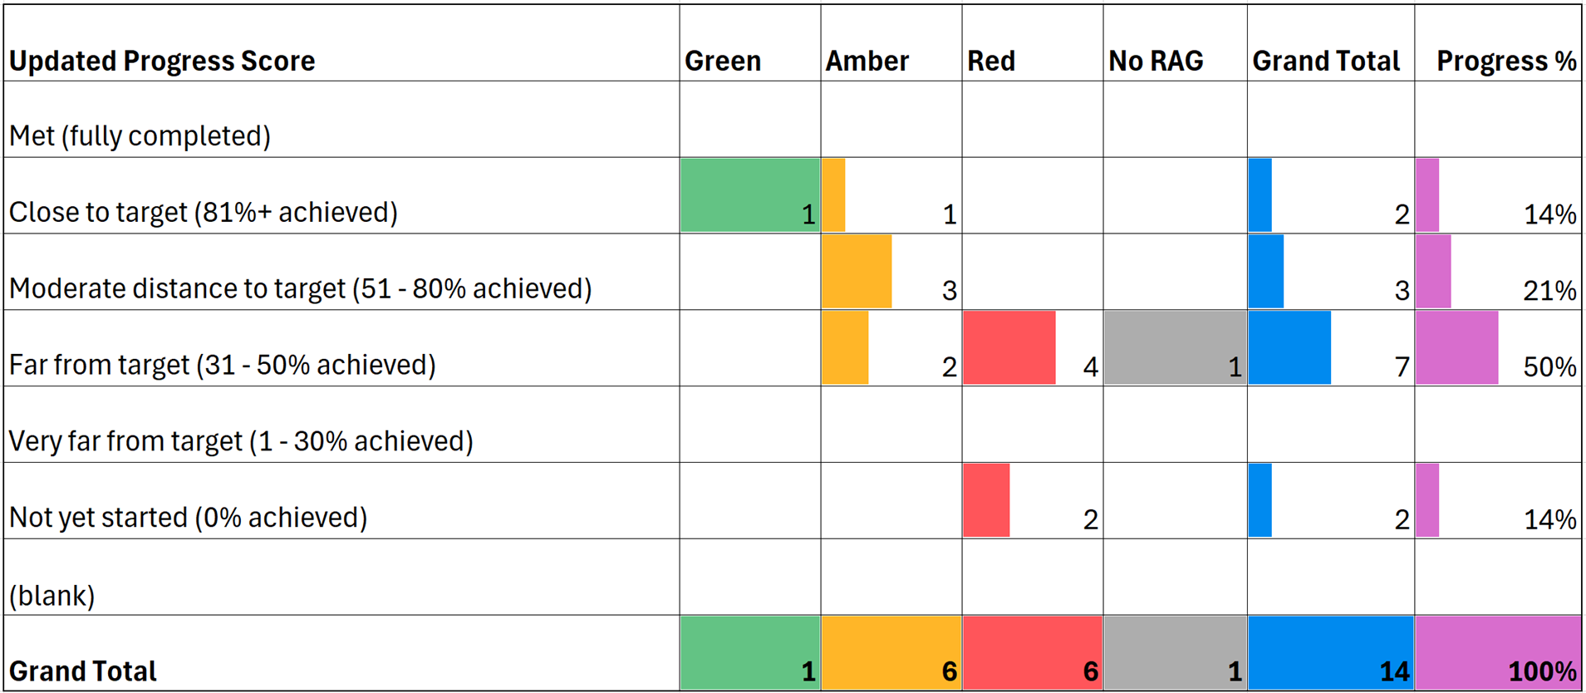

The key areas of progress within this workstream include:
- Capturing the experiences of people most likely to receive the poorest care.
- Engagement-led activities are soliciting more Give Feedback on Care information and colleagues have developed local outreach plans working with regulatory coordinators who are engaging with local voluntary and community groups and local Healthwatch to reach those most affected by inequalities.
Supporting this aim, though not articulated as part of a recommendation, Data and Insight colleagues have been finding new ways to use data from CQC’s NHS Patient Survey Programme to support Strategic Insight around differences in people’s experiences of care by protected and other demographic characteristics.
Recommendations requiring us to improve include:
- Information that captures demographic and protected characteristics, such as ethnic minority status to help us receive and understand types of concerns people have about care and tackle inequalities. This action cannot progress without technological prioritisation and resource decisions to build the functionality on the new regulatory platform
- Meeting the expectations and improving the experiences of people when they raise concerns with us

Challenges and dependencies across the two workstreams
Progress has faltered due to underestimating the scale of work required at the outset. Challenges with rolling out whistleblowing training to operational colleagues have been impacted by the priority to implement the new regulatory model without seeing that all these issues are regulatory. Interim measures to share information and guidance are in place.
CQC’s technological transformation (specifically, the new Regulatory Platform) has impacted progression in this area, with functionality required to support LLRC requirements ranking as lower priority compared to other regulatory functionality. Being unable to monitor the demographic and protected characteristics of people who raise concerns has been identified over the years, not just through LLRC. This impacts on our ability and credibility (we assess this in the services we regulate) as a regulator. CQC needs to make a prioritisation and investment decision about the functionality of the regulatory platform.

Listening, acting on and responding to concerns about CQC and HR processes
Two workstreams and 39 recommendations aim to improve CQC’s approach to listening and responding to concerns raised by CQC colleagues and supporting colleagues to raise these openly and safely.
Workstream 2: Our Freedom to Speak Up policy
Of the recommendations in this workstream, 3 (38%) have been met, 5 (63%) are very far from target or report no progress (Table 4). All can progress without impediment.
Table 4: Progress on Freedom to Speak Up (WS2) recommendations and RAG status
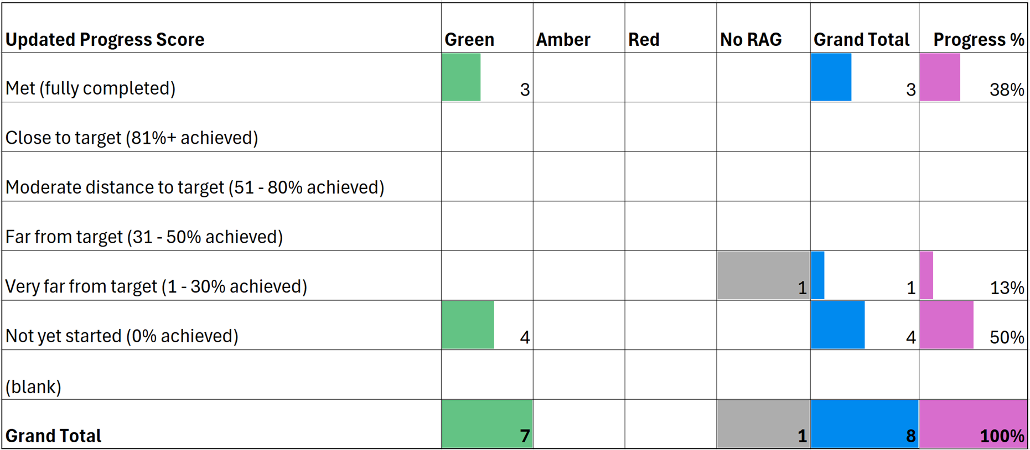

The key areas of progress within this workstream include:
- the appointment of two new Freedom to Speak Up (FTSU) guardians to increase capacity in this area, and
- the delivery of FTSU development sessions with CQC Executive Team and Board to support them to think about the importance of positive speaking-up cultures and to reflect on what that means to leadership.

Progress has been limited but will now start in relation to:
- aligning FTSU work with wider culture recommendations, such as ensuring that barriers to speaking up are addressed and reported to ET and Board
- taking account of relevant guidance, as well as reporting and evaluating the effectiveness of the FTSU approach.

Progression for these recommendations has been dependent on others being achieved first. Plans to evaluate the impact of FTSU through revisiting data collected by guardians are in place.

There has been solid progress implementing reasonable adjustments at recruitment, and colleagues are working with the Business Disability Forum to understand the potential for further improvements. The approach to reasonable adjustments for existing colleagues was described as overly complex and taking too long.

Workstream 4: How we listen to our staff
Of the recommendations in this workstream, 24 are met or close to completion (77%) (Table 5). All uncompleted recommendations can continue progressing.
Table 5: Progress on how we listen to our staff (WS4) recommendations and RAG status
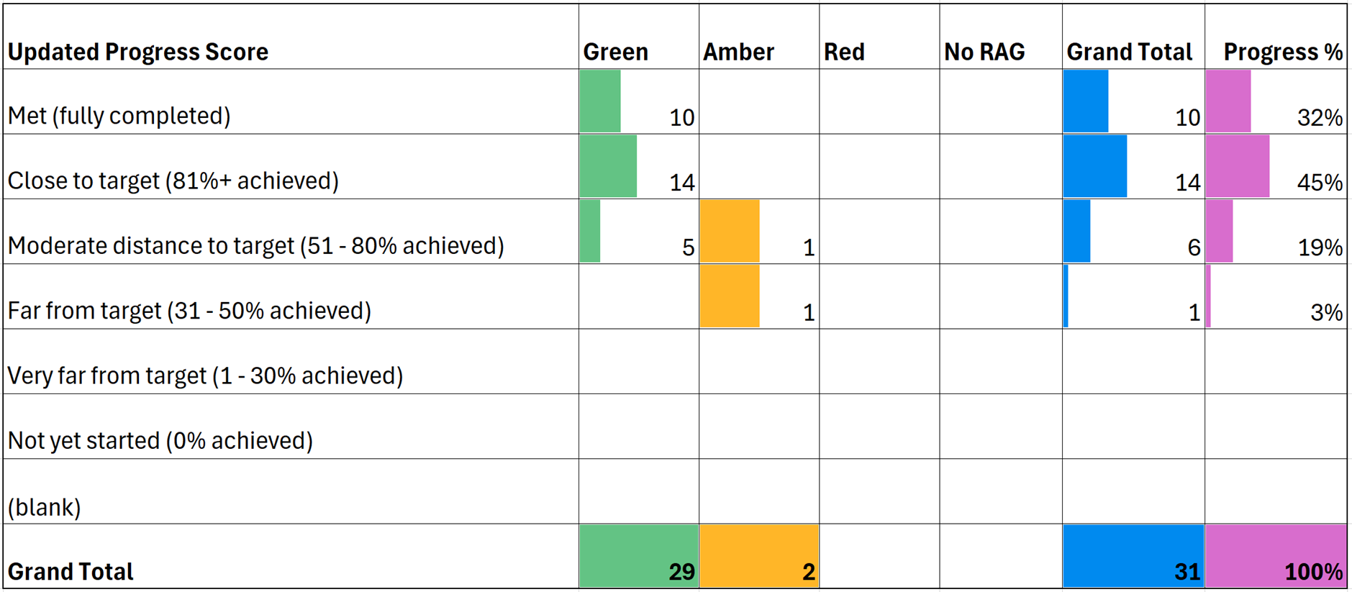
Key achievements include:
- implementation of quarterly ‘People and Culture Assurance Packs’ to enhance the Board’s understanding of People related issues,
- the development of guidance such as Terms of Reference to support consistent implementation of the change process,
- development of a reasonable adjustments' library and workplace passports to support inclusive and consistent application of reasonable adjustments.
The organisation is also in the process of delivering workshops to refresh the organisation’s values and associated behaviours.
Mapping work has been undertaken to identify where Equality Impact Assessments (EIAs) need to be completed as part of the transformation, including how approaches to structural racism can be integrated as part of EIAs.

Recommendations that still to complete include:
- ensuring our processes maintain the employment rights of advisory and complementary colleagues
- ensuring EIAs are conducted in a timely manner to feed into change process
- ensuring that measures are taken to recognise the organisational benefit of advisory and complementary colleagues
- timely use of Equality Impact Assessments during change processes
- continued work ensuring effective management of change

Challenges and dependencies across the two workstreams
While most progress against the recommendations has been made in this workstream, the feedback of colleagues unambiguously confirms that benefits of completed LLRC work are yet to materialise or be felt. Given many recommendations have only recently completed, this is not surprising. However, the 2024 People Survey results indicated most colleagues do not feel psychologically safe at work, do not feel listened to, and feel unsafe to raise concerns or feel their concerns are not considered inclusively. Colleagues perceive a culture of defensiveness and inadequate infrastructure to deal with their concerns appropriately.
Psychological safety is essential for an organisation to deliver quality and improvement. CQC has committed to facilitating a culture where speaking up is welcomed. However, delayed timescales (many in this area a result of long review and sign off processes) have led to a perception that our commitment has waned.
Progress across ‘Freedom to Speak Up’ (WS2) has been stalled in some places, though we understand there are interdependencies with wider culture work requiring a sequential delivery approach. For example, the development of standard operating procedures to support FTSU policy was delayed pending the recruitment of the two new FTSU guardians. Similarly, work to align FTSU processes to wider culture work is ongoing but requires consideration as a wider piece of work. As such, progress is expected to accelerate as other associated recommendations are achieved in this area.
More effective and consistent communication about changes will reassure colleagues that the organisation remains committed to the LLRC aims to listen well and encourage colleagues to share honest feedback. Equality networks shared that there are pockets of great work happening, but many colleagues are not aware of these. For example, colleagues are enthusiastic about the forthcoming reasonable adjustments library, which were co-produced with Equality Networks. People Survey results confirmed that when concerns are raised, colleagues need to know what has happened as a result.

Learning from the employment tribunal
Workstream 3: Learning from the tribunal case
Of the recommendations in this workstream, 9 (69%) are completed or close to completion and the rest are in progress (Table 6). All uncompleted recommendations are currently able to progress.
Table 6: Progress on learning from the tribunal case (WS3) recommendations and RAG status
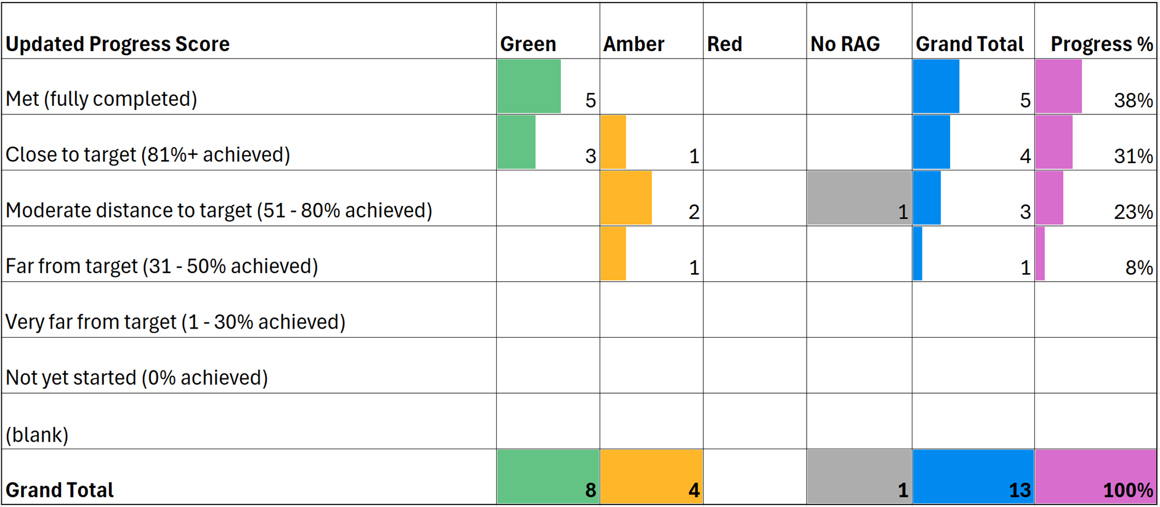

Key achievements include:
- closer working between Legal and the People Directorate on emerging tribunal claims, and
- regular Chief Executive Officer updates on Human Resources cases.
The recruitment of a new employment lawyer to provide specialist employment knowledge and provide expert oversight of cases is expected to support improvements within this workstream.
Recommendations that are yet to be completed include:
- ensuring MoU’s are in place with all pertinent review and regulatory bodies to ensure they are notified of parallel investigations being undertaken by CQC. This will ensure more consistent conclusions are drawn when investigations straddle multiple organisations.

Challenges and dependencies
Progress was slowed while waiting for appropriate employment expertise to be secured, though this is now in place. Relevant across all workstreams but cited as a particular challenge here was that recommendation articulation and allocation should involve Senior Delivery Owners, enabling shared understanding of required actions and ensuring involvement from the most appropriate colleagues.

Organisational recommendations
Workstream 6: Organisational recommendations
Four recommendations focused on wider organisational policy and processes. None are yet complete, though there are no significant obstacles to further progress.
Table 7: Progress on organisational recommendations (WS6) and RAG status
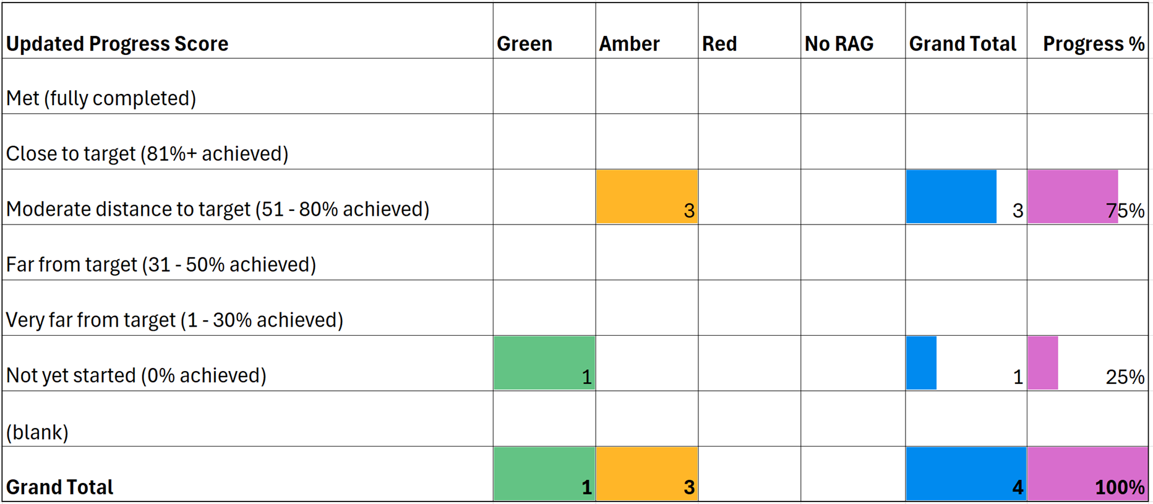
The key areas of progress within this workstream include:
- a portfolio of race and racism training has been developed and to date, delivered to Board
- the organisation has also developed a new Equality Impact Assessment template, supporting the monitoring of Equality objectives with priorities agreed by the Executive Team and Board.
Recommendations that are yet to be completed include:
- implementing race and anti-racism training across CQC
- embedding evaluation and impact monitoring against all recommendations
Challenges and dependencies
Evaluation of individual recommendations has been inhibited by time and the knowledge of evaluation methods of those responsible for delivery. Evaluation is also only being considered once work has delivered, rather than being built into planning and implementation stages. However, further workshops and guidance led by the Research and Evaluation Team will aim to support development of approaches to allow evaluation. This will be important to ensure continual improvement of implemented actions. Articulation of recommendations should be assessed to ensure those not yet delivered remain fit for purpose and are allocated to the correct owner.

Conclusion
- Performance and delivery
After 12 months, half of recommendations (42) are complete or close to completion and 14% (12) are very far from completion or yet to start. Most activity has been against actions aimed at improving the way CQC listens to colleagues and learns from employment tribunals.
- Implementation and achievements
Recommendations that have been achieved tend to be where work was already underway, could be delivered through one team and involved reviews of policy, guidance or training. Those requiring cross organisational collaboration or relating to more complex cultural change are yet to complete and will be necessary for LLRC aims to be realised.
Where recommendations have not made anticipated progress, many challenges result from the impact of CQC’s transformation programme; exacerbating difficulties in managing cross-organisational interdependencies, securing resources and prioritising LLRC work. New technology has been a significant barrier to the delivery of recommendations around how CQC responds to care concerns.
Planning and co-ordination at inception of LLRC have not helped mitigate these challenges. Recognition of the scale of implementation of the 84 recommendations and sequencing recommendation delivery from the outset could have allowed expectations around achievable pace to be set more appropriately, with recognition that it would take longer than 12 months to fully deliver all LLRC aspirations. A lack of structured management, leadership and communication has hindered LLRC work to date; however CQC has renewed LLRC governance and leadership to support future work.

- Impact

There is not yet any evidence of positive impact of LLRC workstreams, but confirmation from CQC colleagues and externally that the work remains necessary and important. The 2024 People Survey results in particular show people do not feel safe to speak up about concerns and do not feel re-assured as to what will happen if they do.

Most recommendations regarding care concerns are still being actioned and we are not meeting the expectations of those raising concerns about care. Ensuring recommendations remain aligned with LLRC aims will be necessary to achieve cultural change.

To support future progress, we recommend:
- Focus the LLRC on the 10 aims. Recommendations need to be streamlined for delivery. There is a need to identify what is necessary to have impact against the aims and to plan the investment of time and resources in an appropriate sequence
- Prioritise aims and recommendations. Prioritisation needs to be undertaken across all aims and recommendations, with cross CQC consensus as to actions to be undertaken over the next year, and targets for when subsequent recommendations will be delivered
- Ensure appropriate leadership and support. The LLRC sponsorship at ET level and through senior leadership should continue. Workstream leaders and senior delivery owners need to be reinstated to monitor progress and implementation of recommendations. Leads should ensure aims and recommendations are articulated appropriately, are assigned to the right people and in collaboration with senior delivery owners, ensure that implementation happens in a way that supports realisation of LLRC aims. A delivery manager should be assigned to support the LLRC sponsor
- Regular performance reports. Performance management information needs to be reported monthly and in full. Performance reports should be simplified (based on RAG status) and should support the prioritisation of recommendations. The start and finish dates for delivery should be clear to support evaluation of impact
- Appropriate governance. LLRC progress should report into the Strategic Oversight Prioritisation and Improvement Committee (SOPIC) to support prioritisation against other CQC requirements and ensure appropriate resource allocation, enabling greater collaboration and co-ordination across activity going forward
- A communications approach is developed to consistently update CQC colleagues on progress against LLRC, provide transparency as to prioritisation decisions and to support understanding of the cultural change LLRC intends to deliver
- Implement LLRC recommendations into business planning. LLRC aims and recommendations around listening to colleagues and Freedom to Speak Up are integrated into CQC Business Planning where appropriate, ensuring these become integrated in the operations of the organisation.

Next steps
An impact evaluation is planned that will explore in detail achievement against the 10 LLRC aims and CQC are working with a research consultancy to provide independence. At the time of this report, LLRC leadership and governance has been revitalised and Executive leadership will be provided by the Chief Inspector of Adult Social Care and Integrated Care.
Work has started reshaping performance tracking of delivery, with facility to monitor dependencies and support cross organisational prioritisation. Support will be offered by Research and Evaluation colleagues to those leading work to incorporate evaluation into their work and monitor progress over time.

