

TABLE OF CONTENTS

People summary | 4
- People metrics comparison over 3 years | 4
Recruitment and Attraction
- Number of adverts/vacancies/applicants/shortlisted candidates/successful candidates | 5
- Successful candidate attraction | 5
- Vacancy fulfilment rate | 5
- Independent panel members | 5
- Diversity in recruitment | 6
- New starters diversity | 7
Current Workforce
- FTE budgeted/actual FTE/actual headcount/vacancy rate/workforce stability/% permanent staff/average fixed term contract length | 8
- Employee status by FTE/assignment status by FTE/grade breakdown by FTE | 8
Diversity and Inclusion
- Self-reporting figures | 9
- Diversity declarations | 9
Reward & Recognition
- Voucher recipients by ethnicity, disability and sexual orientation | 10
- Vouchers recipients by grade | 10
- Vouchers by success profile themes | 10
Absence
- 12 month/6 month/sickness related to stress % rates | 11
- Top 5 sickness reasons/ Top 5 special leave reasons | 11
- Number of colleagues absent for 5 days/20 consecutive days in last 6 months | 11
Sickness Trends & Diversity
- Comparison of sickness rates, and physical vs mental health absences | 12
- Comparison of mental health absence over 3 years by ethnicity, disability & sexual orientation | 13
- Comparison of sickness rates over 3 years by ethnicity, disability & sexual orientation | 14
Turnover
- Turnover rates/avoidable vs unavoidable leavers/leavers by grade | 15
- Leaving well | 15
- Leavers diversity | 16
Turnover Trends
- Annual comparison of % turnover rates | 17
- Annual comparison of % avoidable vs unavoidable leavers | 17
Required Learning
- Required learning information | 18
- Required learning completion rates | 19-20

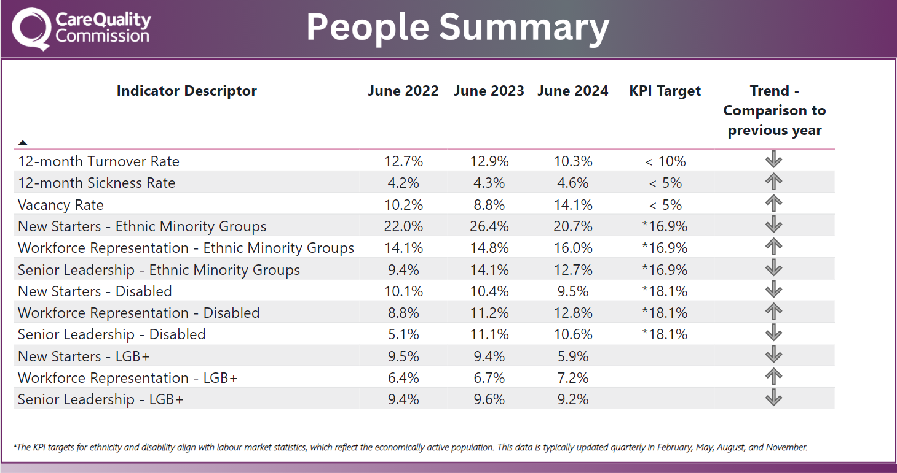
People Summary
A summary table of key people metrics and the organisation’s position over the last three years. The metrics include Sickness Rate, Turnover, Workforce Representation

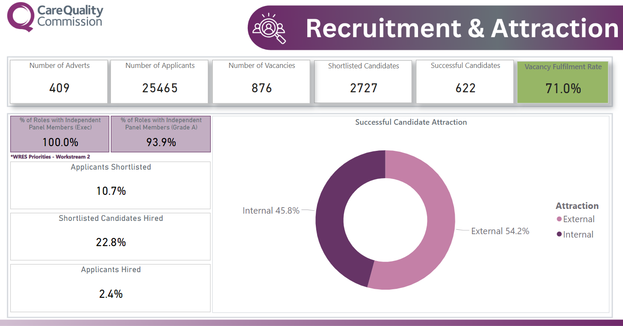
Recruitment and Attraction
A donut chart of internal vs external candidate attraction.
11 card visuals showing; Number of adverts, Number of applicants, Number of vacancies, Shortlisted Candidates, Successful Candidates, Vacancy Fulfilment Rate, Roles with Independent Panel Members

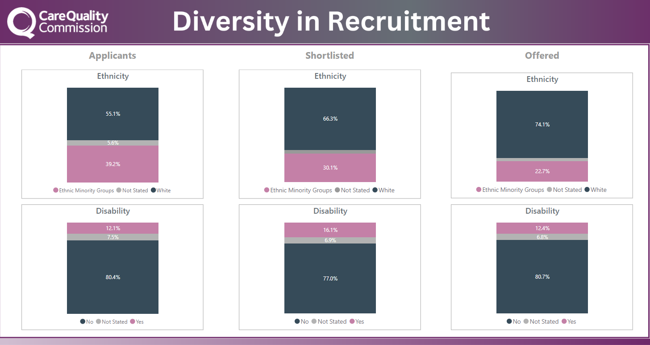
Diversity in Recruitment
6 vertical stacked column charts comparing applicants, shortlisted candidates and successful applicants by ethnicity and disability.
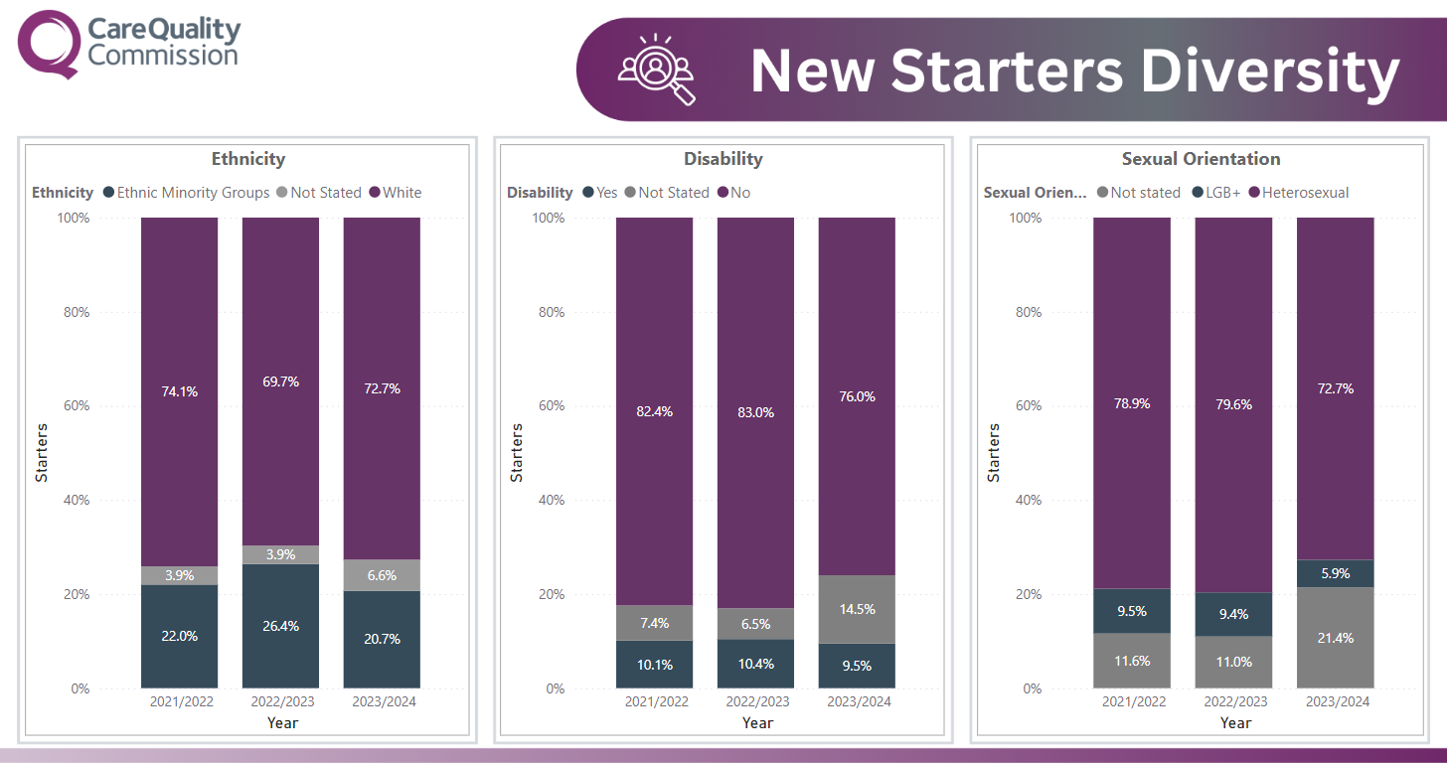

New Starters Diversity
Stacked column charts over the last three years comparing new starters by ethnicity, disability and sexual orientation.
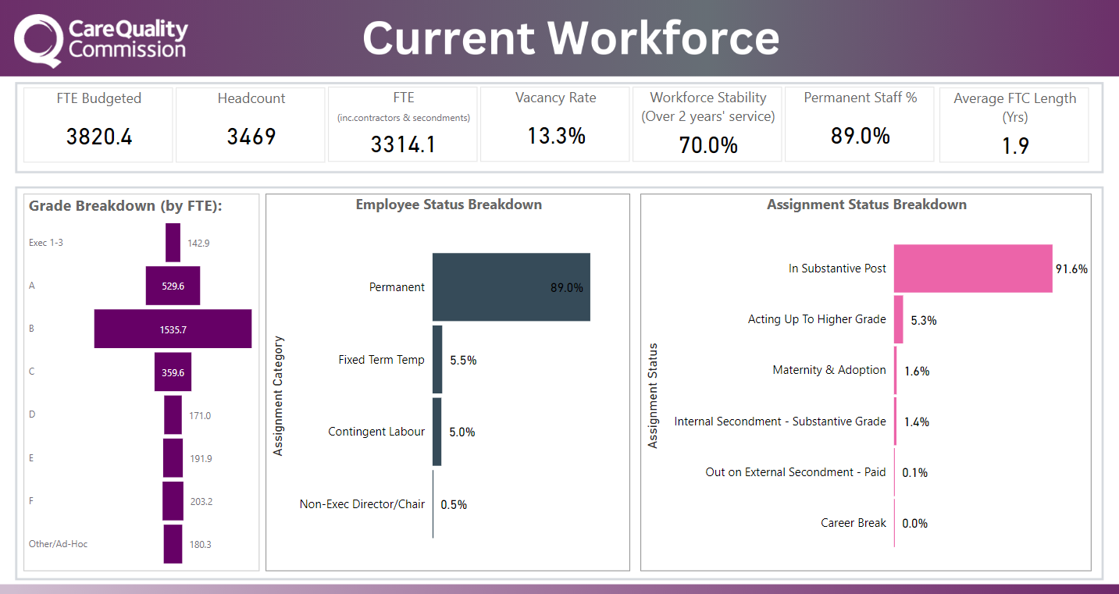
Current Workforce
7 cards with key metrics; FTE, Headcount, Vacancy Rate, Workforce Stability, Permanent Staff, Fixed Term Contract
Funnel visual showing a breakdown of the organisation by grade and 2 horizontal bar charts showing the workforce by employee status and workforce by assignment status
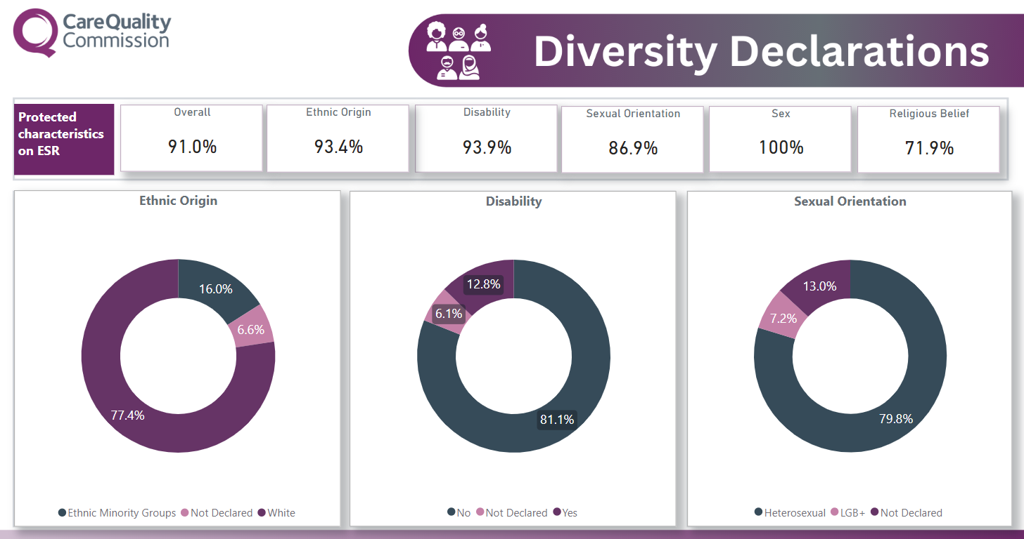
Diversity Declarations
6 cards showing the percentage of declarations by protected characteristics; ethnic origin, disability, sexual orientation, sex, religious belief
3 pie charts showing workforce representation by ethnic origin, disability and sexual orientation

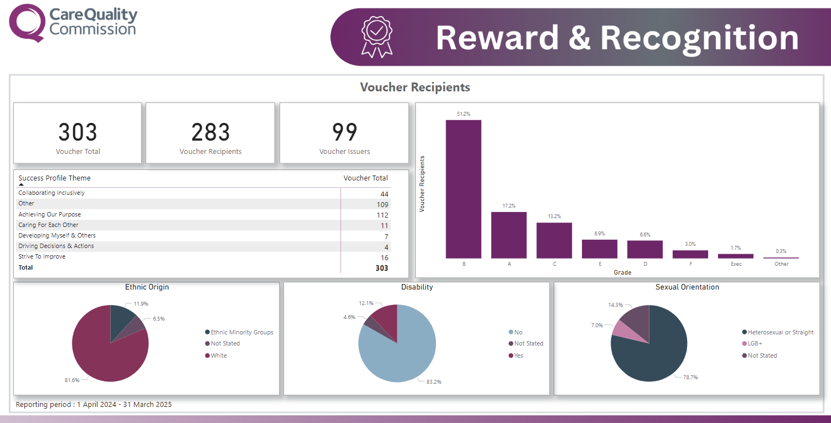
Reward & Recognition
3 cards showing number of reward vouchers issues, number of voucher recipients and number of voucher issuers
Table with breakdown of vouchers by success profile theme and 3 pie charts showing reward voucher recipients by ethnic origin, disability and sexual orientation
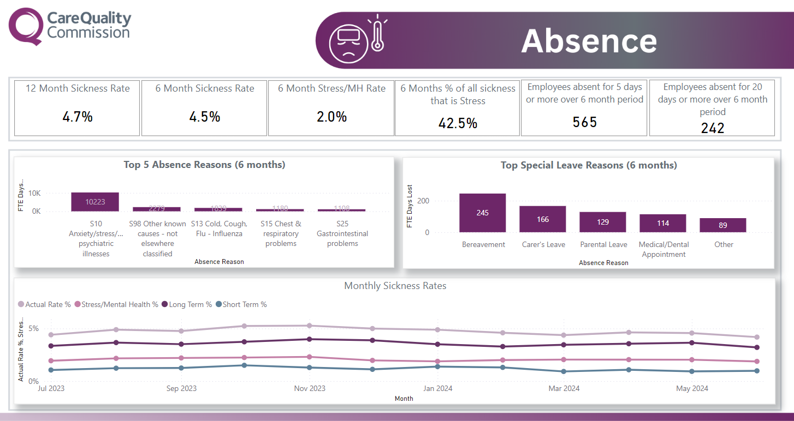
Absence
6 cards showing key absence metrics; 12 months sickness rate, 6 months sickness rate, 6 months stress/mental health, employees who have hit absence triggers
2 Vertical bar chart showing top 5 sickness absence reasons and top 5 special leave reasons in the last 6 months
Line graph showing monthly overall sickness rate, mental health sickness rate, long term sickness rate and short-term sickness rates
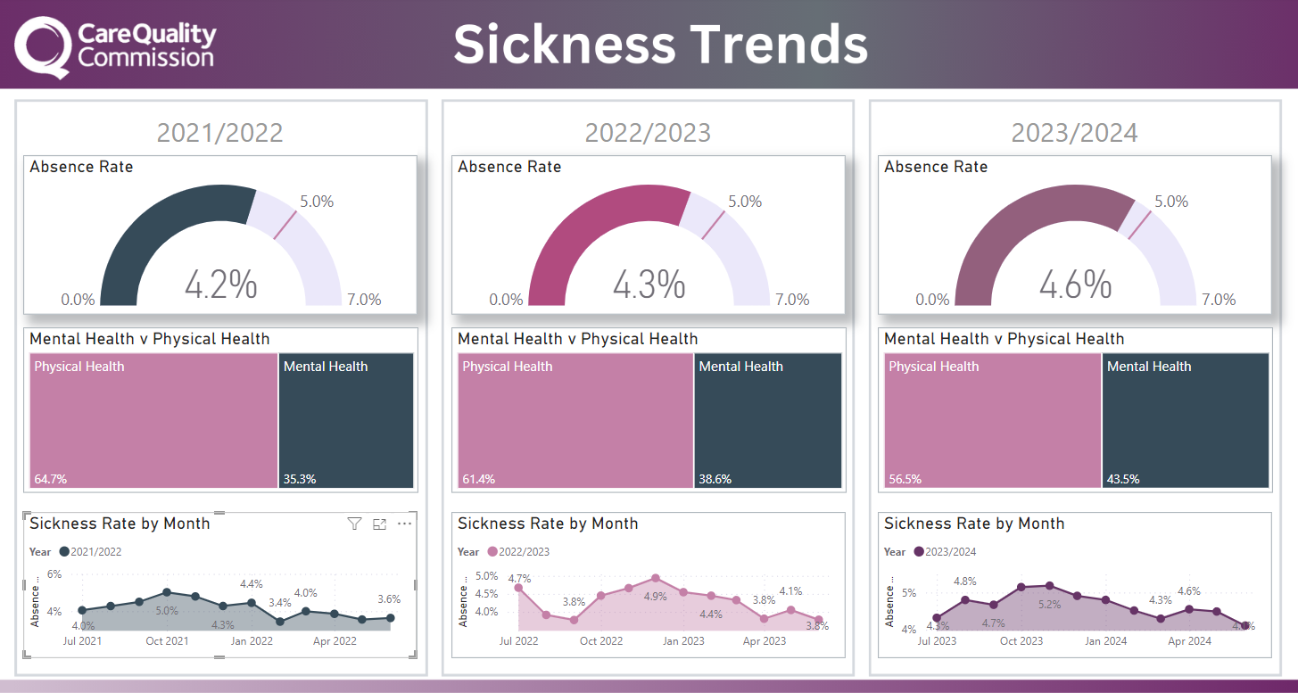
Sickness Rate
3 gauge charts showing absence rate over the last three years against the sickness KPI target of less than 5 percent
3 tree maps of absence broken down by physical and mental health over the last three years

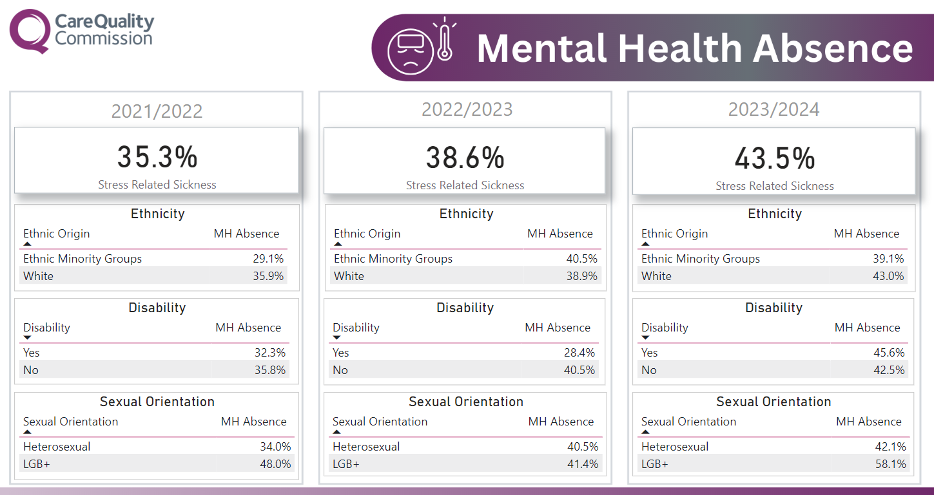
Mental Health Absence
3 cards showing percentage of stress/mental health related absence over the last three years
9 tables showing percentage stress/mental health related sickness by ethnicity, disability and sexual orientation over the last three years

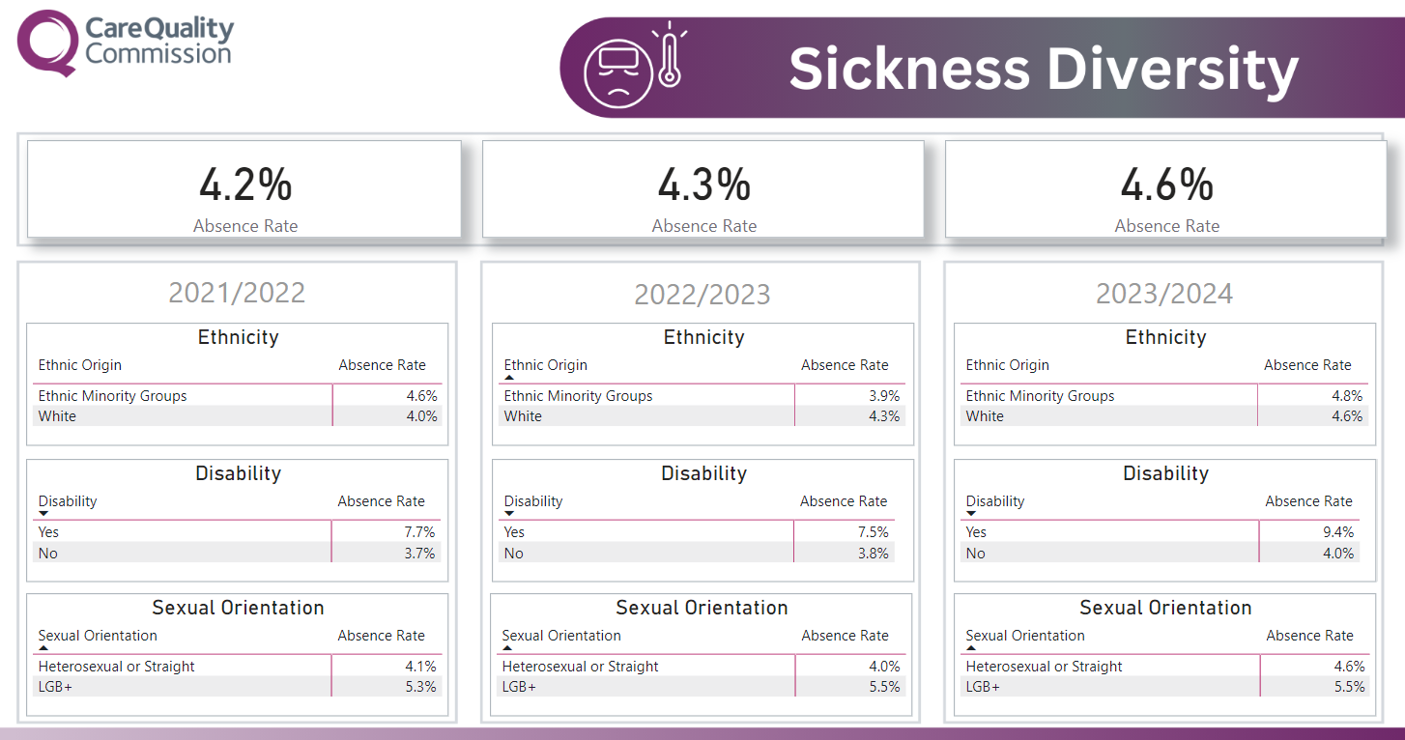
Sickness
3 cards showing 12-month absence rate over the last three years
9 tables showing 12-month absence by ethnicity, disability and sexual orientation over the last three years

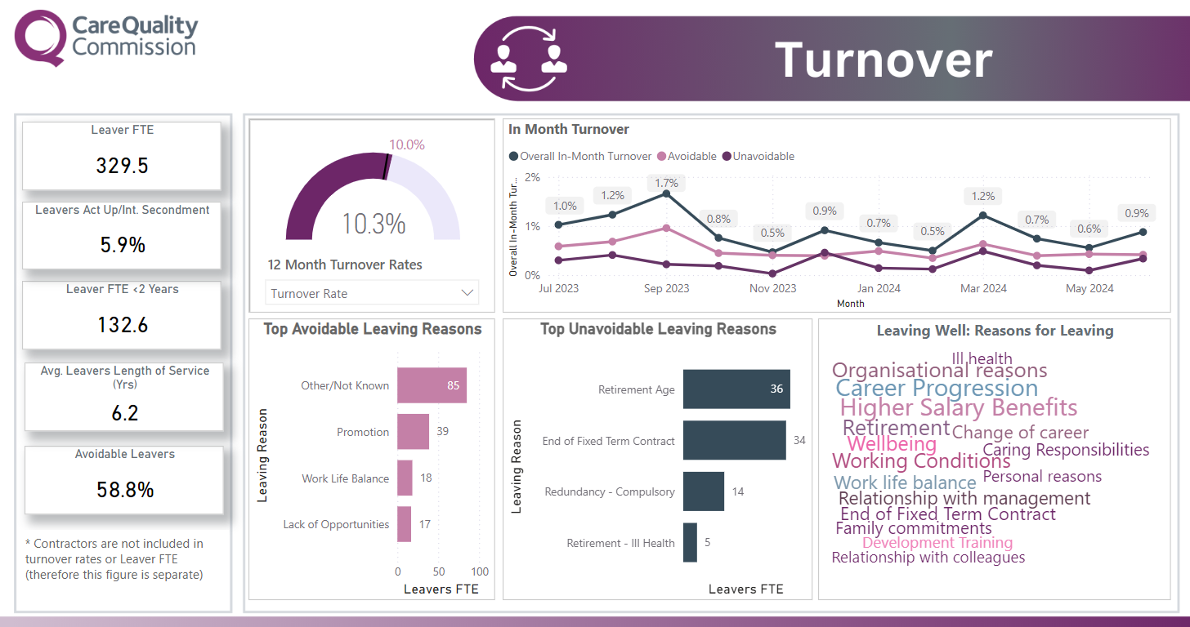
Turnover
5 cards showing leavers FTE, leavers acting up, leavers length of service and avoidable leavers
Gauge chart showing 12-month turnover rate
2 horizontal bar charts showing avoidable and unavoidable leavers by top reason
Word cloud showing leaving reasons
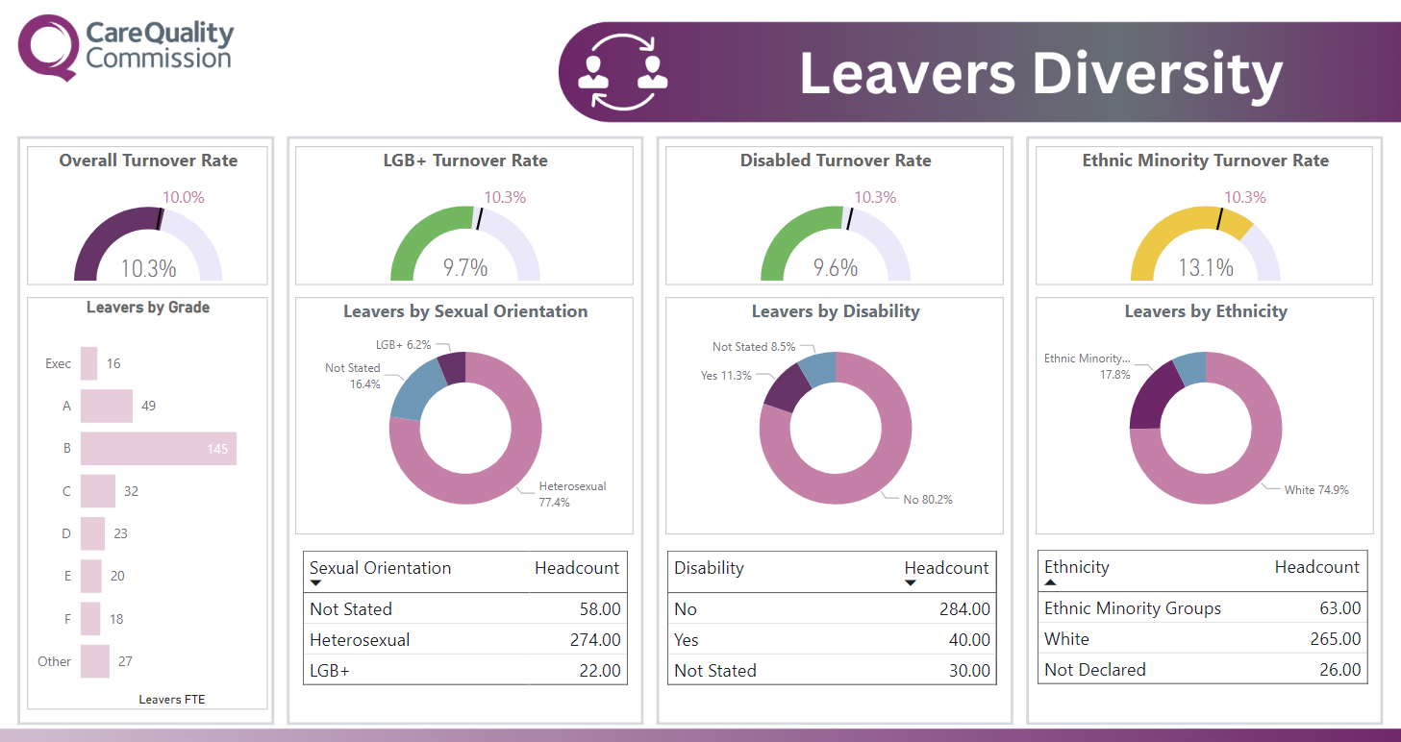
Leavers Diversity
4 gauge charts – 1 showing overall turnover rate against the KPI of less than 10 percent and 3 charts showing turnover rates by ethnicity, disability and sexual orientation against overall turnover rate
Horizontal bar charts showing leavers by grade
3 tables and 3 tables showing leavers in the last 12 months by ethnicity, disability and sexual orientation
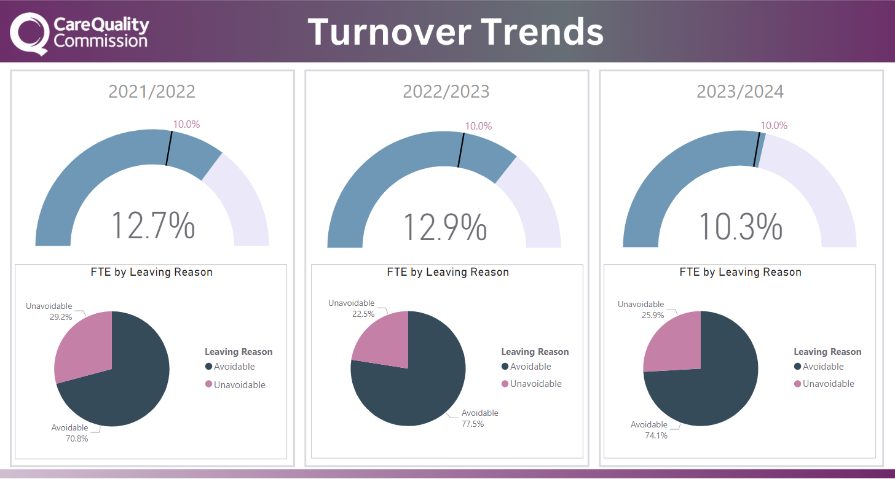
Turnover Trends
3 gauge charts showing 12-months turnover rates over the last three years
3 pie charts showing leavers by avoidable and unavoidable reasons over the last three years

REQUIRED LEARNING
CQC corporate required learning is learning that we all need to complete, either once (when we join the organisation), annually, or every two years.

Title Type Duration Frequency

Anti Bias and Fairness eLearning 30 Mins Annually

CQC Values Information eLearning 30 Mins Annually

Equality, Human Rights, Diversity and Inclusion eLearning 30 Mins Annually

Fraud Prevention eLearning 30 Mins Annually

Display Screen Equipment eLearning 30 Mins Every two years

Health & Safety Foundation eLearning 30 Mins Every two years*

Knowledge and Information Management eLearning 30 Mins Once

Quality Improvement Bronze Foundation Programme Video 40 Mins Once

Foundational learning: Introduction to our new regulatory approach 4 Modules** 3hrs Once
Opportunities in our new regulatory approach from an equality and human rights perspective
Introduction to Framework of Operational Delegations and Assurance (FODA)
Introduction to our new Regulatory Model
Using our regulatory model to tackle inequalities and protect human rights

Annual training runs 01 April - 31 March except CQC Values Information which is aligned to NHS Digital which is 01 July - 30 June (CQC Values Information has been extended to 31/12/23 and new Values training to be launched in 2024)

*Measured from date module completed
** ALL 4 modules must be completed in order to show as complete

COLLEAGUES CURRENTLY OUT OF THE BUSINESS ARE NOT INCLUDED IN THE FIGURES
Out of the Business is defined as anyone who is on Long term sick, Maternity or adoption leave, career break, external secondment or is suspended.
(Long term sickness - 28 days or more and have not returned on or after 15th of the reporting month)
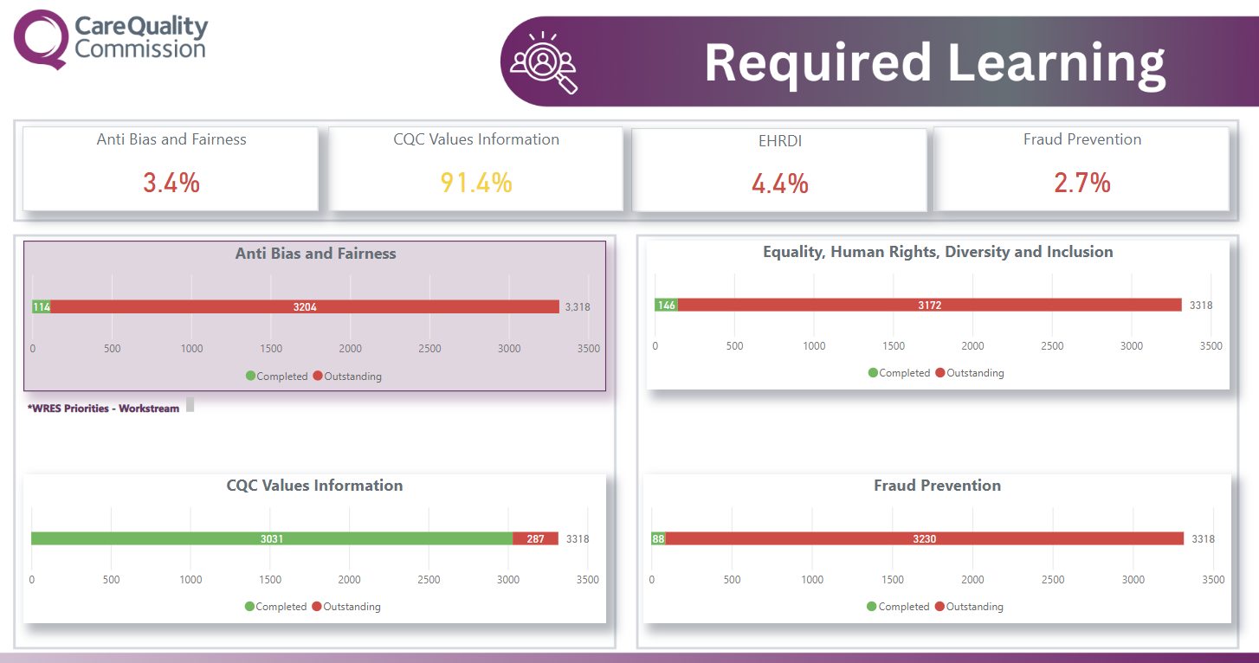
Required Learning
4 cards showing and 4 vertical stacked charts showing completion rates for the following modules:
Anti Bias & Fairness; CQC Values Information; Equality, Human Rights, Diversity and Inclusion; Fraud Prevention

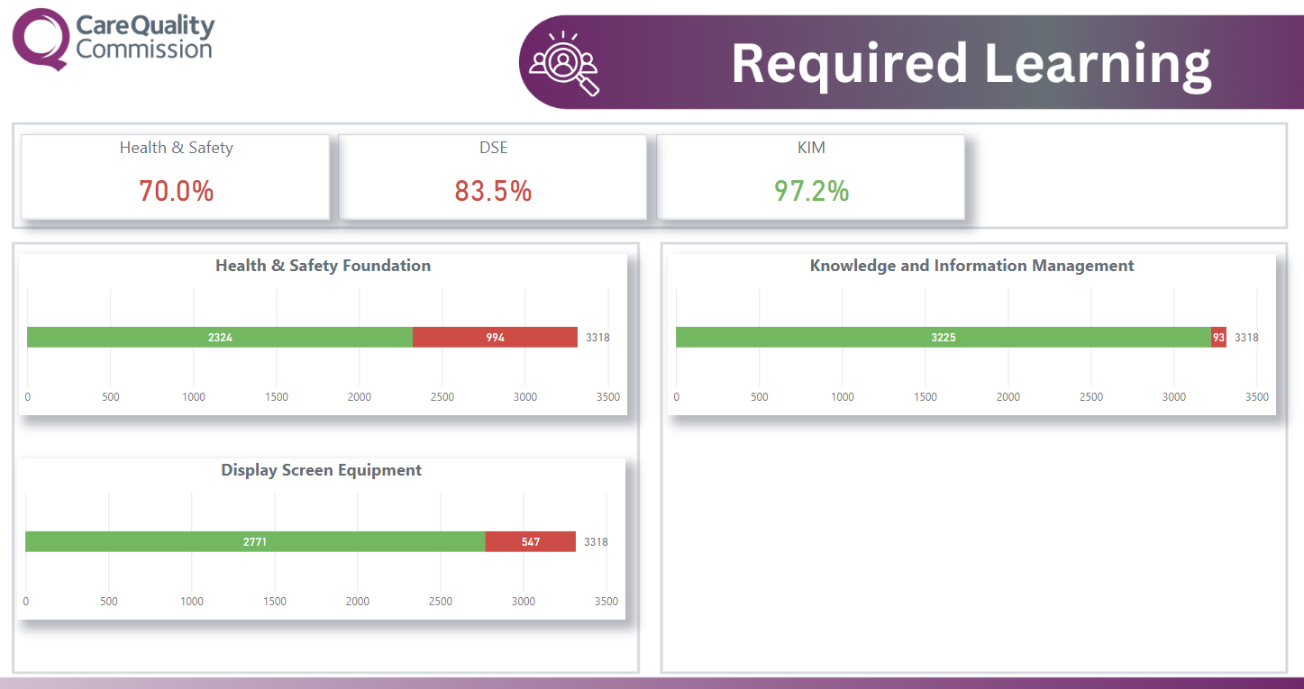
Required Learning
3 cards showing and 3 vertical stacked charts showing completion rates for the following modules:
Health and Safety; Knowledge and Information Management; Display Screen Equipment

